Terzian response to the power of ideas
- Identify what you believe to be the single most influential idea in human history—whether for good or ill. What is the idea, and why do you think it is so important?
There are so many important ideas in history that it would be difficult to select one above so many others. If I could think of one idea that has enabled the modern world it would be the scientific method.
More recently, the idea of splitting the atom has had the most profound influence on contemporary society. It has a positive impact by creating a source of unlimited energy. However, the negative has been the development of nuclear weapons. Other than plagues in the past, this has been the first existential threat to homo sapiens. We seem to now be in an era where certain ideas, if operationalized, also will become existential threats to humanity. The latest iteration of these ideas is AI. As James Barrett warns and his book “Our Final Invention,” the development of artificial general intelligence (AGI) will lead to the turning over of many careers to machines, thus leading to a potential crisis of meaning for homo sapiens. If handled in the typical capitalist manner, it will lead to mass poverty for those who do not own the means of production. Beyond AGI is a specter of artificial super intelligence (ASI), which Barrett envisions working to the benefit of the machines, and probably to the detriment of human society.
- How do destructive ideas, such as eugenics or racial supremacy, gain widespread acceptance? What conditions make a society vulnerable, and what are the most effective ways to combat them?
An example of a destructive idea comes from vaccine skeptics. Recently, we have seen the head of the department of Health and Human Services canceling mRNA research. These cancellations were not based on scientific evidence, rather they were based an ideological stance. Over the next 10 years, if things do not change, we can expect to see the impact of such a decision on the health of the public, especially if we are faced with a pandemic.
- In what ways do our mediums of communication—from art and literature to modern digital technology and memes—shape the power and spread of ideas? Discuss a specific idea whose impact was fundamentally changed by the medium that carried it. Perhaps consider here memes such as Pepe the Frog, Dark Brandon, or the Nasty Woman.
It’s quite clear that social media is having a major influence on Communications between and among individuals and groups. Algorithmic manipulation is key to directing conversations in specific ways. We are all familiar at this point with how we are manipulated by having our biases reinforced, rather than being challenged by different opinions.
- In what ways do art, music, and literature serve as powerful vehicles for transmitting, challenging, or reinforcing dominant societal or political ideas? Share a specific creative work that you believe successfully shaped or changed public consciousness.
I had a personal experience with creating a photograph that elicited both positive and negative responses to the idea of refugees. When presented at a monthly contest of the Camera Club, it became very controversial. It Illustrated the power of visual ideas.
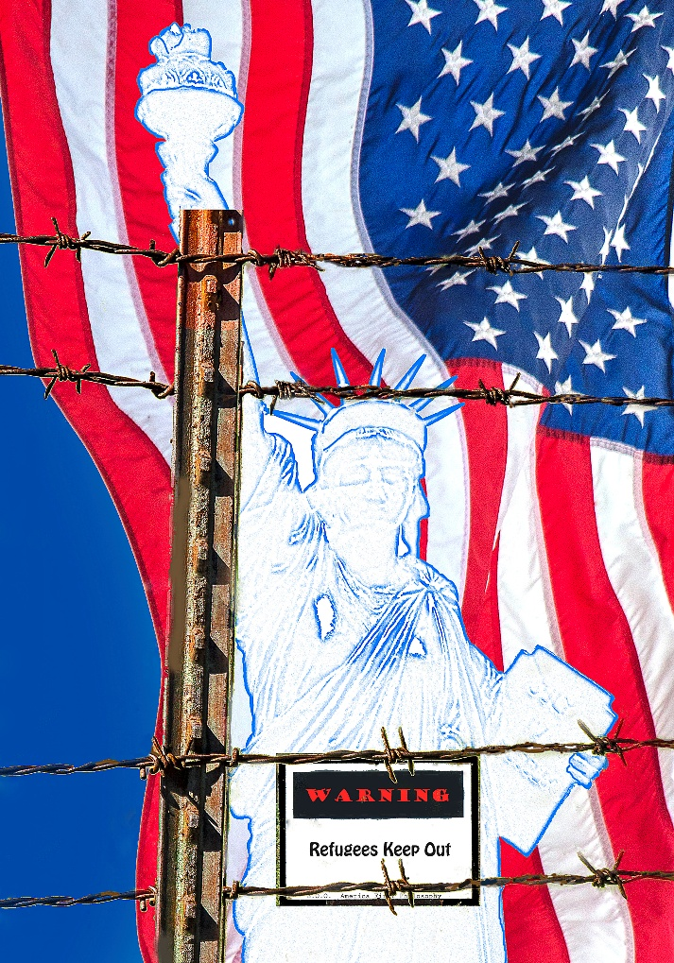

- Describe an idea that changed you personally. It could be from a book, a film, a conversation, or a moment of reflection. What was the idea, and what was its impact on your life's trajectory?
And an idea that has guided my life has been the existential notion that life has no intrinsic meaning and that it is up to us to find meaning in life. My life course has been one of trying to live a life that has social meaning. That we are individuals, but we can only exist because there are other individuals in the world. We are part of a collective and should live our lives with that understanding.

