Terzian Response to Political Realignment
I would like to consider the question “How would you describe the new coalitions that are emerging, and what do they mean for the future of American governance?”
If you look back at the major political alignments starting in 1932 with the Roosevelt administration and looking forward to the present, there were a number of realignments. Claude AI nicely summarizes the major realignments as follows:
“The New Deal Realignment (1932-1936) This was transformative. The Great Depression shattered the Republican coalition that had dominated since the 1890s. FDR assembled a new Democratic coalition bringing together urban machines, white Southerners, labor unions, African Americans, Catholics, Jews, and immigrants. This "New Deal Coalition" made Democrats the majority party for a generation.
The Civil Rights Realignment (1960s-1970s) The Democratic Party's embrace of civil rights legislation fractured the New Deal coalition. White Southern Democrats began shifting Republican, a process that accelerated after the 1964 Civil Rights Act and 1965 Voting Rights Act. Meanwhile, African Americans became overwhelmingly Democratic. This "Southern Strategy" by Republicans gradually flipped the South from solidly Democratic to reliably Republican.
The Reagan Realignment (1980) Reagan brought together economic conservatives, social conservatives (particularly evangelical Christians), and national security hawks. This added the religious right as a major force in the Republican coalition and solidified the party's shift toward free-market economics and social conservatism.
MAGA (2016-present) This feels like an actual realignment because it's reshuffling who is in each coalition:
- Republicans gained non-college whites, especially in the Rust Belt and Appalachia, flipping places like Iowa, Ohio, and Wisconsin from swing states to red-leaning
- Democrats gained college-educated suburbanites, flipping Orange County CA, suburban Atlanta, and Arizona
- The parties essentially traded demographics—education level became a stronger predictor of vote than income
- Issue priorities shifted: trade protectionism, immigration restriction, and cultural issues became more central than tax cuts and entitlement reform.”
If we are defining a political alignment as a fundamental change in the electorate in the two major parties then I would postulate such a change would be associated with one or more (or a combination) of the following: race, age distribution of U.S. population, cultural conflict and/or the economy.
RACE: Race has always played a major role in politics. The shift of white Democrats in the South to the Republican Party was a direct result of the civil rights movement. Race has now re-emerged as a major issue between the parties. The MAGA crowd have been attacking both racial preferences and history as exemplified by their response to DEI. The movement is predominantly white and older, including some extremist organizations that are supportive of white power. The left has been trying to develop coalitions of black and brown people. They have been supporting a “wokeness” agenda that many are now seeing as extreme. A look at population demographics between now and 2060 may explain the motivation for this behavior. “The Non-Hispanic White population will decline from 67% of the population in 2005 to 47% in 2050. More recent projections indicate a decline from 58.9% of the population in 2023 to 44.9% by 2060. The Hispanic population will rise from 14% of the population in 2005 to 29% in 2050. The Black/African American population was 13% of the population in 2005 and will be roughly the same proportion in 2050. The Asian American population will increase from 5% of the population in 2005 to 9% in 2050, with projections showing growth from 15.5 million to over 40 million people.” Given Americans obsession with identity, it seems inevitable that race will be a major factor in politics over the next 20 years.
AGE DISTRIBUTION OF POPULATION: The distribution of age over the next 20 years will have a major impact on older Americans. There is a great deal of concern as to whether there will be enough working Americans to pay for the social programs for seniors. One way to look at that is to look at the dependency ratio. The dependency ratio is a measure of the number of dependents aged zero to 14 and over the age of 65, compared with the total population aged 15 to 64. Working age Americans are going to be responsible for the social program costs of those over 64 and the dependency of those under 15. The ratio can be also broken down to look at the difference between the working population and those over 64. The chart below examines this. The higher the ratio the more dependency. As indicated in the chart, since 2010 the ratio has been going up rather dramatically. It is safe to assume that future political alignments will be influenced by how well future governments are able to deal with the issue of social entitlements.
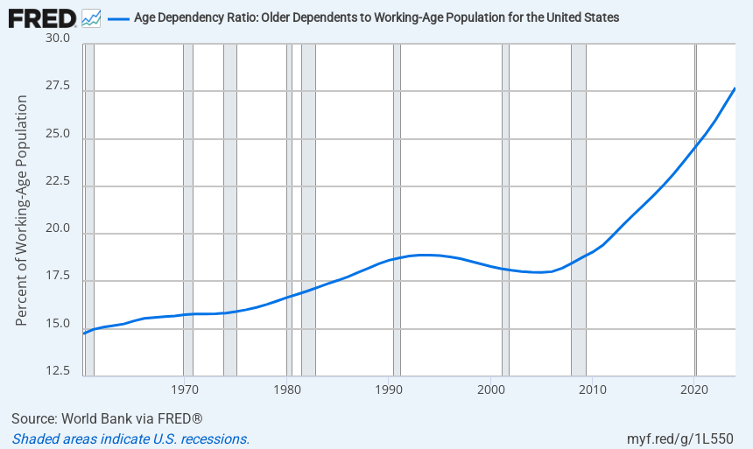
CULTURE: there are a large number of cultural issues that will continue to be played out through the political parties. Besides the typical liberal – conservative – libertarian-threads, there seems to be a growing trend towards a more authoritarian, centrally controlled form of government played out through a strong executive and a weakened legislature. There has been a dramatic shift in how citizens value government and our traditional institutions. This is being reflected in the political alignment that we are presently experiencing in the MAGA movement.
On the Liberal left there are a number of efforts to coerce people to get on board with policies and beliefs that violate the values and norms of many citizens. This is having an effect on how people are aligning themselves with political parties.
Christian evangelism is another factor that may create further divisions depending on how they get played out through the political system.
ECONOMY: Artificial intelligence will play a major role in how the economy operates in the future. If it becomes a job creator and an engine for growth, I don’t believe it will have any impact on political realignment. However, if it leads to massive layoffs and high unemployment it certainly will.
The national debt is another factor that is being ignored by both parties but could have a significant impact on the future direction of each of these parties, especially if international faith in the US dollar falters.
Most recent discussion about affordability is something that bears watching. The cost of education, housing, transportation, children, and the factors associated with the middle-class lifestyle are all important factors that will impact our politics.

Information by Claude AI
I use this term with the understanding that it is a social construct rather than a biological reality.
Information available on Fed Stats

