TOPICAL SEMINAR February 11, 2026

POLITICAL REALIGNMENT

BY Pete Stoehr (peterstoehr1946@gmail.com

Sometimes, when I put on my philosopher’s cap, my mind wanders. Occasionally, when it does, a great truth, previously unknown to me, emerges. More often, what I see as a great truth is a mirage masquerading as a truth. Often, it is just garbage, a sort of distracting static, like this:
“If my pet mongoose took a mate, would I then have a pair of mongeese, or two mongooses.” (Spellcheck favors the latter. On the other hand, it’s okay with Spellcheck, or even spellcheck, Spell Check, or spell check, so maybe it’s not so smart.)
Sometimes, I am even led to question conventional wisdom. For example, we all know that the world, sometimes referred to by its proper name, “America,” is divided into two camps:
One is Racist, Rapacious, and Rapist.
The other is Anti-God, Anti-American, and Anti-Free Will.
Now, I know they exist, because others have seen them and talked about them in print, on radio, TV and via the internet, but I’ve never actually met anyone from either camp. I found that frightening, because every time I eliminated a suspect, I increased the odds of finding bad guys in the remainder.
In my paranoia, I started to question sources. When I came across this quote in the suggested readings, something didn’t seem right, based on my personal experience:
“If there is one statistic that best captures the transformation of the American economy over the past half century, it may be this: Of Americans born in 1940, 92 percent went on to earn more than their parents; among those born in 1980, just 50 percent did. Over the course of a few decades, the chances of achieving the American dream went from a near-guarantee to a coin flip.” Roge Karma, “Why America Abandoned the Greatest Economy in History,” The Atlantic, November 25, 2023.
Now, an American born in 1940 was 83 years old in 2023, so his highest earning days were mostly behind him. Those born in 1980 were 43 years old, just entering peak earning years, so that may yet prove to be true, but a 43 year old born in 1940 lived in a household making 25% less in real dollars than his child born 40 years later.

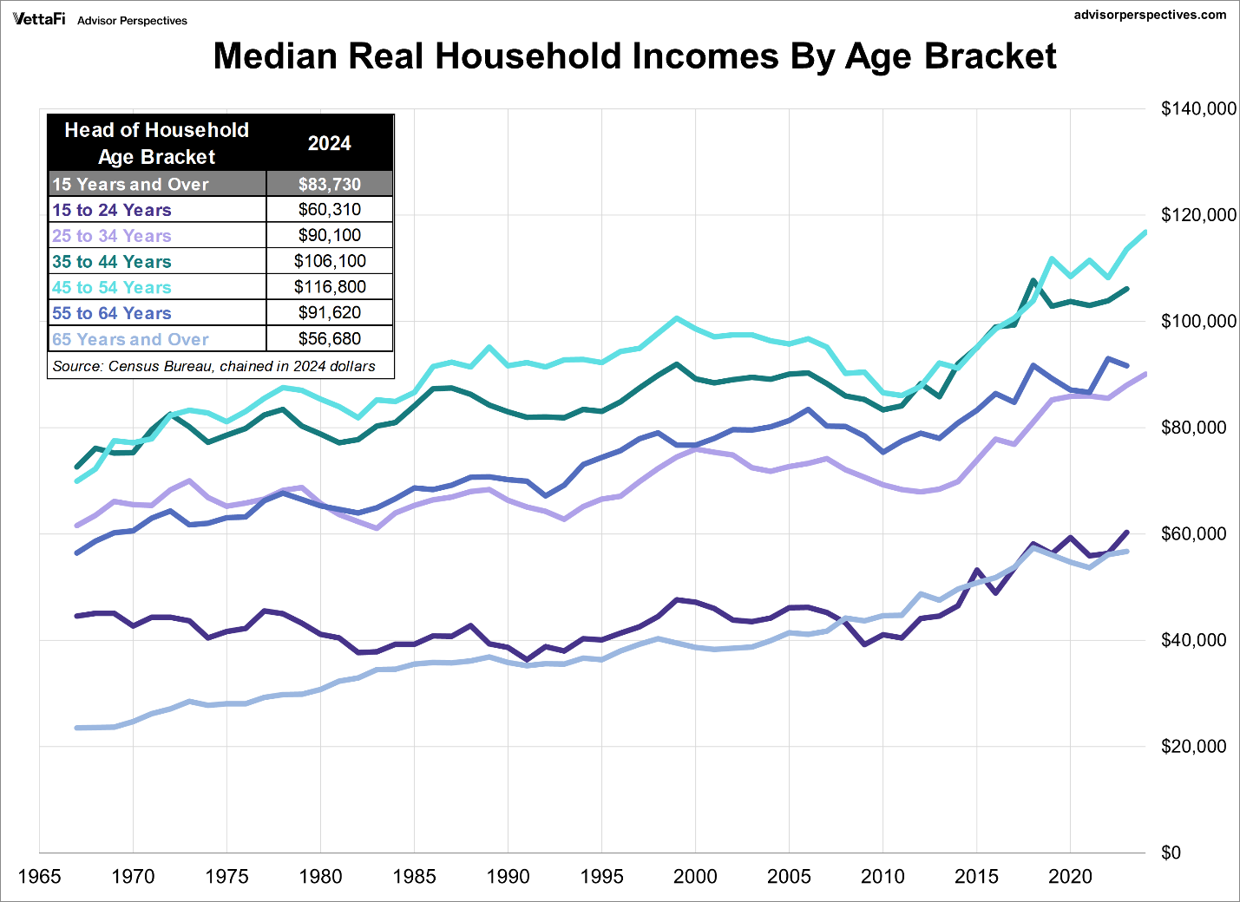
This graph kind of ruined Mr. Karma’s credibility for me. I did read the 7 page article and underlined something as questionable in almost every paragraph. But instead of checking them out, I decided to find out who he was.
SURPRISE! He is a proud member of Notre Dame’s Class of 2018, so he was about 27 when the article was published. My grandson is almost 25, although he graduated from Bard, which may be higher rated academically. In any case, he’s very bright, but the smartest thing he ever said to me was “I feel like a slacker because I only have two jobs and everyone else I know has three.”
In December, we had a seminar entitled “What is Wisdom,” as I recall. The consensus seemed to be that Wisdom was a product of Knowledge plus Experience. Someday, Mr. Karma may learn to find conclusions based on facts, rather than find facts that fit his conclusions. And my grandson may say, “I remember when I was your age. I worked form dawn to midnight for practically nothing!” as he strolls through his antique Tesla collection selecting one for the next car show.
******
A wise man once said that anything can be proved by statistics.
Another wise man said that not all priests and Scout leaders are pederasts, but if you were one, those might be fields that would interest you. Likewise, not all politicians are solipsistic sociopaths, but if you were one, you might want to enter that occupation.
******
I think that many Americans believe that last sentence. “It’s the economy, stupid!” worked for Bill Clinton, and for FDR (A chicken in every pot). Relatively few get very far into the last rung of Maslow’s “Hierarchy of Needs,” the self-actualization stage, which is the only growth stage he lists beyond the deficiency needs of basic physical, safety, love and belonging, and esteem.
Then about the time they get there, retirement brings physical and possible financial and social issues. Other than the game aspects of it, few have much interest or belief in political outcomes.
Most would find “Why?” or “Who Cares?” an adequate answer to the questions posed. We are in a post-literate society. (Both verbal and financial literacy, possibly math and science as well.) That is a problem beyond both my reach and my grasp.
Enjoy today. Likely, we will not suffer the worst of our feared outcomes, nor will our children or their children. If we do, we will have had today, if not, we still will have had today.

