Instructions for the Seminar on Wisdom
For our seminar on wisdom, I am asking participants to respond to their personal experiences with wisdom. To better understand what we mean by wisdom, let’s first turn to contributors of Wikipedia:
“Wisdom, also known as sapience, is the ability to apply knowledge, experience, and good judgment to navigate life's complexities. It is often associated with insight, discernment, and ethics in decision-making. Throughout history, wisdom has been regarded as a key virtue in philosophy, religion, and psychology, representing the ability to understand and respond to reality in a balanced and thoughtful manner. Unlike intelligence, which primarily concerns problem-solving and reasoning, wisdom involves a deeper comprehension of human nature, moral principles, and the long-term consequences of actions.
The Wikipedia author goes on to write “Philosophically, wisdom has been explored by thinkers from Ancient Greece to modern times. Socrates famously equated wisdom with recognizing one's own ignorance, while Aristotle saw it as practical reasoning (phronesis) and deep contemplation (sophia). Eastern traditions, such as Confucianism and Buddhism, emphasize wisdom as a form of enlightened understanding that leads to ethical living and inner peace. Across cultures, wisdom is often linked to virtues like humility, patience, and compassion, suggesting that it is not just about knowing what is right but also acting upon it.”
Examples of wisdom are around us all the time. To simulate our thinking about wisdom let me offer you some examples. The first is from a series of letters written by Roman philosopher Lucius Annaeus Seneca, who lived 4 BC to 65 AD, entitled “Letter 26 On old Age and Death. I selected this letter because I thought it spoke to me.
“It’s only a short time since I was telling you I was in sight of old age. Now I‟m afraid I may have left old age behind me altogether. Some other term would be more in keeping now with my years, or at least my present physical state, since old age connotes a period of decline, not debility. Put me in the list of the decrepit, the ones on the very brink! However, I congratulate myself, mind you, on the fact that my age has not, so far as I’m aware, brought any deterioration in my spirit, conscious as I am of the deterioration in my constitution. Only my vices and their accessories have decayed: the spirit is full of life and delighted to be having only limited dealings with the body. It has thrown off a great part of its burden. It’s full of vigor, and carrying on an argument with me on the subject of old age, maintaining that these are its finest years. Let’s accept what it says, and let it make the most of its blessings. It tells me to start thinking and examine how far I owe this serenity and sobriety to philosophy, and how far I owe it simply to my years, and to investigate with some care what things I really am refusing to do and what I’m simply incapable of doing – and its prepared to accept whatever I‟m really pleased to find myself incapable of doing as equivalent to refusing to do them; and what cause can there be for complaint, after all, in anything that was always bound to come to an end fading gradually away? What is troubling about that? Nothing, you may say, could be more troubling than the idea of our wasting and perishing away – melting out of existence, one may aptly call it, since we aren’t struck down all of a sudden but worn away, every day that passes diminishing in some degree our powers.‟ Moving to ones end through nature’s own gentle process of dissolution – is there a better way of leaving life than that? Not because there is anything wrong with a sudden, violent departure, but because this gradual withdrawal is an easy route. Anyway, here’s what I do: I imagine to myself that the testing time is drawing near, that the day that is going to see judgement pronounced on the whole of my past life has actually arrived, and I take a look at myself and address myself in these terms: All that I’ve done or said up to now counts for nothing. My showing to date, besides being heavily varnished over, is of paltry value and reliability as a guarantee of my spirit. I’m going to leave it to death to settle what progress I’ve made. Without anxiety, then, I’m making ready for the day when the tricks and disguises will be put away and I shall come to a verdict on myself, determining whether the courageous attitudes I adopt are really felt or just so many words, and whether or not the defiant challenges I’ve hurled at fortune have been mere presence and pantomime. Away with the world’s opinion of you – it’s always unsettled and divided. Away with the pursuits that have occupied the whole of your life – death is going to deliver the verdict in your case. Yes, all your debates and learned conferences, your scholarly talk and collection of maxims from the teachings of philosophers, are in no way indicative of genuine spiritual strength. Bold words come even from the timists. It’s only when you’re breathing your last that the way you’ve spent your time will become apparent. I accept the terms and feel no dread of the coming judgement. That’s what I say to myself, but assume that I’ve said it to you as well. You’re younger than I am, but what difference does that make? No count is taken of years. Just where death is expecting you is something we cannot know; so, for your part, expect him everywhere. I was just intending to stop, my hand considering its closing sentence, but the accounts have still to be made out and this letter issued with its travelling expenses! You may assume that I won’t be announcing the source I intend borrowing from – you know whose funds I’m drawing on! Give me a fraction more time and payment will be made out of my own pocket. In the meantime Epicurus will oblige me, with the following saying: “Rehearse death”, or – the idea may come across to us rather more satisfactorily if put in this form – It is a very good thing to familiarize oneself with death. You may possibly think it unnecessary to learn something which you will only have to put into practice once. That is the very reason why we ought to be practicing it. When we can never be sure we have mastered something, we must keep learning it. “Rehearse death.‟ To say this is to tell a person to rehearse his freedom. A person who has learned how to die has unlearned how to be a slave. He is above, or at any rate beyond the reach of, all political powers. What are prisons, warders, bars to him? He has an open door. There is but one chain holding us in fetters, and that is our love of life. There is no need to cast this love out altogether, but it does need to be lessened somewhat so that, in the event of circumstances ever demanding this, nothing may stand in the way of our being prepared to do at once what we must do at some time or other.”
Another example is the well-known Serenity Prayer.
GOD, grant me the Serenity
to accept the things I cannot change.
Courage to change the things I can,
And Wisdom to know the difference.
Living one day at a time,
Enjoying one moment at a time,
Accepting hardship as the pathway to peace.
Taking, as He did, this sinful world as it is,
Not as I would have it.
Trusting that He will make all things right
if I surrender to His will.
That I may be reasonably happy in this life,
And supremely happy with Him forever in the next.
Amen.
Examples can be found in popular music.
For example: Kenny Rogers “The Gambler”
[Verse 1}
On a warm summer's evenin' on a train bound for nowhere
I met up with a gambler, we were both too tired to sleep
So we took turns a-starin' out the window at the darkness
The boredom overtook us and he began to speak
[Verse 2]
He said, "Son, I've made a life out of readin' people's faces
Knowin' what their cards were by the way they held their eyes
So if you don't mind me sayin', I can see you're out of aces
For a taste of your whiskеy, I'll give you some advice"
[Verse 3]
So I handеd him my bottle and he drank down my last swallow
Then he bummed a cigarette and asked me for a light
And the night got deathly quiet and his face lost all expression
Said, "If you're gonna play the game, boy, you gotta learn to play it right"
[Chorus]
You gotta know when to hold 'em, know when to fold 'em
Know when to walk away, know when to run
You never count your money when you're sittin' at the table
There'll be time enough for countin' when the dealing's done
[Verse 4]
Every gambler knows that the secret to survivin'
Is knowin' what to throw away and knowin' what to keep
'Cause every hand's a winner and every hand's a loser
And the best that you can hope for is to die in your sleep
Many examples exist in the visual arts
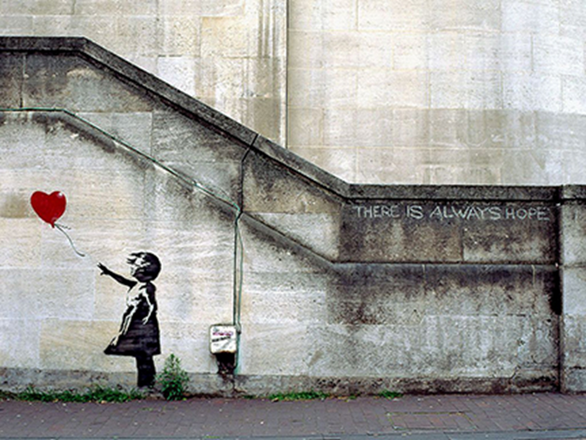



Another example is Divine Wisdom.
“Divine wisdom is a central theme in the Bible, reflecting God's perfect knowledge and understanding. It is a gift from God that enables believers to live righteously and make decisions that align with His will. The Bible presents divine wisdom as both a characteristic of God and a quality that He imparts to His followers.”
Examples of Buddhist thoughts about wisdom
“Wisdom in Buddhism isn’t theoretical. It’s not just being clever or well-read. It’s the direct insight into the nature of reality—especially the three marks of existence: impermanence (anicca), suffering (dukkha), and non-self (anattā) Wisdom is cultivated through:
- Mindfulness (sati): seeing clearly in the present moment
- Concentration (samādhi): deep mental focus
- Ethical conduct (sīla): living with integrity, which purifies the mind
- Direct insight (vipassanā): seeing things as they really are, beyond appearance
It’s not enough to believe; wisdom comes from seeing for oneself. This is why the Buddha often said, “Ehipassiko”—Come and see.”

There are an unlimited number of examples of wisdom in philosophy, the arts, science, spirituality, religion and psychology. The point here is not to study the notion of wisdom, but rather to share expressions of wisdom that you feel will nurture our wellbeing. This can be done in a number of ways.
- Share an example of wisdom and give some explanation of its meaning for you.
- Write an essay sharing your wisdom with us, which we may apply to our daily lives.
- It is not an overstatement to say that we are living in difficult times in our country. There is a climate of resentment and anger that is percolating to a point where society is in danger of unprecedented disruption. This is the time to share your thoughts about how we can deploy wisdom in ways that can help us through this turbulent period.
- Use any other approach that you think will be helpful in sharing wisdom.
Submitted by Aram Terzian

https://en.wikipedia.org/wiki/Wisdom
See https://plato.stanford.edu/entries/seneca/ for more information
lucius Seneca, Letters from a Stoic
https://biblehub.com/topical/u/understanding_divine_wisdom.htm#google_vignette
https://spiritualculture.org/what-is-wisdom-buddhist-sayings-that-illuminate/

