# **TOPICAL SEMINARS**

# **COMEDY**

NOVEMBER 12, 2025

BY Geri O’Hare ([gohpnp2@aol.com](mailto:gohpnp2@aol.com)) and

Pete Stoehr ([peterstoehr1946@gmail.com](mailto:peterstoehr1946@gmail.com)

“Man is the only animal that laughs and weeps; for he is the only animal that is struck with the difference between what things are, and what they ought to be.” – William Hazlitt (1819)

"Everybody laughs the same in every language because laughter is a universal connection." ~ Yakov Smirnoff

"Everything is funny, as long as it's happening to somebody else." - Will Rogers

**This was the Topic Description presented to you:**

What makes something funny? What is the relationship between comedy and society. Is there something that connects comedy over time…what might Aristophanes (*The Frogs*), Petronius (*Satyricon*), and Moliere (*Tartuffe*) have in common with Lenny Bruce, Richard Pryor, George Carlin? Does comedy that is now seen as offensive (Stepin Fetchit, the Three Stooges), Dark Comedy, Sophomoric Comedy, and “Laughing because you think you’re supposed to, even if you don’t get it” remain funny? Why or why not? And how does comic writing, including satire, Jonathan Swift, Gail Collins, Maureen Dowd, relate to that performed before an audience? We will explore the nature of comedy in society and discuss its meaning as an art form and as an important part of culture.

Ordinarily we would give you some links to background material to get you started, pose a few academic questions such as those posed above, and ask you to do further research and provide a provocative summary of your findings, leading lead to a spirited debate.

We both did this independently, started discussing and came to the same conclusion:

“NEVER WATCH THE BUTCHER MAKE THE SAUSAGE,” or you’ll never eat sausage (or in this case, laugh) again.

The topic is too broad. It should be spontaneous and improvisational, and withers in the cold light of day.

**So, Let’s Do This:**

We’ll present you with some axioms, which you will accept as factual for this exercise.

We’ll also give you links to various background and historical information, and some stuff to put you in the mood. We don’t want to hear about them again.

**YOUR ASSIGNMENT** (If you agree to accept this-otherwise these instructions will self-destruct in 30 seconds) will be to find two short scenes or stand-up routines and analyze them according to our axioms. Ideally, one will be a piece that you find funny and others may not, and the other will be one that others generally find funny and you do not. Describe why you like (or hate) each piece and why others seem to hate (or love) it.

Hopefully, we will all have fun while, perhaps, learning something about how others think.

**AXIOMS FOR THIS EXERCISE**

No two brains process a stimulus exactly the same.

The “Sixth Sense,” also called extra sensory perception, takes all the physical stimuli acting at a given instant, combines them with one’s life experience, and predicts or extrapolates what comes next - (“Mary had a little____,” “Ring around the_____”). (OUR axiom, remember.)

The **Sense of Humor is stimulated by tricking this Sixth Sense**. In the early days of Radio, a copywriter wrote a ditty – “Ring Around the (Bathtub!).” Corny, but it sold a lot of Ajax. Among the main stimuli for the Sense of Humor are:

* Puns and wordplay (For the past 4000 years, at least.) Shakespeare was very fond of them.
* Irony
* Exaggeration
* Slapstick, pratfalls and Physical Humor (or anything that helps us recall the simplicity and freedom of childhood)
* Shared memories
* The unexpected

**Humor** can arise naturally (from babies, animals, or a stupid, harmless accident) or be manufactured.

**Comedy** is always manufactured. It requires an audience willing and able to become engaged with the performers. It works best if it contains the basic elements of a narrative:

* A **beginning**, where characters, setting and some conflict, problem or objective are introduced.
* A **middle**, where the “hero” almost succeeds, before being thwarted, then overcomes the obstacle, only to be confronted by a more difficult obstacle. (This usually happens three times. Each test is tougher than the last),
* An **end**, where the hero finally succeeds against all odds, any loose ends are tied up, and, in comedy, everyone lives happily ever after (except, perhaps, the villain).

Besides theatrical comedy, radio, short skits and some stand-up and longer jokes or cartoons work for our exercise. One-liners, newspaper columns and comic novels probably don’t. A comic skit could be part of a dramatic work, though.

**SOME RULES of COMEDY**

It must be **FUNNY.** Jerry Seinfeld says that’s the only rule, but that’s simplistic. Yes, your goal is to go beyond amusing, heading for hilarious, **BUT** know your audience. As kids we learned to tell or not tell some things to our mothers, some to our teacher, some to all the kids, and some only to our best friend. Some people will find some things objectionable, dull, or not understandable.

It must find **common ground** with the audience: school, work and family, and their rules are safe, riskier topics

It must be **good-hearted**. Some comics (Don Rickles comes to mind) can heckle audience members and get away with it, but they are rare. In Rickles’ case, he chose people who he sensed would enjoy the repartee with him, in an audience that came to see the verbal jousting. He was also very careful to maintain a personal image as a kind and charitable man.

It must **laugh at you**, not at others. Fat people can make fat jokes, Irish can make Irish jokes, Jews can make Jewish jokes. Those who are not fat, Irish or Jewish may find an analogy in their own experience (“My family was the same, and we’re Black!”) and slowly realize that we all go through life together. Done wrong, of course, it becomes dull or objectionable.

**And So It Goes….**

**LINKS**

**Hundreds (Thousands?) of funny quotes from all over the world over the centuries**

**<https://www.azquotes.com/quotes/topics/funny.html?p=21>**

**A great explanation for all things humorous:**

<https://www.britannica.com/topic/humor>

**Advice to comedians:**

From SideSplitters Comedy Club, Tampa FL:

<https://sidesplitterscomedy.com/comedy-fails-why-jokes-fail-and-how-to-prevent-it/>

**Easy to Follow History:**

<https://anyjokestuff.com/history-of-jokes/>

**Social Change and Advocacy:** Comedy can be a powerful tool for social change by drawing attention to issues, disarming audiences, lowering resistance to persuasion, breaking down barriers, and stimulating discussion. Examples include shows like Last Week Tonight with John Oliver and Black-ish, according to Rutgers University researcher Silvia J. Feldman. <https://www.rutgers.edu/news/comedy-can-help-change-world-rutgers-researcher-says>

**The Ethics of Offensive Comedy**:Punching Down and the Duties of Comedians

<https://www.cambridge.org/core/services/aop-cambridge-core/content/view/A5B6FAAD512460544CB5A4D3127DE96A/S1358246124000171a.pdf/the-ethics-of-offensive-comedy-punching-down-and-the-duties-of-comedians.pdf>

**Aristophanes “The Frogs” 405 BC Preview (By Puppets):**

[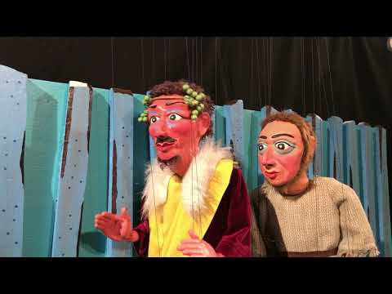](https://www.youtube.com/embed/f-kF46762n8?feature=oembed)

**The Frogs (Sondheim Musical- Shaw and Shakespeares replace Euripedes and Aeschylus) Sound starts at 43 seconds:**

[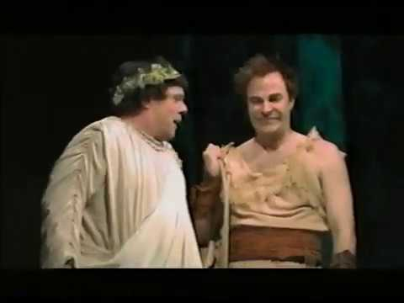](https://www.youtube.com/embed/9xqPj-Ic6Kc?feature=oembed)

**Shakespeare “The Comedy of Errors”(1592):**

[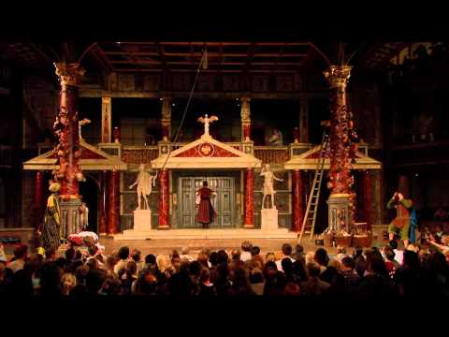](https://www.youtube.com/embed/0ll5UK6jhHw?start=11&feature=oembed)

**Chaplin “The Kid” (Fight Scene-1921):**

[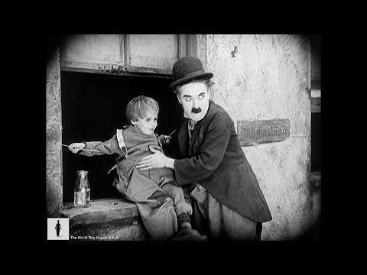](https://www.youtube.com/embed/Z7-QdoofMq8?feature=oembed)

**Abbott and Costello “Who’s on First” (1937, but based on an earlier routine):**

[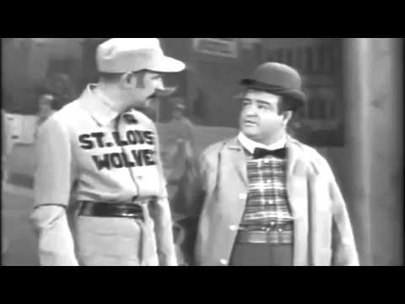](https://www.youtube.com/embed/2ZksQd2fC6Y?feature=oembed)

**Meg Ryan and Billy Crystal “When Harry Met Sally (Fake Orgasm)” 1989:**

**(Note-Rob Reiner directed, the customer delivering the last line was his mother)**

[](https://www.youtube.com/embed/b0OeM6UUAoI?feature=oembed)

**George Carlin “”Saving the Planet” (2007):**

[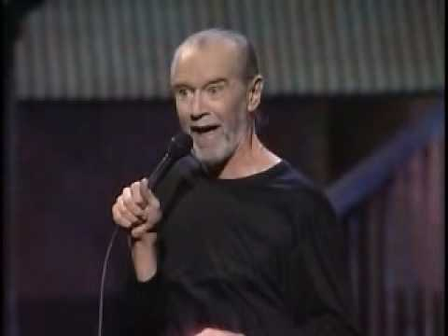](https://www.youtube.com/embed/7W33HRc1A6c?start=80&feature=oembed)

**FROM HERE ON, IT’S FUN STUFF DISCARDED AS INAPPROPRIATE FOR THE INTRODUCTION:**

**Plus** **ça** **Change**, **Plus** **c'est** **la Même** **Chose:**

Ancient Egyptians were amused by nudity, drunkenness, slapstick and political satire:

**1a. In 2600 B.C.E.**, King Snefru received this advice from the court magician Djadjamankh: "How do you entertain a bored pharaoh?

You sail a boatload of young women dressed only in fishing nets down the Nile and urge the pharaoh to go catch a fish."

Inscribed on a roll of papyrus. Reported by *Sunday Times* of London on June 29, 1997.

**1b. 4.624 years later**:

[former President Donald Trump held a town hall](https://www.nytimes.com/2024/10/15/us/politics/trump-fox-news-women-town-hall.html) in front of “a handpicked audience of Trump-loving women in Georgia.” Oct 2024

**“This was the first time Groper Cleveland has been around this many women since they started padlocking the doors at Miss Teen USA.”** *— JIMMY KIMMEL*

**Almost 5000 years of progress!**

**SOME MAY FIND THIS OFFENSIVE**

It features Catholic nuns and sexual innuendo. My wife, Kathy, got it from an old friend and gave it to me. We both found it hilarious and not hurtful. Let me give some context before you decide whether or not to look at it.

Kathy was raised in an Irish Catholic neighborhood in New York. She was taught by nuns through high school. She graduated from Hunter College, before it became coed and had to lower its standards. While at Hunter, she was a national delegate to the Newman Club convention. The Newman Clubs were formed in secular schools to maintain the Catholic traditions of Catholic undergraduates.

She also spent about 15 years at a camp formed to give lower income children in the city a taste of fresh air and country life. She started as a camper and ended an assistant Director. She met and worked with all races and those of all religious beliefs, including Jews, Mormons and atheists. All of her friends whom I have met shared a deep and caring value system and a lifetime practice of giving back to children and to the community.

Kathy’s only prejudice is against tedious people and husbands who fall behind on their chores.

**SCROLL DOWN FOR THE JOKE**

Three nuns were in a car that went off a cliff. They died and arrived at St. Peter’s gates together.

St. Peter addressed them:

“Sisters, we’ve had to make some rule changes because too many people were trying to sneak in when they didn’t deserve to enter Heaven yet. I’m going to ask each of you a question. If you answer correctly, you may go right in to Heaven. Who would like to go first?”

Nun No. 1 steps up and St. Peter says, “Who was the first woman?”

“Eve.”

“Correct! Walk right through the gates.”

Nun No. 2 steps up and St. Peter says, “Where did Eve live?”

“The Garden of Eden.”

“Correct! Walk right through the gates.”

The Mother Superior, who was driving, steps up. St. Peter says “Sister, I’m going to have to ask you a trickier question, is that all right?”

“Of course. I understand.”

“Okay. What did Eve say when she first saw Adam naked?”

Mother Superior screws up her face, closes her eyes, and says:

“Oh, my. That’s a hard one!”

“Correct! Walk right through the gates.”