Topical Seminar Response: Masculinity
Rich Harris – October 2026
What if our writing prompts were:
- Are empathy, equality, care, and emotional openness inherently feminine – or are they human qualities principally shaped by culture and circumstance?
- Must these traits conflict with strength, courage, ambition, and competitiveness?
- Why do some contemporary accounts of femininity appeal to cooperation, collectivism and transgressive gender roles?
- How does anxiety about femininity become politically powerful, particularly within the culture wars and the femosphere?
- What would a positive vision of femininity look like, and how can society nurture it?
I raise this counterfactual to suggest that I find it difficult to consider the masculine without holding it in tension with the feminine. In social psychology, for example, masculinity may be defined in one of two ways: a pole on a continuum of gender (see for example the Mf scale) or a categorically distinct personality concept (see for example the BSRI). In either case, masculinity is analyzed and understood in relation to or in contrast with femininity rather than singled out to be problematized. While this makes sense to me, I’d like to steer clear of social science analysis (my comfort zone) and turn to art and philosophy as an interpretive lens for this topic.
As I was thinking about the materials for this topic, I couldn’t help recalling a sculpture Ellen & I saw on excursion to Ephesus when we took a trip to the Aegean. While there we saw an arresting statue of Dionysus in female garb (on the left below). In turn, this reminded me of another androgenous representation of him (on the right below).
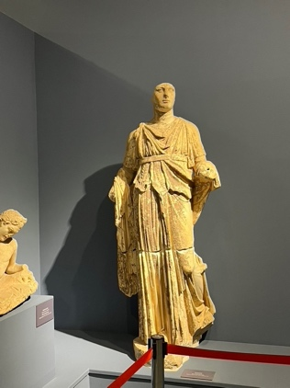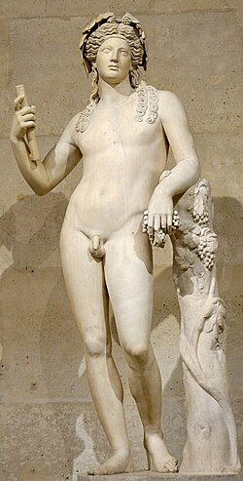
These portrayals are consistent with Greek mythology in which Dionysus spent his early years disguised as a girl to hide from Hera’s revenge: he was another of Zeus’ bastard children that Hera sought to destroy. Unsurprisingly, he symbolizes a transgressive social stance associated with intoxication, emotion, unconstrained natural impulses – in short, the socially constructed (mythologized?) vision of the feminine in western thought. Similarly, consider these two statues of Apollo:
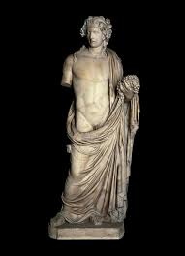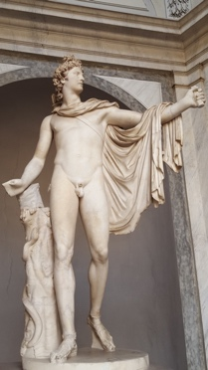
They both appear sexually ambiguous. In contemporary parlance we might refer to their appearance as “gender fluid,” especially in contrast to ancient figures of Zeus and Hercules that are bearded, muscular, and erect – in short, decidedly masculine; or Aphrodite portrayed smooth, soft and curvaceous – in short decidedly feminine (see below).
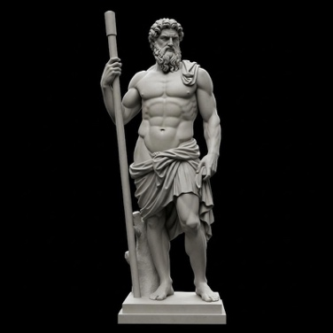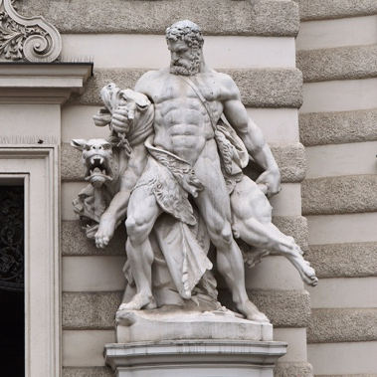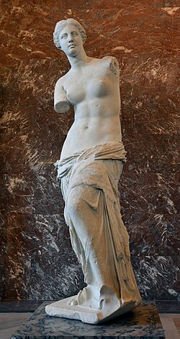
It seems obvious that the ancient Greeks were suggesting something profound about masculinity and femininity, namely that there are idealized norms of the masculine and the feminine, but society is defined by an essential tension between these ideals that requires Dionysian and Apollonian intercession to hold a balance. However, veering radically in either a Dionysian or an Apollonian direction can be unhealthy for the individual or society.
Nietzsche developed this perspective on art in his study The Birth of Tragedy:
…art owes its continuous evolution to the Apollonian-Dionysian duality, even as the propagation of the species depends on the duality of the sexes, their constant conflicts and periodic acts of reconciliation.
While he was concerned with aesthetic development, I think the same dynamic can be applied to the social and political realms as intimated in some well-known films and novels. For example, the 1930 classic, The Blue Angel (Marlene Dietrich’s first movie hit), portrays a staid, bourgeois professor, symbolizing the extreme Apollonian who falls into the thrall of a Dionysian femme fatale cabaret star, Lola, and is gradually stripped of his singular masculinity. His cool Apollonian veneer of structure and rationality erodes under Dietrich’s Dionysian sexuality; by the film’s end he is literally reduced to a clown in the cabaret show.
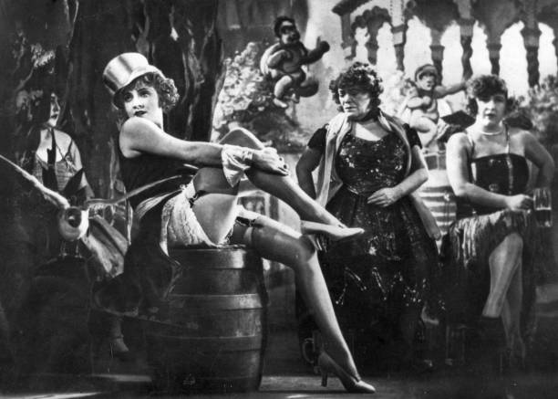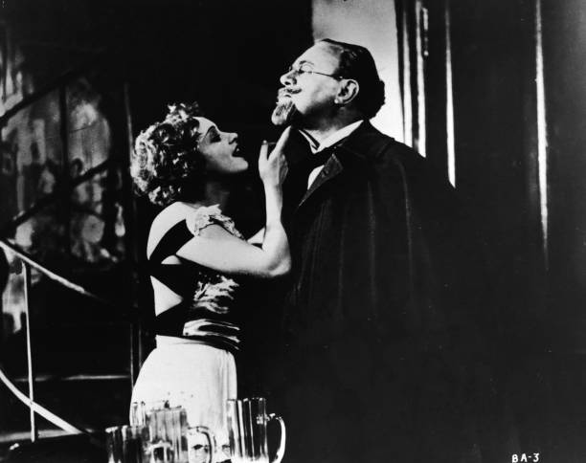
A pure Dionysian impulse may be, corrupting and transgressive, a pure Apollonian impulse is arid and unsustainable.
Another powerful example of the need for balance is found in Dostoevsky’s disturbing saga, The Brothers Karamazov. Setting aside patriarch Fyodor Karamazov’s illegitimate child (Smerdyakov): the eldest son Dmitri projects toxic masculinity in his “sensual” Dionysian passion, and violent temper, while the middle son Ivan displays an unadulterated Apollonian rationality displayed clearly in his tale of the Grand Inquisitor, and the youngest son Alexei exudes a balanced persona, at once empathetic and fearless. In the end, it is Alexei’s centered character that saves both Dmitri and his love Grushenka who had adopted the Dionysian femme fatale pose after being abused when she behaved according to the stereotyped feminine norms of society.
Perhaps a positive vision of masculinity (and femininity) would be a persona centered in one’s biological reality but with the courage to embrace the creative Dionysian/Apollonian tension implicit in all societies. I’ll close with an image of the Hindu deity Ardhanarishvara, a combination of the male Shiva and the female Shakti.
