Tezian Response to the Romantic Era
While reading the materials David produce for this month’s seminar, I came across the name of the poet William Cullen Bryant. This was of interest to me as I went to the William Cullen Bryant Grammar School in West Philadelphia as a child. I was curiouswhy the school was named after a poet, so, using Claude AI, I found the following information about the school.
“When it was built: The school originated as West End School, which opened at the northwest corner of 61st Street and Cedar Avenue in 1903, supplementing an older building already on the site. Archival photos suggest the two buildings were joined in 1913, the year the school was enlarged and renamed William Cullen Bryant School.
How it got its name: The school was named after William Cullen Bryant (1794–1878), a celebrated American figure of the 19th century. He was an American romantic poet, journalist, and long-time editor of the New York Evening Post. He is also known as one of the key figures behind the creation of Central Park in Manhattan. As a poet, he is best remembered for "Thanatopsis," and he served as editor of the New York Evening Post for 50 years.
It was common practice in American public schools during the late 19th and early 20th centuries to name schools after prominent literary and civic figures, and Bryant — often called the "American Wordsworth" — was one of the most admired poets and journalists of his era, making him a popular namesake for schools across the country.”
This appears to be a good example of how romanticism influenced the American educational system in the early 20th century.
I would like to address one of the questions David raises: On Friday, March 13th, Michael Redmond will be delivering a talk exploring how Romantic figures rose up against the cool confidence of the Enlightenment’s faith in reason, science, and mastery of nature. He intends to ask, “in your own life, are you more a child of the Enlightenment or of Romanticism- and what might it mean to live well between the two?”
To help me answer this question, I developed a framework to help understand the relationship between the Enlightenment era and the Romantic era (see figure one below). Unfortunately, I am doing this before listening to Michael’s lecture on the topic. But it shows the reader my understanding of the relationship. It would be safe to say that I am highly into the enlightenment movement and weakly into the romantic movement. Most of the ways that I’ve tried to understand my world have been through objective inquiry. I remember quiet conversations with myself hoping that as I aged, I would take a special interest in philosophy and engage in the Arts through photography. After coming to Lewes, I involved myself in activities supporting these underdeveloped dimensions of my life. Topical Seminars and the Coastal Camera Club have been major vehicles to my broadening perspective. I also give credit to the relationship with David, which has also helped in broadening my perspective.

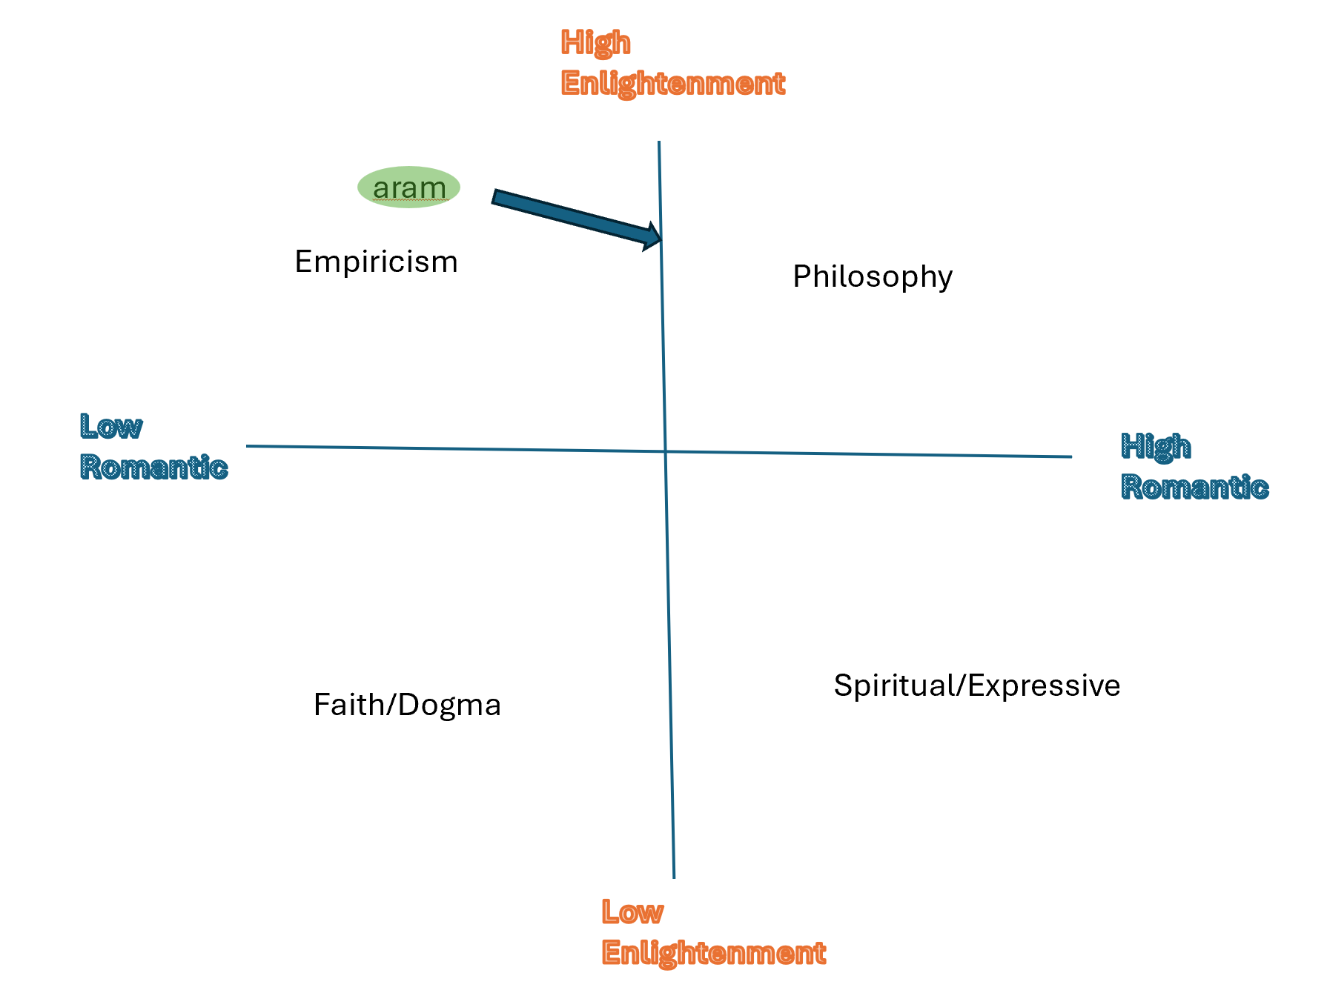

https://www.youtube.com/watch?v=hGvX15W5dE4

