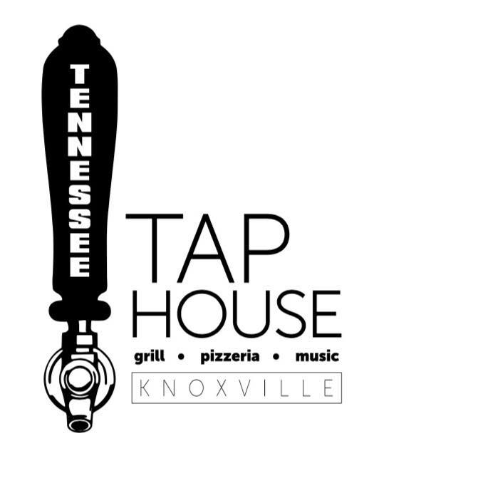
Tennessee Tap House Luncheon Menu - Available daily 11 am – 3 pm
$8.50
Tap House Third Pound Burger – Our hand patted six ounce burger, served with lettuce, tomato, onions and pickles with a side of our handcut fries….. Add Cheese .50 Add Bacon .50
BLT Wrap - Our Apple Wood Smoked Bacon, lettuce and tomato wrap….. Add Cheese .50
Chicken Tenders – Our fresh hand breaded chicken tenders served with cole slaw and hand cut fries.
Soup & Salad Combo – Choice of small Caesar or House salad and a cup of soup.
BLT Combo – ½ BLT with choice of a small side house or Caesar salad or a cup of soup….. Add Cheese .50
Chicken Philly Wrap – a lunch version of our Chicken Philly, served with a side of fries.
Chicken Salad Salad – Half Tap House Salad topped with our homemade Chicken Salad and choice of dressing.
$9.50
Fish n Chips – Beer battered and lightly fried, served with a side of cole slaw, hand cut fries and tartar sauce.
Meatloaf – Tap House Luncheon Favorite – served with mashed potatoes, gravy, and green beans.
Turkey BLT Club Combo – ½ Turkey BLT Club with choice of a small side salad or cup of soup.
Turkey Reuben – Roasted turkey, Sauerkraut, thousand island dressing and melted swiss. Served with fries.
Veggie Lunch Plate – Choice of 3 fresh vegetables
Chicken Parmesan Sandwich – Fried Chicken Tenders topped with 5 cheeses with hand cut fries.
BLT Sandwich- BLT with mayonnaise served with potato chips. Add Turkey for $2
$10.50
Philly Cheese Steak Wrap – a lunch version of our Philly Cheese Steak served with a side of fries.
Famous Tennessee Tap House Pizza – 10 Inch Hand Tossed Small Pizza with your choice of Two Premium Toppings….. Two Super Premium Toppings Add $1
Baked Schrod - Luncheon portion of our Ritz Cracker crumb coated schrod baked and served with a side.
Lasagna- Four layers, five cheeses and our Pomodoro Sauce. Served with garlic bread.
Lunch Pasta - a lunch portion of our Pasta of the Day.

