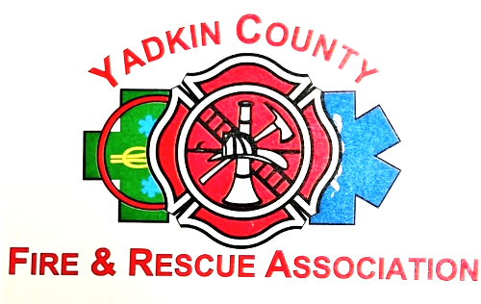

Yadkin County Volunteer Fire and Rescue Association
Scholarship Program

The purpose of the Yadkin County Volunteer Fire and Rescue Association Scholarship program is to provide funding for those who have the passion and desire to pursue a career in Public Safety and Emergency Services. The Yadkin County Volunteer Fire and Rescue Association realizes the need and demand for dedicated individuals to these particular career paths and through this scholarship want to provide as much support and guidance as possible.

Eligibility: Graduating Yadkin County high school seniors who are pursuing a degree in Public Safety or Emergency Services. The eligible recipient must be a member in good standing of a Yadkin County volunteer fire or rescue department and that department must be in good standing with the Yadkin County Volunteer Fire and Rescue Association.

Availability: Each year the Yadkin County Volunteer Fire and Rescue Association will award up to five (5) one thousand dollar $1000.00 Scholarships to eligible recipients.

Process: Each eligible senior should submit the attached application.

The application should have the following documentation attached:

- letter from their Chief;

- two (2) reference letters outside of their departments;

- copy of their senior year grades, SAT or any scholastic scores the applicant wants to submit for review;

- an Essay stating why you are pursuing this career path, what you hope to accomplish and how it will benefit the public or community.

Deadline: April 1 of each year will be the deadline for submission. The application should be submitted by mail posted no later than April 1st or by scanning the documents and emailing a pdf copy to scholarship@YCVFRA.com the mailing address is:
Attn: YCVFRA Scholarship Committee
P.O. Box 804
Yadkinville, NC 27055

Yadkin County Volunteer Fire and Rescue Association
Scholarship Program

Application

Applicant’s full name: __________________________________________________________

Address: _____________________________________________________________________

City/State/Zip: ________________________________________________________________

High School: _________________________________________________________________

Fire or Rescue Department: ______________________________________________________

Chief: ______________________________________________________________________

College or University Planning to Attend: __________________________________________

Planned course of Study: _______________________________________________________

I hereby declare that, to the best of my knowledge and belief, the forgoing answers and information is complete and correct.

Applicant’s Signature ___________________________________________________________

Date ________________________________________________________________________

Checklist:

_____ Application

_____ Letter from Chief

_____ Two (2) reference letters outside of department

_____ Senior year grades with GPA, SAT and scholastic scores

_____ Essay

