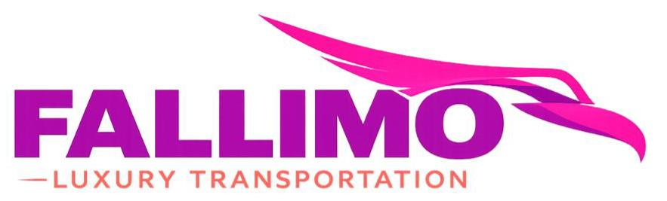
Billing Details:

Name on Card:

Card Number:

Expiration:

CVC/CVV:

Billing Address:

Client ID:

Payment Policy: All payments must be made in full 45 days before the contracted date of service. A credit card imprint may be obtained for all rides. Clients may also be asked to provide a copy of their Driver's License. The payment information on file may be used for overtime charges and other related charges listed below, if applicable. Personal checks will not be accepted any later than 45 days before the date of service. If full payment is not made within 45 days of service, the payment information on file may be charged for payment. Deposit Policy: Until an initial deposit is made, vehicles cannot be guaranteed. All deposits are non-refundable. All payments are non-refundable. For wedding packages, the remaining, full balance of the amount due will be charged 60 days before service. For all other events other than weddings, the remaining, full balance of the amount due will be charged 45 days before service unless full payment had already been received. All payments to be processed through NJ Limobus LLC.
CANCELLATIONS/MODIFICATIONS: No requests for cancellations or modifications can be made via phone call. Cancellations or Modifications MUST BE MADE VIA EMAIL TO info@fallimo.com ONLY! Fallimo Inc. cannot guarantee any changes in schedule or time after the original time block has been reserved. Vehicle Damage: The guarantor of this reservation will be held responsible for any damages to the contracted vehicle by themselves or individuals that they allow into the contracted vehicle. Fallimo Inc. reserves the right to terminate service with no refund to the client(s) renting the service act in a disorderly or violent manner. There is a minimum sanitation charge of $300.00 for any stains or fluids spilled resulting from illness inside our vehicles. Fallimo Inc. reserves the right to initiate collection proceedings for all service or damage fees that are not paid within 14 days after the date of service. Fallimo Inc. will collect and all attorney’s fees, collection expenses, and court costs incurred by Fallimo Inc. in its effort to collect the balance owed. Smoking/Alcohol Policy: All vehicles are non-smoking. There is a $125 charge per occurrence. Fallimo Inc. reserves the right to terminate service with no refund if passengers are smoking. If needed, a driver will pull over and stop to accommodate the passengers to smoke outside the vehicles. The use of illegal drugs in our vehicles is prohibited and can result in the termination of service without a refund. Alcohol consumption is not permitted in the company of minors or minors. General Additional Policy: Any parking fees incurred (other than within Atlantic City, NJ) is the responsibility of the guarantor of this reservation. If for any reason, Fallimo Inc. is unable to perform the service as contracted for; its liability shall be limited to no more than a full refund of any monies paid by the customers hereunder. Fallimo Inc. reserves the right to substitute vehicles in the event of a vehicle malfunction or additional scheduling conflict. Fallimo Inc. does not refund for unforeseen traffic delays that could impact the timing of the client’s itinerary. Please allow for extra time if necessary. Fallimo Inc. reserves the right to not perform service if the weather is inclement and could jeopardize the safety of passengers and chauffeurs. All Fallimo Inc. drivers have the authority to determine if vehicles can safely enter narrow driveways or make tight turns. All limo-buses and vehicles operate under State and local traffic laws, and pick-up and drop-off at several city locations (including but not limited to Atlantic City, NJ and New York, NY) are prohibited in several areas. Limo buses may be prohibited by law from traveling on certain roadways or expressways in various areas, as well as certain bridges and tunnels, and may have to plan alternate routes in compliance with these laws. Fallimo Inc. is not responsible for additional time that may be incurred due to taking these alternate routes. Fallimo Inc. is also not responsible for delays caused by adverse weather conditions, states of emergency, accidents or detours while a ride is in progress. Clients should allow a reasonable amount of buffer time within their scheduling. Fallimo Inc. cannot be held responsible for a start delay of under fifteen minutes. Fallimo Inc. may also assist in obtaining promotions offered by area casinos but Fallimo Inc. is not responsible for and cannot guarantee these promotions. For safety purposes, clients and their respective parties cannot walk in the vehicles while the vehicle is in motion. Clients and their respective parties are not to touch or attempt to open safety hatches on the vehicles except in the case of an accident or relevant emergency. Fallimo Inc. will not be held responsible for any injury sustained if the vehicle must come to an immediate stop. Fallimo Inc. reserves the right to charge the customer for any overtime charges incurred at the rate contracted. Overtime rates will be billed in half-hour increments, rounding up to the half-hour. There is no guarantee that overtime hours beyond the contracted block of time will be guaranteed. Fallimo Inc. reserves the right to conclude services at any moment once the contracted time has expired. The itinerary for service is due ten days before the date of service. It is requested that the itinerary be completed on the forms provided. Fallimo Inc. will not refund or reimburse clients if the driver is redirected to a route that deviates from the driver’s GPS or mapping and time is lost. Fallimo Inc. will not refund or reimburse clients for time lost if the driver needs to find additional addresses not included on the original itinerary. This contract must be signed and returned before the date of service. Kegs, coolers, popcorn, chips, and glass beer bottles are prohibited in the cabin of the vehicle. Coolers can be stored in the storage areas or trunks of the vehicle if there is ample space. The stereo has an automatic shut-off when it reaches an excess level of volume. Fallimo Inc. is well maintained, however, failure of DVD, TV, iPod or stereo system to work during service may result in a refund not to exceed a total of $100. Please check the vehicle upon exiting to make certain that items of value are not left behind. Personal belongings are ultimately the responsibility of the client or their owner.

SIGN AND ACCEPT:

DATE ACCEPTED:

