Total Drain Tanks

When needing tanks that provide complete drainage, these tanks are the perfect choice. The fitting is installed in the bottom of the tank.

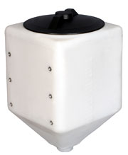 5 or 10 Gallon Tank 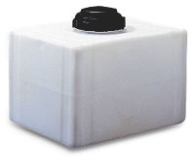 12 Gallon Tank

|  |  |  |  |  |  |  |  |
| --- | --- | --- | --- | --- | --- | --- | --- |
| **Total Drain Tanks** | | | | | | | |
| **Gallon Capacity** | **Width** | **Overall Height** | **Length** | **Fill Opening** | **Outlet/Drain Specification** | **Premium Weight Part No. White** | **Avail** |
| 5 square¤ | 11" | 18" | 11" | 8"-(63480) | 1-1/4"-(67067) | [42321](https://www.norwesco.com/_site_components/uploads/pdfs/Total%20Drain/5%20Gallon%20Total%20Drain%20Tank.pdf) | I,J* |
| 10 square¤ | 13" | 21" | 13" | 8"-(63480) | 1-1/4"-(67067) | [42351](https://www.norwesco.com/_site_components/uploads/pdfs/Total%20Drain/10%20Gallon%20Total%20Drain%20Tank.pdf) | I,J* |
| 12¤ | 14" | 15" | 18" | 5"-(63484) | 3/4"-(60401) | [60521](https://www.norwesco.com/_site_components/uploads/pdfs/Total%20Drain/12%20Gallon%20Total%20Drain%20Tank.pdf) | A |
| The 5 gallon square is packaged 4 per box.  No single piece shipments. | | | | | | | |
| The 10 gallon square is packaged 2 per box.  No single piece shipments. | | | | | | | |