Freestanding Tank

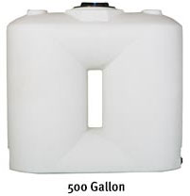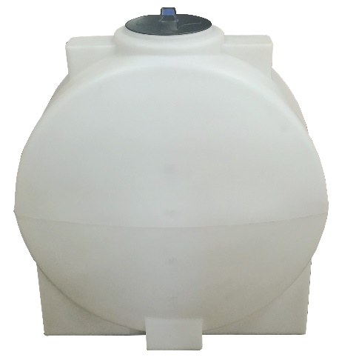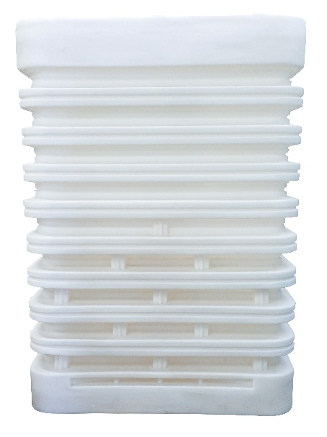

These tanks have been designed with residential and commercial applications in mind. The dimensions of the tanks allow them to fit through a conventional doorway.

|  |  |  |  |  |  |  |  |  |  |  |  |
| --- | --- | --- | --- | --- | --- | --- | --- | --- | --- | --- | --- |
| **Freestanding Tanks** | | | | | | | | | | | |
| **Gallon Capacity** | **Note** | **Width** | **Overall Height** | **Length** | **Fill Opening** | **Outlet/Drain Specification** | **Premium Weight Part No. White** | **Avail** | **Note** | **Water Only Weight Part No. White** | **Avail** |
| 100 |  | 22" | 45" | 38" | 8"-(63480) | 1-1/4"-(60403) | [44800](https://www.norwesco.com/_site_components/uploads/pdfs/Freestanding/100%20Gallon%20Free%20Standing%20Slender%20Tank.pdf) | B,E,I |  | - | - |
| 100 Boxed |  | 22" | 45" | 38" | 8"-(63480) | 1-1/4"-(60403) | [44802](https://www.norwesco.com/_site_components/uploads/pdfs/Freestanding/100%20Gallon%20Free%20Standing%20Slender%20Tank.pdf) | B,E,I |  | - | - |
| 250 |  | 29" | 44" | 62" | 16"-(63485) | 1 1/4"-(60403) | [42337](https://www.norwesco.com/_site_components/uploads/pdfs/Freestanding/250%20Gallon%20Free%20Standing%20Water%20Tank.pdf) | B,C,D,E,G,H,I,L |  | - | - |
| 300 |  | 25" | 65" | 59" | 16"-(60038) | 1 1/4"-(60403) | [44960](https://www.norwesco.com/_site_components/uploads/pdfs/Freestanding/300-25%20Gallon%20Freestanding%20Tank.pdf) | F,H,L | * | [44976](https://www.norwesco.com/_site_components/uploads/pdfs/Freestanding/300-25%20Gallon%20Free%20Standing%20Water%20Tank.pdf) | F,H,L |
| 300 |  | 29" | 50" | 66" | 16"-(63485) | 1 1/4"-(60403) | [44330](https://www.norwesco.com/_site_components/uploads/pdfs/Freestanding/300-29%20Gallon%20Freestanding%20Tank.pdf) | B,C,D,E,G,I |  | - | - |
| 400 |  | 29" | 70" | 66" | 16"-(63485) | 1 1/4"-(60403) | [43856](https://www.norwesco.com/_site_components/uploads/pdfs/Freestanding/400%20Gallon%20Free%20StandingTank.pdf) | B,C,D,E,G,H,L | * | [44361](https://www.norwesco.com/_site_components/uploads/pdfs/Freestanding/400%20Gallon%20Free%20Standing%20Water%20Tank.pdf) | H,L |
| 500 |  | 31" | 70" | 74" | 16"-(63485) | 1 1/4"-(60403) | [43616](https://www.norwesco.com/_site_components/uploads/pdfs/Freestanding/500%20Gallon%20Free%20StandingTank.pdf) | B,C,D,E,G,H,L |  | - | - |
| 750 |  | 35" | 85" | 82" | 16"-(63485) | 2"-(60405) 2" siphon (60335) | [44310](https://www.norwesco.com/_site_components/uploads/pdfs/Freestanding/750%20Gallon%20Free%20Standing%20Tank.pdf) | B,C,E |  | - | - |
| 1000 |  | 40" | 89" | 92" | 16"-(63485) | 2"-(60405) 2" siphon (60335) | [44045](https://www.norwesco.com/_site_components/uploads/pdfs/Freestanding/1000%20Gallon%20%20Freestanding%20Tank.pdf) | B,C,E |  | - | - |
| 400 | VR | 33" | 84" | 43" | 16"-(63485) | NA | - | - |  | [44654](https://www.norwesco.com/_site_components/uploads/pdfs/Freestanding/400%20Gallon%20Vertical%20Ribbed%20Water%20Tank.pdf) | B |
| 600 | VR | 35" | 84" | 58" | 16"-(63485) | NA | - | - |  | [44655](https://www.norwesco.com/_site_components/uploads/pdfs/Freestanding/600%20Gallon%20Vertical%20Ribbed%20Water%20Tank.pdf) | B |
| *Dark Green VR = Vertical Ribbed | | | | | | | | | | | |