Chemical Injection Tank Systems

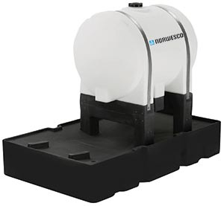Our chemical injection tank system is designed for applications in the oil and gas industry.  The package includes a leg tank, stand, and enclosed containment basin.  The enclosed containment basins have a pump mount, a 2" and a 3" female threaded connection for additional items such as solar panels.

|  |  |  |  |  |  |  |  |  |  |  |
| --- | --- | --- | --- | --- | --- | --- | --- | --- | --- | --- |
| **Chemical Injection Tank Systems** | | | | | | | | | | |
| **Part #** | **Description** | **Diameter/ Width** | **Height** | **Length** | **Fill Opening** | **Avail** |  |  |  |  |
| [44099](https://www.norwesco.com/_site_components/uploads/pdfs/Chemical%20Injection%20System/65%20Injection%20System%20Assy%20PN.pdf) | 65 Chemical Injection System (tank, stand, basin) 65 Leg Tank Stand for 65 Leg Tank Containment Basin - 95 Gallon | 23" 23" 36" | 26" 32" 11" | 43" 33 1/2" 61" | 5"-(63484) | E,I |  |  |  |  |
| [63880](https://www.norwesco.com/_site_components/uploads/pdfs/Chemical%20Injection%20System/125%20Injection%20System%20Assy%20PN.pdf) | 125 Chemical Injection System (tank, stand, basin) 125 Leg Tank Stand for 125 Leg Tank Containment Basin - 165 Gallon | 32" 32" 45" | 35 1/2" 32" 14 1/2" | 43 1/2" 30 1/4" 64" | 6" | E,M* |  |  |  |  |
| [63885](https://www.norwesco.com/_site_components/uploads/pdfs/Chemical%20Injection%20System/225%20Injection%20System%20Assy%20PN.pdf) | 225 Chemical Injection System (tank, stand, basin) 225 Leg Tank Stand for 225 Leg Tank Containment Basin - 300 Gallon | 38" 38" 54" | 41 1/2" 30" 15 1/2" | 52" 34 1/2" 89" | 6" | E,M* |  |  |  |  |
| [63890](https://www.norwesco.com/_site_components/uploads/pdfs/Chemical%20Injection%20System/335%20Injection%20System%20Assy%20PN.pdf) | 335 Chemical Injection System (tank, stand, basin) 335 Leg Tank Stand for 335 Leg Tank Containment Basin - 380 Gallon | 44" 38" 54" | 49" 30" 19 1/2" | 56" 34 1/2" 80" | 6" | E,M* |  |  |  |  |