Inductor Tanks
Norwesco inductor tanks are suitable for mixing chemicals when filling a larger tank. The tanks feature a lid which threads directly into the fill-well of the tank to prevent the sloshing or leaking of contents during transport or application.
Inductor Tanks
Gallon Capacity | Diameter | Overall Height | Fill Opening | Outlet/Drain Specification | Premium Weight Part No. White | Avail | 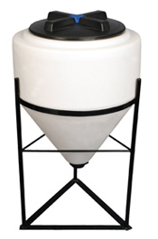
15¤ | 19" | 23" | 8"-(63480) | 2"-(63481) | 60214 | A
15¤ | 24" | 21" | 16"-(63485) | 2"-(63481) | 42064 | A
30¤ | 24" | 28" | 16"-(63485) | 2"-(63481) | 42065 | A
35¤ | 23" | 29" | 8"-(63480) | 2"-(63481) | 45098 | A
40† | 27" | 34" | 16"-(63485) | See † | 44978 | A
60¤ | 31" | 32" | 16"-(63485) | 2"-(63481) | 62205 | A
60 | 24" | 42" | 16"-(63485) | 2"-(63481) | 42066 | A
65† | 27" | 43" | 16"-(63485) | See † | 44979 | A
*80 | 32" | 37" | 16"-(63485) | 2"-(63481) | 47190 | A
† Full drain w/2" MPT molded into tank
*No stand available for this tank.

Inductor Tank Stands
Designed to provide necessary support for the inductor tank during use. Inductor stands are supplied with all necessary hardware.
Inductor Tank Stands
Tank Size (Gallon) | Tank Part No. | A | B | Stand Part No. | 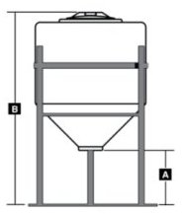
15 x 19"D¤ | 60214 | 15-1/2" | 38" | 60313
15 x 24"D¤ | 42064 | 13-1/2" | 36" | 63397
30 x 24"D¤ | 42065 | 13-1/2" | 43" | 63397
35 x 23"D¤ | 45098 | 15" | 44" | 65517
40 x 27"D-coming soon | 44978 |  |  | 64229
60 x 31"D¤ | 62205 | 14-1/2" | 47" | 62204
60 x 24"D¤ | 42066 | 13-1/4" | 56" | 63397
65 x 27"D-coming soon | 44979 |  |  | 64229

