Flat Bottom Utility Tanks

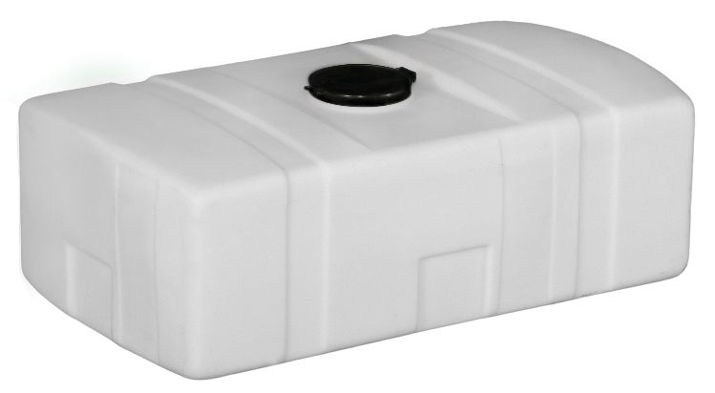

Like the PCO tank, the Flat Bottom Utility tank can be used for many applications. It is the perfect choice when looking for a tank to put in the bed of a pickup truck. Select sizes have bands available as shown below.  The tank may be used with or without bands.

|  |  |  |  |  |  |  |  |
| --- | --- | --- | --- | --- | --- | --- | --- |
| **Flat Bottom Utility Tanks** | | | | | | | |
| **Gallon Capacity** | **Width** | **Overall Height** | **Length** | **Fill Opening** | **Outlet/Drain Specification** | **Premium Weight Part No. White** | **Avail** |
| 7¤ | 9" | 18" | 14" | 5"-(63484) | NA | [44852](https://www.norwesco.com/_site_components/uploads/pdfs/Flat%20Bottom%20Utility/7%20Gallon%20Flat%20Bottom%20Utility%20Tank%20PN.pdf) | I |
| 16¤ | 14" | 17" | 20" | 5"-(63484) | NA | [44853](https://www.norwesco.com/_site_components/uploads/pdfs/Flat%20Bottom%20Utility/16%20Gallon%20Flat%20Bottom%20Utility%20Tank%20PN.pdf) | I |
| 20¤ | 11" | 34" | 15" | 5"-(63484) | NA | [44854](https://www.norwesco.com/_site_components/uploads/pdfs/Flat%20Bottom%20Utility/20%20Gallon%20Flat%20Bottom%20Utility%20Tank%20PN.pdf) | I |
| 26¤ | 18" | 20" | 25" | 8"-(63480) | 3/4"-(60401) | [43835](https://www.norwesco.com/_site_components/uploads/pdfs/Flat%20Bottom%20Utility/26%20Gallon%20Flat%20Bottom%20Utility.pdf) | B,C,D,E,I,L,T |
| 35¤ | 15" | 43" | 15" | 5"-(63484) | 1"-(60427) | [44873](https://www.norwesco.com/_site_components/uploads/pdfs/Flat%20Bottom%20Utility/35%20Gallon%20Flat%20Bottom%20Utility%20Tank.pdf) | I |
| 45¤¬ | 18" | 22" | 38" | 5"-(63484) | 1"-(60427) | [43837](https://www.norwesco.com/_site_components/uploads/pdfs/Flat%20Bottom%20Utility/45%20Gallon%20Flat%20Bottom%20Utility.pdf) | B,C,D,E,I,L,T |
| 50¤ | 19" | 23" | 38" | 8"-(63480) | 1"-(60427) | [42341](https://www.norwesco.com/_site_components/uploads/pdfs/Flat%20Bottom%20Utility/50%20Gallon%20Flat%20Bottom%20Utility.pdf) | B,C,D,E,I,L,T |
| 52¤ | 24" | 15" | 43" | 5" Hinged-(63673) | 1"-(60427) | [43839](https://www.norwesco.com/_site_components/uploads/pdfs/Flat%20Bottom%20Utility/52%20Gallon%20Flat%20Bottom%20Utility.pdf) | B,C,D,E,I,L,T |
| 55¤¬ | 18" | 44" | 18" | 5"-(63484) | 1"-(60427) | [44855](https://www.norwesco.com/_site_components/uploads/pdfs/Flat%20Bottom%20Utility/55%20Gallon%20Flat%20Bottom%20Utility%20Tank.pdf) | I |
| 68 | 27" | 17" | 42" | 5" Hinged-(63673) | 1"-(60427) | [43841](https://www.norwesco.com/_site_components/uploads/pdfs/Flat%20Bottom%20Utility/68%20Gallon%20Flat%20Bottom%20Utility.pdf) | B,C,D,E,I,L,T |
| 100¤ | 27" | 29" | 43" | 8"-(63480) | 1"-(60427) | [42343](https://www.norwesco.com/_site_components/uploads/pdfs/Flat%20Bottom%20Utility/100%20Gallon%20Flat%20Bottom%20Utility.pdf) | B,C,D,E,I,L,T |
| 110 Low Profile | 35" | 18" | 48" | 5" Hinged-(63673) | 1"-(60427) | [42349](https://www.norwesco.com/_site_components/uploads/pdfs/Flat%20Bottom%20Utility/110%20Gallon%20Low%20Profile%20Utility.pdf) | B,C,D,E,I,L,T |
| 150 | 36" | 29" | 48" | 8"-(63480) | 1"-(60427) | [42345](https://www.norwesco.com/_site_components/uploads/pdfs/Flat%20Bottom%20Utility/150%20Gallon%20Flat%20Bottom%20Utility.pdf) | B,C,D,E,I,L,T |
| 200 | 36" | 36" | 48" | 8"-(63480) | 1"-(60427) | [42347](https://www.norwesco.com/_site_components/uploads/pdfs/Flat%20Bottom%20Utility/200%20Gallon%20Flat%20bottom%20Utility.pdf) | B,C,D,E,I,L,T |
| 200 Low Profile | 48" | 20" | 60" | 8"-(63480) | N/A | [44875](https://www.norwesco.com/_site_components/uploads/pdfs/Flat%20Bottom%20Utility/200%20Low%20Profile%20Holding%20Tank.pdf) | E,I |
| 300 Low Profile | 56" | 19" | 95" | 8"-(63480) | N/A | [44233](https://www.norwesco.com/_site_components/uploads/pdfs/Flat%20Bottom%20Utility/300%20Gallon%20Low%20Profile%20Holding%20Tank.pdf) | C,T |
| 500 Low Profile | 52" | 23" | 130" | 8"-(63480) | N/A | [44643](https://www.norwesco.com/_site_components/uploads/pdfs/Flat%20Bottom%20Utility/500%20Low%20Profile%20Holding%20Tank.pdf) | B,T |
| NOTE: The 7 gallon is packaged 4 per box.  No single piece shipments. ¬Fitting is loose, not installed. | | | | | | | |

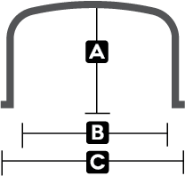

Flat Bottom Utility Tank Bands

Norwesco bands are custom fabricated to support the Norwesco tanks and are galvanized for added corrosion protection. Whether using the tank in a stationary position or for transport, bands are necessary to ensure that the tank retains its shape and integrity.

|  |  |  |  |  |  |  |
| --- | --- | --- | --- | --- | --- | --- |
| **Flat Bottom Utility Tank Bands** | | | | | | |
| **Tank Size (Gallons)** | **A** | **B** | **C** | **Color of band foot** | **No. of Bands** | **Part No.** |
| 50¤ | 19" | 18 1/2" | 23" | Galvanized 1" EMT | 2 optional | [63551](https://www.norwesco.com/_site_components/uploads/pdfs/Flat%20Bottom%20Utility/Flat%20Bottom%20Utility%20Steel/50%20Gallon%20Flat%20Bottom%20Utility%20Steel%20Band.pdf) |
| 100¤ | 24" | 25" | 29 1/2" | Galvanized 1" EMT | 2 optional | [63552](https://www.norwesco.com/_site_components/uploads/pdfs/Flat%20Bottom%20Utility/Flat%20Bottom%20Utility%20Steel/100%20Gallon%20Flat%20Bottom%20Utility%20Steel%20Band.pdf) |
| 150¤ | 24" | 34 1/2" | 39" | Galvanized 1" EMT | 2 optional | [63553](https://www.norwesco.com/_site_components/uploads/pdfs/Flat%20Bottom%20Utility/Flat%20Bottom%20Utility%20Steel/150%20Gallon%20Flat%20Bottom%20Utility%20Steel%20Band.pdf) |
| 200¤ | 33" | 34 1/2" | 39" | Galvanized 1" EMT | 2 optional | [63554](https://www.norwesco.com/_site_components/uploads/pdfs/Flat%20Bottom%20Utility/Flat%20Bottom%20Utility%20Steel/200%20Gallon%20Flat%20Bottom%20Utility%20Stel%20Band.pdf) |
| EMT=Electrical Metallic Tubing | | | | | | |