____________________________________________ ______________________
Student’s Full Name Student ID Number
INFORMATION TECHNOLOGY IN THE GLOBAL SOCIETY
FINAL EXAM
Spring 2020
General Instructions. This Final Examination is being made available to students on Friday, 22 May 2020. Please write or type your answers into this form and return it to the instructor via email at sullivan@sullivanlaw.net. The deadline for submitting your answers to the instructor is Tuesday, 26 May 2020 at 23:59 Riga time. If you encounter any technical problems in the course of taking the exam, or if you find errors in the exam that are confusing, please contact Shawn Sullivan via email, via Skype (my user ID is snsullivan), or by telephone (my telephone number is +1.202.714.9290).

This Final Examination consists of three parts: Part A (True/False), Part B (Multiple Choice), and Part C (Discussion). You should complete all three parts. In preparing your exam answers, you may consult the course textbook, the PowerPoint slides used in class, the materials on the course website, course videos, and any other materials on the Internet.

Part A: True or False Questions

Question  Number | Text of the Question | Insert “True” or “False”
1. | The EU’s e-Commerce Directive does not harmonize EU member states’  laws regarding when a contract is formed online.
2. | Under the General Data Protection Regulation (GDPR), “personal data” refers to information relating to natural persons who are directly or indirectly identifiable. It is not necessary to know someone’s name for that person to be directly identifiable; a combination of other identifiers may be sufficient to identify the individual.
3. | A company’s right to prevent resales of products bearing the company’s trademark will not be exhausted in the European Economic Area unless the trademark holder has personally sold those products in a member state of the European Union.
4 | Latvian contract law has been significantly influenced by the Principles of European Contract Law (PECL) and the UNIDROIT Principles of International Commercial Contracts.
5. | It is legally impossible for an online seller of goods to become liable for trademark infringement by using a competitor’s registered trademarks as search engine advertising keywords.
6. | Early attempts to create “electronic cash” did not achieve widespread success, at least in part, because the companies involved in issuing electronic cash did not inspire the level of trust needed for consumers to use these products.
7. | The E-Money Directive II (Directive 2009/110/EC) increased the capital requirements that electronic money institutions above the capital requirements that had been established in the original E-Money Directive.
8. | Under the European Union Consumer Rights Directive, consumers who enter into distance sales contracts generally are granted a period of 15 days in which they may withdraw from the contract.
9. | Under the U.S. Controlling the Assault of Non-Solicited Pornography And Marketing (CAN-SPAM) Act of 2003, the use of false or misleading header information in unsolicited commercial email is prohibited.
10. | The European Union Consumer Rights Directive provides that the seller in a distance sale contract involving a consumer must disclose to the consumer the name and email address of the company’s chief executive officer.

Part B: Multiple Choice Questions

Question  Number | Text of the Question | Insert Letter of Correct Answer
1. | In 2005, the German corporation Bewegung GmbH was convicted in the United States of entering into a price fixing conspiracy with its competitors. The company was fined, and all of its officers went to prison. All members of the company’s board of directors resigned and were replaced by individuals who had no previous involvement with the company. Three years later, the company’s conviction was reversed on appeal. The prosecution decided to drop the case against Bewegung. Since then, Bewegung has avoided any further violations of law.  In 2020, Bewegung GmbH sent a letter to all Internet search engines operating in Europe. In the letter, it demanded that the search engines de-index all news articles referring to the company’ 2005 conviction. The company based its demand on Article 17 of the GDPR and claimed that it had the right for the conviction to be forgotten.  Which of the following statements most accurately states whether the search engines must comply with, or may deny, the company’s request under GDPR Article 17?  - The search engines may deny the request because Internet search engine operators are neither data controllers nor data processors.  - The search engines must comply with the request because the 2005 conviction was reversed on appeal, and by continuing to display articles about the conviction, the search engines create the false impression that the conviction was valid.  - The search engines may deny the request because information published in 2005 is not subject to the GDPR.  - The search engines may deny the request because corporations do not possess rights under Article 17 of the GDPR.  - The search engines must comply with the request because the right to be forgotten was recognized under the EU’s pre-GDPR data protection regime and continues to be recognized under GDPR Article 17.
2. | Anika is a Latvian university student who wanted to purchase an electric heater to keep her apartment warm. She searched the Internet and found the website of La Chambre Chaude (CC), a Belgian company that specialized in selling room heaters. CC’s website displayed product descriptions in the English, French, Russian, and Latvian languages. It also featured a “shipping costs” page which quoted separate prices for shipping of products to customers in four specific cities: London, Paris, Moscow, and Riga.  Anika placed an order for a heater on CC’s website and downloaded a copy of the contractual terms and conditions of the sale. When the heater arrived, Anika immediately plugged it into a wall socket and began using it. Within 15 minutes, the unit burst into flames. Anika put out the fire but not before the fire destroyed a nearby kitchen table.  Anika is furious and wants to sue CC. However, the contractual terms and conditions provided that if a purchaser wished to file a legal claim against CC, it could only file the claim in a court in Brussels, Belgium.  Which of the following statements most accurately characterizes the legal status of the contract provision requiring any suit against CC to be brought in Belgium?  - The provision is enforceable because CC did not pursue commercial or professional activities in Latvia or direct such activities to Latvia.  - The provision is enforceable because Anika had an opportunity to read the contractual terms and conditions at the time of the sale.  - The provision is unenforceable because the sale transaction involves a consumer contract that is subject to the Brussels Regulation I (recast), and Anika has the right to sue CC in the EU member state of her domicile.
3. | Jonathan’s father, Harold, was a prominent local politician. Harold was struck by a car when he tried to walk across the road. An ambulance carried him to a state hospital, where doctors tried to save his life. Unfortunately, after two days in the hospital, Harold died. The next day, a nurse at the hospital mistakenly e-mailed a copy of Harold’s medical file to her sister, who is a reporter for the local newspaper. One day later, while Jonathan was preparing for his father’s funeral, he saw that the newspaper had published very specific details about Harold’s medical conditions. Jonathan wants to take legal action against the hospital under the GDPR for improperly disclosing Harold’s sensitive personal data. Which of the following is the most likely result?  - Jonathan will win in a claim against the hospital because a person’s medical condition is sensitive personal information that is protected by the GDPR against unauthorized disclosure.  - Jonathan will lose in his claim because the GDPR does not apply to public bodies such as a state hospital.  - Jonathan will lose in his claim against the hospital because information about deceased persons does not constitute personal data and therefore is not subject to the GDPR.  - Jonathan will win in a claim against the hospital because the newspaper reporter who published the information is a relative of the hospital’s nurse.
4. | Aivars Ozola is a software programmer who created a new software program for calculating the amount of income taxes owed by a person. Shortly after he completed the program, his roommate secretly made a copy of the program and sold it to a large company Aivars did not register his software with the government copyright office. Which of the following statements accurately characterizes the rights of Aivars under copyright law?  - Aivars has no remedy under copyright law because software can only be protected by patents.  - Aivars can recover damages from his roommate for copyright infringement because copyright protects the underlying ideas that are expressed in computer programs.  - Aivars cannot take legal action against his roommate because copyright does not come into existence until the “work” (here the software program) has been registered with the copyright authorities.  - Aivars owns the copyright in the software program, and it does not matter that the program is not registered with copyright authorities.

Part C: Discussion Questions

Donnybrook Farms is an Irish company that sells flower seeds on its e-commerce website. Almost all of its customers reside in member states of the European Union.

Donnybrook Farms allows interested persons to download a free catalogue of all seeds in its inventory. The company plans to collect contact information from persons who request the catalogue, so that the company can later send them information by email regarding sales and other promotions.

On its website page, Donnybrook Farms requires anyone who wants to download its catalogue to enter a name, postal address, telephone number, and email address. Then the customer is directed to the following page, where the customer must click the box at the bottom of the page to place the order:

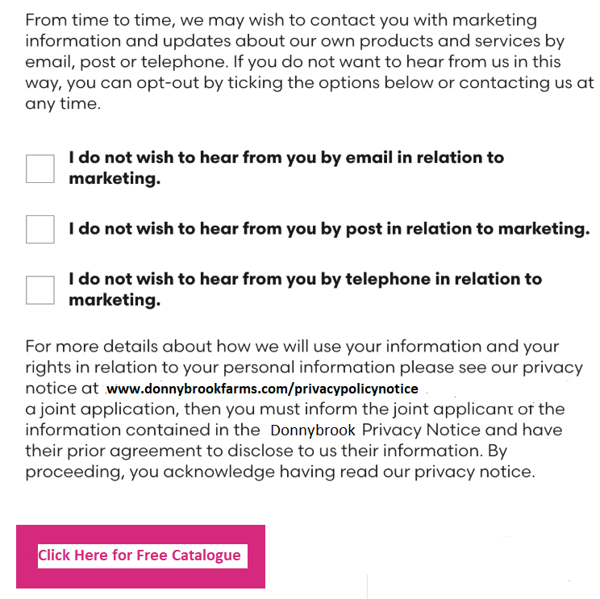

In an answer of 2-4 paragraphs, please evaluate in your own words whether the General Data Protection Directive (GDPR) permits this manner of collecting information about potential customers.

[Write or type answer in this space. You may expand the space if necessary.]

2. | Latvijas Balzams (LB) is leading producer of alcoholic beverages in the Baltic States. It owns several Latvian trademark registrations for its name. It also holds the Internet domain name registration www.latvijasbalzams.lv.  Tom Jones is an unscrupulous used car salesman in New Jersey, USA. He has no business or family ties to the Baltic States, and his only connection with alcoholic beverages is that he consumes them in great quantities. Despite the absence of any relationship with LB, Mr. Jones has registered the Internet domain name www.latvijasbalzams.net. He obtained the registration from GoDaddy.com, a domain registrar that follows the Uniform Domain-Name Dispute-Resolution Policy (UDRP).  Mr. Jones sent an email to LB’s corporate headquarters to notify the company that he holds the www.latvijasbalzams.net domain name registration. He said that he would be happy to transfer the registration to LB if it will pay him €10,000. He added that if LB is not interested in purchasing the domain name, Mr. Jones plans to use the domain name as the Internet address of a new website from which users can subscribe to a streaming pornographic video service.  In an answer of 2-5 paragraphs, please evaluate the likelihood that LB can acquire the http://www.latvijasbalzams.net domain registration from Mr. Jones by commencing a UDRP proceeding against him.  [Write or type answer in this space. You may expand the space if necessary.]
3. | In your own words, explain one significant difference between the legal protection afforded by copyright law and the legal protection afforded by patent law. Your answer should consist of at least two sentences.  [Write or type answer in this space. You may expand the space if necessary.]
4. | In 2-3 paragraphs, please explain in your own words what “cryptocurrencies” are, and describe some of the reasons why some cryptocurrencies can present challenges to law enforcement authorities.  [Write or type answer in this space. You may expand the space if necessary.]

