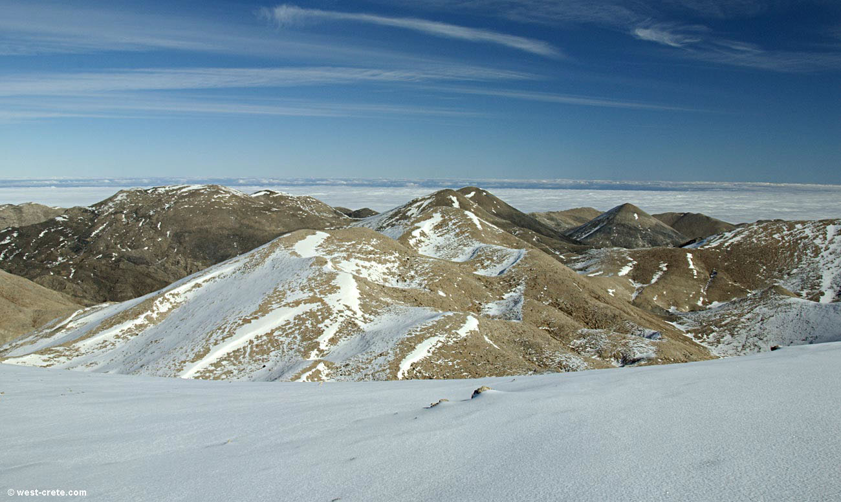The scene opens with a view of the Morning Dew Mountains. Some words appear on the screen:

It is the 12th Indiction of the Modern Era.

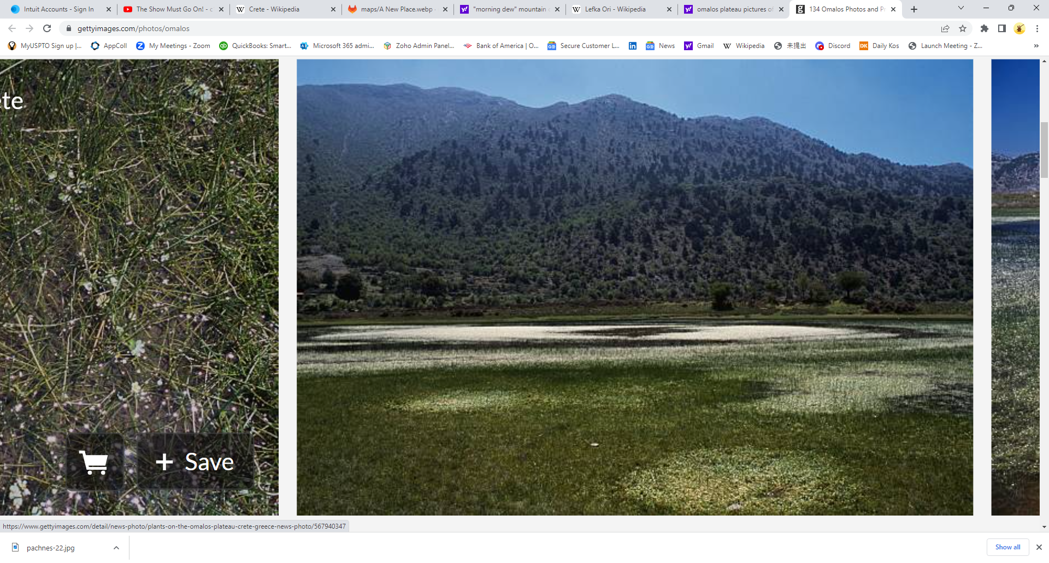The camera pans downward toward the Omalous Plateau, just below the snow line. Some additional words appear on the screen:

It is an auspicious date, the first day of the first month of High Winter…

(Imagine there are people in the image above.)

The camera pans to a man, Halkéon as he is known, and a woman excavating what appears to be an ancient ruin, their shoddy-looking airship in the background. It appears cold, with swirling snowflakes but not much snow on the ground. The man gazes fondly at his wife before wiping sweat from his brow and turning to strike the hard volcanic stone with his pickaxe.

The camera pans out and a story, apparently that of Halkéon, is relayed by a narrator:



The camera pans over to a human, a batling, and an aelf making their way across the plateau.

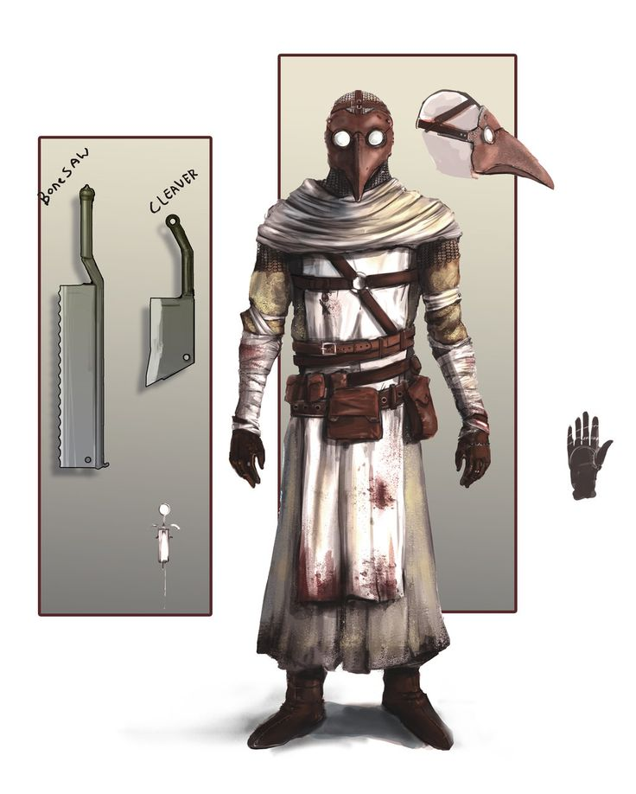

The human, Vargas, sees the couple hard at work and knowingly smiles. There is frequently pain that comes with hard labor and he can help, in his way. His face is passive, though, as he takes in the scene, interested in what he might find.

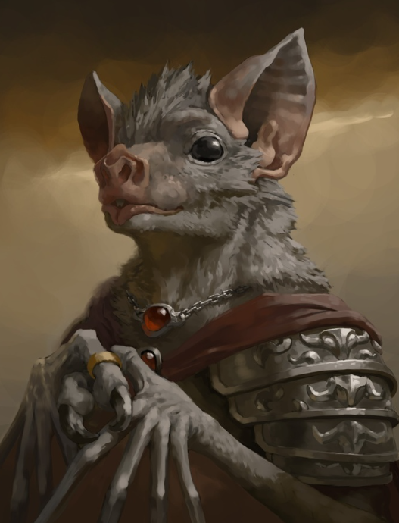

The batling, Fang, flits about with nervous energy. Continuously taking in his surroundings with high pitched peeps out of the range of human hearing, he builds a map of his world with sound and seeks to find valuables within it. He makes a note of the airship, and its apparently shoddy construction. The raggedy clothing are no surprise, given their labors, but the tools they are using are substandard. He is a bit disappointed. Borrowing from these folks may not be particularly lucrative. Still, he observes them keenly and scans the area for valuables.

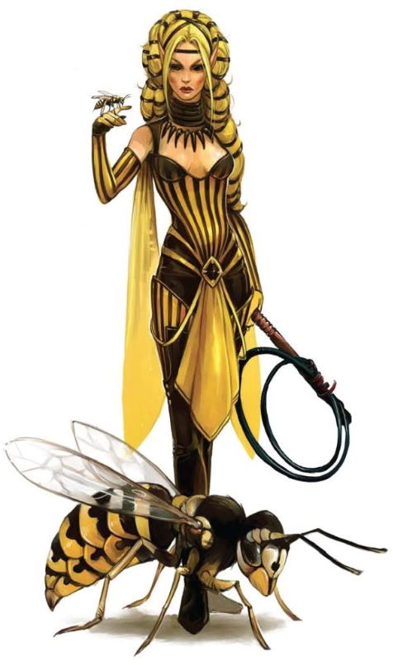

The Aelf, Finley, looks over at her companions and smiles. The swarm of large bees around her buzz happily, as well; they know when Finley is pleased. She can see her companions’ interest in the proceedings ahead. Fine folk indeed! Nodding knowingly, she exclaims, “Of course we’re going to help! You guys are so awesome!”

Vargas understands that she has misunderstood his interest in this couple and, glancing over at Fang as he licks his lips, understands she has misunderstood Fang’s as well. No matter; he’d rather she be happy. So he nods in agreement and grunts, “Yes, let us help them.” He even attempts to smile, though it appears strained as he has little practice.

Fang looks quizzically at Vargas, then at Finley, then smiles broadly, a little more skillfully than Vargas, despite the fangs. “Of course! Let’s help!” And he winks conspiratorially at Vargas.

The screen fades to black.

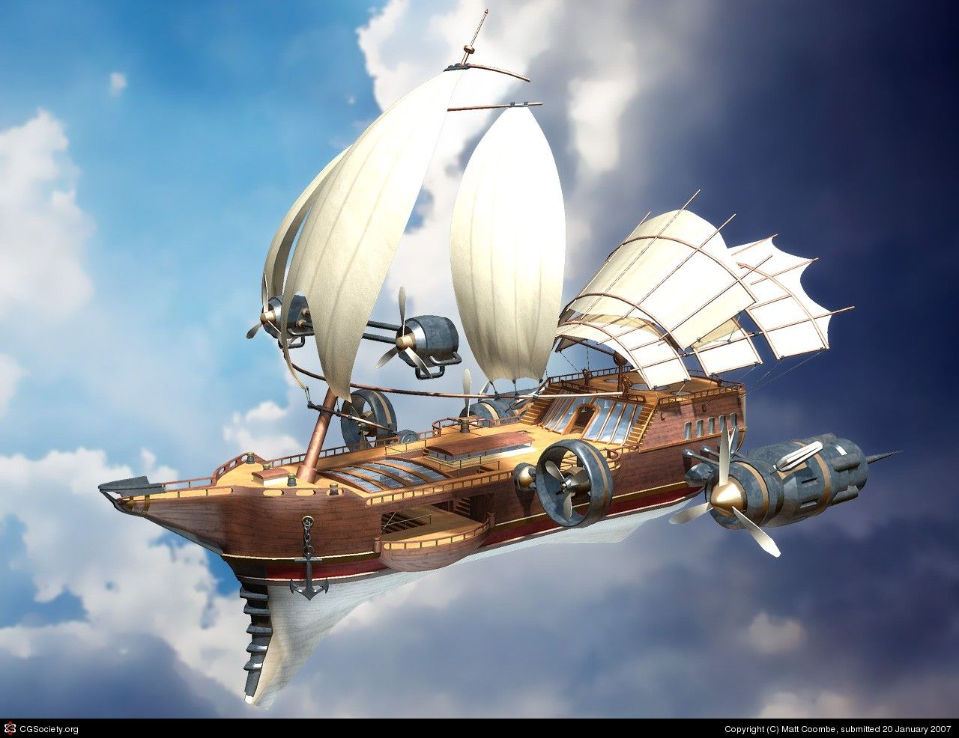**It is an auspicious date, the first day of the first month of High Summer…**

An extravagant airship is landing in a small village. Captain Halkéon strides down the gangplank with his beautiful wife at his side. Fang, in his finery, flies off the airship toward the cargo hold where their big top is stored, getting ready to, well, get ready for Vargas to lift it all out. Vargas follows them all, smiling at his companions as he goes. This will be a fine morning to bring joy to thousands, he thinks.

They are followed by Finley in her gold and black, the buzzing of her bees announcing her presence, as a crowd of townsfolk quickly begin to grow. The circus master had promised talent from across the sea, but this was far beyond what anyone could have possibly imagined! “That’s Finley the Bee!” exclaims one young fellow. His companion whips out a drawing of Finley out of a pocket and shouts “I know!” while shoving the drawing in her friend’s face. “That’s Vargas! The STRONGEST man in the world!” exclaims another.

This venue was far too small to rake in the kind of cash the circus had come to expect. To each of Vargas, Fang, Finley, and Halkéon, it had seemed the idea to come here had come from someone else. None of them realized it had come from all of them at once.

The camera then cuts to the first person to speak….

Mayor Abber comes to see you after the show.



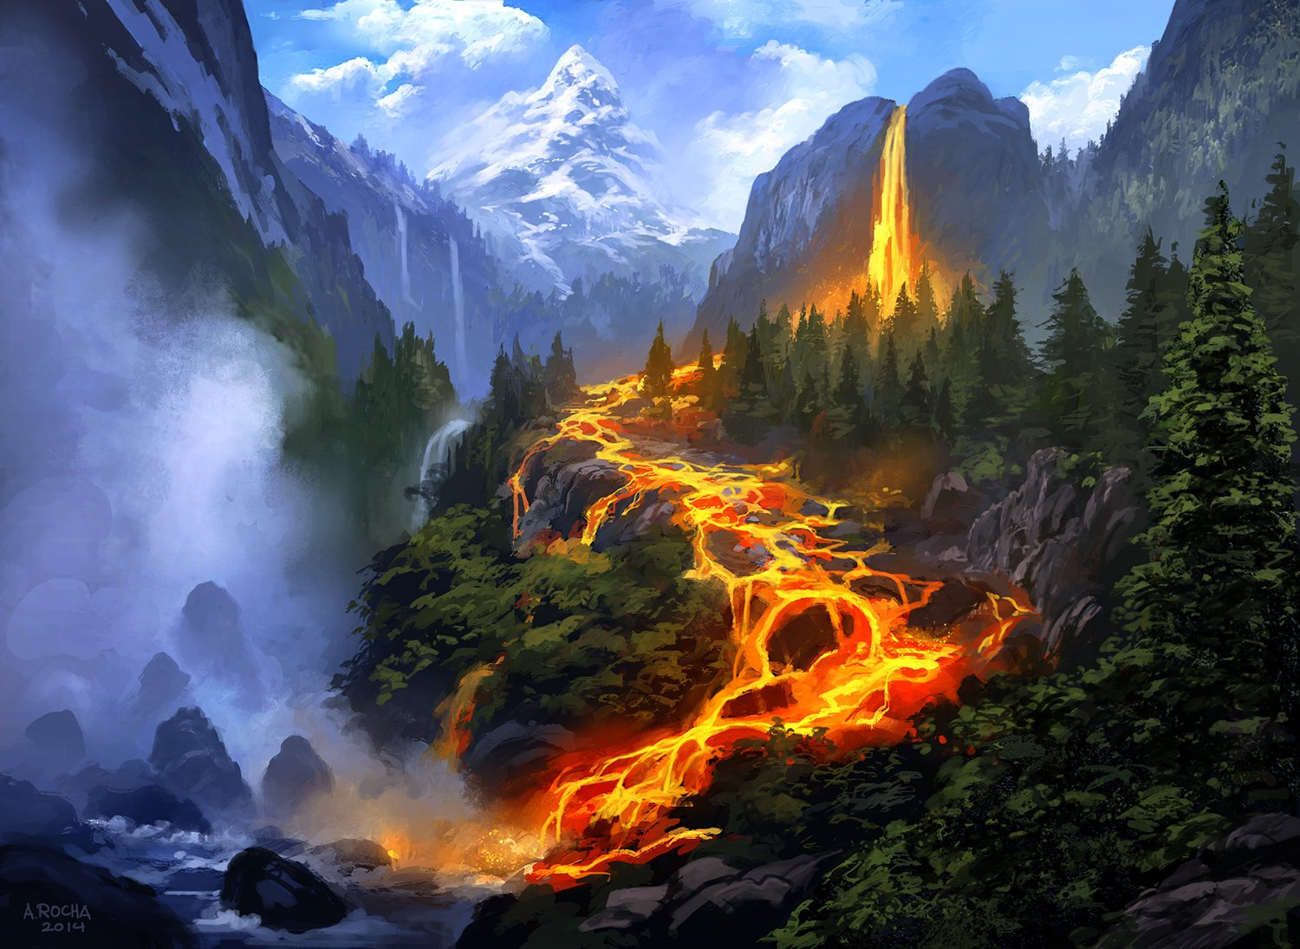**It is an auspicious date, the first day of the first month of High Spring…**

Vargas grunts, so Finley pauses and turns round. She isn’t certain Vargas can even speak the Common Tongue, so a grunt is about the most communicative he ever is. He pulls Fang’s coffin from a large pouch and flips the lid open with his index finger. “It’s too early!” screams the batling as the setting sun causes a small amount of smoke to waft off of his skin. A vampire vampire batling, he is. Finley, the Drow, is sure Fang is safe as the last rays of the sun are blocked by the volcanic mountain they are currently scaling. “Sadist” mutters Halkéon under his breath. Finley nods. It isn’t a bad thing to have a 11 foot tall giant in dinosaur hide armor as an ally, but it’s not all fun and games with a beast like Vargas. He obviously opened the coffin early on purpose.

“There it is,” Halkéon points toward a cave at the northern edge of the Omalous Plateau. Finley shivers a bit, though the weather is not cold. Fang hovers nearby, hissing, “I suppose you’ll want me to risk my life first?” Halkéon was already hurrying in the direction of the cave. “A little caution?” but Fang’s voice of reason goes unheeded.

It seems to be Mirai… at least what’s left of her…. They are too late. A Drow Aelf stands amidst the carnage.

“Dyzallin,” Finley says with disgust. “That’s Lord Shraen to you, my love.” Finley strains as she psychically attacks; Halkéon and Vargas advance in furious rage while Fang positions himself for a surgical strike. Dyzallin, almost casually, raises a hand and paralyzes them all…

The screen fades to black.

The companions make their way across the Omalous Plateau toward the hermitage. All are concerned for the welfare of Mirai, though none more than Halkéon. Everyone feels a vague sense of foreboding as they cross a span of volcanic rock, but they are in too much of a hurry to dwell on it.

As the sun begins to set, they see the hermitage up ahead.

It is the 12th Indiction of the Modern Era.

Halkéon is too stunned to react to the approach of Finley, Vargas, and Fang. And as they gather round, they all intuitively know.

This is where they died… twice.