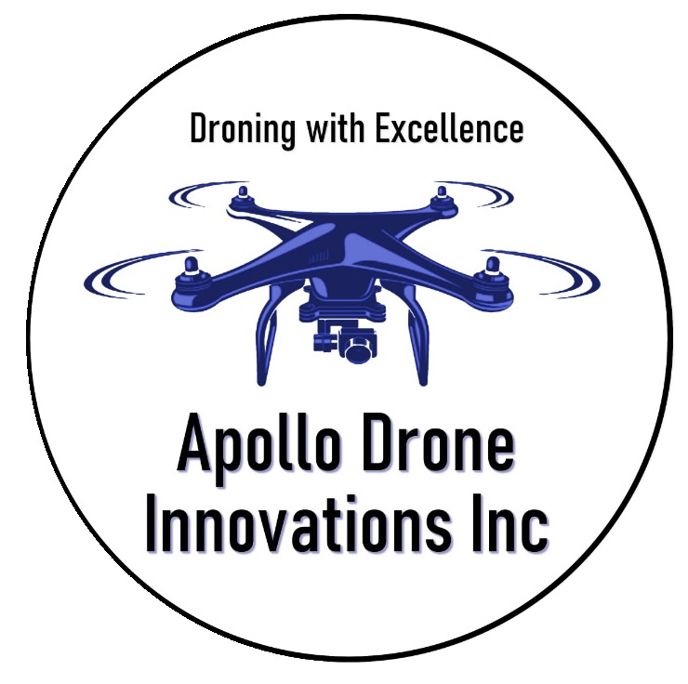

Compliance Statement
Reference (10a.o2.2 (2))
APOLLO DRONE INNOVATIONS undertakes and commits to presenting and facilitating Aviation Security Training in accordance to the requirements stipulated in CAR Part 109, SA-CATS 1-9, and Apollo Drone Innovations. Within this document, the outlines and framework of how this training organization, its employees, and management will undertake to ensure compliance with SA-CATS Part 109 will be discussed. Apollo Drone Innovations Inc will ensure that, at all times, the highest possible level of training is provided by qualified and accredited personnel while ensuring that all quality insurance and compliance requirements are met.
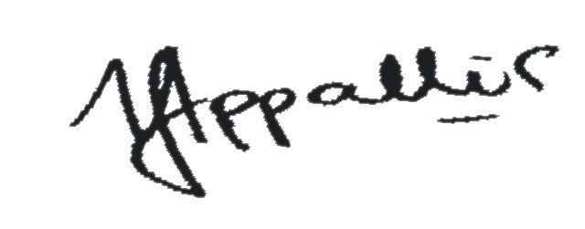
Signed by Responsible Person – Hilton Appollis
: Date: 21/08/2025

