I-LEAD PROJECT  HYDABURG YOUTH LEADERSHIP, EMPOWERMENT, AND DEVELOPMENT  HYDABURG COOPERATIVE ASSOCIATION  ANA- DEPARTMENT OF HEALTH AND HUMAN SERVICES, ADMINNISTRATION FOR CHILDEREN AND FAMILIES  STAFF:  DORINDA SANDERSON: I-LEAD PRJECT MANAGER  NEVAEH PEELE: I-LEAD PROJECT CO-MANAGER  STASHA SANDERSON: I-LEAD MENTOR COACH  BEN YOUNG: I-LEAD HAIDA LANGUAGE COORDINATOR | 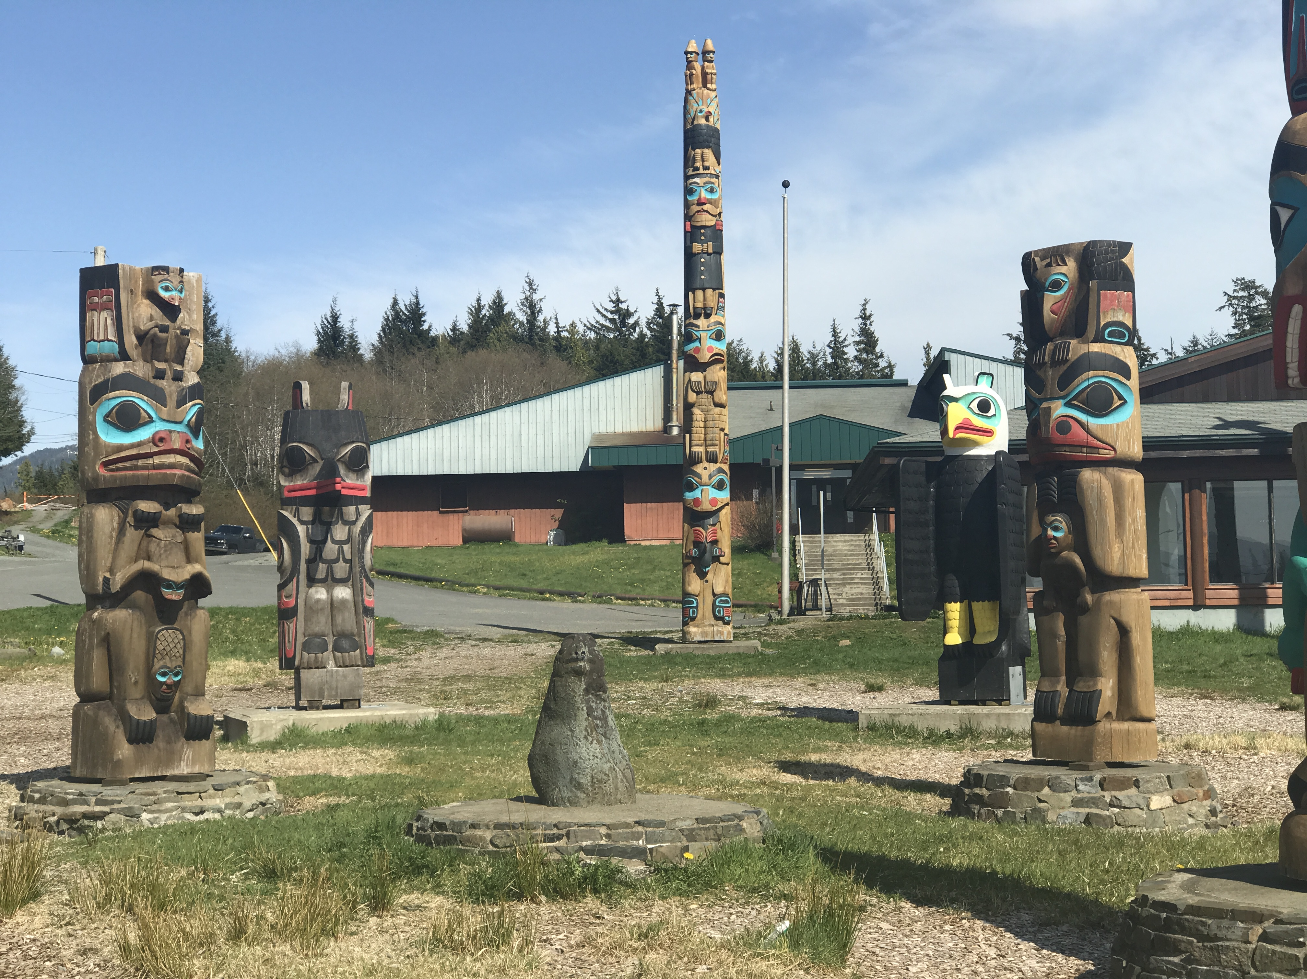 |  | WHAT IS OUR GOAL?  OUR GOAL IS TO FOSTER THE DEVELOPMENT OF HEALTHY, COMPETENT AND CULTRALLY GROUNDED YOUTH TO BE THE NEXT GENERATION OF TRIBAL AND COMMUNITY LEADERS IN HYDABURG.  HOW WILL WE ACCOMPLISH OUR GOAL?  THE I-LEAD STAFF IS COMMITTED TO CREATE A SUCCESSFUL PROJECT WHICH WILL PROVIDE OUR YOUTH WITH EMPLOYMENT OPPORTUNITIES  BY PROVIDING STEPPING STONES (ACTIVITIES, CLASSES AND PROJECTS) FOR THE YOUTH OF HYDABYRG WE WILL BE PAVING THE WAY FOR BRIGHT, CONTRUCTIVE AND SUCCESSFUL LEADERS.  OUR I-LEAD CO-MANAGER CONSISTS OF A STRONG, DEDICATED BRIGHT YOUTH DEVELOPMENT OF ACTIVITIES  OUR MENTOR COACH WORK WITH THE YOUTH AND PARTNER ORGINIZATIONS TO PROVIDE POSITIVE ROLE MODLES WHICH ENABLES THE LEADERSHIP POTENTIAL TO SURFACE IN THE INDIVIDUAL YOUTH, WHICH ULTIMATLEY WILL BEVOME OUR FUTURE LEADERS.

THE FIVE COMPONENT/ PROJECT AREAS THAT ARE TO BE OFFERED THROUGH THIS GRANT FUNDING OPPORTUNITY USE:  - I-LEAD MENTOR PROJECT  - “TRIBAL AND CIMMUNITY LEADERSHIP” PROJECT, CURRICULUM TO BE OFFERED AT THE HIGH SCHOOL LEVEL FOR THE 2018/2019 SCHOOL YEAR AS AN ELECTIVE  - HAIDA LANGUAGE PROJECT  - HAIDA CARVING/ ART PROJECT  - “WE CHOOSE TO LEAD” – METHAMPHETEMINE AND HEROIN USE ELIMINATION/ PREVENTION PROJECT. | HOW WILL OUR YOUTH BENEFIT?  - YOUTH WIL GAIN A BETTER UNDERSTANDING OF THE ROLES AND RESPONSIBILITIES OF COMMUNITY LEADERS.  - YOUTH WILL LEARN WHAT THE EXPECTATIONS OF TRIBAL AND COMMUNITY LEADERS ARE.  - THE YOUTH WILL PARTICIPATE IN COMMUNITY LEADER LEVEL OF DECISION MAKING BY SITTING ON THE BOARDS/COUNCILS.  - THE YOUTH WILL EXPERIENCE THE WORLD OF EMPLOYMENT OPPORTUNITES.  - THE YOUTH WILL BE CULTURALLY GROUNDED.  - THE YOUTH WILL FEEL EMPOWERED BY PROVIDING VALUABLE INSIGHT THROUGH THE EYES OF THE CURRENT LEADERS OF HYDABURG.  - THE YOUTH WILL DEVELOP A SENSE OF VALUE AND SELF WORTH, WHICH WILL EMPOWER THEM TO STEP INTO LEADERSHIP ROLES.  - THE YOUTH WILL FEEL VALUED ND RESPECTED AS FUTURE LEADERS. | FACTS  YOUNG ADULTS WHO WERE AT-RISK FOR FALLING OFF TRACK BUT HAD A MENTOR ARE:  - 55% MORE LIKELY TO ENROLL IN COLLEGE.  - 78% MORE LIKELY TO VOLUNTEER REGULARY.  - 90% ARE INTRESTED IN BECOMING A MENTOR.  - 130% MORE LIKEY TO HOLD LEADERSHIP POSITIONS.  - STUDENTS WHO MEET REGULARY WITH THEIR MENTORS ARE 52% LESS LIKELY THAN THEIR PEERS TO SKIP AN DAY OF SCHOOL AND 375 LESS LIKELY TO SKIP A CLASS  - YOUTH WHO MEET REGULARY WITH THEIR MENTORS ARE 46% LESS LIKELY THAN THEIR PEER TO START USING ILLEGAL DRUGS AND 27% LESS LIKELY TO START DRINKING.  mentoring.org

