Finance Department

City Rates and financial needs, you need to see the Finance Department if you need doubts or your city Rates or any financial details and they are ready to assist.

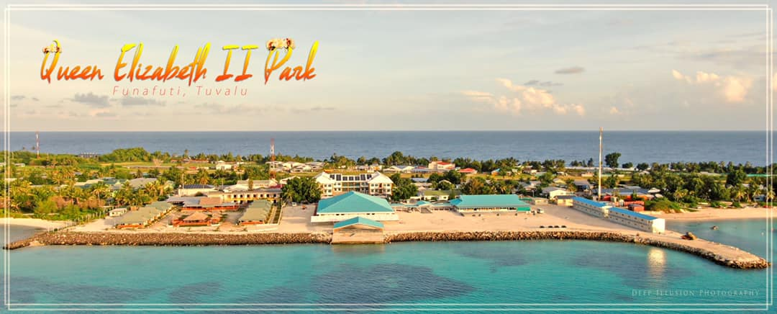

Rates Section

Funafuti City is expected to deliver and provide an acceptable level of public services and public amenities for the benefit of our rate payers. It provide essential services such as community water cistern,

Our main source of income is from City rates.

Change of Mailing Addresses

The Chief Executive Officer

Funafuti, Tuvalu

Luapou.

Payment Options

Rate payers should obtain an official receipt when making payments. Council would not be accepting responsibility where such receipts are not obtained. There are several payment options available to enable the ratepayers to make rate payments as listed below:

* Payment in Person

Payments can be made via by the Cashier at the Funafuti Town Council, Luapou side, Funafuti, Tuvalu. Payment can be made by Cash and Cheque.

* Cashier Office Opening Hours

|  |  |
| --- | --- |
| Monday - Thursday | 9:00 am – 3:30pm |
| Friday | 9:00 am – 3:00pm |

* Direct Deposit /Internet Banking

For direct deposit or Internet Banking, rates could be paid through:

|  |  |
| --- | --- |
| National Bank of Tuvalu | Swift Code: NABTTVTV |

* Refunds Deduction

Rates payers who wish to refund cash due to the failure of Council services it is acceptable. Refunds deduction which is 10% of the total amount will be charge to any of ratepayers who pay for a service and he/she request for a refund.

Arrangements

|  |
| --- |
| Half year installments |
| 1st half installment – 1st January – 30st June |
| 2nd half installment – 1st July – 31st December |