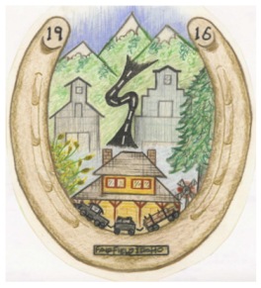
407 Soldier Rd.
City of Fairfield

ALCOHOL CATERING PERMIT APPLICATION

Alcohol Licensee Holder: ________________________________________________ Fee: $ ____________
Business Name as Listed on Idaho State Alcohol License
Address: _______________________________ City: _____________________ County: ________________
State Licensed Premises - Address

Idaho State Alcohol License No. ________________ 20 ____

Permit to be used: ______________________, _________________, Hours: ___________ m. _________ m.
Month Days From To
Location: ______________________________, Catering for: ______________________________________
Premises, Rooms, Suites Name of Party or Convention

Sponsored By: _________________________________________
Name of Organization, Group or Person(s)

□ Alcohol Inside (dispensed and consumed inside a building)

□ Alcohol Outside (dispensed or consumed outside in the open)
This sponsored event will be open to the named organization(s), group(s), or person(s) and guests for a
period of _____ days, not to exceed five (5) consecutive days at the fee of twenty dollars ($20.00) per day.

Responsible Licensee Name: ____________________________________

Official Title: _____________________________________

Date: _____________________________________

Contact Phone No.: _____________________________________

Mayor Approval:_______________________________________
Fire Department_______________________________________
Sheriff Approval_______________________________________

~~~~~~~~~~~~~~~~~~~~~~~~~~~~~~~~~~~~~~~~~~~~~~~~~~~~~~~~~~~~~~~~~~~~~~~~~~~~~~~~~
Copies to: Original White to Licensee, Yellow to Sheriff’s Office, Pink Director of Law enforcement
Copy of Original to City Clerk (stamped)

