2010 Carp National Competition held at Wyreside Fishery
from Tuesday 14th to 16th September 2010

On the 14th of September the Fire Service held its 4th annual carp match at Wyreside fisheries in Lancashire. The match was held over 48hrs and involved 23 anglers from all over the country. It runs as a pairs match although there are prizes for Pairs and Individual winners.

The draw took place at 11am with the all in at 13.30. Once the draw had taken place anglers went to their respective swims. Thankfully the weather held off long enough for everyone to get set up and fishing before the rain set in, and boy did it rain!!!

It wasn’t long before the first fish was caught. This was a stunning 19lb mirror caught by Merv Williams from Essex Fire and rescue. Merv was fishing peg 5 on sunny side 1, with his partner Mark Stock fishing peg 4.

Not long after Merv slipped back his 19lber the first fish was caught from sunny side 2. This was a mirror of 12lb caught by Ian Morrison from Nottinghamshire from sunny 2 soon to be followed by a 13lber from peg 1 on sunny side 1 to the rods of Grant Baugh from South Yorkshire.

The weather then took a turn for the worst. We had rain and strong winds throughout the first night with wind gusts of up to 65mph.

Come the morning there had been a further 4 fish caught. A 16lb 9oz from peg 12 on sunny side 2 caught by Andy Green from Somerset and Avon ‘A’, a 14lb Mirror to the rods of Chris Hole from Devon and Somerset ‘B’. Fish of 20lb 4oz mirror and 14lb 4oz mirror were caught by Daniel Fair (aka Jack) from Hertfordshire ‘A’ fishing Peg 8 Sunny Side1. This had put Jack in a positive lead although there was still plenty of time.
The Hospitality at Wyreside fisheries is second to none. Nothing was too much hassle for them. The evening meals and breakfast baps were delivered hot to each swim. With a choice from 5 different meals each evening and a full English in a roll was more than enough for everybody.

At around lunch time the weather had started to improve. The rain had eased off although we still had the strong winds.
Marc Cavaciuti from Hertfordshire ‘B’ fishing Sunnyside 2 peg 18, slipped his net under a 14lb 2 oz mirror which was soon followed by Mark Stock who was fishing peg 4 on sunnyside 1 who winkled out a lovely 22lb mirror which put Team Essex in the lead. Not long after Marks fish, team mate Merv Williams landed a 12lb 6oz mirror, team Essex were storming ahead

Fish were coming out from both lakes although most were caught from the back of the wind. Fish were showing on the wind but just wouldn’t feed there.

Come the evening the winds started to die down and the atmosphere had a sense of apprehension.

Andy Green fishing sunny side 2 kept our cameraman and official busy during the second night. Andy landed a mirror of 18lb and a common of 15lb. This put Andy in the lead by the second morning. Jack had also upped his tally from Peg 8 on sunny one with a common of 11lb. Things were getting tight at the top and there was only one fish in it.

The morning was like a different world. The wind and rain both stopped and the sun came out. This triggered the fish to get their heads down and start feeding. During the morning there were several fish hooked and lost including 2 by John McGrinder in peg 20 on Sunny 2. Although there were a few fish lost there were a further 5 fish landed with-in a hour. This action started with Marc Cavaciuti having a screaming run on his right hand rod. Whilst playing this fish his left hand rod ripped off as well. Stretching his angling skills Marc managed to net both fish without any hassle. Good angling mate. His fish weighed 15lb 15oz and 13lb 1oz and were both mirrors. Shortly after this Ant Fowell who was fishing next door to Marc in Peg 19 landed a stunning Common of 16lb. One thing that has to be said about Wyreside fisheries is the fish are of a high quality. Lovely scaly Mirrors and bronze commons. Fish of this standard are hard to find at commercial fisheries but the owner Bob has put so much work into this fishery and fish management he has got things spot on.

About half an hour after Ant had put back his common the same rod zipped off again resulting in a 17lb 10oz common.

At this point there were 3 teams in the running for first place with only a couple of pounds separating them. This was all to change with the last take of the match. Again Jack had a take on his right hand rod fishing the margin. From the length of time he was playing it we guessed it was a better fish. After a good ten minutes Jack finally got the upper hand and pulled a lovely 25lb 4oz mirror over his net string. Not only was this the biggest fish of the match it was also a personal best for him. The next 2 hours proved uneventful with no further fish caught.
The end of the match was sounded at 13.30. We were lucky that we managed to get everything packed away in the dry.
We all met on Sunny 1 to have a few group photos done including a couple with one of the matches sponsors ‘Mr Baits Boilies’.

After the photos were done the plan was to meet at the lodge for the presentation and the raffle. But before this there was just one more thing to do….. Jack needed to go for a swim. With 22 other Firefighters assisting Jack really didn’t stand much chance and was thrown a good 10ft into the lake. Well done mate.

Everyone met at the lodge and the results were given out. The trophies were awarded for Individual 1st,2nd,3rd. Pairs 1st,2nd,3rd and biggest fish.

The results were as follows:

Pairs
1st Daniel (Jack) Fair + John McGrinder- Hertfordshire ‘A’ 70lb 12oz
2nd Merv Williams + Mark Stock – Essex 53lb 10oz
3rd Andy Green + Bryn Rex – Devon and Somerset 49lb 13oz

Individual
1st Daniel (Jack) Fair- Hertfordshire 70lb 12oz
2nd Andy Green – Devon and Somerset 49lb 13oz
3rd Marc Cavaciuti – Hertfordshire ‘B’ 43lb 2oz

Biggest Fish
Daniel (Jack) Fair 25lb 4oz

We also had a trophy for Bob the owner to display at his venue for allowing us to use his fishery.

The Raffle then took place, which raised a total of £265 for the FireFighters Charity.

I would just like to thank everyone who took part in the event who I’m sure all enjoyed themselves.

A special thanks needs to said to all those people and companies who have supported us with donations for the raffle and help that was given during the Match. These are:

Bob, Sally and the crew from Wyreside Fisheries.

Andy and Adam From Uncut fishing who filmed the event and help with the weighing of fish whatever the time of day.

Chris from ‘Mr Baits Boilies’ who donated prizes for the overall winner, which included a photo on canvas of his 25lber and 10kg of bait.

Other companies that need a big thank you are:

Osprey Tackle
Dynamite Baits
Rob Maylin at Big Carp Magazine.
MPS defiant
Nash Tackle
Angling Publications
Carpology
Serious Carping-Air Dry bags
Viper Baitboats

There is a video currently being edited which contains lots of action from the match and also some of the competitors rigs etc. The video will be for sale soon with all proceeds going to the ‘Fire Fighters Charity’.
For more information or if you are interested in sponsoring next years event or donating a prize of and kind please contact me at:

firefighterscarpmatch@hotmail.com

Dan(Jack) Fair, Hertfordshire, individual winner.

Best fish of 25lb 4oz

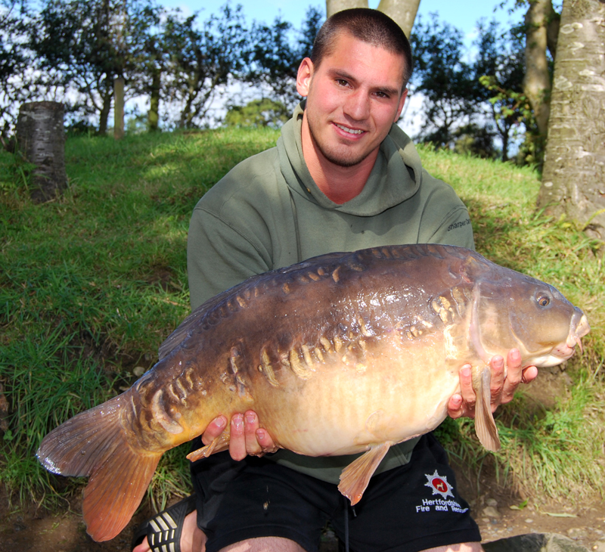

All the competitors for the 2010 Carp National

