APPLICATION FOR MEMBERSHIP 2025 v1.7
Complete and email the Application Form at CAS Secretariat: secretary@ca-society.com
Member Category (tick as appropriate)
☐ Professional Membership (Individual)
☐ Student Membership (Individual)
☐ Organizational Membership (S), Annual Revenue of Organization (USD) under $500K USD (small enterprises/NPOs/NGOs)
☐ Organizational Membership (M), Annual Revenue of Organization (USD) $500K – $1M USD
☐ Organizational Membership (L), Annual Revenue of Organization (USD) $1M+ USD

Contact Details
First Name: Last Name:
Please indicate name prefix: ☐ Mr. ☐ Ms. ☐ Dr. Other:
Organization:
Organization Address:
Home Address: (in case you wish to use it as your main contact address)
Telephone no: (including int dial code)
E-mail address: Web address:

Conformity Assessment Activity (click all that apply)
☐ Testing/Calibration Laboratory ☐ Inspection Body
☐ MS Certification Body ☐ Product Certification Body
☐ Personnel Certification Body ☐ Accreditation Body
☐ Regulator/Government (define ) ☐ Other (define )

Consent and Agreement
☐ I have read and agree to the CAS Code of Conduct (https://ca-society.com/code-of-conduct).
☐ I understand the Membership Terms & Conditions and Annual Dues structure.
☐ I acknowledge that CAS will collect and process my personal information for the purposes of administering my membership, providing access to society services and benefits, and communicating with me regarding activities, events, and updates. My data may be shared with CAS chapters or affiliates strictly for these purposes and will not be sold. I have the right to access, correct, or delete my data at any time by contacting secretary@ca-society.com. Full details are available in the CAS Privacy Policy (https://shorturl.at/0lXhM). I hereby consent to the processing of my personal information as outlined above.
☐ I confirm that the information provided is true and accurate to the best of my knowledge.

I apply for CAS membership and agree that if I am admitted, it will be bound by the CAS's Codes of Conduct.
Signature (type your name):
Date:
PAYMENT OF MEMBERSHIP FEE
To make your membership process as smooth as possible, CAS offers a variety of secure and convenient payment methods. You can complete your payment using: PayPal, Venmo, GooglePay, CashApp Pay, AfterPay, and major Debit & Credit Cards. Simply choose the method of your preference at checkout. All transactions are encrypted & processed securely.
Member  Category  fee | Payment Link via Internet  Click the link. You’ll go to the same payment link and see a page with your membership category name and and fee, plus the option to pay | Payment Link via QR Code  Scan the code with your phone camera. You’ll go to the payment link and see a page with your membership category name and and fee, plus the option to pay | Via Bank Wire Transfer  (Add $15 for Bank fees)  Or CREDIT CARD  Direct Charge
Professional Individual  USD $40 | PAYPAL:  https://tinyurl.com/ye29ypcu  SQUARE:  https://square.link/u/q0dPCNqa | 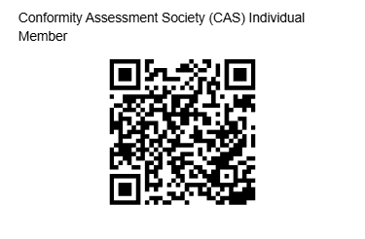 | Wire Transfer  Account name:  CAS AMEX account  Account number:  400117613937  Routing number (ACH):  124303243  Routing number (Wire):  124303243  Bank address:  American Express National Bank  P.O. Box 30381  SALT LAKE CITY, UT 84130  Note: Since this is a USA Bank account no IBAN is available.  CHARGE YOUR CREDIT CARD MANUALLY  If you wish us to charge your credit card, manually, please complete the  “Credit Card Authorization Form”  that is attached to the last page of this application form
Student  USD $20 | PAYPAL:  https://tinyurl.com/CASociety  SQUARE:  https://square.link/u/90KzNFJN | 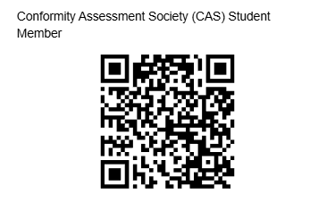
Organization  (S)*  USD $250 | PAYPAL:  https://tinyurl.com/338t6rdf  SQUARE:  https://square.link/u/UxQBu5pZ | 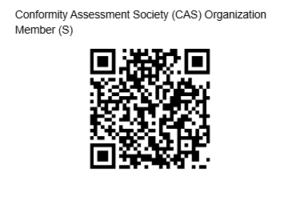
Organization  (M)*  USD $500 | PAYPAL:  https://tinyurl.com/2cdyzuuu  SQUARE:  https://square.link/u/jgr1PdA6 | 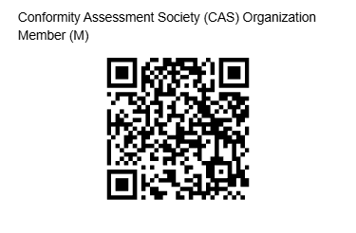
Organization  (L)*  USD $1000 | PAYPAL:  https://tinyurl.com/ycky9a7v  SQUARE:  https://square.link/u/mWwdKtM9
IMPORTANT NOTE: The full amount of applicable fee should be transferred to CAS. The applicant is responsible for paying all types of taxes, government charges, applicable duties, bank/card transfer fees and other miscellaneous fees and surcharges.
Complete and email the Application Form at CAS Secretariat: secretary@ca-society.com
MEMBERSHIP GRADES AND BENEFITS

PROFESSIONAL MEMBER  Professional Members are the backbone of the Conformity Assessment Society (CAS). They are individual experts who play critical roles in testing, inspection, certification, accreditation, standardization, and quality assurance across sectors and borders.  Who Can Join?  - Assessors and auditors  - Certification and accreditation professionals  - Technical experts and evaluators  - Scheme developers and consultants  - Trainers and capacity-building professionals  - Standardization and regulatory specialists  Member Benefits  - Access to technical resources, updates, and expert forums  - Participation in working groups, surveys, and public consultations  - Recognition as a member of a global professional community  - Opportunities to contribute to scheme development and best practices  - Discounted access to CAS-endorsed tools, webinars, and events  - Eligibility for future CAS endorsements and awards  Annual Fee USD $40 | STUDENT MEMBER  Student Membership in the Conformity Assessment Society (CAS) is designed for aspiring professionals who are currently enrolled in academic programs related to quality, engineering, science, sustainability, compliance, or related fields.  Who Can Join?  - University and Technical College Students  - Postgraduate and doctoral researchers  - Interns or apprentices in testing, inspection, or certification fields  - Emerging professionals exploring careers in conformity assessment  Member Benefits  - Access to educational resources, guides, and technical papers  - Participation in selected webinars, online forums, and student events  - Opportunities for mentorship from experienced CAS professionals  - Networking with global experts and potential future employers  - Early exposure to international standards and certification pathways  - Eligibility for CAS student challenges, awards, and recognition programs  Annual Fee USD $20
Membership Certificate-Card (for all grades of membership)
All approved members of the Conformity Assessment Society (CAS) receive a Membership Certificate and a personalized Membership Identification Card as formal recognition of their affiliation.
ORGANIZATIONAL MEMBER
Organizational Membership in the Conformity Assessment Society (CAS) is open to organizations actively engaged in or supporting the fields of certification, inspection, testing, standardization, accreditation, and regulatory compliance.
Who Can Join?  - Certification and inspection bodies (CABs)  - Laboratories and testing facilities  - Accreditation bodies and scheme owners  - Industry associations and regulators  - Educational and training institutions  - Technology providers and consulting firms | Organizational Member Benefits  - Recognition as a CAS Organizational Member on official platforms  - Participation in technical committees, working groups, and scheme development  - Opportunities to co-host or sponsor CAS webinars, white papers, and events  - Priority invitations to exclusive CAS briefings and networking forums  - Discounts on CAS-endorsed tools and services
Annual Organizational Member Fee
Annual Revenue of Organization (USD) under $500,000 (small enterprises/NPOs/NGOs) USD $250
Annual Revenue of Organization (USD) $500K – $1M USD $500
Annual Revenue of Organization (USD) $1M+ USD $1000
CONFORMITY ASSESSMENT SOCIETY (CAS) APPLICATION DISCLAIMERS
Eligibility and Approval: Submission of this application does not guarantee acceptance into CAS. All applications are subject to review by the CAS Membership Committee. CAS reserves the right to approve or reject applications at its sole discretion without obligation to disclose reasons.
Membership Rights: Membership privileges (such as voting rights, committee participation, or use of CAS logo) vary by membership type and may be subject to further conditions.
Use of Information: All personal and organizational information submitted will be handled confidentially and used solely for CAS membership administration, unless explicit consent is given for public listing or promotion.
Code of Conduct Compliance: Members are expected to always comply with the CAS Code of Conduct (https://ca-society.com/code-of-conduct). Failure to do so may result in suspension or revocation of membership.
Non-Liability Clause: CAS membership does not constitute endorsement, accreditation, or certification by CAS, nor does it confer any regulatory authority. CAS shall not be liable for any damages arising from membership status or denial thereof.
Membership Dues: Membership fees (if applicable) are non-refundable except in cases of administrative error. Renewal is subject to annual review and fee payment.
Modification Rights: CAS reserves the right to amend its membership criteria, benefits, dues, or terms at any time, without prior notice.

POLICY ON THE USE OF CAS NAME, LOGO, AND AFFILIATION BY MEMBERS
The Conformity Assessment Society (CAS) recognizes that membership is a valued association and encourages members to take pride in their affiliation. However, to maintain the integrity and public trust in CAS, all members must comply with the following conditions regarding the use of CAS identity:
General Principles
- CAS membership does not imply certification, accreditation, or endorsement by CAS of the member’s services, qualifications, or activities.
- Members may refer to their membership status in CAS truthfully but must avoid any wording that could mislead the public, clients, or regulatory bodies.
Permitted Usage
Individual and corporate members in good standing may:
- State: “Member of the Conformity Assessment Society (CAS)” on personal or corporate profiles, websites, business cards, CVs, and promotional materials.
- Use the CAS membership badge or digital mark, if issued, in accordance with official CAS guidelines.
- Mention their affiliation in publications, presentations, and academic papers, provided it does not imply endorsement of the content by CAS.
Prohibited Usage
Members shall not:
- Use the CAS logo on certificates, reports, conformity declarations, or inspection/certification documents.
- Claim or imply that CAS endorses, accredits, certifies, or validates any products, services, training programs, or personnel associated with the member.
- Misrepresent their role within CAS (e.g., falsely claiming to be a board member, officer, or representative).
Approval and Revocation
- CAS reserves the right to require prior approval for any use of its name/symbols beyond what is explicitly permitted.
- Improper or unauthorized use of CAS intellectual property may result in disciplinary actions, including membership suspension or termination, and legal remedies where applicable.
Reporting Misuse
Suspected misuse of the CAS name or logo should be reported to: secretary@ca-society.com

CAS “Privacy Policy” is provided here: https://shorturl.at/0lXhM
CAS “Code of Conduct” is provided here: https://ca-society.com/code-of-conduct

Complete and email the Application Form at CAS Secretariat: secretary@ca-society.com

Credit Card Authorization Form

Please complete all fields. This authorization will remain in effect for this charge only.

Credit Card Information
Card Type: ☐ MasterCard ☐ VISA ☐ Discover ☐ AMEX
Cardholder Name (as shown on card):
Card Number: CVV no:
Expiration Date (mm/yy):
Cardholder ZIP Code (from credit card billing address):

I authorize Conformity Assessment Society to charge my credit card above for agreed upon purchases. I understand that my information will not be saved to file.

Applicant Signature Date

