The Kinard Branch
of the
Ivy Family Tree
And History

Kinard (the meaning being “bold” or “guardian”) has appeared as
Kinnaird, Keynot, Keinat, Kinnard, Kynnard, Kennard, Kynhande, Kinzerd, Kinnart.

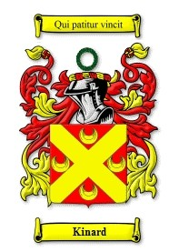

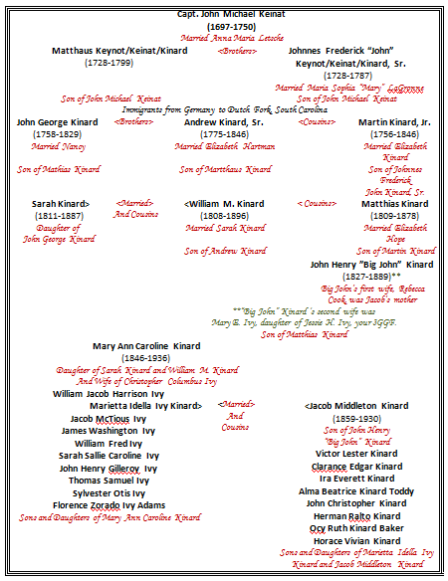
18th Century Germany
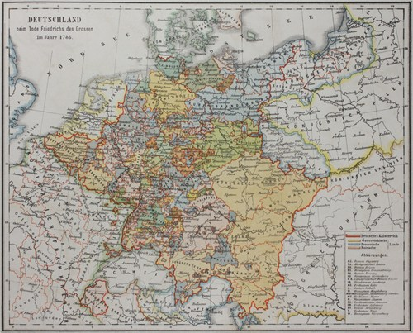
The Beginning of Mass Migration from Germany to North America
Beginning in the Eighteenth Century, many families migrated from Germany to North America, first from Southern Germany, later from Northern and then from Eastern Germany.
A disproportionately vocal and visible minority of the German migrants were political liberals facing reprisals from their efforts in the failed uprising of 1848. The great majority, however, sought to depart from unpromising and circumscribed peasant life in Germany and to become independent farmers of 100 acres or more in the American west.
Several families by the name of “Kinard,” or similar spellings, settled in the Newberry County part of the Dutch Fork of South Carolina. The first of these Kinard families were the sons of Michael Keinat and wife, Anna Maria Letsche, of Undingen, a village in the Landkreis (County) of Reutlingen, Baden-Württemberg, Germany. The village is now a part of the municipality of Sonnenbühl.
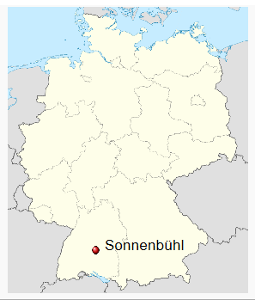

THE FAMILY OF MICHAEL KEINAT

Michael Keinat, a Carpenter by trade, was born on 31 October 1697 in Winterlingen, the son of Johannes Keinat (Carpenter) and Lucia Koch. He was married on 15 February 1724 to Anna Maria Letsche who was born on 9 June 1694, the daughter of Johann Jacob Letsche and Anna Gugel of Undingen. Michael and Anna Maria Keinat lived in Undingen where all of their children were born. There were four sons living in 1744 when they migrated from Germany to South Carolina. The family of Michael Keinat arrived in South Carolina during the last days of the year 1744. They were among about 300 Protestant “Palatines” who came from Europe on Capt. Brown’s ship, the St. Andrew (SC Gazette, issue of 7 January 1745, and Council Journal, Meeting of 2 January 1745).

During this time, the Kinard family migrated from Reutlingen, Baden-Württemberg, Germany and settled in the Newberry County part of the Dutch Forks of South Carolina. The earliest of these families arrived in South Carolina late in 1744. This Kinard family was among a group of Protestant "Palatines" that arrived on Capt. Brown's ship, the St. Andrew.

The Ship “The Saint Andrew”
Charleston, South Carlina, Dec 31, 1744. The passengers on the 1744 voyage of the St. Andrew may have contracted to be delivered to Philadelphia, but the ship was diverted by Capt. Brown to the port of Charleston.
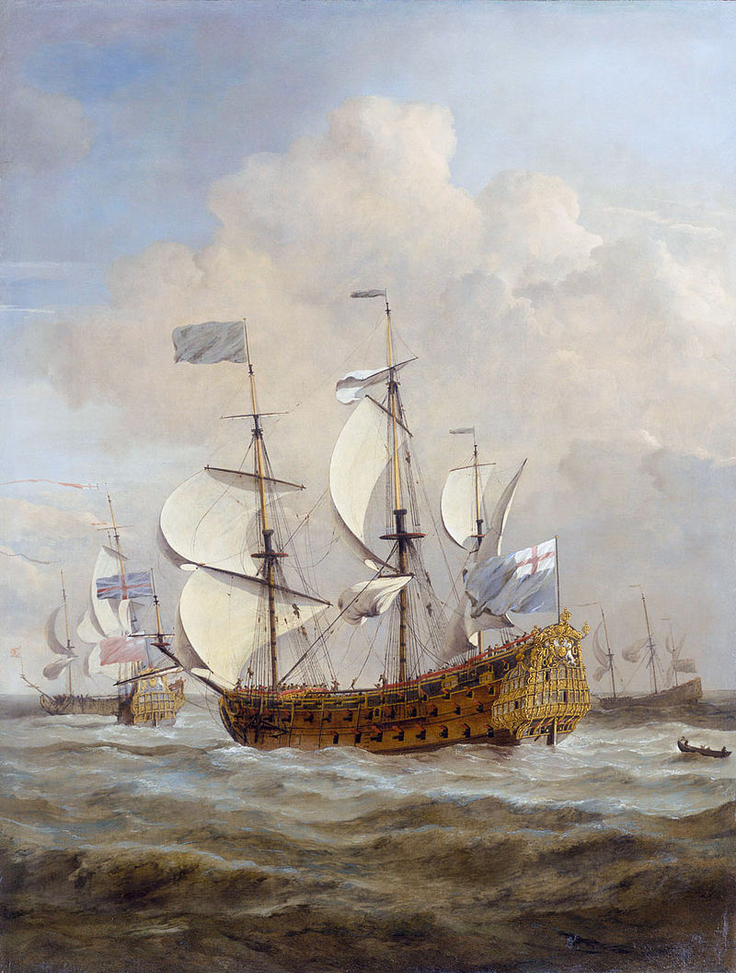
'HMS St Andrew at Sea in a Moderate Breeze',
oil on canvas, by Willem van de Velde the Younger
"The papers in Philadelphia (Pennsylvanische Berichte, American Weekly Mercury) reported that the Captain in effect forced the German immigrants to land in Charleston rather than Philadelphia and that the ship was chased by French privateers." From The South Carolina Gazette, January 1745.
Petitions For Land from South Carolina Council Journals
1745 Page 11: Meeting of 2d January 1744
“His Excellency also aquatinted the Board that the Palatine Protestants to the number of one hundred, who had lately arrived in Capt. Brown’s Ship came on the 31st of December last, in a Body to the Council Chamber and took the State Oaths to His Majesty, all of them having determined to remain and settle in this Province. 24 Jan 1744/5:
Read the petition of a considerable number of Protestant Palatines, most humbly showing that the poor petitioners have been on board the St. Andrew’s, Captain Brown commander, these twenty-six weeks past, and there is as yet no likelihood for them to get free of her, because there are none of us yet who have purchased their service; they therefore humbly pray his Excellency and Honors that they may find so much favor as to their passages that a sum equivalent to discharge the same be raised by the government, for which they promise to join in a bond to repay the same within the term of three years, with lawful interest; and that if any of them shall not be able to pay the above sum within that time, that the government in that case shall have full power to dispose of them and their families as they shall think proper. Ordered to make investigations and report. Partial passenger list, as reconstructed from petitions for land in the South Carolina Council Journals. Lists show location of land and acres of land granted (headright grant of 50 acres per person). In some cases, the person who purchased their services…
“John Keynot and brother Martin (15), served Henry Middleton, both parents died in service, 100, Saxegotha, 26 Jan 1749/50.”
Johannes Friedrich "John" Keinat / Kennet / Kinard, Sr, the son of John Michael Keinat and Anna Maria Letsche, was born on 9 July 1726 in Undingen. See the petition above, on 26 Jan 1749 (1750 in modern calendar) for bounty land, for himself and his youngest brother, Martin Kinard. The petition states that they had arrived in South Carolina several years before and their parents had died in the service of Mr. Henry Middleton. They both were granted 50 acre tracts on Crims Cr. In 1762, Johannes Keinat (as John Kennet) bought the 200 acre land grant of John Rheynard on Cannons Cr. (Memorials 6:21). This land is near Bethlehem Lutheran Church, Pomaria, SC. (Council Journal, Meeting of 29 January 1745). Mathias, Margaret, John, and Martin Kinard later claimed to have arrived on this ship in their petitions for bounty land in South Carolina. John Kinard, Sr. is believed to have died before 1786.
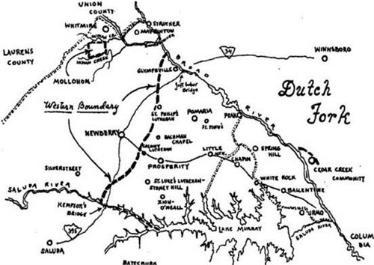
There is also suggestive evidence that he may have married Mary Black. John Kynot had a 100 acre survey of 1772 on headwaters of Risters Cr. branch of Wateree Cr. between Pomaria and Chapin, SC. An adjacent survey of 100 acres in 1773 was that of Mary Black. Later surveys show both lands as being owned by John Kinard.
Johannes Keinat is said to have married Mary LaGrone. She may have been Mary Magdalena LaGrone, born about 1732, the daughter of Laurentz LaGrone and Anna Ursula Beneter. The family of Lorentz LeGrone and son, Tobias LeGrone, had migrated to South Carolina in 1752 from Schönau in Baden, Germany.
The son, John Kinard, Jr., was later owner of this land (Plat of his land showing division among children is found in Newberry Court of Common Pleas B-112). Many of the descendants of Johannes Keinat were members of Ruff’s Meeting House and later Bethlehem Lutheran Church which came into existence in 1817.

CHILDREN OF MICHAEL KEINAT AND ANNA MARIA LETSCHE
I. Johann Friderich Keinat, born 6 November 1724.
II. Johannes Keinat, born 9 July 1726.
III. Matthäus Keinat, born 7 March 1728.
IV. Johann Martin Keinat, born/died 23 April 1730.
V. Johann Martin Keinat, born 3 April 1731, died the following day.
VI. Hans Jacob Keinat, born 20 March 1732, died 14 February 1733.
VII. Clara Keinat, born 7 July 1734, died 1 October 1735.
VIII. Johann Martin Keinat, born 11 December 1736.
Three of the sons of Michael Keinat and Anna Maria Letsche claimed in their bounty petitions to have arrived on the St. Andrew. In April 1747, Mathias Keinat petitioned for bounty indicating that he had come to South Carolina about 2 years and 3 months earlier in the ship St. Andrew. In January 1750 (modern calendar), Johannes Keinat petitioned for bounty for himself and his youngest brother, Martin (Council Journal, Meeting of 26 January 1750). His petition stated that they had come with parents on Capt. Brown's ship and that both parents were dead in the service of Henry Middleton.
The three sons obtained land grants in the Pomaria section of Newberry County. The original bounty grants of 50 acre grants for Johann and Martin Keinat were on Crims Cr. The original 50 acre bounty grant of Mathias Keinat was near Bethlehem Lutheran Church.
MARGARETHA KEINAT
In March 1750 Margaretha Keinat petitioned for bounty claiming that she had come on Capt. Brown’s ship and had served 5 years with Mrs. Carsen and Mrs. Ducat (Council Journal, Meeting of 6 March 1750). Margaretha Keinat (as “Margaret Kennett”) obtained a 50 acre bounty grant adjacent St. John’s Lutheran Church (Pomaria) land. Margaretha was evidently a close relative of the family of Michael Keinat. Who she married is not known. Her land grant was later owned by John Swittenberg.

JOHANNES KEINAT
Johannes Keinat, the son of Michael Keinat and Anna Maria Letsche, was born on 9 July 1726 in Undingen. He is believed to have died before 1786. In 1762, Johannes Keinat (as John Kennet) bought the 200 acre land grant of John Rheynard on Cannons Cr. (Memorials 6:21). This land is near Bethlehem Lutheran Church, Pomaria, SC. The son, John Kinard, Jr., was later owner of this land (Plat of his land showing division among children is found in Newberry Court of Common Pleas B-112). Many of the descendants of Johannes Keinat were members of Ruff’s Meeting House and later Bethlehem Lutheran Church which came into existence in 1817.
Johannes Keinat is said to have married Mary Lagrone. She may have been Mary Magdalena Legrone, born about 1732, the daughter of Lorentz LeGrone and Anna Ursula Beneter. The family of Lorentz Legrone and son, Tobias Legrone, had migrated to SC in 1752 from Schönau in Baden, Germany.
CHILDREN OF JOHANNES KEINAT:
A. John Kinard, Jr., died on 5 August 1800 (age 47 yrs.). His wife was named Elizabeth and who died on 22 June 1825 (age 70 yrs.). They are buried in the Barre Cemetery, Pomaria, SC. Elizabeth is thought by some to be a daughter of Johann Engelberth Stockmann. (Stockmann had a daughter named Anna Elisabeth who was born in Germany on 24 October 1748). John Kinard, Jr. served in Maj. Water’s Regiment during the Rev. War. There are several records for Rev. War services for the several John Kinards that were living in the Newberry county part of Ninety Six District at that time.
John Kinard, Jr. inherited his father’s land on Cannons Cr. and purchased additional adjoining lands. His estate was divided among his widow, Elizabeth, and sons: Henry; Michael; Christopher; Samuel; Nicholas; George; and Peter Kinard; and daughter, Elizabeth, the wife of George Adam Stockman (Newberry Court of Common Pleas B-112).
Children of John Kinard, Jr. and wife Elizabeth:
1. John Peter Kinard, born 1776, died 23 August 1828, married Catherine Sligh Wicker, daughter of John Jacob Sligh, Sr. and Christina Cromer, and widow of John Uriah Wicker. They are buried in the Barre Cemetery.
2. John Michael Kinard, born 4 July 1778, died 9 November 1842, married Margaret Kinard, born 4 December 1784, died 5 September 1871, daughter of Martin Kinard and Mary Witt. John Michael Kinard bought land in 1806 on Palmetto Br. of Bush River, now called Kinard's Cr. (Newberry Deeds H-313). They are buried in the Kinard-Nobles Cemetery.
3. Capt. George Kinard, born about 1780, died 5 February 1833, married Catherine Koon, born about 1780, died 22 January 1861, daughter of George Adam Koon, Sr. Capt. George Kinard is buried in a separate cemetery just south of the Barre Cemetery, Pomaria, SC
4. Nicholas P. Kinard. The wife of Nicholas P. Kinard was named Mary Margaret. She was born about 1802 and died on 27 October 1861.
5. Samuel Kinard, died 1843, married Elizabeth Holman, daughter of Andrew Holman, Jr. and ___ Dominick.
6. Christopher Kinard, born 20 July 1785, buried 1 April 1857, wife named Anna Catherine, born 9 February 1790, died 24 May 1855. They are buried in the Christopher Kinard Cemetery.
7. Henry Kinard, died 1831, married Elizabeth Stockman, born 12 July 1797, died 18 July 1879, daughter of Henry Stockman and Nancy Hair.
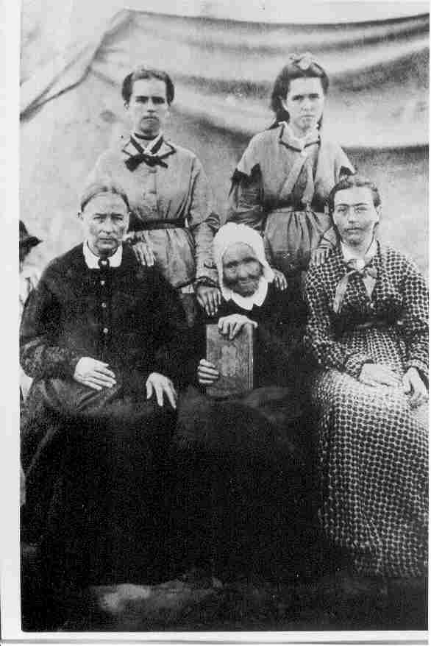
Elizabeth Margaret Ann Stockman, wife of Henry Kinard, and her daughters.

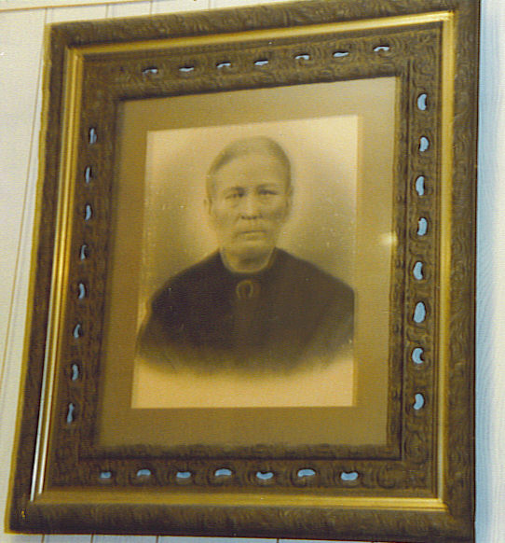
Anna Caroline Kinard, daughter of Henry Kinard and Elizabeth Stockman
8. Elizabeth Kinard, born about 1797, died in September 1877, married George Adam Stockman, born about 1794, died January 1860, son of Henry Stockman and Nancy Hair.
B. Michael Kinard was born on 30 November 1754 and died on 6 May 1839. He married Catherine Swittenberg who was born in 1756 and died on 4 November 1800. She was a daughter of John Swittenberg. During the Rev. War, Michael Kinard served in the Militia after the fall of Charleston in the Company of John Adam Summer, in the Regiment of Col. Philemon Waters (Accounts Audited 4286). Michael Kinard is buried in the Schumpert Cemetery, Prosperity, SC.
Children of Michael Kinard and Catharine Swittenberg:
1. Catherine Kinard, born about 1774, married John George Fellers, born about 1772, died May 1816, son of John Fellers.
2. Mary Kinard, born 18 December 1787, died 29 December 1872, married 19 March 1805, Frederick Schumpert, born 23 November 1783, died 28 January 1846, son of Peter Schumpert and Mary Elizabeth Shaffer. They are buried in the Schumpert Cemetery, Prosperity, SC.
3. Elizabeth Kinard, married Henry Shealy, Sr., born 1780, died 1828, son of John Wendel Shealy and Anna Mary Epting.
4. Christina Kinard, born 11 January 1791, died 22 November 1839, married John Swittenberg, born 9 April 1786, died 26 April 1830, son of William Swittenberg and Elizabeth Setzler. They are buried in St. John's Lutheran Church cemetery, Pomaria, SC.
5. John Kinard, born 21 October 1793, married 1) Rosannah Bates, died January 1822; married 2) Mary Ann (Polly) Morriss, born about 1804, died 28 May 1881, daughter of Samuel Morris, Jr. After 1850 they moved to Columbia Co., FL.
6. Mary Magdalena (Polly) Kinard, born 1794, died 1864, married (as second wife) John Monts, born 11 December 1793, died December 1878, son of Gosper Monts and Anna Mary Minnick.
7. Eve R. Kinard, born about 1800, died 5 May 1880, married David Bowers, born about 1802, died 29 October 1864, son of Stephen Bowers and Nancy Bates. They are buried in the David Bowers family cemetery.
8. Michael Kinard, Jr., born 10 April 1802, died 13 October 1833, married Nancy Harmon, born 5 November 1801, died 20 December 1878, daughter of John (Big John) Leonard Harmon and Rachel Busby. They are buried in the Zion Methodist Church cemetery.
C. Martin Kinard died on 29 September 1846. He married Elizabeth Kinard who was born about 1760 and died before 1837. She was a daughter of Johann Martin Keinat and Mary Witt. Martin Kinard made will 25 February 1837 (Newberry Estates Box 12, Pkg. 2). They lived near St. Paul’s Church, Newberry County, SC.
Children of Martin Kinard and Elizabeth Kinard:
1. Christina Kinard, born about 1796, died after 1850, married John Koon, born about 1797, died December 1854, son of Dr. George Adam Koon.
2. John George Kinard, died 7 March 1889 (88 yrs), married (1) Elizabeth Harmon, born 6 November 1807, died 6 January 1850; married (2) 1 September 1853, Mrs. Sarah Richmond Sligh. They are buried in Kinard Cemetery #5.
3. Matthias Kinard, born about 1809, died about 1878, married Elizabeth Hope, born about 1809, died after 1870, daughter of Christian Hope, Jr. and Catherine Dominick.
Matthias Kinard and Elizabeth Hope Kinard had a son named John Middleton “Big John” Kinard, born, 30 March 1827, died 20 August 1889.

Big John’s first wife was Rebecca Elizabeth Cook, and his second wife was Mary E. Ivy, the daughter of Jesse H. Ivy, your 3rd GFF. The children of Big John Kinard were Rena B. Kinard Prysock, Jacob Middleton Kinard (1859-1938), Nancy Melinda Kinard Prysock (1862-1942), Minnie Viola Kinard (1879-1931), and Permelia Ann Kinard (1881-1943).

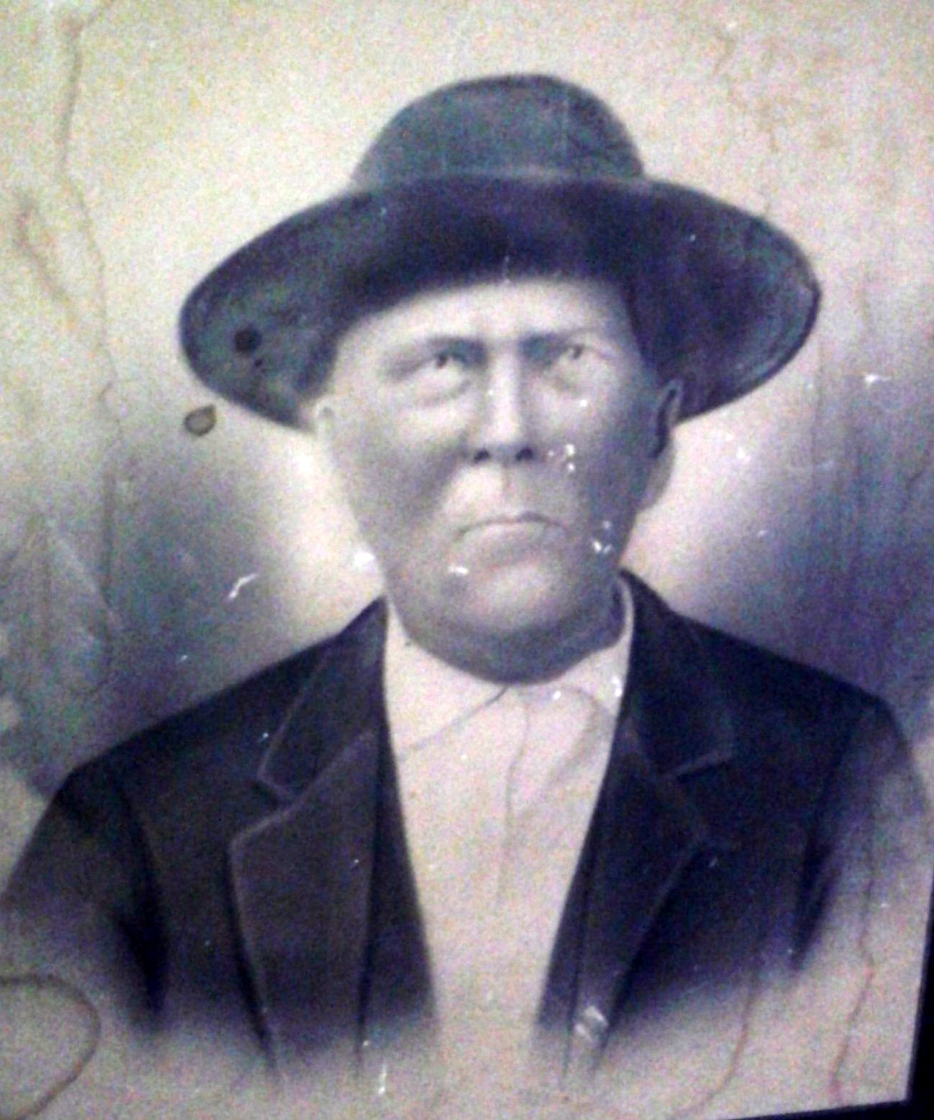

John Middleton “Big John” Kinard

Big John’s son, Jacob Middleton Kinard, born 29 December 1859, died 18 September 1930, married Marietta Idella Ivy Kinard, 21 September 1872, died 19 February 1944, the daughter of Christopher Columbus Ivy and Mary Ann Caroline Kinard Ivy.

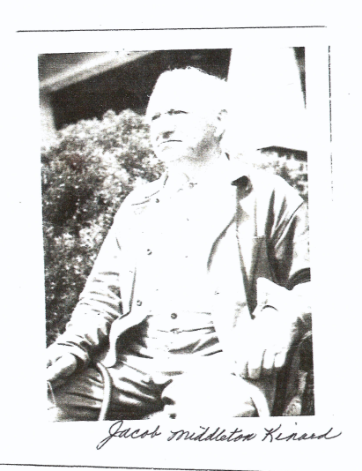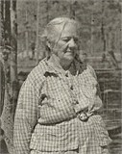

Matthias Kinard and Elizabeth Hope also had a daughter named Mary Martha Elizabeth Penn Kinard, born 23 Sept. 1825, died 6 December 1897. Mary Elizabeth married John Soloman Prisock, born 10 August 1818, died 10 October 1898).

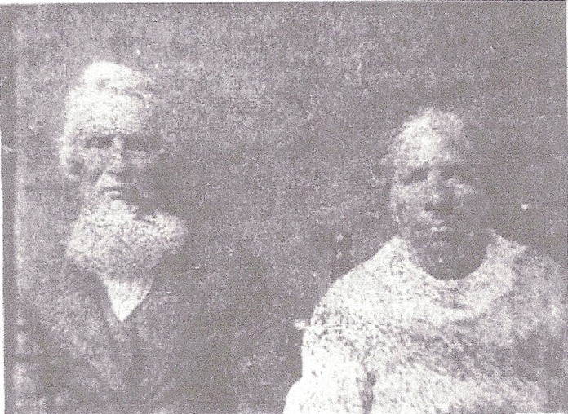

John Solomon Prisock - Mary Martha Elizabeth Penn Kinard Prisock
4. Adam Kinard, did not marry.
D. Christina Barbara Kinard. Christina Barbara, the wife of George Stockman who died before 1790, may have been a daughter of Johannes Keinat. George Stockman was the son of Johann Engel Stockman. After the death of George Stockman, Christina Barbara Stockman married 2) John Weedaman. After the death of Weedaman, Barbara gave land to son, John Adam Stockman, that had been signed over in 1797 to Barbara Weedinman by John Kinard, Adm. of Estate of John Weddinman (Newberry Deeds C-974). Barbara Weedinman married 3) 16 September 1799, William Frederick Houseal who acquitted her of any interest in her property (Newberry Deeds D-392). On 15 February 1800, Barbara Houseal signed over her personal estate to children: John, Adam, Christena, and George Stockman, and Solomon Weddingman (Newberry Deeds D-493).
Children by George Stockman:
1. John Peter Stockman. Moved before 1820 to Williamson County, TN. Before 1830 he moved to Catahoula Parish, LA.
2. John Adam Stockman. Moved before 1820 to Williamson County, TN. Margarete Stockman, found in 1830 census of Perry County, AL, may be the widow of John Adam Stockman.
3. Christena Stockman.
4. John George Stockman, born about 1787, was a widower in 1850, living in Perry County, AL. He was married on 11 February 1852 to Mary Judkins.
Child by John Weedaman:
5. Solomon Whitman. He moved with members of the Stockman family to Williamson County, TN. He was married on 15 September 1816 to Catherine Lagrone, born about 1800, daughter of John Adam LaGrone and Mary Magdalene Houseal. They settled in Perry Co., AL.
E. Elizabeth Kinard may have been the wife of Uriah Koon. Uriah Koon was the eldest son of George Adam Koon, Sr. and lived on Crims Cr. in the area of Pomaria. In 1802, Uriah Koon with wife Elizabeth sold land with deed witnessed by Henry Stockman and Michael Kinard (Newberry Deeds E-517). When Uriah Koon sold land in 1822 his wife was named Christina (Newberry Deeds P-2, 277). Afterward the family of Uriah Koon moved to the Mt. Calvary Lutheran Church area near Johnston, S.C. Several of the sons remained in Newberry District.
Known sons Uriah Koon and wife, Elizabeth:
1. Abraham Koon, died 13 August 1827, wife named Catharine (Katy), died about 1864. The family cemetery of Abraham Koon is located close to the land on Crims Cr. that Uriah Koon got from his father in 1792.
2. Uriah Koon, Jr., wife named Eve Margaret. In 1819, Uriah Koon, Sr. sold land to Uriah Koon, Jr., who, with wife Eve Margaret, sold the same tract in 1821 (Newberry Deeds P-2, 181).
3. Elijah Koon, wife named Elizabeth.
B. Silas Koon, died before 1837, married Hannah Suber who died in 1837.
MATTHÄUS KEINAT
Matthäus Keinat, the son of Michael Keinat and Anna Maria Letsche, was born on 7 March 1728 in Undingen. He died about 1799 in Newberry District. His wife’s (or wives’) name is not known. In addition to his early bounty grant that was located near Bethlehem Lutheran Church, he acquired additional grants in the area of Prosperity, SC. In 1773, he made a deed leaving all his real and personal estate to children: Martin, Jacob, George, Margaret, and Mathias Kinard (Charleston Deeds E-4, p. 396).
On 27 August 1799, George and Mathias Kinard sold halves of one of Matthäus Keinat’s land grants on waters of Cannons Cr. (Newberry Deeds D-366 & 367). According to the deed Matthäus Keinat made to his children in 1773, this land had been left to sons, Martin and George Kinard.
Eight children of Mathias Keinat have been identified. Mathias Kinard, the son of Matthäus Keinat, moved to Alabama before 1830, as did his sisters, Elizabeth who married Martin Cook, and Margaret who married Frederick Hogel. Later, several of the grandchildren of Matthäus Keinat migrated before the Civil War later to the same area and to nearby Winston County, MS.
CHILDREN OF MATTHÄUS KEINAT:
A. Martin Kinard died prior to 1799 without heirs.
B. John George Kinard died in 1829, leaving wife named Nancy. George Kinard’s family lived in the vicinity of Bachman Chapel Lutheran Church, Prosperity, South Carolina. After the Civil War, the work of David W. Kinard, grandson of George Kinard, led to the founding of Bachman Chapel Lutheran Church. John George Kinard and wife are buried in Kinard Cemetery #1.
Children of John George Kinard and wife, Nancy:
1. Martin Kinard, born about 1801, died after 1860, wife named Mary, believed to be Mary Margaret Sligh, born 15 May 1800, daughter of John Jacob Sligh, Jr. and Mary Magdalena Summer.
2. George Kinard, born 23 March 1803, died 14 March 1847, married Mary (Polly) Singley, born 14 August 1808, died 17 May 1885, daughter of Jacob Singley and Martha Sibella Kinard. They are buried in Kinard Cemetery #1.
3. Michael Kinard, born 18 April 1805, died 27 January 1853, married Sarah (Sallie) Quattlebaum, born 5 September 1806, died 16 August 1891, daughter of Peter Quattlebaum, Sr. and Catherine Cappelman. They are buried in Kinard Cemetery #1.
4. Nancy Kinard, born about 1808, married John Christian Long, born 1807, died about 1856, son of Thomas Long and Mary Magdalena Minick. About 1848 they moved to Winston County, MS.
5. Sarah Kinard, born about 1811, may have been the wife of William Kinard, born about 1808, died 31 July 1896, son of Andrew Kinard and Elizabeth Hartman. William Kinard and wife are buried in Betheden Lutheran Church cemetery, Winston County, MS.
(Sarah Kinard married William “Billy” Kinard, their daughter was your GGM, Mary Ann Caroline Kinard, who married Christopher Columbus Ivy, your GGF.)

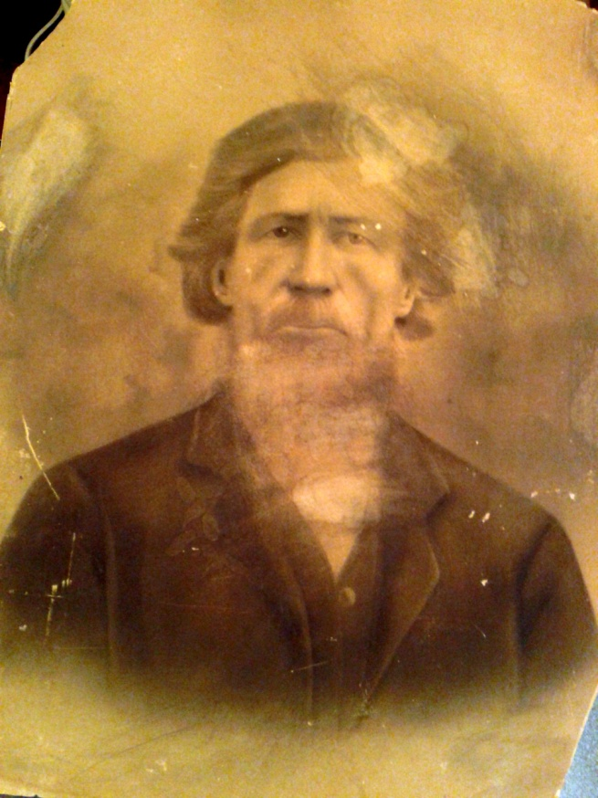

William “Billy” Kinard

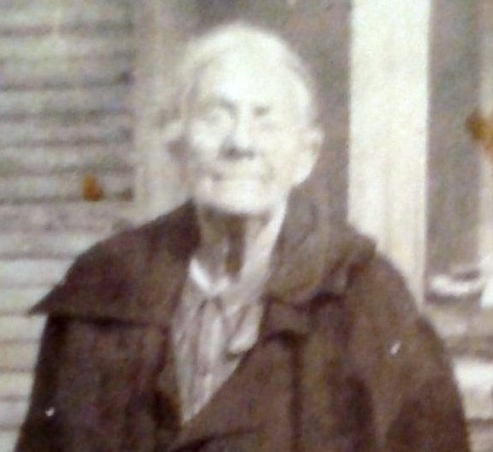
Mary Ann Caroline Kinard Ivy
“Your Great Grandmother”

6. Margaret Kinard, born about 1812, died after 1850, married (as first wife) Matthias Singley, born 4 February 1797, died 10 January 1887, son of Jacob Singley and Martha Sibella Kinard.
C. Jacob Kinard. Believed to have died young.
D. Margaret Kinard, born about 1770, died after 1840, is believed to have been the wife of Frederick Hogel, Sr., son of John George Hagel and wife, Mary Catherine. The family of Frederick Hogel, Sr. moved to Greene (later Hale) County, AL, and settled in a community that came to be known as Hogglesville.
Sons of Frederick Hogel, Sr. and Margaret Kinard:
1. George Hoggle, born 1802, died after 1870, married Nancy Kinard, born 1806, died after 1880, daughter of Mathias Kinard and wife Margaret. Both are buried in Pleasant Valley Methodist Church cemetery, Hale County, AL.
2. Mathias Hoggle, born 1805, died after 1870, married Sarah Richardson, born 1803, died 4 September 1884, daughter of Frederick Richardson and Mary Payne. About 1828 they moved to Wilkes County, GA, then before 1840 to Perry (later Hale) County, AL.
3. Frederick Hoggle, Jr., born 1809, died 4 May 1872, married Sophia Richardson, born 1810, died after 1860, daughter of Frederick Richardson and Mary Payne. They lived in Wilkes County, GA, then before 1840 moved to Perry (later Hale) County, AL.
E. Mathias Kinard, Jr., born about 1772, died after 1840, wife named Margaret, born before 1780, died after 1850. Before 1830, Mathias Kinard moved to Alabama and settled in Perry (later Hale) County.
Children of Mathias Kinard, Jr. and wife, Margaret:
1. John 0. Kinard, born 1801, wife named Priscilla, born 1809.
2. Mathias Kinard, III, born about 1804, died after 1860, Hale County, AL, married 4 August 1834 (Perry County, AL), Mary Ann Sims, born about 1812, died after 1870.
3. Nancy Kinard, born 1806, died after 1880, married George Hoggle, born 1802, died after 1870, son of Frederick Hoggle, Sr. and wife, Margaret. Both are buried in Pleasant Valley Methodist Church cemetery, Hale County, AL.
4. Mary Kinard. Married 20 March 1832 (in Greene County, AL), Allen O’Quinn.
5. Henry Kinard.
6. James Kinard, born about 1812, died 28 February 1878, married Mary Ann (Annie) Bundrick, born about 1808, died 23 April 1893, daughter of Nicholas Bundrick and Catherine Prisock. A Bible in the family of Mathias Kinard, Jr. says James Kinard’s wife was Annie Bundrick and that James was a brother of Mathias Kinard, Jr.
7. Hugh Kinard, born about 1815, died 17 March 1890, Bucksnort, Hale County, AL, wife named Jane, born 1820, died after 1880.
8. Harriet Kinard, born about 1829, married 26 September 1847, Henry W. Prisoc, born about 1825, died 7 February 1898, Hale County, AL, son of Adam Prisock and Mary Richardson.
F. Andrew Kinard, Sr., born about 1775, died 14 May 1846, married Elizabeth Hartman, born about 1783, died 11 December 1850, daughter of John Moritz Hartman and Anna LaGrone. In 1798, Andrew Kinard bought from Matthias Kinard a 250 acre tract on Eleazer Cr. branch of Cannons Cr. (Newberry Deeds D-349). In 1833, Andrew Kinard sold parts of this tract to John Kinard (Newberry Deeds R-218) and to Mathias Kinard (Newberry Deeds R-219). These lands are in the vicinity of Bachman Chapel, Prosperity, SC.
Several of the sons of Andrew Kinard moved to Winston County, MS. Matthias, William, and Gosper Kinard came to Winston County in 1847. Then, in the early 1850's, Jacob and David Kinard moved to Winston County.
Children of Andrew Kinard and Elizabeth Hartman:
1. Matthias Kinard, born about 1803, died about 1856, moved to Winston County, MS, married Mary Penn (?). Matthias Kinard ran a general store in Winston County. Buried in Bevil’s Hill Cemetery.
2. Catherine Kinard, died before 1846, married John Metts, Jr., born about 1802, died after 1870, son of John Metts, Sr. and Mary Magdalene Koon.
3. Mary Kinard, died before 1846, married Samuel Livingston, Sr., born about 1777, died 28 December 1852, son of John Livingston, Jr. and Margaret Maffett.
4. William (Billy) Kinard, born about 1808, died 31 July 1896, wife named Sarah (Sally). May have married Sarah Kinard, born about 1811, daughter of John George Kinard and wife Nancy. They are buried in Betheden Lutheran Church cemetery, Winston County, MS. (See photo above of William “Billy” Kinard.)
5. John (Jolly John) Kinard, born about 1810, married Rebecca Livingston, born about 1812, daughter of John Livingston, Jr. and Margaret Maffett.
6. Elizabeth Kinard, born about 1812, died 1 December 1882, married John Adam Witt, born 1803, died 1871, son of Martin Witt. They are buried in Bethlehem Lutheran Church cemetery, Lake City, FL.
7. Gosper Kinard, born 12 December 1816, died 26 February 1891, married 1) Sarah Livingston, died before 1859, daughter of Martin Luther Livingston, Jr. and Janet/Reginette Harmon; married 2) widow M. I. Reedy; and married 3) Mary Vauhn, daughter of Dr. Vaughn of Winston County, MS. He is buried with third wife in Bevill's Hill Methodist Church cemetery, Winston County, MS.
8. David Kinard, born about 1817, died 5 June 1853, married Mary (Polly) Nates, born about 1820. David Kinard is said to be buried in an unmarked grave in Bevils Hill Cemetery, Winston County, MS.
9. Jacob Kinard, born 4 February 1817, died 21 March 1881, married Martha Livingston, born 10 January 1824, died 5 January 1906, daughter of Martin Luther Livingston and Janet Harmon. They are buried in Betheden Lutheran Church Cemetery, Winston County, MS.
10. Andrew Kinard, Jr., born about 1819, died 1863, married Elizabeth (Betsy) Livingston, born 1822, daughter of John Livingston and Margaret Maffett.
11. Solomon Peter Kinard, born 13 September 1820, died 14 March 1882, married Susanna Wertz, born 19 November 1822, died 25 November 1872, daughter of John Werts and Eve Margaret Riser. Solomon Kinard was a Jailer and later Postmaster of Newberry before the Civil War. They are buried in Rosemont Cemetery, Newberry, SC.
G. Rebecca Kinard, born 1778, died 28 Aug 1818, married (as first wife) Jacob Cook, Sr., born 1777, died 27 November 1834. They are buried in the Jacob Cook family cemetery near Prosperity, SC.
Children of Jacob Cook, Sr. and Rebecca Kinard:
1. John Cook, born 3 October 1801, died 25 March 1865, married Catherine Hope, daughter of Christian Hope, Jr. and Catherine Fellers, born 24 October 1803, died 20 March 1878. They are buried in Colony Lutheran Church cemetery, Prosperity, SC.
2. David Cook, born 20 March 1803, died 27 April 1869, married Elizabeth Threat, born 3 April 1802, died 8 June 1888. Both are buried in Colony Lutheran Church cemetery.
3. Jacob Cook, Jr., born 31 October 1804, died 15 December 1868, married Elizabeth Nates, born 8 November 1810, died 30 April 1873, daughter of Andrew Nates and Catherine Hope. Both are buried in St. Luke's Lutheran Church cemetery, Prosperity, SC.
4. Elizabeth Cook, born about 1807, died 1839, married (as first wife) Samuel Bowers, born about 1798, died 25 January 1874, son of Stephen Bowers and Nancy Bates.
5. Rev. Henry Cook, born 6 March 1809, died 3 December 1870, married 6 October 1829, Nancy Richardson. Henry Cook was a Methodist Minister and settled in the Betheden community, Winston County, MS. Henry Cook and wife are buried in Betheden Lutheran Church cemetery.
6. Rosannah Cook, born about 1811, married William R. King. Rosannah King is buried in the old Cook family cemetery near Prosperity, SC.
7. Michael Cook, born 16 March 1813, died 3 August 1891, married 14 June 1834 (Greene County, AL), Wineford Evans, born 26 June 1816, died 30 April 1877. They later moved to the Cofedeliah community in Neshoba County, MS.
8. Levi Cook, born 1817, wife named Happy.
H. Elizabeth Kinard, born 1780, died after 1850, married Martin Cook, born 1774, died 1846. Before 1829, they moved to Greene (later Hale) County, AL.
Children of Martin Luther Cook, Sr. and Elizabeth Kinard:
1. John Adam Cook, born about 1798, died 1880, wife named Elizabeth.
2. Andrew Cook, born 1805, married 25 June 1832 (Greene County, AL), Mary (Polly) Crockett, born 1817 (GA), died 1875.
3. Henry Douglas Cook, born about 1806, died 27 February 1876, married Elizabeth Richardson, born 1807, died 15 December 1889, daughter of Jonadab Richardson. They are buried in Liberty Methodist Church cemetery, Hale County, AL.
4. Martin Luther Cook, born about 1810, died 1887, married 1) 19 March 1831 (Greene County, AL), Harriett Crockett, born 1813, died 27 June 1848; married 2) 3 April 1849 (Perry County, AL), Irene Horne, born 1828, died 1894. All three are buried in Pisgah Cemetery, Hale County, AL.
5. Elizabeth Cook, born about 1816, died 1851, married 8 October 1847, Thomas Carrol, born 1825.
JOHANN MARTIN KEINAT
Johann Martin Keinat, the youngest son of Michael Keinat and Anna Maria Letsche, was born on 11 December 1736 in Undingen. Martin Keinat’s family lived on Crims Cr. and, after his death, the homeplace was sold in 1805 with deed naming his children and the spouses of the daughters (Newberry Deeds L-183).
The wife of Martin Keinat is said to have been Mary Witt. In 1804, Martin Kinard, Sr. sold 200 acres on waters of Buffalo Cr. south of Prosperity, to his son, Martin Kinard, Jr. (Newberry Deeds G-59). The land consisted of two adjacent 100 acre grants, one to Mary Vidle and one to Elizabeth Wittle. This record says that Elizabeth had transferred her land to Martin Kinard by deed but says nothing about how Martin came to own the Mary Vidle grant. Mary Vidle was most likely the wife of Martin Kinard. Mary and Elizabeth Wittle were most probably daughters of Jurg Widle who migrated to SC with wife and 5 children in 1754, arriving on the Priscilla. A bounty grant to Widle was on the south side of the Saluda River.
CHILDREN OF JOHANN MARTIN KEINAT AND MARY WITT
A. Elizabeth Kinard, born about 1760, married Martin Kinard, died 29 September 1846, son of Johnannes Keinat. Their family is described above in the Johannes Keinat section.
B. Christina Kinard, born 21 January 1761, died 25 September 1846, married John Phillip Sligh, Sr., born 9 April 1753, died 21 December 1818, son of Hans Ulric Schleich and Anna Barbara Senck. Phillip Sligh had a large estate on Cannons Cr. north of Prosperity, S.C. Philip Sligh, Sr. is buried in Sligh Cemetery #1.
1. Elizabeth Slgh, born 27 December 1781, died 17 June 1854, married Jacob Buzhardt, born about 1774, died 25 July 1854. They are buried in Buzhardt Cemetery #2, Newberry County, SC.
2. Mary Sligh, born 30 December 1783, died 2 June 1852, married Phillip Buzhardt, born about 1779, died 4 October 1852, son of Jacob Buzhardt and wife Margaret. They are buried in Buzhardt Cemetery #1, Newberry County, SC.
3. David Sligh, born about 1790, died 5 February 1851, first wife named Martha, born about 1812; second wife named Polly Sarah.
4. John Phillip Sligh, Jr., born 16 June 1792, died 7 February 1883, married Elizabeth Eichelberger, born 6 December 1800, died 12 November 1883, daughter of John Eichelberger and wife, Anna Barbara. They are buried in Sligh Cemetery #1, Newberry County, SC.
5. (John) George Sligh, born 1795, died 4 March 1816. Buried in Sligh Cemetery #1.
6. Catherine Sligh, born 15 September 1799, died 26 October 1855, married 1) John Barre, born about 1785, died about 1820; married 2) as second wife, Andrew Cromer, born 7 October 1786, died 19 July 1858.
C. Martha Sibella Kinard, born about 1763, died before 1830, married Jacob Singley, born about 1760, died after 1830, son of Martin Singley and Setona Regina Wagnar. They lived in the St. Paul's Lutheran Church neighborhood, Pomaria, SC.
1. Rev. Martin Singley (Lutheran Minister), died 12 January 1858 (age 76). He married Sophia A. Hope who died 18 May 1858 (age 71 yrs.), the daughter of Christian Hope and Mary Shealy. They are buried in the Singley Cemetery.
2. Christopher Singley, born 1785, married Mary Sibella wicker, born about 1789, daughter of John Henry Wicker and Elizabeth Cromer.
3. Elizabeth Singley.
4. John Singley, born about 1794, died after 1866, married Elizabeth, died after 1862. Moved to Elmore County, AL after 1830.
5. Matthias Singley, born 4 February 1797, died 10 January 1887, married Margaret Kinard, born about 1812, daughter of John George Kinard and wife Nancy; married 2) Nancy Adeline Beard Sligh, born 15 June 1839, died 17 March 1928.
6. George Frederick Singley, born 1798, died 1833 (drowned in the Pearl River, Marion County, MS). Fought in the War of 1812. George Frederick Singley married Margaret Ann (Roby) Taylor, born 1795, died after 1860. They lived in Marion County, MS.
7. Adam Singley, born 1800, married Mary Magdalene Bundrick, born about 1807, daughter of Nicholas Bundrick and Catherine Prisock. They moved, about 1832, to Greene (later Hale) County, AL.
8. John F. Singley, born about 1800, wife named Temperance.
9. Mary (Polly) Singley, born 14 August 1808, died 17 May 1885, married George Kinard, born 23 March 1803, died 14 March 1847, son of John George Kinard and wife Nancy. They are buried in Kinard Cemetery #1, Prosperity, SC.
10. Jacob Singley.
11. James Singley.
D. Frederick Kinard, born about 1768, died about 1811, married (her first husband) Catherine Elizabeth Chapman, born 4 June 1775, died 4 March 1858, daughter of Abraham Chapman and Ann Elizabeth Herring. After his death she remarried John Rinehart, Sr.
Children of Frederick Kinard and Catherine Elizabeth Chapman:
1. John William Kinard, born 29 December 1796, died 17 November 1851, married Christina Werts, born 6 April 1801, daughter of John Werts and Ann Catherine Hair. William Kinard is buried in Kinard Cemetery #2.
2. Frederick Kinard, Jr., born 2 September 1800, died 12 July 1871, wife named Christina, born 20 January 1805, died 26 January 1892. They are buried in St. Mark’s Lutheran Church cemetery, Saluda County, SC.
3. Sarah Kinard, born 26 July 1804, died 3 August 1884, married John Rinehart, Jr., born April 1798, died 25 February 1855, son of John Rinehart, Sr. and Gertraud Quattlebaum.
4. Elizabeth Kinard, died March 1830, married (as second wife) Jacob D. Caughman, born 19 January 1796, died 16 September 1860, son of Andrew Caughman and Anna Mary Derrick. They are buried in St. Mark’s Lutheran Church cemetery, Saluda County, SC.
5. Catherine Kinard, died 1830. Did not marry.
E. Mary Kinard, born about 1770, died 6 September 1850, married Michael Kibler, Sr., born about 1768, died 17 June 1844, son of Hans Michael Kübler and wife, Anna Margaretha. They are buried in Kibler Cemetery #2 near St. Paul’s Church, Pomaria, SC.
Children of Michael Kibler, Sr. and Mary Kinard:
1. John Kibler, died about 1831, married 1) Mary Christina Barre, died March 1817, daughter of Jacob Barre and Mary Christina Quattlebaum; married 2) Anna Mary Eichelberger, daughter of John Eichelberger, Sr. and wife, Barbara.
2. Michael Kibler,Jr., died before1850, married Elizabeth Koon, died 1872, daughter of Henry Koon and Katherine Epting.
3. David Kibler, born 1802, died 1882, buried Prosperity Cemetery, married 1) Mary Fellers, born 20 June 1802, died 8 July 1862, daughter of John George Fellers and Catherine Kinard; married 2) 5 June 1865, Hannah T. Moore Suber, born 7 January 1828, died 2 May 1874, daughter of Abraham Moore and Elizabeth Brown and widow of Jacob Suber; married 3) Rebecca Reeves Hair, born 1830, died 5 April 1910, widow of Thomas Mathias Hair
4. Catherine Kibler, born about 1804, married John Charles Dickert, born 25 July 1801, died 23 October 1850, son of Peter Dickert and Anna Maria Stockman.
5. Mary Kibler, born about 1808.
6. John Adam Kibler, born 3 December 1811, died 21 January 1877, married 1) Christiana Fellers, died 1829 (age 19), daughter of John George Fellers and Catherine Kinard; married 2) Bathsheba Maffett, born 11 August 1810, died 22 August 1850, daughter of Robert Maffett, Sr. and Barbara Hair; married 3) Nancy Catherine Kinard, born 24 October 1825, died 28 October 1895, daughter of Michael Kinard and Sarah Quattlebaum. John
Adam Kibler is buried with third wife in St. Paul's Lutheran Church cemetery, Pomaria, SC.
7. Elizabeth Kibler, born 8 January 1813, died 11 January 1844, first wife of David Koon, born about August 1800, died December 1853, son of John Koon and Barbara Rinehart. They are buried in the Glymph family cemetery, Pomaria, SC.
8. Jacob Kibler, born 3 February 1816, died 21 December 1890, married 25 January 1855, Frances Elvira Chapman, born 27 July 1833, died 15 August 1875, daughter of Samuel Chapman and Elizabeth Worthington. They are buried in the Chapman-Summers Cemetery. Jacob Kibler was Tax Collector of Newberry from 1848 to 1852.
9. Margaret Kibler, born 1 January 1818, died 20 October 1888, was the second wife of David Koon. She is buried in the Glymph family cemetery, Pomaria, SC.
10. Christina Kibler, born 24 June 1821, died 19 November 1859, married George Howard Dickert, born 18 June 1819, died 19 May 1879, son of Peter Dickert, Jr. and Anna Maria Stockman.
F. John Kinard, born about 1772, died about November 1808. Did not marry.
G. Martin Kinard, Jr., born about 1778, died 5 August 1854, married Eve Katherine Koon, born 8 September 1787, died 14 September 1856, daughter of Henry Koon and Eve Katherine Epting. They lived near Pomaria, S.C. then moved to Laurens County near the Newberry County line, in a community now known as Kinards. They are buried in Sharon Methodist Church cemetery, Kinards, SC.
Children of Martin Kinard, Jr. and Eve Katherine Koon:
1. Gen. Henry Harrison Kinard, born 29 March 1806, died 17 June 1869, married 1) 20 February 1827, Mary Ann Counts, born 2 March 1809, died 19 March 1851, daughter of Capt. John Counts and Elizabeth Eichelberger; married 2) Louisa C. Counts, daughter of John Adam Counts and Sarah Ruff.
2. Sarah (Sallie) Kinard, born 1808, died 4 October 1862, married Lemuel Glymph, born 7 January 1795, died 5 December 1860, son of John Glymph and Elizabeth Rikard.

3. John Pinkney Kinard, born 1810, died 5 September 1890, married Emeline Maryann Rook, born 22 December 1820, died 1 November 1882. Both are buried in Beth Eden Lutheran Church cemetery. John Pinkney Kinard was born 10 June 1817 according to Family Bible record. He was a signer of the SC Ordinance of Secession and a Capt., then Maj., in Co. F, 20th Regt, SC Infantry. They are buried in Beth Eden Lutheran Church cemetery, Newberry County, SC.

4. Middleton T. Kinard, born about 1812, died 6 September 1867, married Sarah Jane (Sallie) Harmon, born July 1836, died 4 December 1865, daughter of Rev. William Harmon and Honora Bridget Frean. They are buried in the Sharon Methodist Church cemetery, Kinards, SC.

5. Elizabeth Kinard, born 29 March 1815, died 8 March 1887, married Jacob Summer, born 5 May 1817, died 6 April 1880, son of John Nicholas Summer and Elizabeth Counts. They are buried in the Sharon Methodist Church cemetery.
6. Martha Kinard, married John Goree.
7. Hulda Mary Kinard, born 11 November 1823, died 22 October 1844, married (as first wife) John K. Hinson, born 16 March 1816, died 29 September 1854.
8. Mary Katherine Kinard, born about 1826, died 16 November 1866, married 1 February 1844, James J. Reeder, born about 1814, died 1 June 1896. They are buried in the Bush River Baptist Church cemetery.
H. Margaret Kinard, born 4 Dec 1784, died 4 Aug 1871, married John Michael Kinard, Sr., born 4 July 1778, died 9 November 1842, son of John Kinard, Jr. and wife Elizabeth. Both are buried in the Kinard-Nobles Cemetery, Newberry County, SC.
1. Sarah (Sally) Kinard, born about 1802, died 1 June 1891, married 10 February 1817, William Summers, born 4 September 1796, died 5 July 1847, son of Col. John Summers and Rosannah Waters. In 1861, Sarah moved to Florida and is buried at Pleasant Grove Methodist Church cemetery, Lake City, FL.
2. Elizabeth Kinard, born about 1805, died 1885, married John T. McNeil, born about 1806.
3. Margaret Kinard, born 2 October 1807, died 9 May 1900, married John Nobles, born 25 December 1790, died 25 August 1848. They are buried in the Kinard-Nobles Cemetery.
4. John Michael Kinard, Jr., born 8 January 1810, died 4 August 1895, wife named Zilpha, born 10 January 1809, died 29 January 1841. They are buried in the Kinard-Nobles Cemetery.
5. Marinda Kinard, born about 1815, died 1877, married Henry Bailey, born about 1815, died about 1874.
6. Rhoda Kinard, born 30/31 January 1817, died 10 December 1850, married 1) John H. Enlow, born 27 April 1818, died 3 August 1841; married 2) John LeGrone, Jr., born 15 August 1819, died 18 October 1899, son of John LeGrone, Sr. and Mary Magdalene Summer. She is buried with first husband in the Kinard-Nobles Cemetery, Newberry County, SC.
7. John K. E. Kinard, died 1839, married Keren Happoch (Happy) Stockman, born 1818, died 22 March 1857, daughter of John Peter Stockman and Catherine Dominick Hope.
….contributed by Carl W. Nichols

FROM THE HISTORY OF SOUTH CAROLINA BY HARRY GARDNER CUTLER, p. 238
"Jacob Calvin Kinard has spent all his life in the community now known as Bamberg County. His years have been spent profitably and pleasantly in the planting industry and for a number of years he has been identified with the Town of Ehrhardt, which he is now serving in his sixth consecutive term as mayor.
Mr. Kinard was born in what was then Barnwell County, June 28, 1853. The Kinards have lived in South Carolina for several generations, and the Holland Dutch contributed at least one strain to the ancestry. His grandfather, George Kinard, was a native of Newberry and a farmer. The father, Adam Kinard, was born in Barnwell County, served for a short time in the Confederate army, and spent his life as an industrious farmer. He married Elizabeth Baggie, a native of Barnwell, now Bamberg, County. They had twelve children, Jacob Calvin being the youngest. Ten reached years of maturity. In 1876 Jacob Calvin Kinard took part in the riots of the period of reconstruction. He had four brothers who were soldiers in the Confederate army. They were Alfred; John, who was killed in the second Manassas battle; George, who was slightly wounded, and Daniel. Alfred and Daniel came home without suffering injury in the struggle.
Jacob Calvin Kinard was reared and educated in the community where he was born and in early manhood followed farming. He has been a resident of Ehrhardt since 1898 and has an interest in the hotel business and other lines of enterprise. His plantation consists of no acres, which he now leases on the crop sharing plan.
In 1870 Mr. Kinard married Miss Malinda Chassereau. a native of Barnwell County and daughter of John Chassereau. He has raised two orphan children, who are now happily married and residents of the Ehrhardt district. Willis Chassereau married Mr. Kinard's niece, Dora Kinard. Minerva Chassereau married Mr. Kinard's nephew, Quillie Kinard.
Mr. Kinard was an alderman several terms before entering upon his duties as mayor. He is affiliated with the Masonic order and the Ehrhardt Baptist Church.
History of South Carolina, Volume 5 Page 238 By Harry Gardner Cutler.

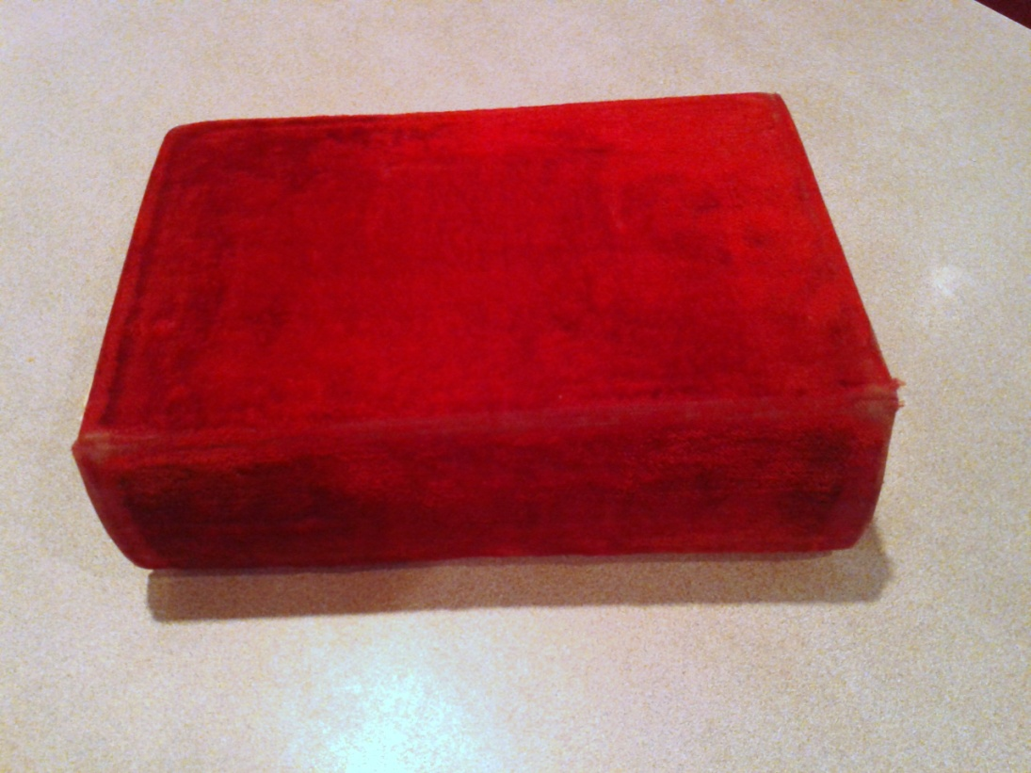
This Bible belonged to Marietta Ivy Kinard,
given to her by her father, C.C. Ivy.
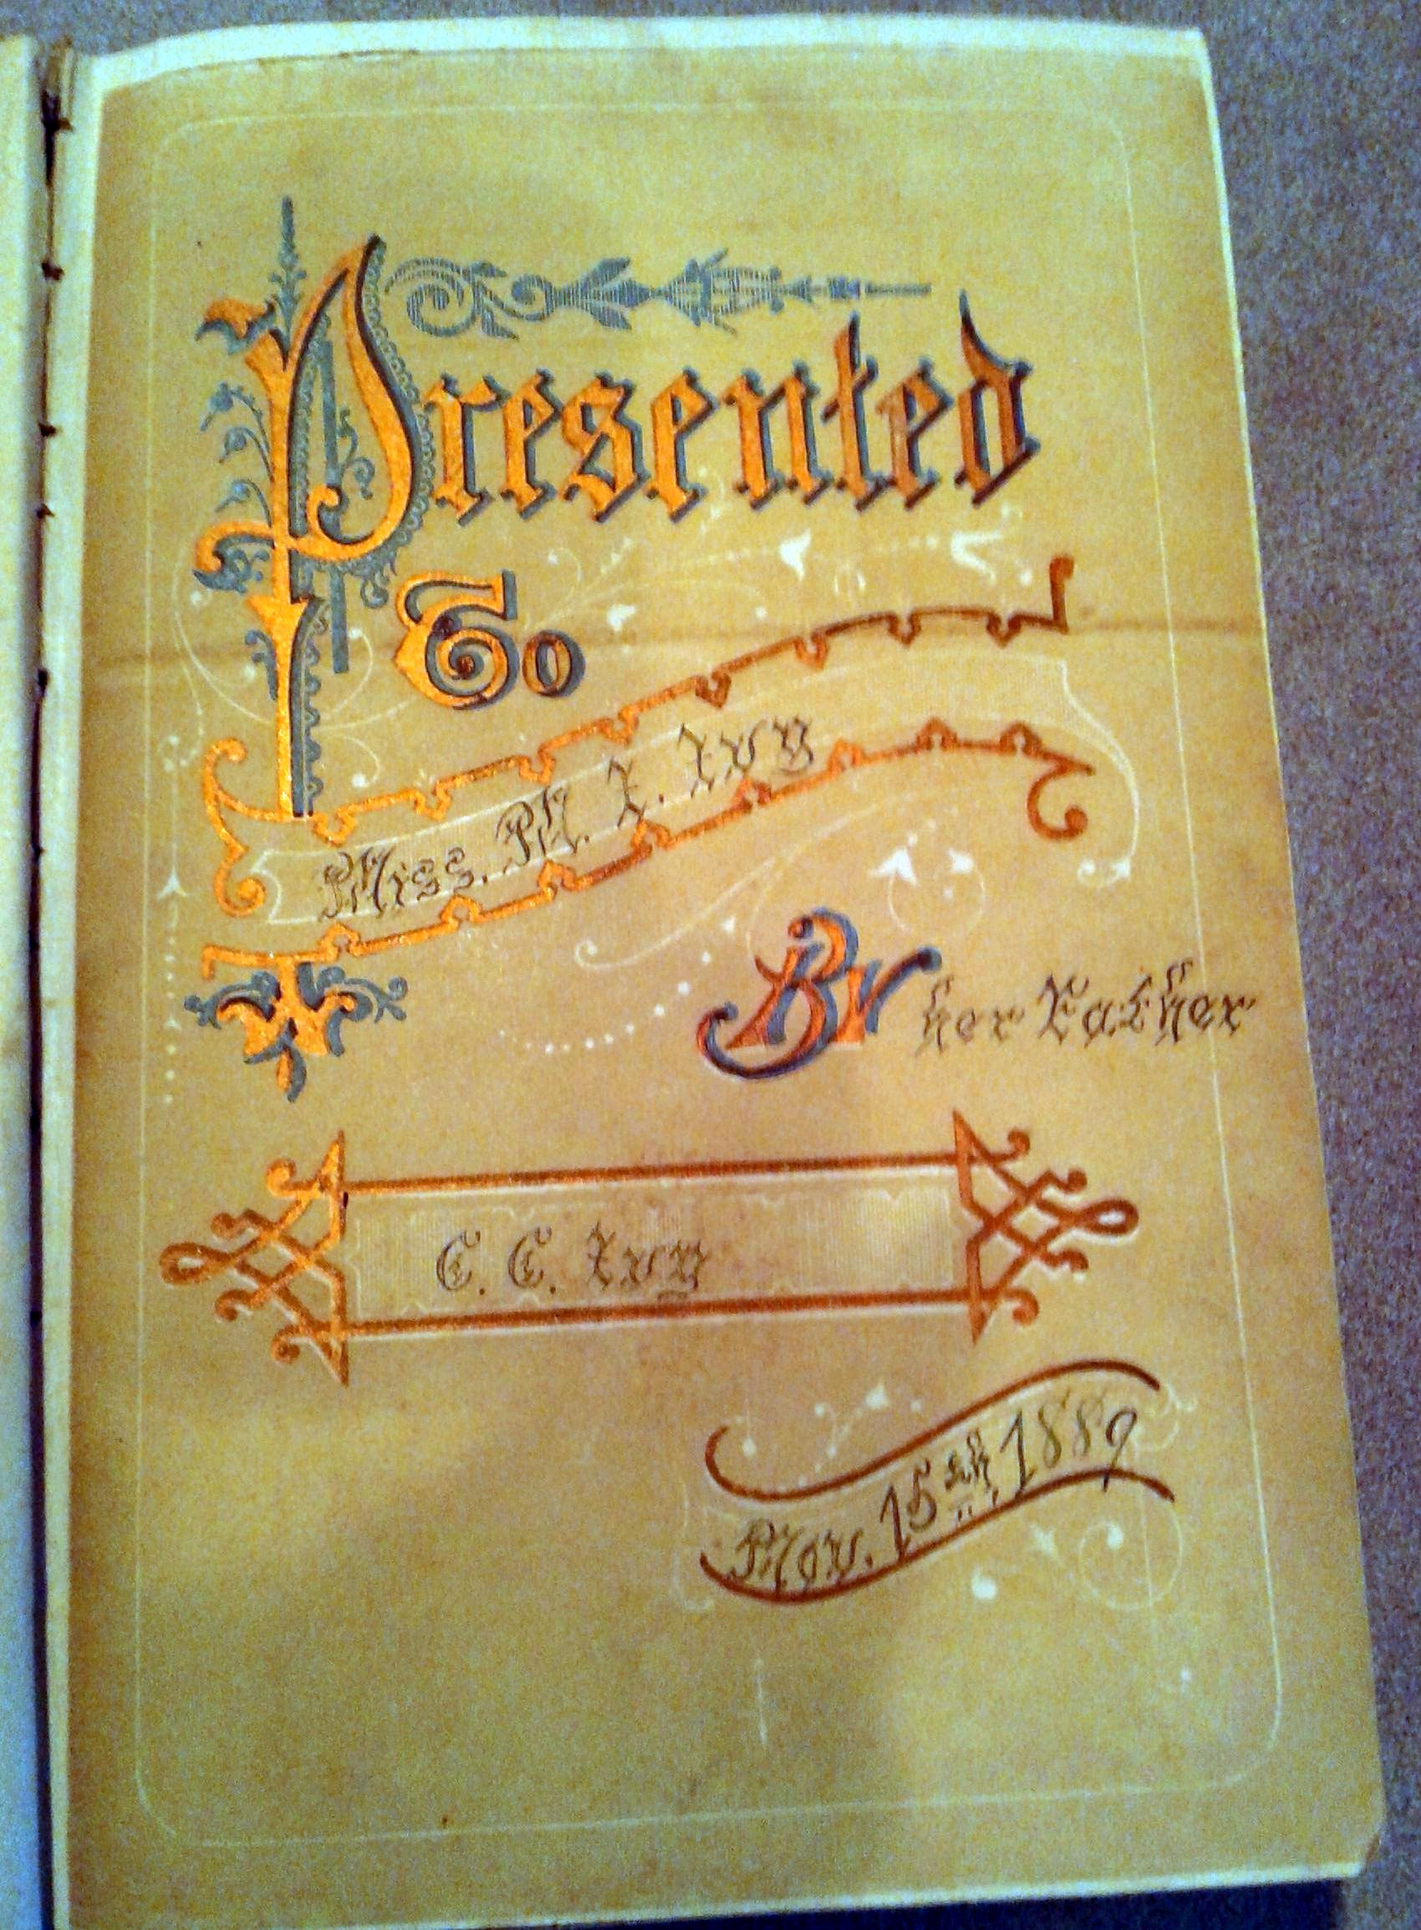

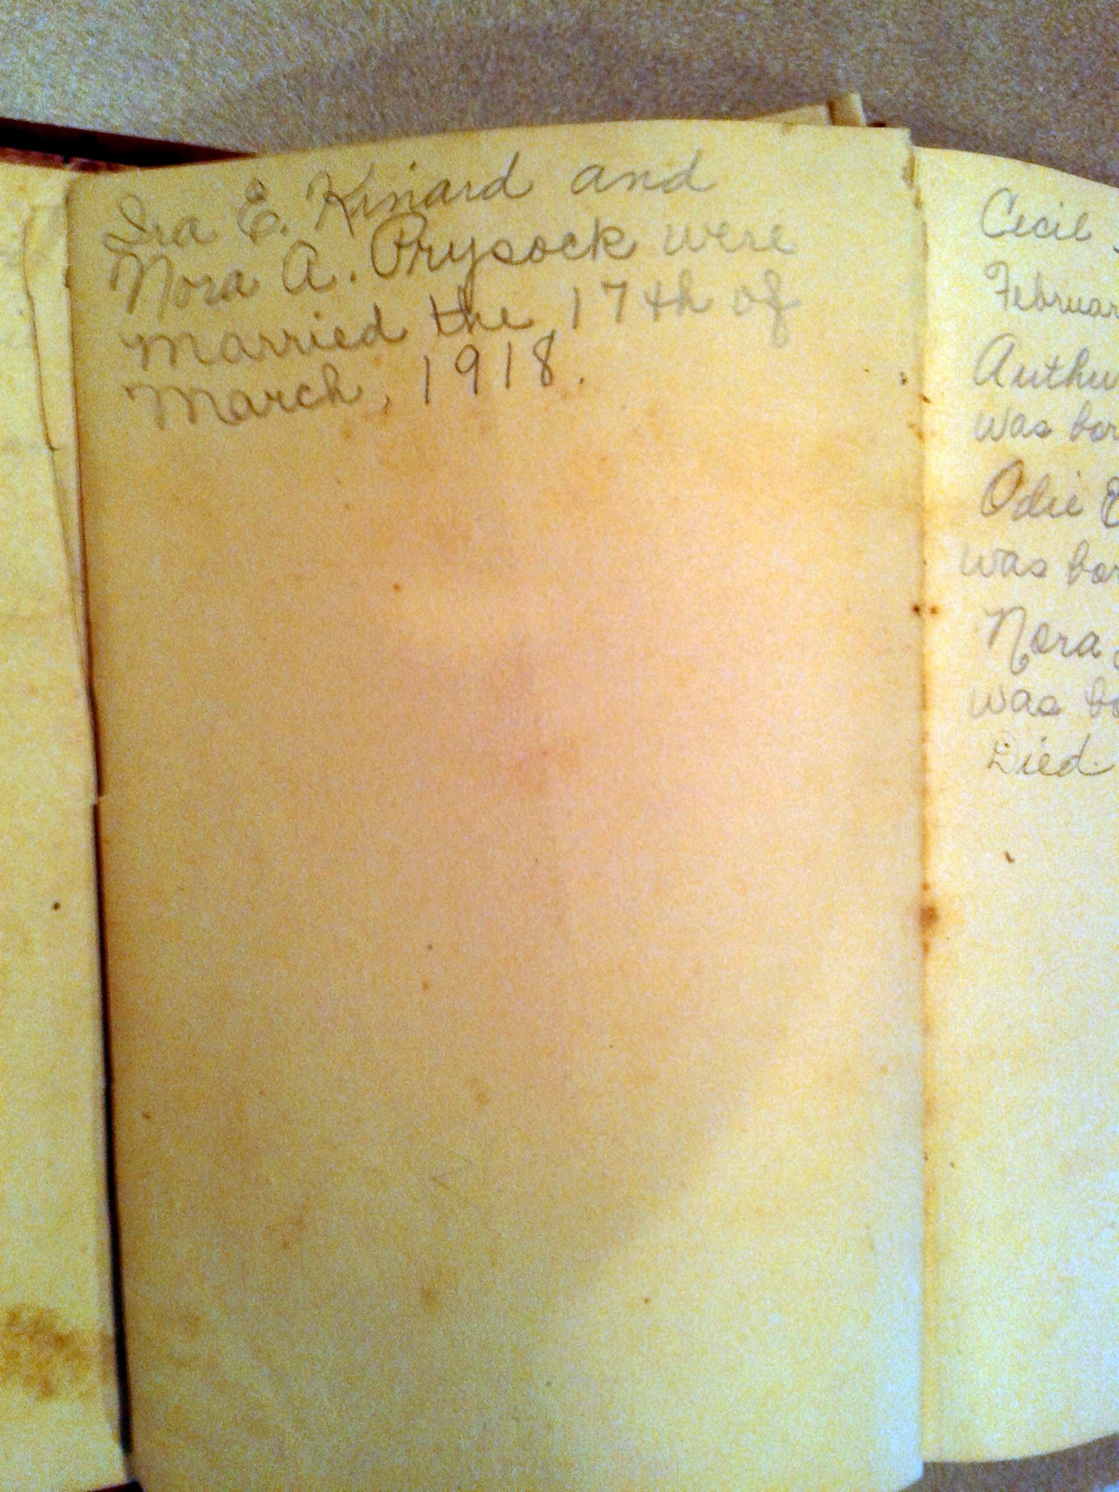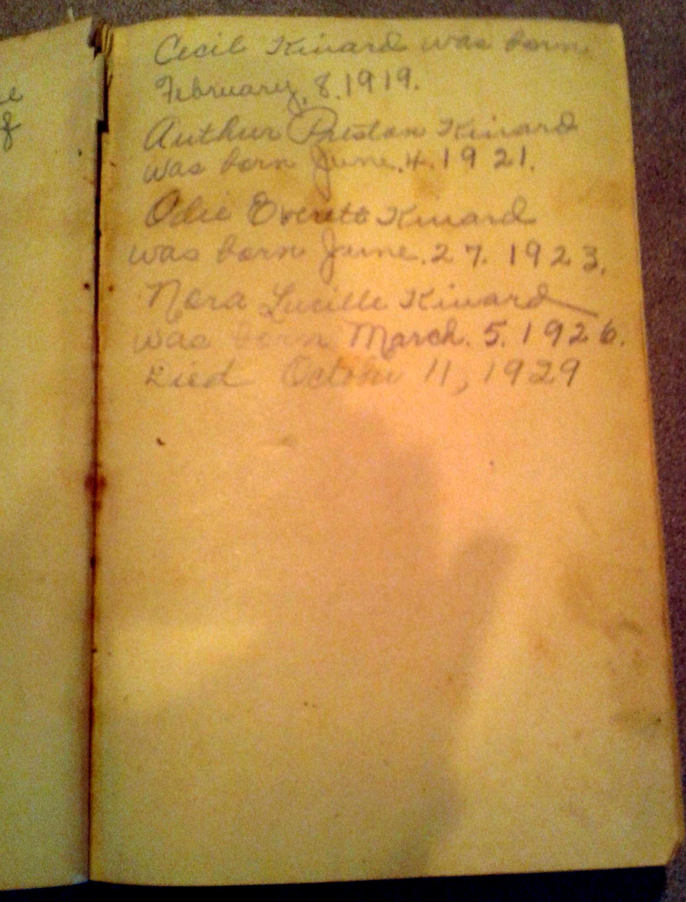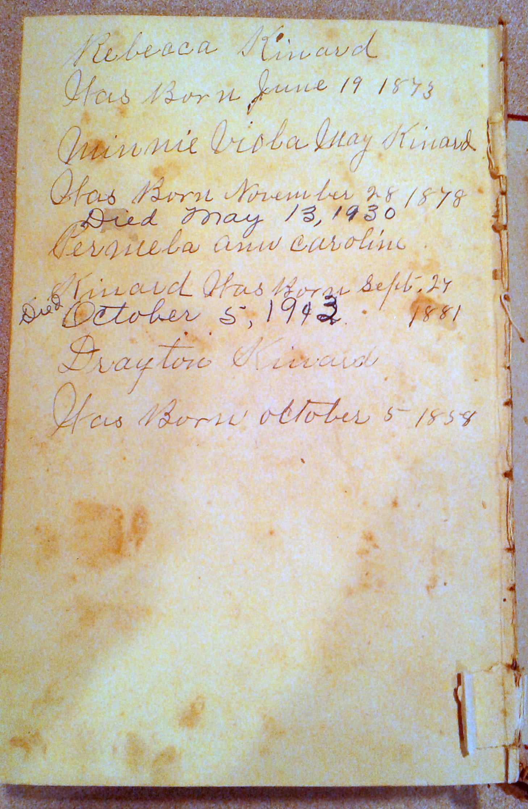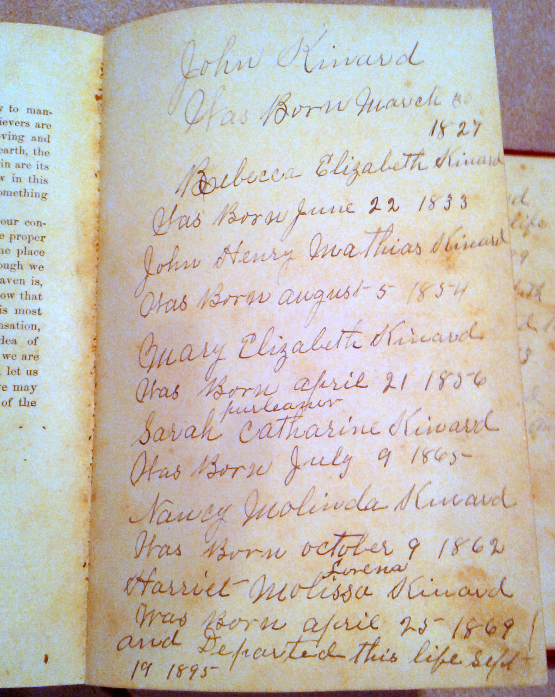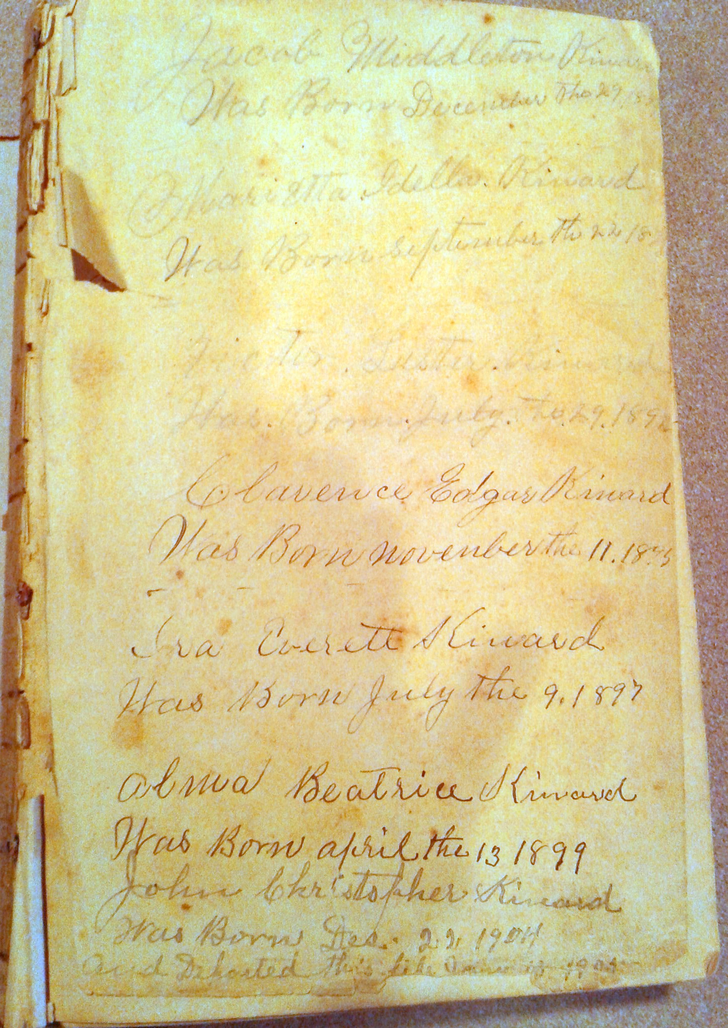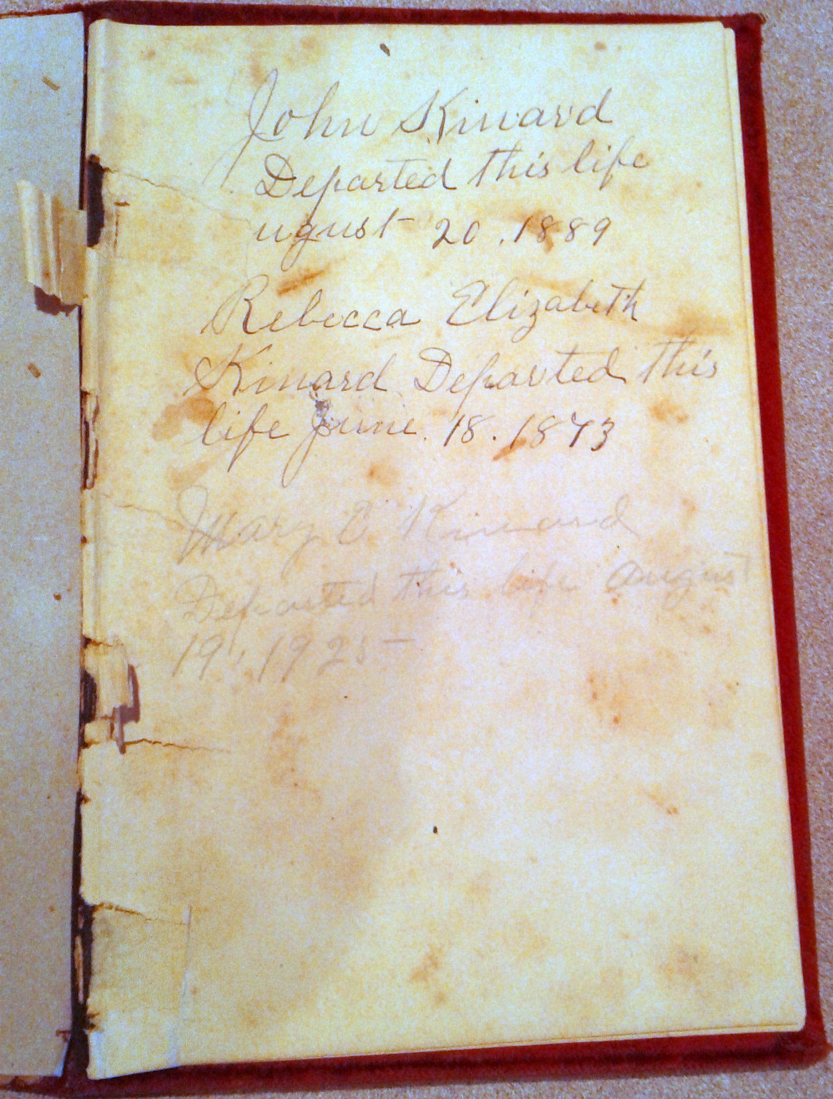
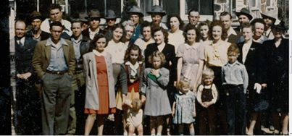1st row –Dorothy Ivy, Lula B. Ivy Young, (holding onto Jimmy Kinard), Peggy Stoner, Mary Lois Kinard, Eugene Kinard, David Kinard. 2nd row - Eugene Ivy, Dot Kinard, Maggie Louella Ivy, Dorothy Kinard, Helen Kinard, Jean Kinard, Wilma Kinard, (?), Ruby Ivy, Mary Warbbington. 3rd row - Billy Ivy, Ray Baker, Otis Ivy, Louella Ivy, (?), Nora Kinard, (Prysock), Ocy Baker. 4th row - (?), Sam Ivy, ?, Preston Kinard, Cecil Kinard, Odie Everett Kinard, Herman Kinard, Ira Kinard, (?), (?), Raphael Ivy. Photo taken 1946 or 1947.
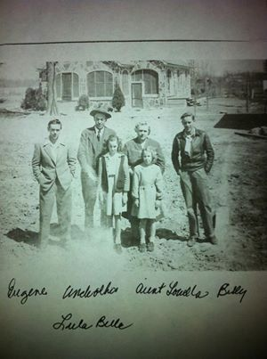
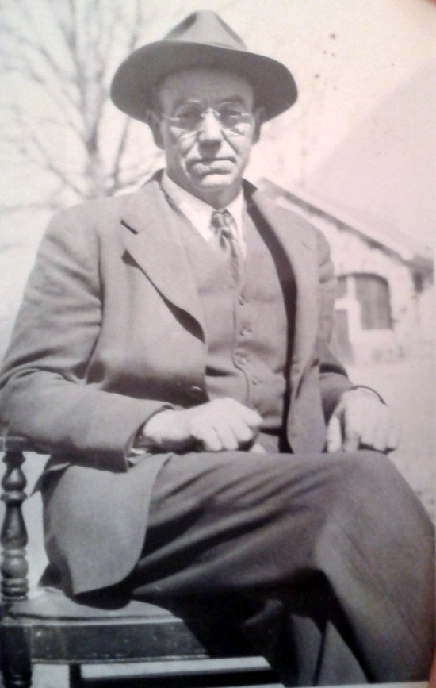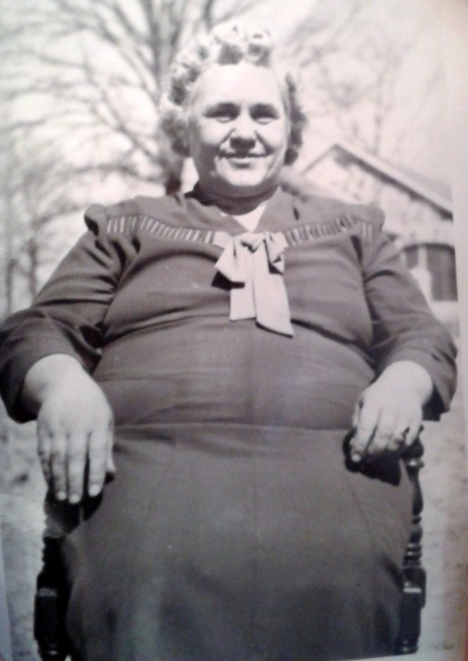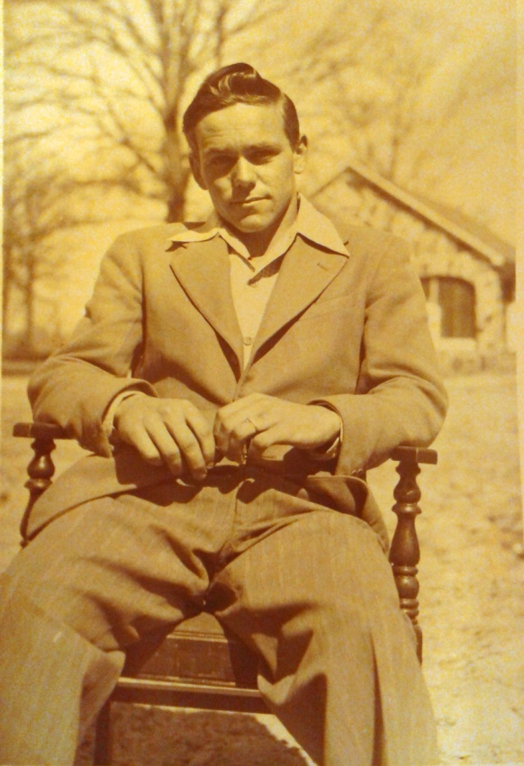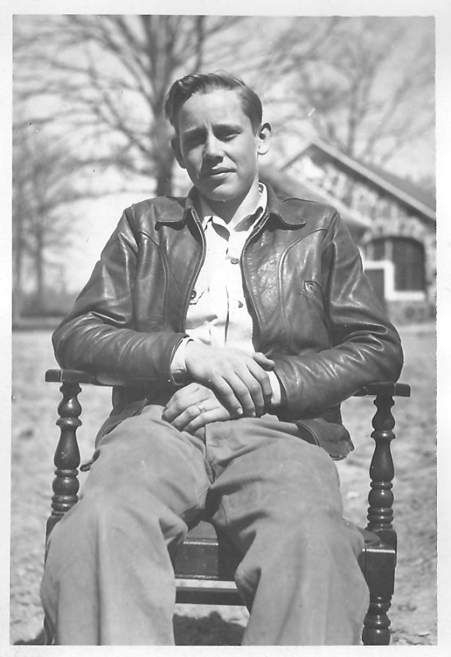
Sylvester Otis Ivy, Maggie Louella Ivy, Eugene Ivy, Billy Ivy
1946 or 1947
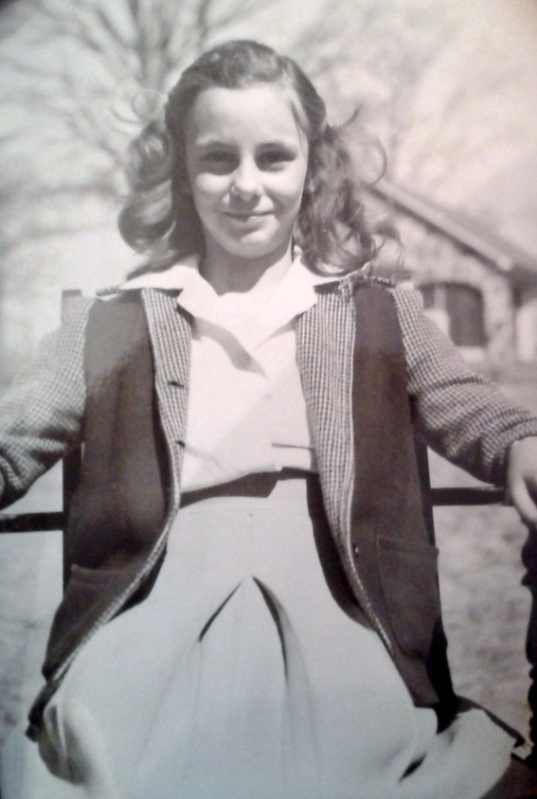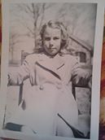
Lula Belle Ivy Young and Peggy Stoner, daughter of Carolyn Ivy Coleman – 1946 or 1947
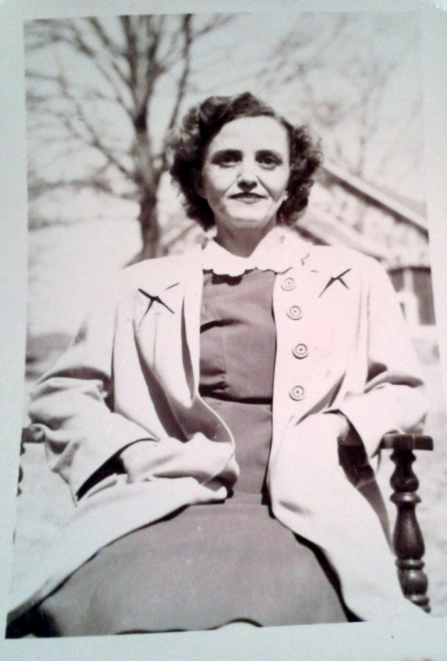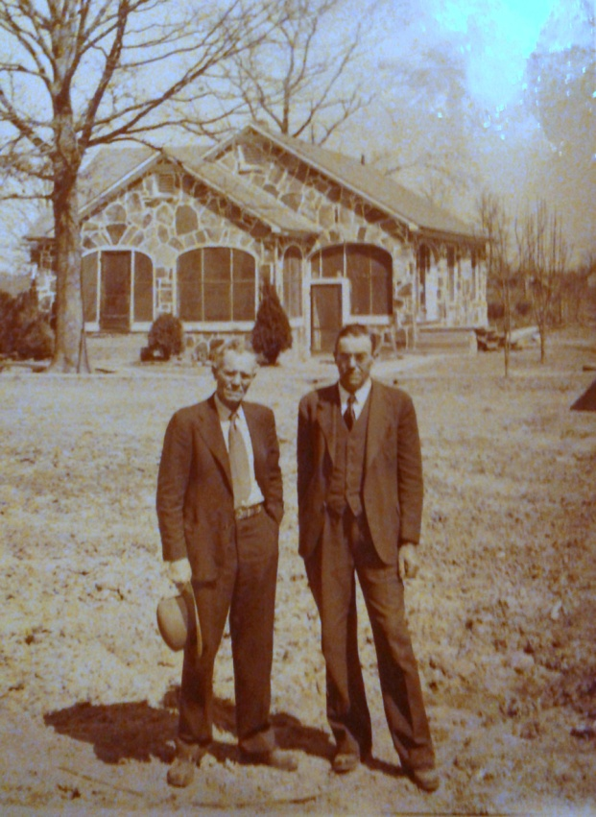
Dorothy Ivy, Sam Ivy and Sylvester Otis Ivy – 1946 or 1947
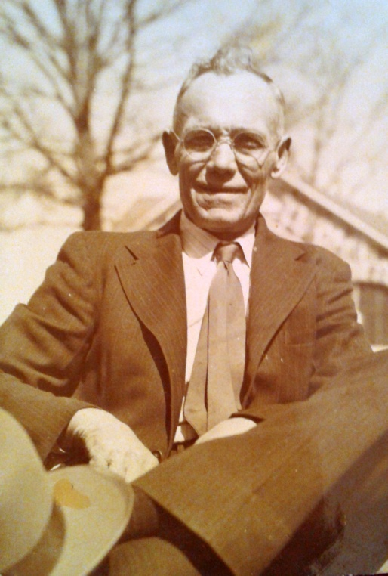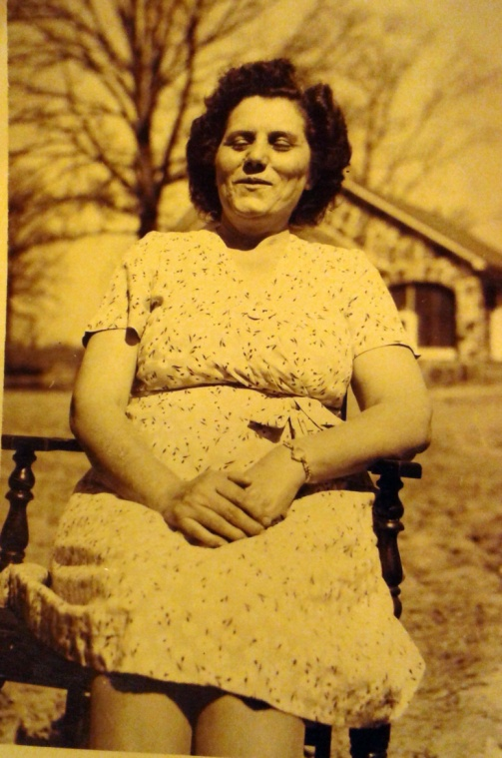
Sam Ivy and Nora Kinard – 1946 or 1947
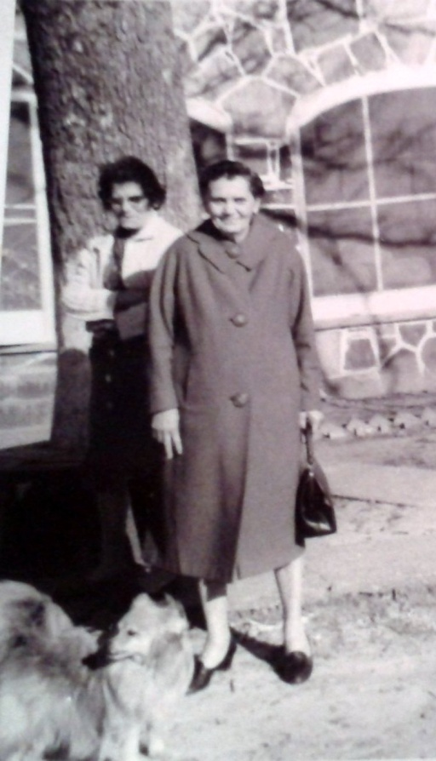
Nora Kinard and Hettie Ivy – 1966
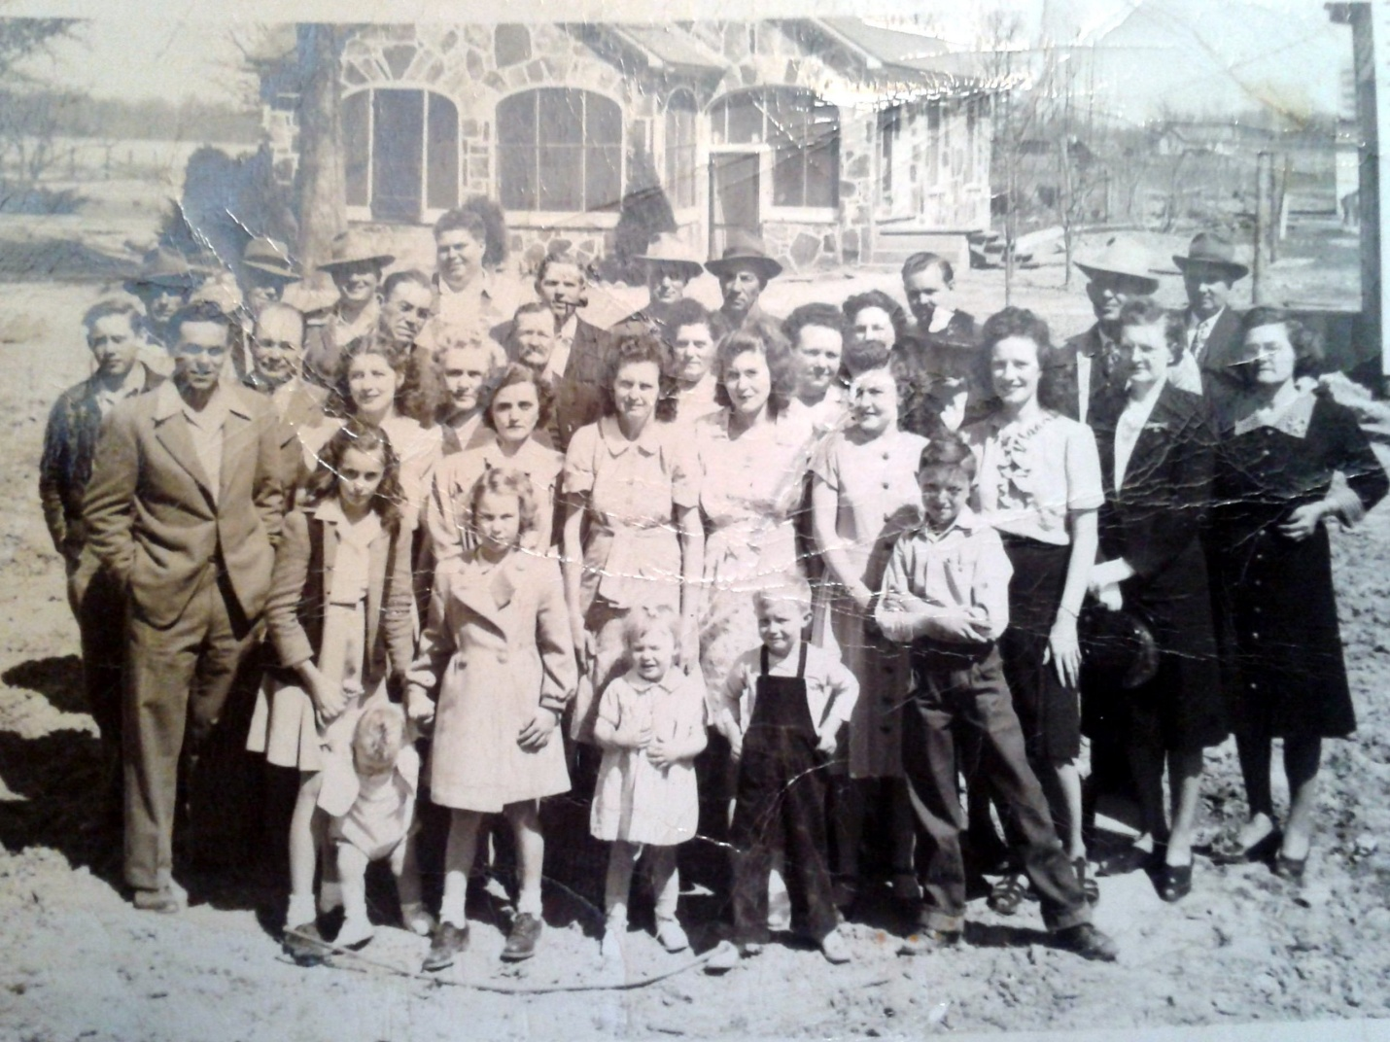
Ivy and Kinard families 1946 or 1947.
1st row - Lula B. Ivy Young, (holding onto Jimmy Kinard), Peggy Stoner, Mary Lois Kinard, Eugene Kinard, David Kinard. 2nd row - Eugene Ivy, Dot Kinard, Dorothy Kinard, Helen Kinard, Jean Kinard, Wilma Kinard, (?), Ruby Ivy, Mary Warbbington. 3rd row - Billy Ivy, Ray Baker, Otis Ivy, Louella Ivy, (?), Nora Kinard, (Prysock, I think) Ocy Baker. 4th row - (?), Sam Ivy ?, Preston Kinard, Cecil Kinard, Odie Everett Kinard, Herman Kinard, Ira Kinard, (?), (?), Raphael Ivy.
Ruby May Slaven Trail has on the ruffled shirt and is between Wilma and Raphael's wife Ruby Ivy.Between Aunt Nora and mother is Maggie Prysock Slaven. Just before Uncle Sam and Preston is Garfield Slaven, Maggie's husband.
The young boy whose leg is off to the side and has arms crossed is J. G. Slaven, Maggie and Gar's baby boy.
Back row of men goes Garfield Slaven, Uncle Sam Ivy, Odie Kinard, Cecil Kinard, Preston Kinard (with what appears to be pipe in mouth) Uncle Herman Kinard, Uncle Ira Kinard, Albert "Buddy" Trail (Ruby Mae's husband), Mr. Sam Warbington and Raphael Ivy. Aunt Julia Ivy has on the hat with what looks like a white flower. She is standing by Mother.
….identified by Mary Lois Kinard, Mary Kathryn Norris and Lula Belle Ivy Young.
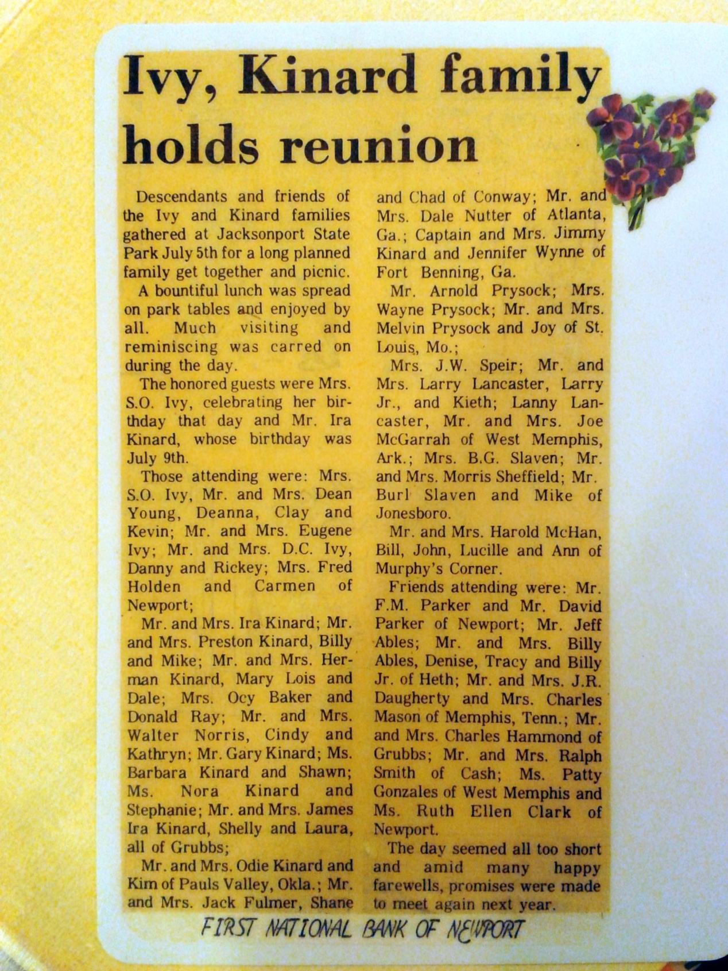

Beth-Eden Evangelical Lutheran Church
Newberry, SC
Organized 1843

The name Beth-Eden is mentioned in the Bible in Amos 1:5. It is usually listed as Eden, Betheden, or Beth-Eden.
Location: Beth-Eden is located in Newberry County, six miles north of Newberry off the Old Whitmire Road on S.C. 36-481

Beth-Eden's Early History

At a meeting of the Evangelical Lutheran Synod of South Carolina and adjacent states held at St. Mark's in 1842, a resolution was passed appointing Rev. G. H. Brown missionary to labor at Liberty Hill station and in the surrounding country. In discharging his duty of exploration he found in the neighborhood where Beth-Eden now stands several Lutheran families anxious to worship God according to the faith and customs of their forefathers. And, though few in number and in moderate circumstances, they were willing to undertake the erection of a house of worship.

On March 9, 1842, 4.4 acres of land was surveyed, and on April 19, 1843, it was deeded to Jacob Baker for Beth-Eden Church by W. W. McMorris. The church bought 1.25 acres from Thomas Chandler (1805-1878) for $25.25. Jacob Barre gave two strips of land, each a fraction of an acre, to the church at different times.

In a short time their church was completed at a cost of $600. A congregation was organized, and the house was dedicated to the service of God on the second Sunday in September 1843. Rev. G. H. Brown, Rev. John C. Hope, and Rev. Herman Aull officiated at the dedication.

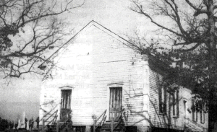
The original Beth-Eden Church Building, Newberry, South Carolina

In 1847, under the pastoral leadership of Rev. E. A. Bolles, a parsonage was built on the church lot at a cost of $600. In 1858 the members decided to enlarge and entirely remodel the church house. A committee consisting of John P. Kinard, John P. Aull, and J. Hilary Sligh was appointed to supervise the work which cost $1,300. The female members of the congregation furnished the church with a sofa, table, chairs, lamps, and carpet.

1859 Synod Meeting

The annual convention of the Synod met at Beth-Eden Church for six days beginning on October 27, 1859. Rev. Samuel Bouknight was President of the Synod at this time. In his President's report, he stated: "We assemble for the two-fold purpose of being together as an organized portion of Christ's Church and to confer with each other in mutual consent, living like those that have but one head, and praying like those that possess one heart." He also thanked God "that the yellow fever epidemic had not visited the sea port towns in the bounds of our Synod. "

The concluding words of retiring President Samuel were "From all that I have been able to learn of the state of our churches, I say to you that where the Word of God has been faithfully preached and the Sacraments administered, our churches have not only maintained but improved. "

A hundred years later, in 1959, Rev. Karl W. Kinard, DD, was President of Synod. Synod met at Beth-Eden in 1850, 1859, and 1864.

The old wooden frame church was tom down by members of the congregation around the 20th day of May, 1948. The ladies of the church brought picnic lunch for the men who undertook to dismantle the old building. Construction on the new church was begun on July 13, 1948, under the supervision of J. Caldwell Franklin, a member. The Rev. C. J. Rice was pastor at this time. Money for the new church was raised by donations, pledges, and barbecues.

The New Church

Much of the lumber in the old church was reused in the new building as it was of good quality "heart" pine. Some pegs were found to have been used in the framework of the old church building. The sills from the old church were in good condition and were sawed up to make the window frames for the new church.

Cornerstone Laying

A special service for the "Placing of the Cornerstone" in the new church was held at Beth-Eden by the Rev. C. J. Rice on Sunday, November 20, 1948. The guest speaker was the Rev. Karl W. Kinard, DD, President of the Lutheran Synod of South Carolina.

Two marble tablets have been placed to the right of the entrance to the church. These tablets display the names of all who have served as pastors from the date of organization until the present time.

At one time, Beth-Eden, Colony, and St. James churches were united in a parish to form the "Beth-Eden Parish". The Rev. J. D. Kinard, DD was the first pastor to serve in this parish arrangement. He served from 1910 until 1912. Dr. Kinard was the father of the Rev. Karl W. Kinard, DD, who served as President of the Lutheran Synod of South Carolina and was guest speaker at the laying of the cornerstone for the new church.

The mortgage was paid off in May, 1951. The dedication of the new church by the Rev. Karl W. Kinard, DD was held on December 3, 1951. At this service, Dr. Kinard remarked about having played among the oak trees on the church grounds as a small boy when his father was serving as pastor.

Some Interesting Facts

Major John P. Kinard (1810-1890) was a Captain in the Confederate States Army. He was a member of Beth-Eden and was present at the South Carolina Synod meeting at Beth-Eden on October 27, 1859. He was a signer of the Ordinance of Secession. The Drayton Rutherford Chapter of the United Daughters of the Confederacy marked his grave with a bronze marker on May 10, 1963.

Buford M. Summer, M.D. (born 1838), son of Jacob and Elizabeth Kinard Summer, died on September 13, 1863, while a prisoner of war at Fort Delaware. He is buried in Beth-Eden cemetery. He was a nephew of Major John P. Kinard, signer of the Ordinance of Secession, and a grandson of Nicholas Summer, a charter member of Beth-Eden. He was graduated from Charleston Medical College in the fall of 1860.

Early History of Beth-Eden Lutheran Church Winston County, Mississippi

Compiled by Eleanor C. Wicker of Greenville, Mississippi, with the use of information shared by Miss Nita Kinard and Mrs. Beatrice (Kinard) Harsh of Winston County, Mississippi..

Beth-Eden Lutheran congregation in Winston County, Mississippi, was organized in March, 1853, to meet the need of a group of Lutherans who had migrated to Winston County from Newberry, S. C., between 1842 and 1853. Pioneers made these trips by wagon trains which took about six weeks. They cleared land, built homes, and planted and harvested crops. They wanted to organize a Lutheran Church, since many of them were Lutherans.

Jacob Baker, a charter member of Beth-Eden Newberry, migrated to Winston County in 1852. He remembered that Rev. G. H. Brown had been sent to Attala County, Mississippi, to help organize a church there. Jacob Baker wrote to Rev. Brown and appealed to him to come to Winston County and help organize a church. In March, 1853, Rev. Brown wrote rode horseback a distance of about 60 miles to Winston County. The organizing meeting was held at the voting precinct and it was decided to name the church "Beth- Eden" since that was the name of Rev. Brown’s home church in South Carolina.

During the summer of 1853, Rev. Brown came back to Winston County and held a "protracted meeting" at Center Camp Ground (now Beth-Eden) which was the property of the Methodist Episcopal Church, South. A number of others united with the congregation - one being John R. Crumpton.

On October 10, 1853, trustees for Center Camp Ground Methodist Congregation signed a deed to Jacob Baker, William Kinard, Christian Long, and Eli Suber, trustees of Beth-Eden Lutheran Congregation, for a tract of land for the benefit of a Lutheran Church.

The first church building (dating to 1854) was built of rough lumber and was unceiled. It was used until it burned in 1904 or 1905. The present structure was undertaken soon after the fire and with donated labor, lumber, and material was completed about 1907 or 1908.

Among the charter members (many from Newberry, S. C.) of Beth-Eden, Winston, were:
Jacob and Margaret Eve (Kinard) Baker and family
William and Sarah (Kinard) Kinard and family (William was one of five brothers who came)
John Christian and Mary Nance Long and family
Eli and Letty Suber and family
Henry and Sarah Cannon and family
Jacob and Mary Martha Metts Warner and family (Parents of Rev. John Thomas Warner)
Peter Asbury and Mary Eleanor (Maffett) Wicker and family (It is of interest to note that Peter A Wicker and his twin brother, Jacob A., are both buried in Beth-Eden cemeteries - Peter in Mississippi and Jacob in South Carolina.)
Francis and Margaret Wilson and family; daughter Jane Elizabeth and son Drayton M. Wilson Jacob Kinard (The grandfather of the two Kinard sisters: Miss Nita and Mrs. Beatrice (Kinard) Marsh, to whom, along with Mr. and Mrs. D. H. (Eleanor) Wicker, we are deeply indebted for this information.)
The charter members listed above are all listed in the 1850 Newberry County Census Book.

A rich heritage has been passed to us by our founding fathers and ancestors. Let us continue to work together, to give God the glory, and ask his guidance in proclaiming the Gospel.

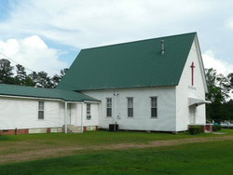

Beth Eden Lutheran Church, Winston County, Mississippi

….researched via Internet and submitted by Mary Kinard

