More Information on Will of Reuben Benthall’s Will
John Sharp, 25-Jul-2024

I found these documents on Family Search which concern Reuben’s will and final inventory. Let’s see what sense we can make of them. Source 722a describes where the lands of Reuben Benthall are being divided for the 5 sons of Reuben. I will have to show it in a few screenshots.
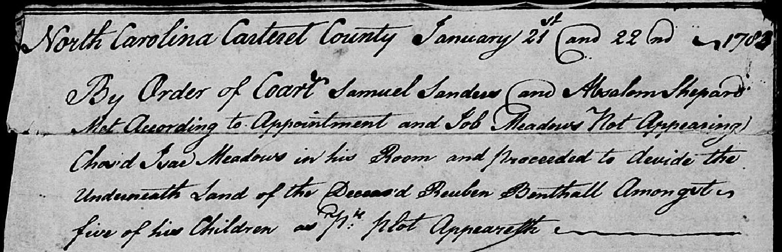
This first shot of Source 722a is the following text:
“North Carolina Carteret County January 21st and 22nd ~1783
By order of Court Samuel Sanders and Absalom Shepard Met According to Appointment and Job Meadows Not Appearing [Chair’d?] Isac Meadows in his Room and proceeded to divide the Underneath Land of the Deceas’d Reuben Benthall Amongsts five of his Children as P^{er} Plot Appeareth ~~~~
Next is a drawing of the land to be divided.
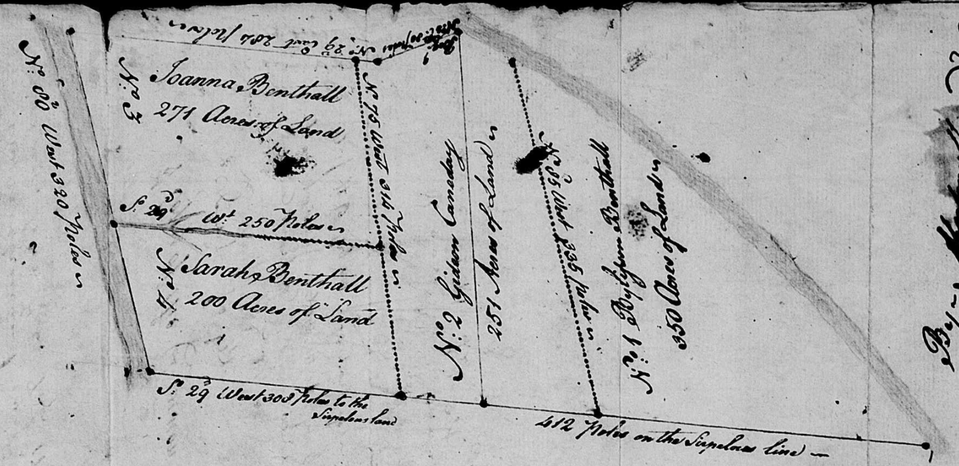
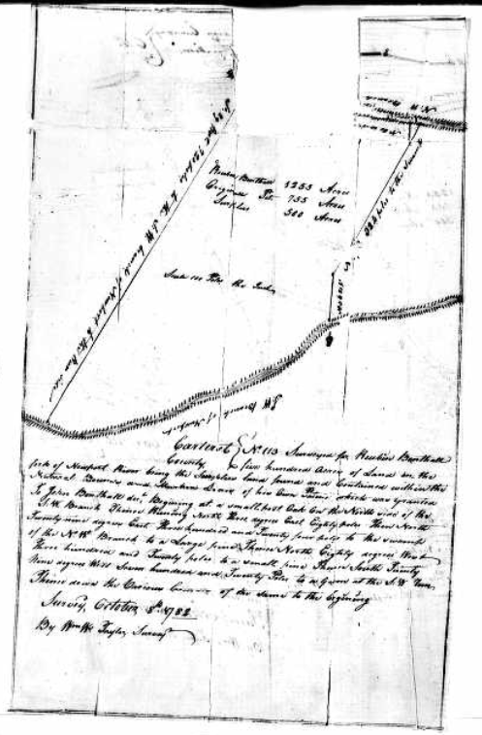
If we rotated this drawing 90 degrees to the right, it would look like the drawing from Land Patent 668, dated October 10th, 1780. So here we can see Reuben’s land being divided (the upper drawing, not the drawing to the right).
On the side of drawing of Reuben’s land to be divided (Source 722a), to the west of Reuben’s land, is a written phrase:
“No. 5 William Sanders”
I wonder if this means this is the land of William Sanders in 1783? It’s not inconceivable since William Sanders married Reuben Benthall’s daughter, Patience, in Carteret County in 1782. So this makes sense that William may have lived next to Reuben.
At the bottom of 722a, it is signed by Absalom Shepard and Gideon Canaday, Executors.

At the top of the next source (722b), there is a bit of writing (see image at top of next page). This writing says:
“North Carolina
Carteret County
This is to certify that the foregoing is the [result?] of the Division of the Lands of Reuben Benthall filed in the office of the Clerk of the Superior Court of Carteret Co., NC. Let the instrument with this certificate be registered this Feb. 9th 1906.
L. A. [Garret?] A. S. P.”
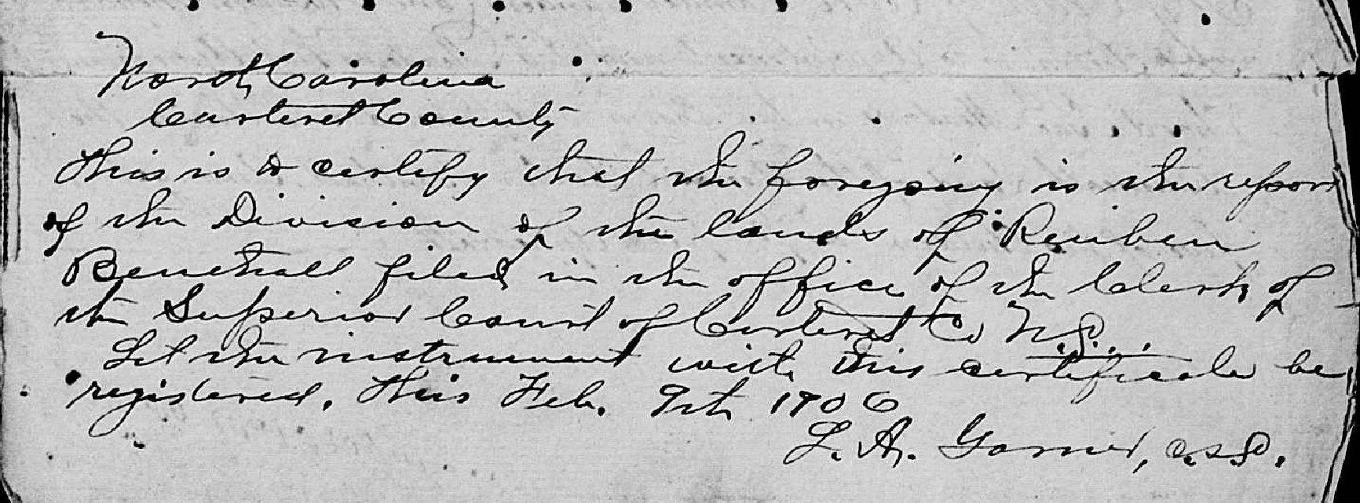
The 1906 year threw me for a little bit, but it seems to be real as this year is repeated in several places on this document. The next section of Source 722b is:
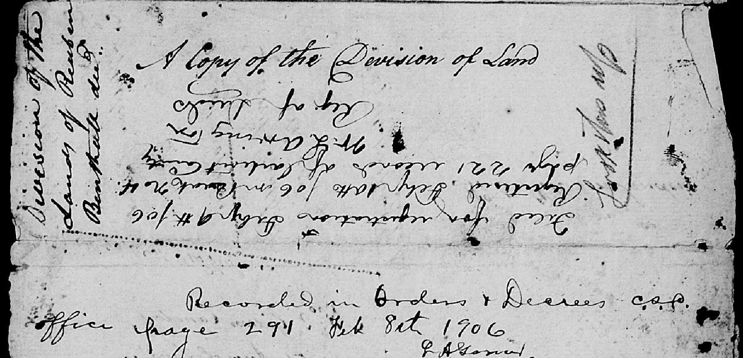
Some of the writing just refers to the document being for the division of Reuben’s land. The middle part of the image has the writing:
“Filed for registration Feb 9th 106 [assume they meant 1906?]
Registered Feb 10th 106 [assume they meant 1906?] in Book No 4, page 221 records of Carteret County.
W. L. Arrington
Reg. of Deeds”

The bottom of the image above says “Recorded in Orders & Decrees c.s.p. Page 291, Feb 8th 1906. L. E. Garret A. S. P.”

Source 722c is the beginning of an inventory of Reuben Benthall’s household goods and estate at the time of his death. This is dated June 8th, 1782 pointing to the date of his death in early 1782.
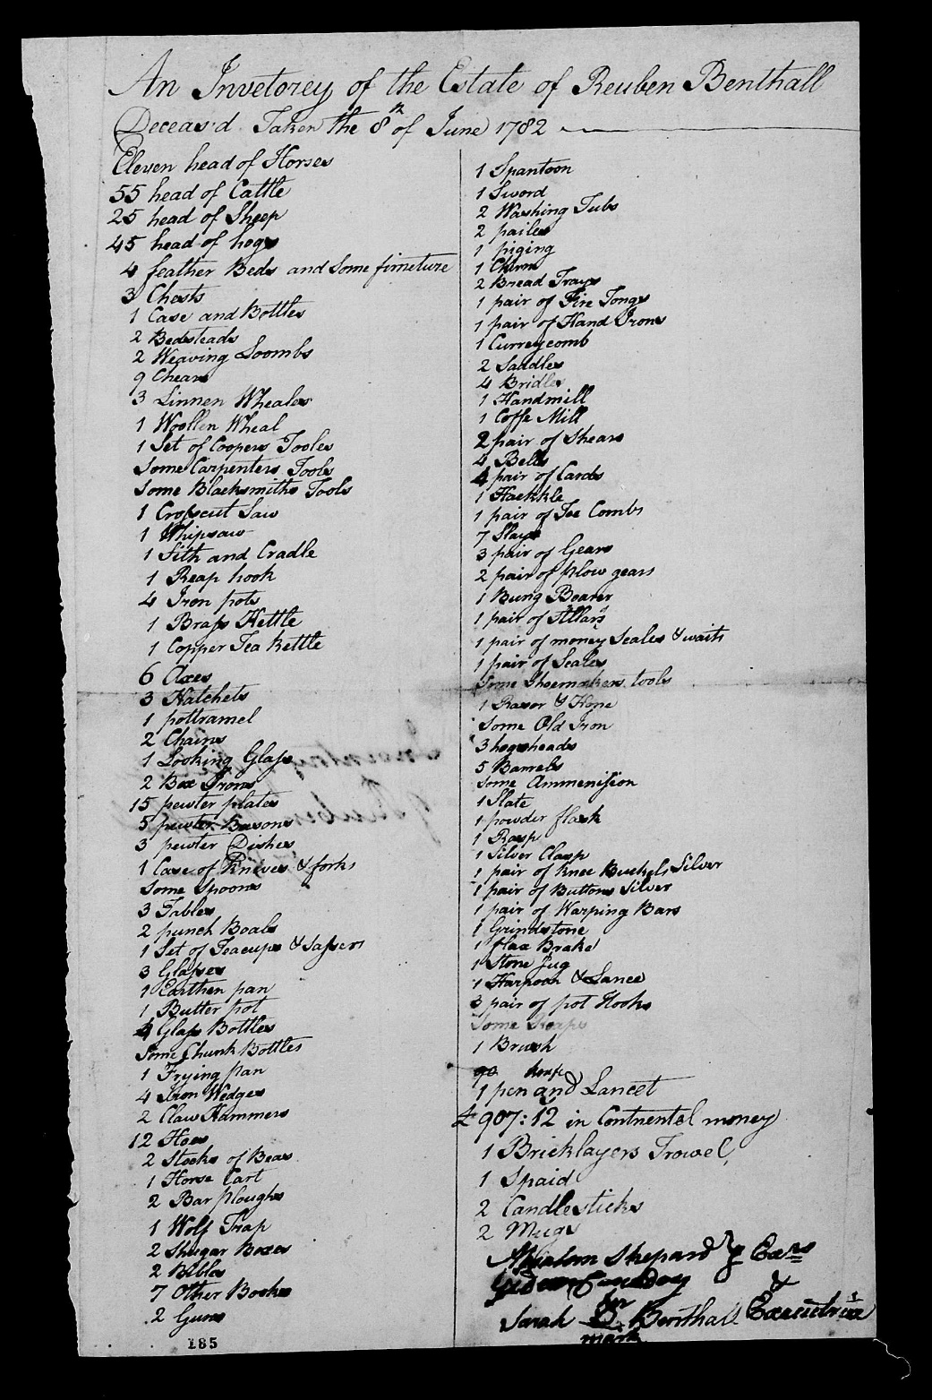
The inventory consists of:
Eleven head of horses | 1 Spantoon [Spittoon?]
55 head of Cattle | 1 Sword
25 head of Sheep | 2 Washing Tubs
45 head of hogs | 2 pailes [pails]
4 feather Beds and Some furniture [furniture] | 1 piging
3 Chests | 1 Churn
1 Case and Bottles | 2 Bread Trays
2 Bedsteads | 1 pair of Fire Tongs
2 Weaving Loombs [Looms] | 1 pair of Hand Irons
9 Chears [Chairs] | 1 Curreycomb
3 Linnen Wheales | 2 Saddles
1 Woolen Wheal | 4 Bridles
1 Set of Coopers Tools | 1 Handmill
Some Carpenters Tools | 1 Coffe [Coffee?] Mill
Some Blacksmiths Tools | 2 pair of Shears
1 Crosscut Saw | 4 Bells
1 Whipsaw | 4 pair of [Carobs? Cards?]
1 [Sith? Lith?] and Cradle | 1 Haekkle [hackle?]
1 Reap Hook | 1 pair of Tea Combs
4 Iron Pots | 7 Slay [Sleigh?]
1 Brass Kettle | 3 pair of Gears
1 Copper Tea Kettle | 2 pair of plow gears
6 Axes | 1 Bung Boarer
3 Hatchetts | 1 pair of [Ltllass? Stllass?]
1 pottramel | 1 pair of money Seales & waits [weights?]
2 Chains | 1 pair of Seales
1 Looking Glass | Some Shoemakers Tools
2 Box Irons | 1 Raser [razor] & hone
15 Pewter Plates | Some old iron
5 Pewter Basons [Basins] | 3 hogsheads
3 Pewter Dishes | 5 Barrels
1 Case of Knives & Forks | Some ammunition
Some Spoons | 1 Slate
3 Tables | 1 powder Flask
2 Punch Bowls | 1 Rasp
1 Set of Teacups & Saucers | 1 Silver Clasp
3 Glasses | 1 pair of Knee Buckets Silver
1 Earthen Pan | 1 pair of Buttons Silver
1 Butter Pot | 1 pair of Warping Bars
[Unknown number of] Glass bottles | 1 Grindstone
Some [Chunk?] Bottles | 1 flax Brakel
1 Frying Pan | 1 Stone Jug
4 Iron Wedges | 1 Harpoon & Lance
2 Claw Hammers | 3 pair of pot Hooks
12 Hoes | Some [Roapes? Stoapes? Ropes I think]
2 [Stocks of Beas? Bees? Stooks of ?] | 1 Brush
1 Horse Cart | 1 pen knife & Lancet
2 Bar Ploughs | $ 907:12 in Continental Money
1 Wolf Trap | 1 Bricklayers Trowel
2 Shugar [Sugar?] Boxes | 1 Spaid [Spade]
2 Bibles | 2 Candlesticks
7 Other Books | 2 Mugs
2 Guns
Absalom Shepard
Executors
Gideon Canaday
Sarah (her mark) Benthall Executrix
There are some pretty interesting things in this inventory. Reuben had eleven horses, but only two saddles and four bridles. So it seems that most of the horses weren’t for riding, or for more than two people to ride at the same time. He did have a horse cart, so maybe some of the horses were more for pulling the cart (and potentially the Slays, if that meant Sleighs). He had some bar ploughs, so maybe some of the horses were for that, also.
Reuben and his family weren’t great readers, with only 2 bibles and 7 other books. Sarah couldn’t read, as evidenced by her using a mark to sign the inventory.
Reuben had 907 pounds, 12 shillings in Continental money at the time of his death. The Revolutionary War had not officially ended (treaty signed in September 1783), but the last major land battle (Yorktown) had been fought (September-October 1781). However, this money was almost worthless. There’s a fascinating Wikipedia article on money during the Revolutionary War. To quote from the article:
“By the end of 1778, Continentals retained from ¹⁄₅ to ¹⁄₇ of their face value. By 1780, the bills were worth ¹⁄₄₀ of their face value. Congress attempted to reform the currency by removing the old bills from circulation and issuing new ones, without success. By May 1781, Continentals had become so worthless that they ceased to circulate as money. “
So this may explain why Reuben had so much of this money at the time of his death – it literally wasn’t useful as money!
I have no idea what a “pottramel” is. I can’t find any reference to this using Google searches. Same with “haekkle”, but as I mentioned in the transcribed inventory, maybe this is “hackle” which normally refers to the erectile hairs (as in “that raised his hackles”) on a horse’s back but maybe it can refer to a comb for these hairs?
The next page (Source 722d) is just the mostly blank back of the inventory page. It does have the writing “Inventory of the Estate of Reuben Benthall, 1782” on it. The next 3 pages (Sources 722e – 722g) are an account of the sale of items from Reuben’s estate from October 23, 1784. This is not the only sale! There will be another later.
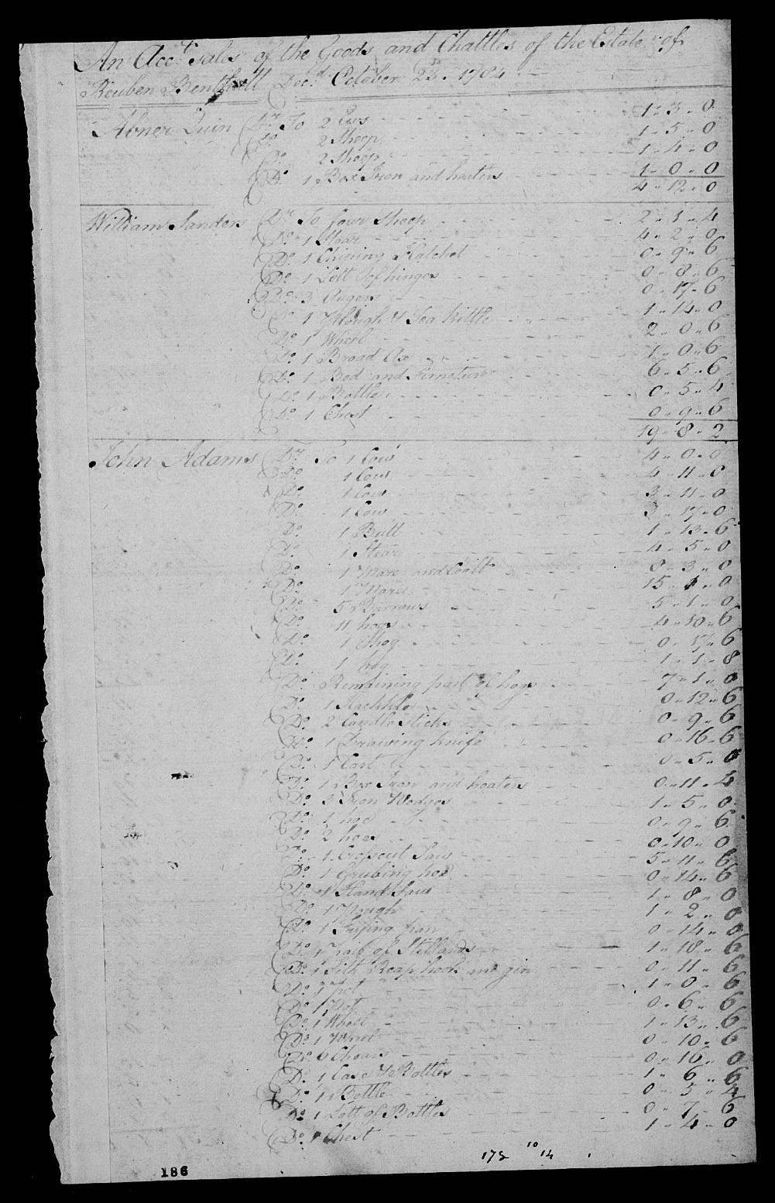
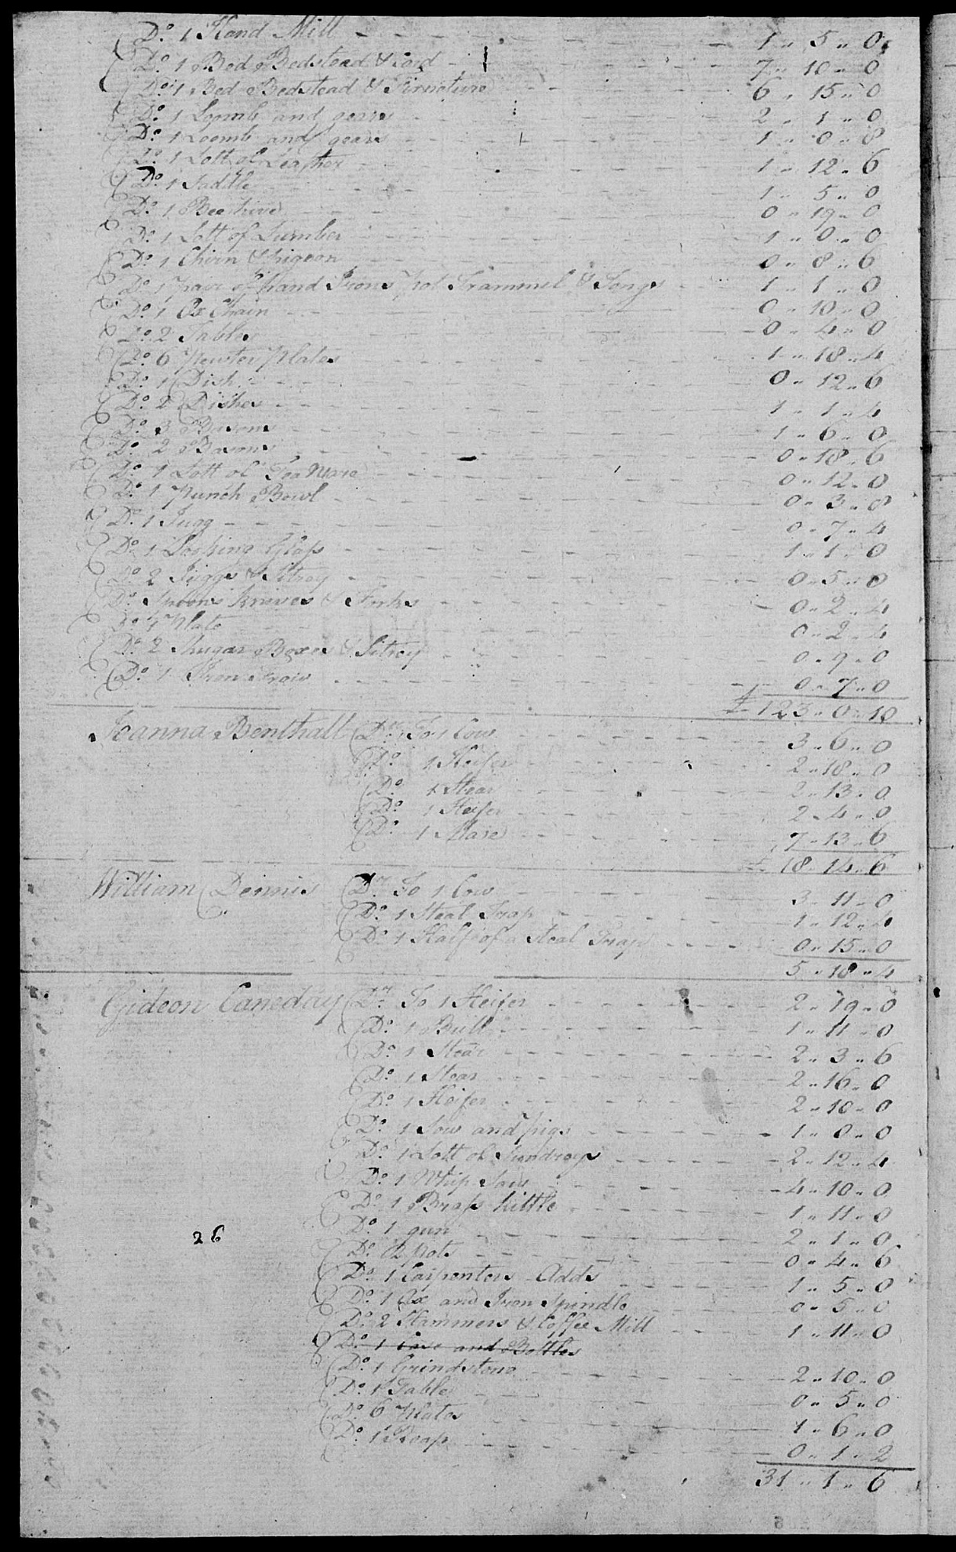
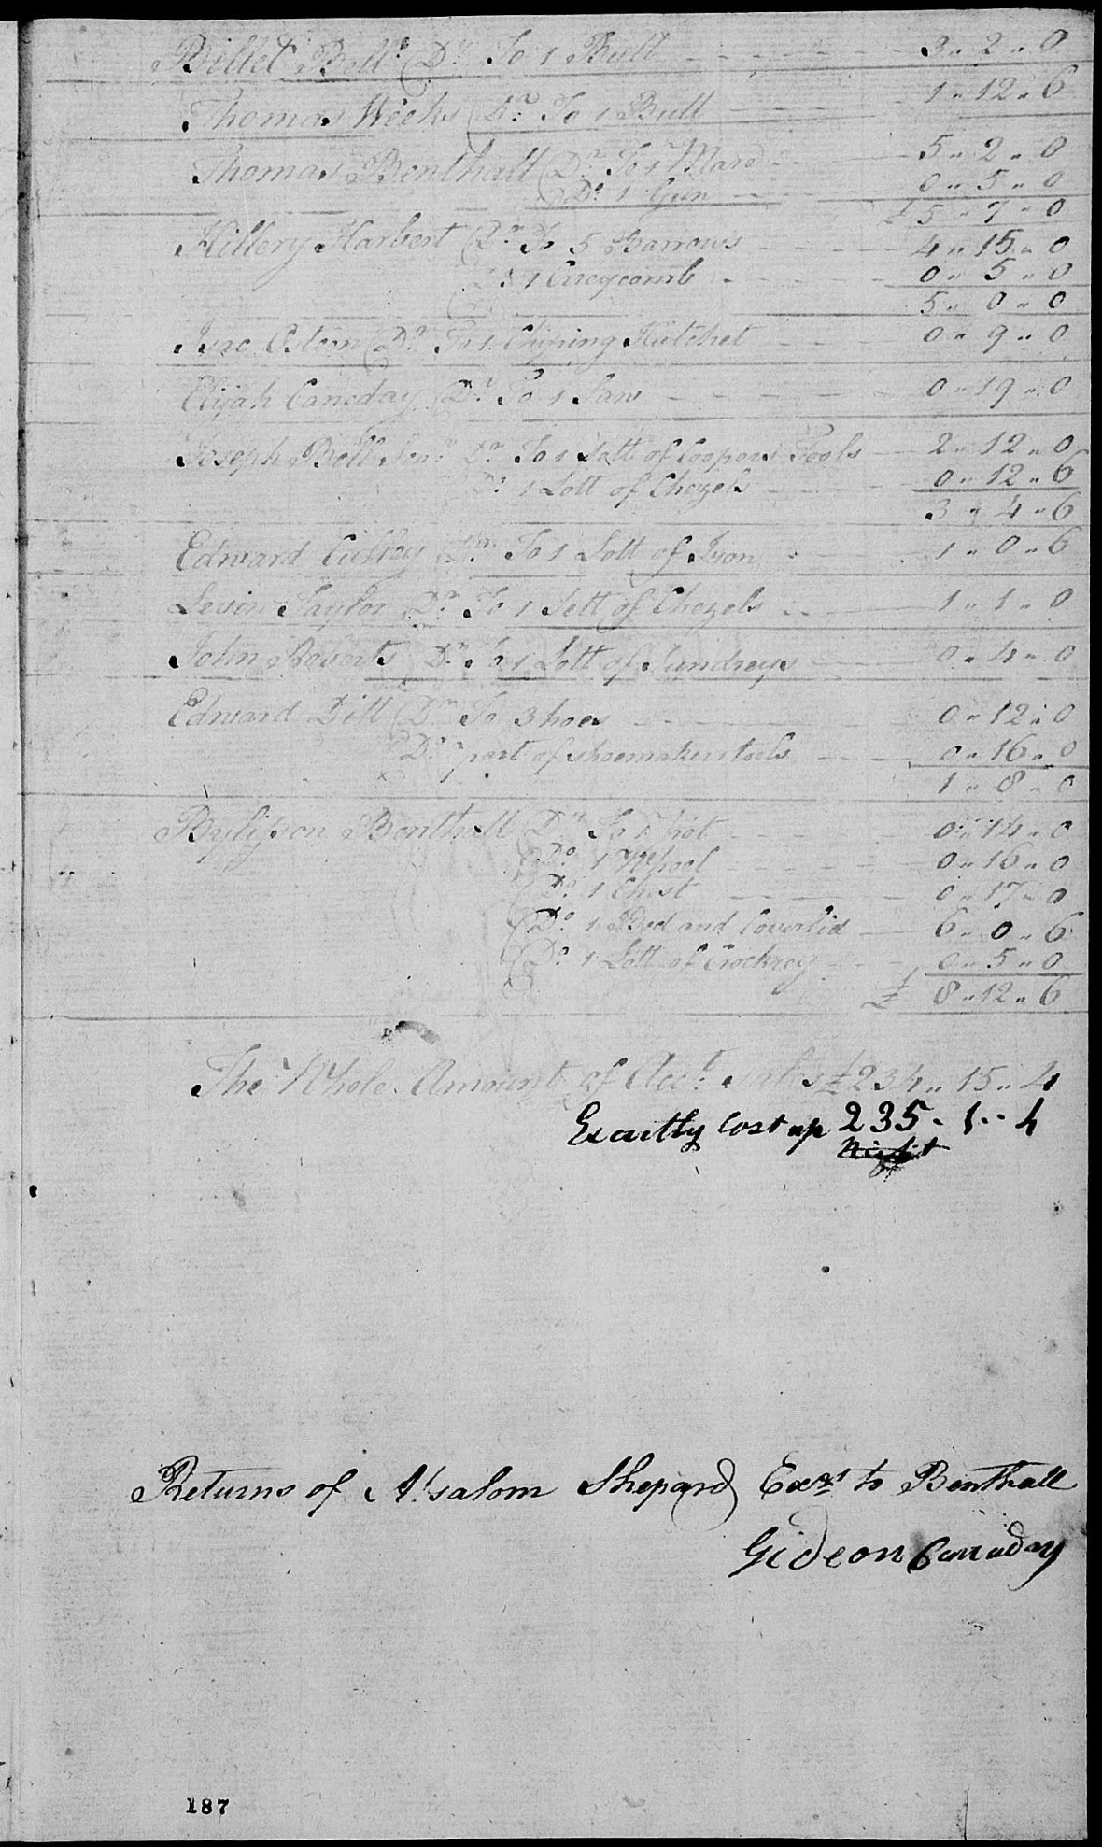
An interesting thing about these sales accounts is that the sale amount is given in the standard “Pounds – Shillings – Pence”. Maybe these are English currencies, as we discussed above that the Continental money was essentially worthless.
Another interesting thing is that it looks like these accounts were just written down, as the sales occurred right there at the time! It’s not an account written after the fact. I am basing this on the sale of hogs to William Sanders. From the inventory above, we can see that Reuben had 45 hogs at the time of his death. In the account sales, we see that William bought 11 hogs for 4 – 10 – 6, then he bought another hog for 0 – 17 – 6, then another hog for 1 – 1- 8, then the remainder of the hogs for 7 – 1 – 0. So the scribe was just writing sales down as they occurred.
As we look at the sales, we see:
- Abner {Quin?] bought 2 cows, 4 sheep, and sundry for about 4 pounds, 12 shillings.
- William Sanders (husband of Patience Benthall, Reuben’s daughter, and neighbor of Reuben) bought a LOT of stuff for a total of 123 pounds and 10 pence! My currency converter says that this is about $28,000 in today’s money.
William’s purchases also give us a clue into some of my earlier questions. It wasn’t “pottrammel”, it was “pot trammel”. A “pot trammel” is the metal hanger that you use over an open fire to hang all of the pots while you are cooking. It’s sometimes called a “trammel hook”. Here are some examples, as they range from pretty simple to really elaborate. We don’t know what type William bought from Reuben.
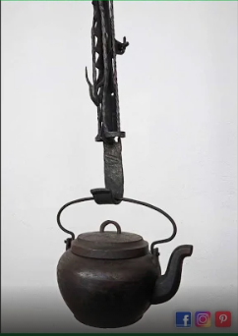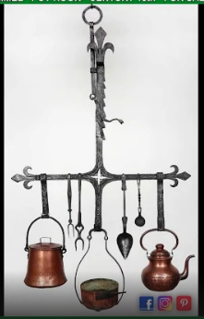
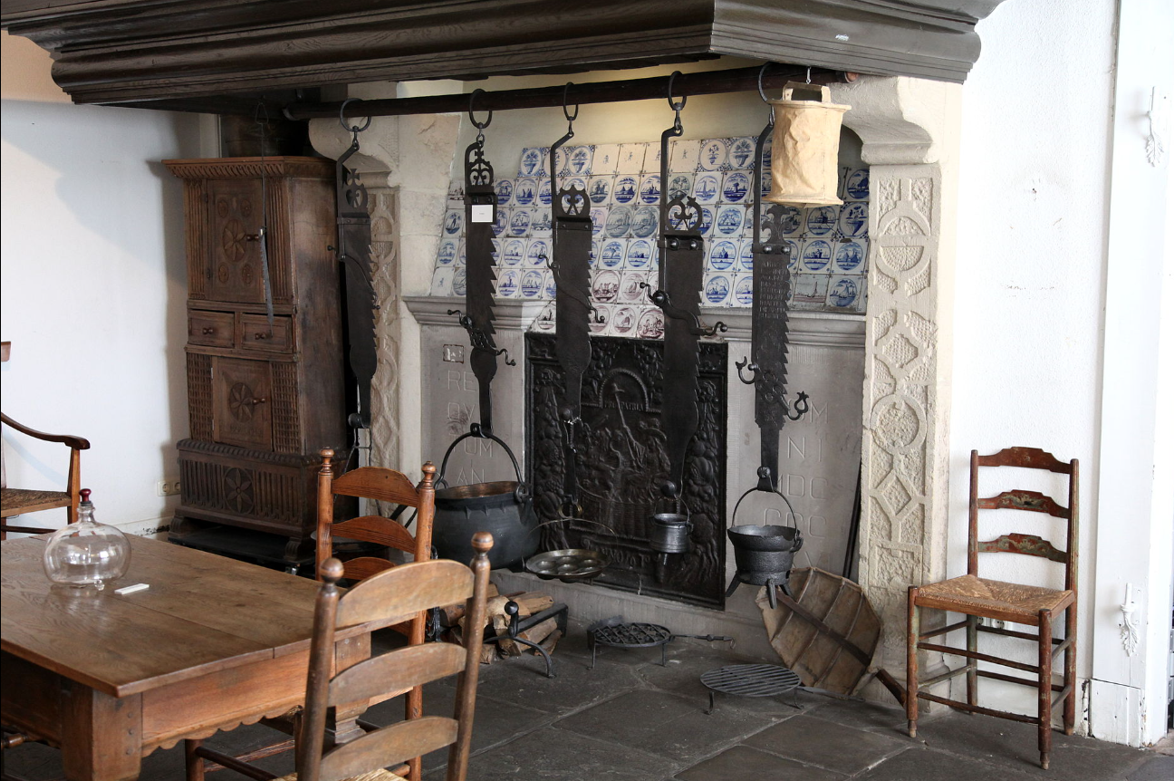

We also learned that Reuben kept bees (in the inventory, I didn’t know if it was 2 stocks of Beas or Stooks of Beas (a “stook” is a bundle of several sheaves of grain that were stood up in a field after harvest to allow them to dry. I have run across this before.) In William’s purchases, we see that he bought a hive of bees for 19 shillings.
- Joanna Benthall bought some cows, horses, heifers for 18 – 14 – 6. According to some information I found on Geni.com, Reuben and Sarah had a daughter Johanna born in 1769. So in 1784, she would be approximately 15 years old – pretty young to be able to afford these items for this amount of money. Maybe Reuben had a sister names Joanna? As an aside, Reuben’s daughter Johanna died in 1786 at approximately 17 years old, so she didn’t have long to live after this auction. I know that Geni.com isn’t a great source (I can’t find any sources to back up this information on this page for Johanna, but it’s all I have for now).
- William [Dennis?] bought a cow and some stuff for 5 – 18 – 4.
- Gideon Canaday bought livestock and a fair amount of stuff for 31 – 1 – 6.
- [Billet?] Bell bought a bull for 3 – 2 – 0.
- Thomas Weeks bought a bull for 1 – 12 – 6.
- Thomas Benthall bought a [mare?] and a gun for 5 – 7 – 0.
- Hillery [Harbest? Harbent?] bought 5 harrows and a currycomb for 5 – 0 – 0.
- Isac [Osteen? Ancestor of the current evangelist?] bought a hatchet for 9 shillings.
- Elijah Canaday bought a [Lan?] for 19 shillings.
- Joseph Bell [Sr.?] bought the coopers tools and other for 3 – 4 – 6.
- Edmund [Cutler?] bought some iron for 1 – 0 – 6.
- [Levon?] Taylor bought a lot of [Chizels? I wonder if this means Chisels?] for 1 – 1 – 0.
- John Roberts bought a lot of [no idea what this is] for 0 – 4 – 0.
- Edmond Dill bought some hoes and shoemaker tools for 1 – 8 – 0.
- [Brighton? Bashington?] Benthall bought some stuff for 8 – 12 – 6.
There are 2 summations at the bottom of the Sales Account:
“The Whole Amount of Acct. Sales £ 234 – 15 – 4”
And below that:
“Exactly Cost up 235 – 1 – 4”.
Below the summations:
“Returns of Absalom Shepard Execs. To Benthall
Gideon Canaday”
Well, either not everything sold at the October 23, 1784 auction. Because they had another one on September 8, 1786 (Source 722i).
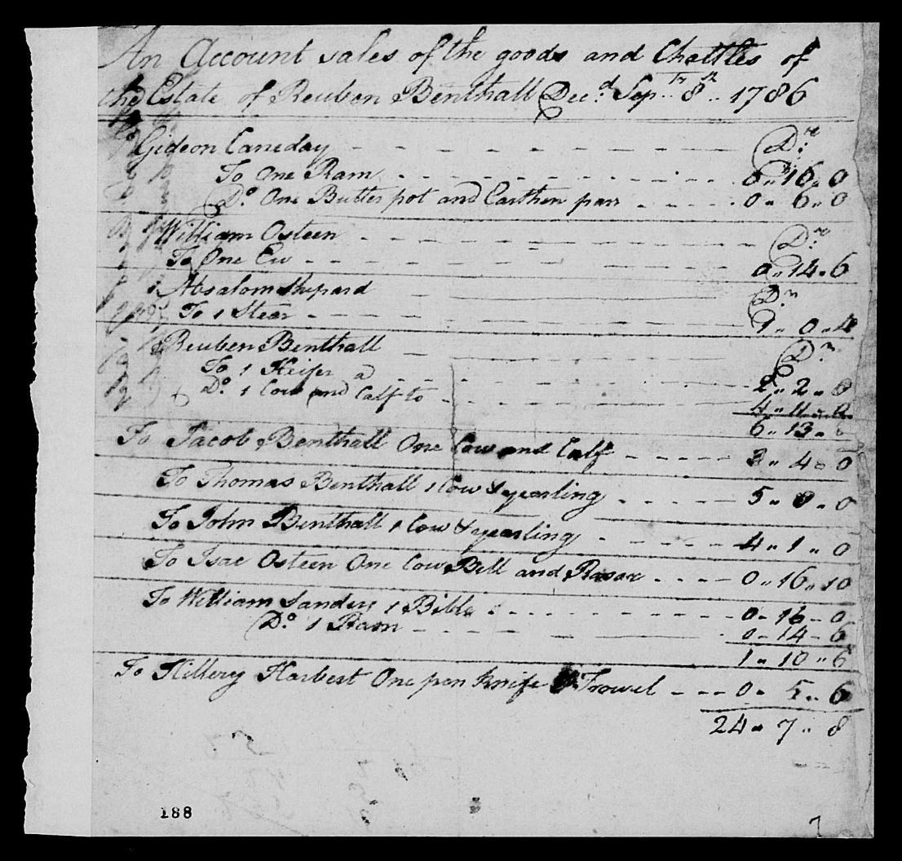
The return on this auction was much less than the first one. The title on the page is:
“An Account sales of the goods and Chattles of the Estate of Reuben Benthall Dec’^{d} SepTM 8th 1786”
The sales at this auction were:
- Gideon Canaday bought a ram for 0 – 16 – 0 and some pots for 0 – 6 – 0.
- William Osteen bought a ewe for 0 – 14 – 6.
- Absalom Shepard bought a steer for 0 – 14 – 6.
- Reuben Benthall [son?] bought a cow, her calf, and a heifer for 6 – 13 – 8.
- Jacob Benthall bought a cow and her calf for 3 – 4 – 0.
- Thomas Benthall bought a cow and her yearling for 5 – 0 – 0.
- John Benthall bought a cow and her yearling for 4 – 1 – 0.
- Isac Osteen bought a cow bell and a razor for 0 – 16 – 10.
- William Sanders bought a Bible for 0 – 16 – 0 and a ram for 0 – 14 – 6.
- Hillery Harbest bought a pen knife and trowel for 0 – 5 – 6.
The total for this sale was 24 – 7 – 8.
Source 722j is just the back of the page for the second auction. It just says “Second record of Sales of Reubenthalls Estate.”
Source 722k is mostly blank with the writing “Rec’d Currant Settlement of the Estate of Mr. Reuben Benthall Dec’d.”
Source 722l is an account of all of the expenses owed by the Estate of Reuben Benthall. This is a difficult page to read as you can see below. I can read a lot of it, but not all. The top of the page says:
“December 9th 1788. Pursuant to an Order of Court appointing We the Subscribers to Settle and Audit the Accounts between the Estate of Reuben Benthall Deceased [?] and the Executors to the said Estate. We met and Settled the the [sorry, “the” is listed twice] Same as p^{r} [per] account. Signed
Below this is a list of all of the debts owed by Reuben Benthall’s estate to various entities.
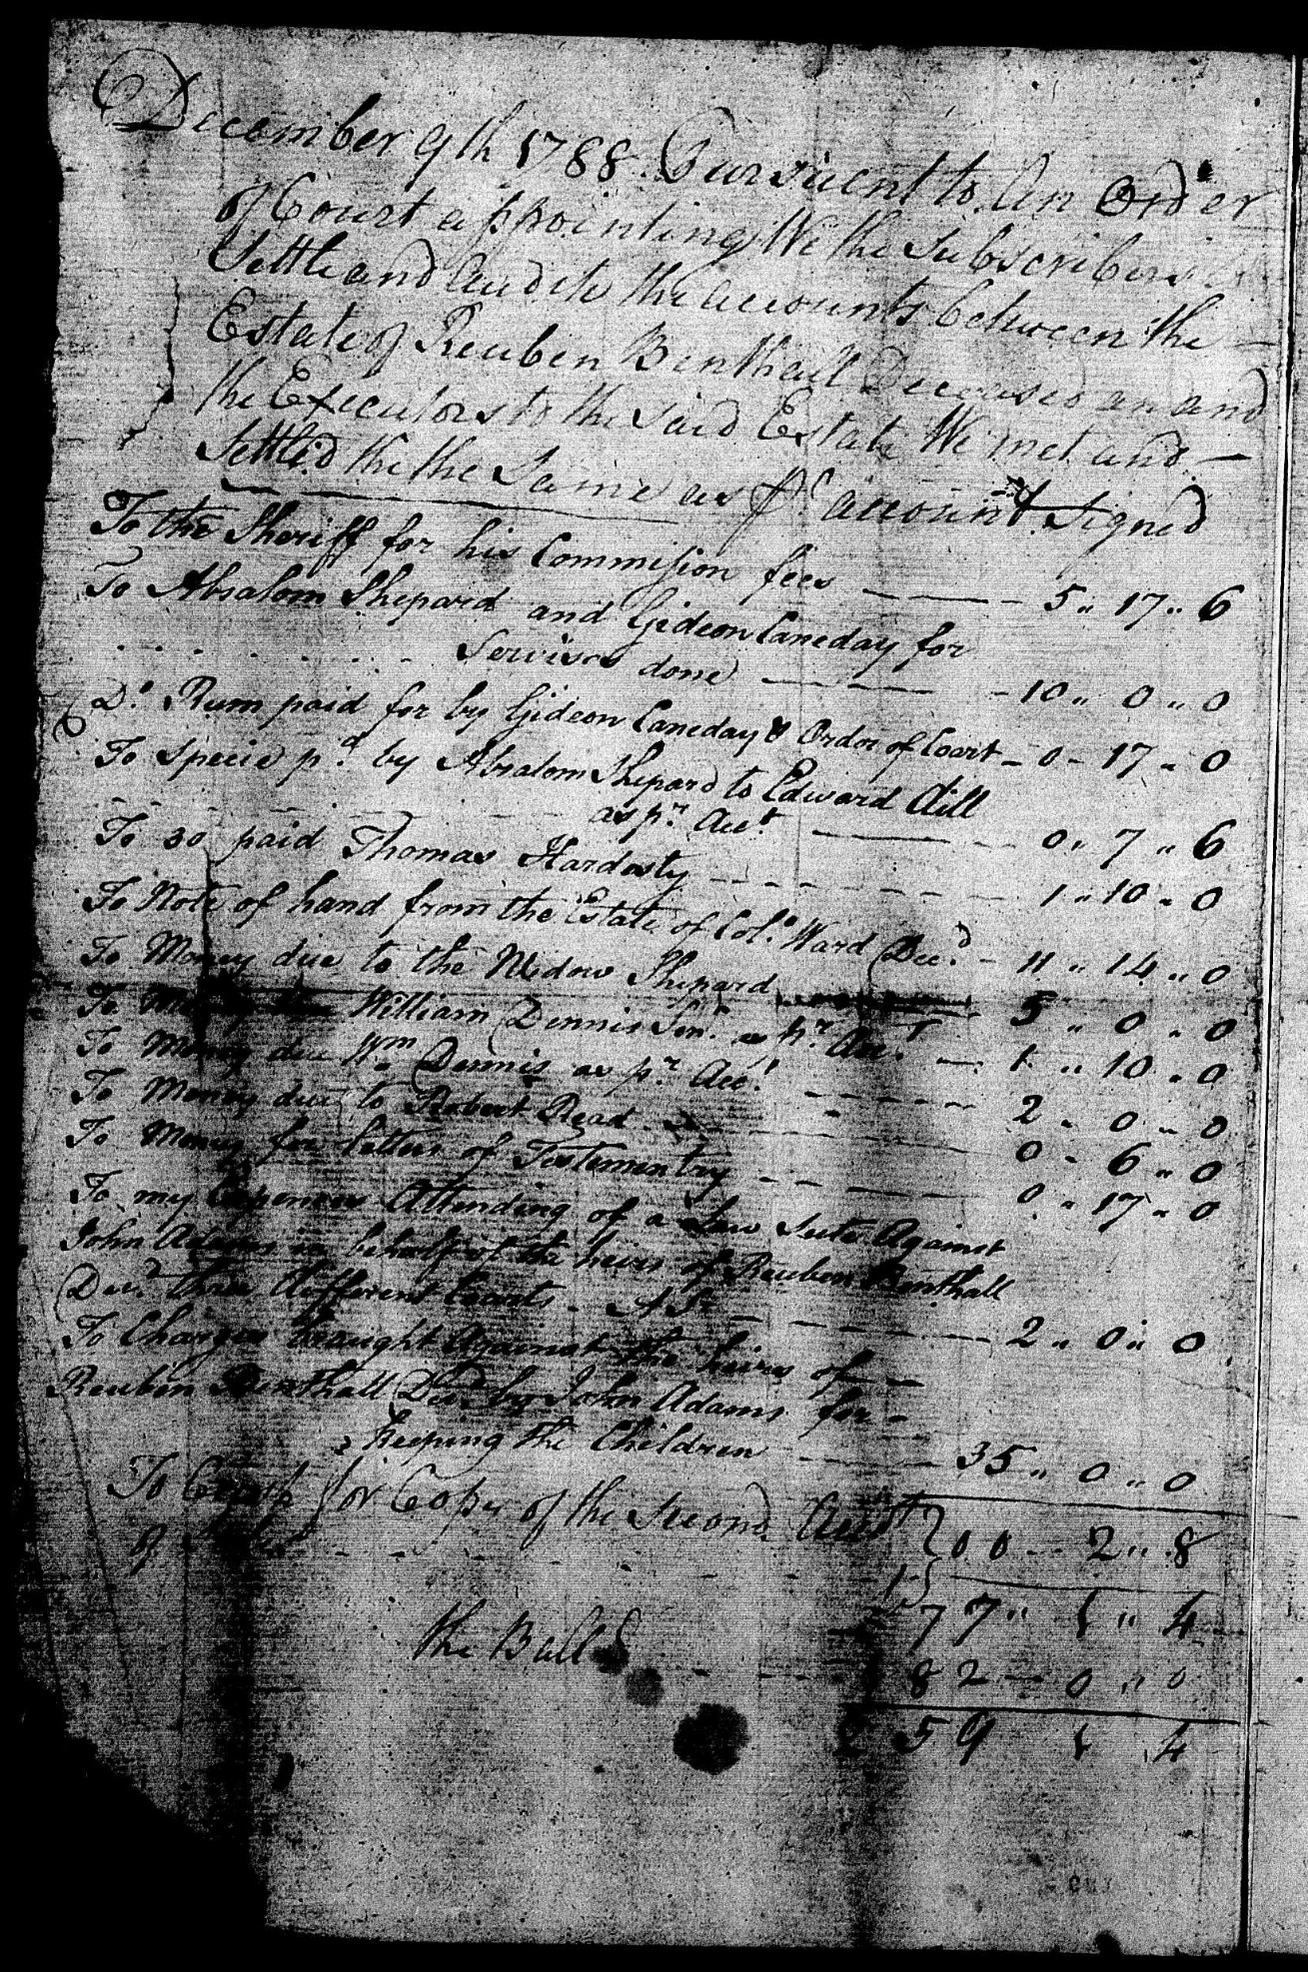
To the Sheriff for his Commision fees 5 – 17 – 6
To Absalom Shepard and Gideon Canaday for Services done 10 – 0 – 0
Rum paid for by Gideon Canaday and Order of Court 0 – 17 – 0
Specie p^{d} by Absalom Shepard to Edward Dill as p^{r} Acct 0 – 7 – 6
[30?] paid Thomas Hardesty 1 – 10 – 0
Note of hand from the Estate of Col. Ward, Dec^{d} 11 – 14 – 0
Money due to the widow Shepard 5 – 0 – 0
Money due to William Dennis Sen^{r} as p^{r} Acct. 1 – 10 – 0
Money due W^{m} Dennis as p^{r} Acct. 2 – 0 – 0
Money due to Robert Read 0 – 6 – 0
Money for letter of [Testimony?] 0 – 17 – 0
To my [???] attending of a law Suite Against John [Adams?] on behalf of the heirs of Reuben Benthall Dec^{d} [thru?] different [????] Accts 2 – 0 – 0
To Charges brought against the heirs of Reuben Benthall Dec^{d} by John Adams for keeping the Children 35 – 0 – 0
To [Court?] for copy of the second Acct. of [Sales?] 0 – 2 – 8
77 – 1 – 4
The Ball’d [balance?] 182 – 0 – 0
259 – 1 – 4

Source 722m is the final settlement of the accounts of the state (see the image below). This document says:
Contra Credit
By the Amount of the Acct. of Sales 235 – 1 – 4
By Second Acct of Sales 24 – 0 – 0
259 – 1 – 4
By the Balance Due 77 – 1 – 4
£182 – 0 – 0
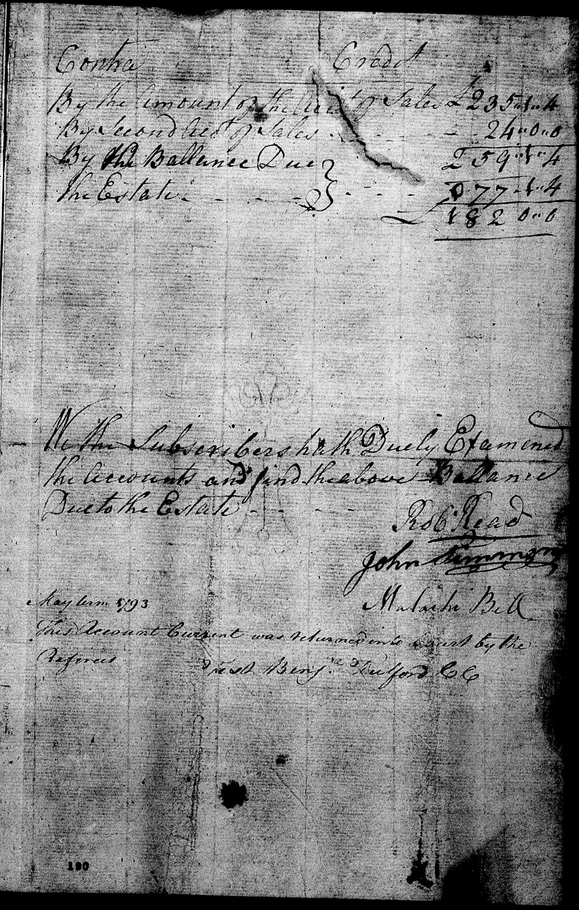
The middle of the page has the writing:
“We the Subscribers hath Duly Examined the Accounts and find the above Balance Due to the Estate.
Rob Read
John [Summers?]
Malachi Bell”

Below this writing is more writing which says:
“May term 1793

This Account Current was returned [unto?] [Court?] by the [Referees?]
[Treiz?] Benj. [? Ford CC]
[ I think this is Hertford CC – see here]

