Change History
Version | Date | Changes
FT-020.00 | 13-Jun-2021 | - Original document
FT-020.01 | 12-Mar-2024 | - Added Change History table  - Added titles “Parent of this Family” and “This Family” to this page.  - Added a Header to all pages.  - Deleted “FT-020” box on second page of the document, as it keeps moving around and is superfluous anyway with a Header.  - Added US Federal Census data for 1850, 1860, 1870, 1880, 1900, 1910, 1920, and 1930.
Notes: The newest version is in blue font, and the changes made to the document are also denoted in blue font in the document below.
Parents of this Family
FT-XXX |  |  |  |  | FT-XXX
Levi Pike |  | Paulina Lide |  |  | Benjamin Parker |  | ? Torrance
Birth Year | Death Year | 1825 | Death Year |  | Birth Year | Death Year | Birth Year | Death Year

This Family
Edward Levi Pike |  |  | Amanda Parker
Born | 1855¹, 1856²,1859³ | Married: | Born | February 1869¹  February 1868²
Where | Alabama USA | November 22, 1884 | Where | Mississippi, USA¹
Died | Unknown | Where: | Died | March 19, 1939²
Where | Unknown |  | Where | Philadelphia, Neshoba County, MS, USA²
Buried | Unknown | Source: | Buried | Henry's Chapel Cemetery  Philadelphia, Neshoba County, Mississippi, USA²
Sources | - 684a, 684b  - 682  - 683 | 121 | Sources | - 182  - FindaGrave

Children:
Name | Born | Where | Source | Died | Where | Buried | Source
Mattie Lou |  |  |  |  |  |  | FT-009-XX

Other Marrriages:
Husband – Other wife |  | Sources
When
Where
Other Children
Comments

Amanda – James R. Crapps |  | Sources: 182, 692, 693, 694
When | December 26, 1889 | 121
Where | Mississippi, USA
Other Children | None
Comments

Story:
Activity | Sources
Marriage

Levi Pike and Paulina Lide (Edward Levi’s parents) were married February 23, 1846 in Clarke County, AL:

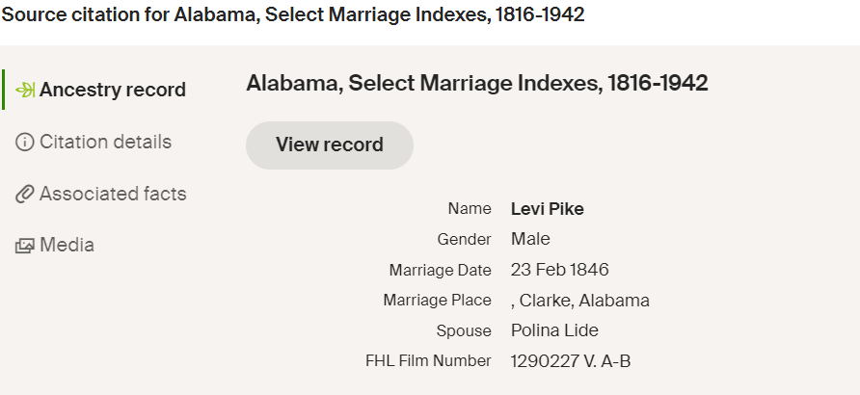

1850 US Federal Census, enumerated September 29, 1850 in Clarke County, AL USA  In 1850, the Pike family was living in Clarke County, AL. Levi was 35, was from New York State, and was a professor of something that I cannot read. It looks like this:  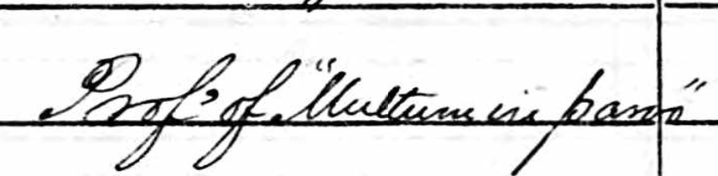  I am not sure what this is, and I don’t know of any colleges near Grove Hill, Clarke County in 1850. So I am not sure what he taught, or where he taught, or even IF he taught. Maybe that was his career in New York, and he moved to the South to be a plantation owner?  Pelina (Paulina) was 20 years old, and was born in AL (Clarke County, I believe). Their children are listed as:  - James, male, 3 years old, born in AL  - Sarah, female, 1 year old, born in AL.  As shown in the Alabama State Census in the row below, the Pikes did have a single slave in 1850. I checked with the Slave Schedules and found a single black female 65 years old. Most likely a house slave, that cooked for the family. | 686 - Federal Census_1850_Levi Pike - Paulina Lide Family  688 - Federal Census Slave Schedule_1850_Levi Pike - Paulina Lide Family
1850 Alabama State Census for Clarke County  In this state census for Alabama, we find that the Levi Pike family consisted of:  - 1 White male under 21 years of age [John Note: James]  - 1 White male over 21 years of age [John Note: Levi]  - No White males between 18 and 45 years old  - 1 White male over 45 years of age [John Note: Levi]  - 1 White female under 21 years of age [John Note: Sarah]  - 1 White female over 21 years of age [John Note: Paulina/Pelina]  - 1 Slave | 687 - Alabama State Census_Clarke County_1850_Levi Pike - Paulina Lide Family
US Federal Census, Non-Population Schedule, Alabama, 1850  I have seen this Schedule a couple of times before, but it’s rare. What we can see is that Levi Pike owned:  - $5 worth of farming machinery  - 1 horse  - 2 cows  - 3 other cattle  This adds up to $125 of livestock  - 8 bales of 400-lb, ginned cotton  - 60 lbs of wool  - 6 bushels of peas and beans  - 10 bushels of Irish potatoes  - 300 bushels of sweet potatoes  - 100 lbs of butter  - 150 lbs of beeswax and honey  - $46 of homemade manufactures  - $76 of Animal something or other  So from this, with only young kids and a 65 year old female house-slave, we have to conclude that Levi was doing a lot of this work! He was planting a fair sized garden (peas, beans, Irish Potatoes, Sweet Potatoes, cotton), milking cows, making butter, raising sheep and shearing their wool, and doing some type of homemade manufactures (or maybe that was the value of the butter, beeswax, and honey?). All of this by an Italian opera singer! (see row below)  At any rate, it’s an interesting look into the daily life of farmers in the mid-1800s. | 690a - Federal Census Non-Population Schedule_1850-1880_Levi Pike_Page 1  And  690b - Federal Census Non-Population Schedule_1850-1880_Levi Pike_Page 2
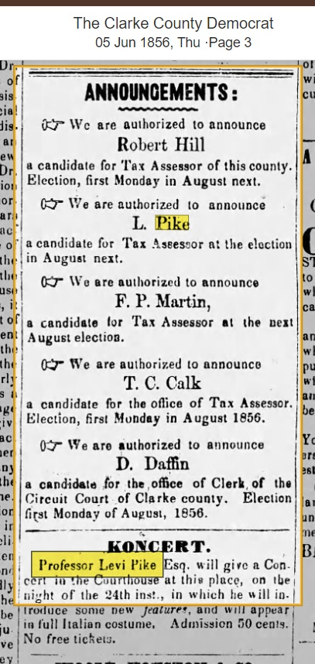  Something Cool!  Here’s something cool. It looks like our Levi Pike ran as a candidate for Tax Assessor for Clarke County. Also, he was a singer! Maybe an opera singer. It looks like he gave a concert at the Clarke County Courthouse in Grove Hill on June 24, 1856 in full Italian costume. I have no idea if he sang in Italian, but the only thing that comes to mind is Italian opera arias. | 689 - The Clarke County Democrat_05-Jun-1856_Page 3_Levi Pike
Land Grant to Levi Pike, March 1, 1859  In March of 1859, Levi Pike received two grants of land from the U. S. government – one grant about 120 acres and 1 grant about 40 acres. The two pdf documents to the right are the actual grants, while the two jpg documents are maps showing where the land grants were. Here are the 2 maps(the first is the 120 acre grant in the upper left of the orange square below.  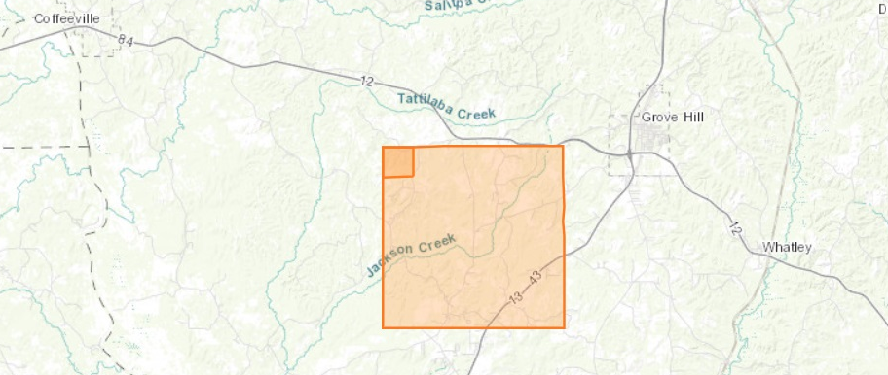  Here is the second map showing the 40 acres, which is directly south of the 160 acre grant:  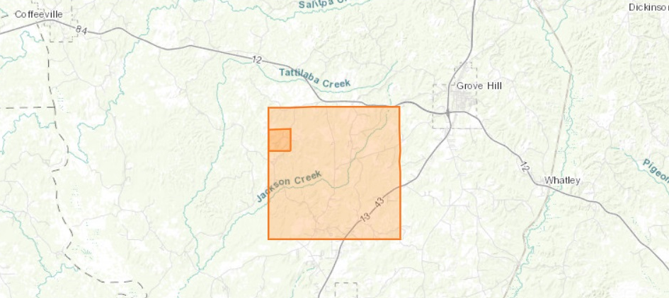  Here’s another map showing where this area is in relation to Mobile, AL, etc. You can see that Grove Hill and Coffeeville are at the top of all 3 maps. The red-dotted outline SW of Grove Hill and S of Coffeeville is St. Stephens, where the land office was that granted the lands to Levi Pike.  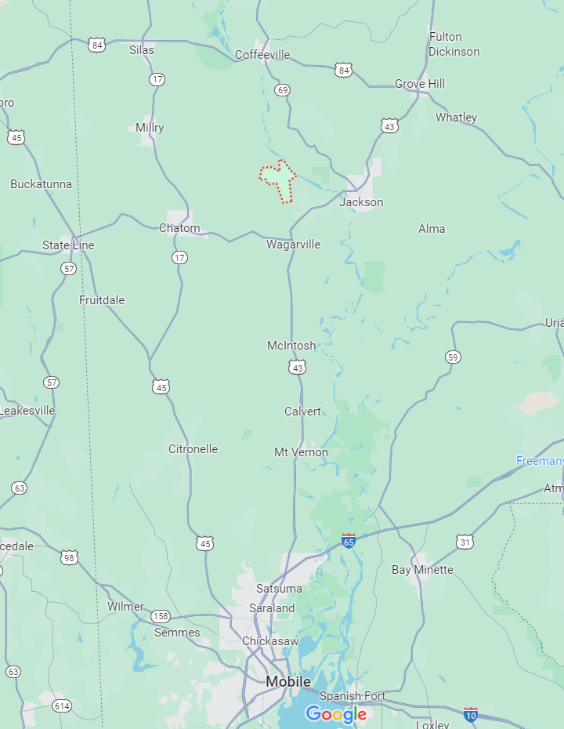 | 691b - Land Grant_Levi Pike_01-Mar-1859 (pdf of 691a).pdf  691b-map - Land Grant_Levi Pike_01-Mar-1859.jpg  691c - Land Grant_Levi Pike_01-Mar-1859.pdf  691c-map - Land Grant_Levi Pike_01-Mar-1859.jpg
1860 US Federal Census, enumerated June 1, 1860 in Grove Hill, Clarke County, AL USA  In 1860, we find a very prosperous Pike family living in Grove Hill, Clarke County, AL. Grove Hill was and is the county seat of Clarke County. Levi Pike (42) and Paulina Unknown (29) are married and have a full household. Levi is a farmer with $800 of real estate and $2500 of personal estate (slaves?). Levi was born in New York, while the rest of the family were born in Clarke County, AL. Living with Levi and Paulina are:  - James L., male, 13 years old  - Levi A., male, 10 years old  - Cinthia L., female, 7 years old  - Edwin A., male, 5 years old  - Mary M., female, 1 year old  - Cinthia Lyde, female, 16 years old, working as a domestic [John Note: Cinthia may actually be Paulina’s sister. Paulina’s last name is probably “Lide”.]  - Achilis Lyde, male, 7 years old [John Note: Cinthia’s brother?]  Levi Pike did own slaves in 1860 – 2 of them.  - Male, 26 years old, black  - Female, 60 years old, black  The two slaves lived in a single slave house. So it looks like Levi had the older black female slave back in 1850, then when he got the land grant in 1859, he immediately went and got a young black male slave to help him. | 684a - Federal Census_1860_Levi Pike - Paulina Lide Family_Page 1  And  684b - Federal Census_1860_Levi Pike - Paulina Lide Family_Page 2  685 - Federal Census Slave Schedule_1860_Levi Pike - Paulina Lide Family
1870 US Federal Census, enumerated July 28, 1870 in the Coffeeville Beat, Clarke County, AL USA  In 1870, Paulina Pike was living in Coffeeville, AL with her children. I don’t know who the father was yet [as of 05-Mar-2024]. Paulina (45 – implied birth year of 1825) keeps house and she can’t read or write. She was born in AL. Living with Paulina are:  - Luther, son, 22 years old, working as a laborer, born in AL  - Julia, daughter, 12 years old, born in AL  - Eddy (Edward Levi), son, 14 years old, born in AL  - Mavilla (?), daughter, 10 years old, born in AL  - Adella, daughter, 2 years old, born in AL  - Benjamin Rogers, 25 years old, born in AL  - Cynthia Rogers, 22 years old, born in AL  - Betty Pace Rogers, daughter of Benjamin and Cynthia, 6 years old | 682- Federal Census_1870_Paulina Pike Family
1870 US Federal Census, enumerated September 8, 1870 in Ripley, Range Three Township 6, Tippah County, MS USA  It took a while, but I finally found the same family as I did for the 1880 Federal Census for the Benjamin Parker family. In 1870, they were in 2 separate households. In 1870, I find Benjamin Parker (60), as a farmer. He has no value of real estate or personal estate listed. He says (or the census taker says) that he was born in TN. His presumed wife in Martha (55), keeping house and also born in TN. Living with them are Luc (Lue?) Duncan (18), also keeping house, born in MS. There is also a Kate Duncan (2), living with them. I don’t know if Kate is Luc’s daughter or sister. The name “Duncan” is what started me thinking this was the right family, since I had found Malinda Duncan living with Benjamin Parker in the 1880 Census. What sold me was that living next door to Benjamin Parker was another family.  That family is Melinda Duncan (30), Keeping house, born in MS. In her house are Parallu (?) (7), born in MS and John (5), also born in MS. Parallu (?) must be Sarah P. Duncan in the 1880 Federal Census.  So it looks like the Parkers are helping their daughter-in-law (Luc) and maybe her daughter Kate. Amanda Parker may not have been born at this time, so she is not listed in the Benjamin Parker household. | 696 - Federal Census_1870_Benjamin Parker - Amanda Parker Family
1880 US Federal Census, enumerated June 24, 1880 in Daleville, Lauderdale County, MS USA  In 1880, Ed Pike was 21 years old and living in Daleville, MS with his mother Paulina (50 – pretty good! She only aged 5 years in the last 10 years!). Paulina is listed as a widow. Ed is a farmer. His birth state is listed as MS, but his mother’s (Paulina) and father’s birth states are listed as “Don’t Know”. Paulina’s birth state is listed as “Don’t Know”, so at least that matches. Paulina’s parents birth states are listed as “Don’t Know” also. Living with Paulina and Ed are the following:  - Rilla, female (sister of Ed), 18 years old, working on farm, born in AL  - Pat, female (sister of Ed), 12 years old, working on farm, born in AL  “Rilla” was listed as “Marilla” in the 1870 Census, and “Pat” must have been “Adella” in the 1870 Census. | 683 - Federal Census_1880_Paulina Pike Family
1880 US Federal Census, enumerated June 22, 1880 in Union County, MS USA  Ok, this one is a little bit of a stretch, but I think it’s the right stretch. I am looking for an Amanda Parker that was born in Mississippi around 1870 +/- 3 years or so. I think her middle initial is “J” based on her FindaGrave page. When I do a search for this person on Ancestry.com in the 1880 US Federal Census, I find an Amanda J. Parker, living in Union County, MS. In the household with her are:  - Malinda Duncan, female, 39 years old, widowed, born in MS, father born in MS, mother born in MS  - Sarah P. Duncan, female, 18 years old, Malinda’s daughter, born in AL, father born in SC, mother born in SC  - John H. Duncan, male, 16 years old, Malinda’s son, born in MS, father born in MS, mother born in AL  - Benjamin Parker, male, 64 years old, Malinda’s father, widowed, born in MS, father born in MS, mother born in MS  - Lewis Parker, male, 30 years old, Malinda’s brother, born in SC, father born in SC, mother born in SC  - Amanda J. Parker, female, 10 years old, Malinda’s sister, born in MS, father born in SC, mother born in SC  - Levi A. Parker, male, 7 years old, Malinda’s brother, born in MS, father born in SC, mother born in AL  - John W. Parker, male, 3 years old, Malinda’s brother, born in MS, father born in SC, mother born in AL  I am not really sure what the census taker was thinking when he wrote down all of this data about where people were born – NOTHING MATCHES! I think this data is almost useless. However, at least we have a set of brothers and sisters that stretch from 3 years old to 39 years old. That should make it easier to move back to 1870, 1860, 1850, etc.  A couple of notes:  - Benjamin’s wife must have died within the last 3 years since John W. Parker is 3 years old. So we are looking for a wife who died around 1877 +/- 1 year.  - Malinda Duncan’s husband must have died no more than 16 to 17 years ago, since John H. Duncan is 16 years old – so sometime around 1863 to 1864. Maybe died in the Civil War? Or has died more recently, but less than 17 years ago.  At any rate, I feel pretty good that this is our Amanda J. Parker. If the 1870 census shows that the mother was named “Rosy” or something similar, this would nail it down. | 695 - Federal Census_1880_Benjamin Parker - Amanda Parker Family
1890 US Federal Census  Most of the census' population schedules were badly damaged by a fire in the Commerce Department Building in January 1921. For more information about the fire, the National Archives published an article, "First in the Path of the Firemen: The Fate of the 1890 Population Census," in its Spring 1996 Prologue.  The extant schedules are numbered and noted following rolls 1-3 below.  Roll 1  Perry County, Alabama (Perryville Beat No.11 and Severe Beat No. 8) [fragments 1-455].  Roll 2  District of Columbia. Q, 13th, 14th, R, Q, Corcoran, 15th, S, R, and Riggs Streets, Johnson Avenue, and S Street [fragments 456-781].  Roll 3  Muscogee County (Columbus), Georgia; McDonough County (Mound Twp.), Illinois; Wright County (Rockford), Minnesota; Hudson County (Jersey City), New Jersey; Westchester County, (Eastchester); and Suffolk County (Brookhaven Twp.), New York; Gaston County (South Point Twp. and River Bend Twp.) and Cleveland County (Twp. No. 2), North Carolina; Hamilton County (Cincinnati) and Clinton County (Wayne Twp.), Ohio; Union County (Jefferson Twp.), South Dakota; Ellis County (J.P. No. 6, Mountain Peak, and Ovilla Precinct), Hood County (Precinct No. 5), Rusk County (No. 6 and J.P. No. 7), Trinity County (Trinity Town and Precinct No. 2) and Kaufman County (Kaufman) [fragments 782-1,233], Texas. | U. S. Census Information
1900 US Federal Census, enumerated June 31, 1900 in Beat 5, Madison County, MS USA  Yay for A. B. Moore! June has 31 days again. Keep fighting the good fight, A. B.!  At any rate, assuming this is really July 1, 1900, Amanda Torrance Pike Crapps (31) was living in Madison County, AL with her new husband James R. Crapps (31). James and Amanda have been married for 10 years. James was born in June 1868 and Amanda in February 1869. Amanda has had one child (Mattie Lou Pike) and she is still alive. Mattie is also living with them and she is 14 at this time, having been born in August 1885. For Mattie and Amanda, they themselves and their parents were all born in MS. James Crapps was born in MS, but his father was born in South Carolina and his mother was born in Georgia. James and Amanda cannot read or write, but Mattie can read and write English. James is a farmer, but he is renting his farm. Other Crapps families live on both sides of James and Amanda.  So this means that Edward / Edwin Pike has been gone for at least 10 years, or earlier than 1890. As listed above, the vast majority of the 1890 Census was lost in a fire, so basically we see an unmarried, 21-year old Edward Pike in the 1880 Census (Source 683), and he has met and married Amanda Torrance, fathered Mattie Lou, and vacated the premises by either death or divorce or absconding by the 1990 Census (Source 182). In the same time, Amanda has met and married Edward, birthed Mattie Lou, was either divorced or widowed by Edward and married James R. Crapps. | 182 - Federal Census_1900_James R Crapps - Amanda Torrance Family
1910 US Federal Census, enumerated April 23, 1910 in Beat B, Range 5, Madison County, MS USA  In 1910, James Crapps (43) and Amanda (44) have been married for 20 years. I think the notation of “M1” for James and “M2” for Amanda means this is James’ first marriage and Amanda’s second marriage. In this Census, Amanda lists herself as born in MS, her father in the “United States” and her mother in MS. James lists himself as born in MS, his father in AL, and his mother in MS. Both are listed as working on their farm, which is rented. Both are now said to be able to read and write – a change from the 1900 Census.  Mattie Lou Pike (23) has now moved out, married (John Wilson, 26, married for 9 years now), is living next door, and has 4 kids:  - Jim (my grandfather), 7 years old  - Ben, 4 years old  - Robert, 3 years old  - John, 2 years old  I wonder if Mattie really was 23, as that would mean she married at 14, started having kids at 16. And her birth year was 1887. In the 1900 Census she said she was born in August 1885, so she should be 25 or so years old at this time. That would make more sense. | 692 - Federal Census_1910_James Crapps - Amanda Torrance Pike Crapps Family
1920 US Federal Census, enumerated January 5, 1920 in Beat 1, Philadelphia, Neshoba County, MS, USA  By 1920, Jim (49) and Amanda (49) had moved to Philadelphia, MS. Amanda and her parents are listed as born in MS. Jim’s had changed again: Jim in MS, his father in NC, and his mother in GA. Jim is now a laborer at a sawmill, while Amanda doesn’t work at all. They are renting their home. | 693 - Federal Census_1920_James Crapps - Amanda Torrance Pike Crapps Family
1930 US Federal Census, enumerated April 14, 1930 in Beat 1, Philadelphia, Neshoba County, MS USA  In 1930 Jim (63) and Amanda (63) are still in Philadelphia, MS, living on McKay Street in a house that they own. The house is worth $100 at this time. A new Census question is the age at which people married: Jim married Amanda when he was 22, and Amanda married when she was 15. Now Amanda says she was born in MS, her father in the United States, and her mother in MS. For Jim, he was born in MS, but BOTH of his parents were born in GA. I don’t know what to believe about Jim’s parents! I am just glad he in not a direct ancestor, so I don’t have to track his parents down. Neither are working at this time. | 694 - Federal Census_1930_James Crapps - Amanda Torrance Pike Crapps Family
Amanda’s Death  Amanda died March 19, 1939 in Philadelphia, MS | FindaGrave
Jim’s Death  Jim died April 12, 1946 in Philadelphia, MS | FindaGrave

