FT-024

FT-044 |  |  |  |  | FT-043
William Jeffreys |  | Melinda Borden |  |  | Irvin Askew |  | Sara Askew (Escue)
1796 | 1879 | 1800-1801 | 1893 |  | 1804 | Bef. 1870 | 1806 | Bef. 1880

Jacob Jeffreys |  |  | Martha Caroline Askew
Born | July 28, 1832 | Married: | Born | May 12, 1839
Where | Alabama | 1865 | Where | Marion County, AL USA
Died | October 30, 1902 | Where: | Died | March 14, 1902
Where | Marion County, AL USA (assumed) |  | Where | Marion County, AL USA (assumed)
Buried | Cooper Cemetery, Marion County, AL USA | Source: | Buried | Cooper Cemetery, Marion County, AL USA
Sources | FindaGrave |  |  | FindaGrave

Children:
Name | Born | Where | Source | Died | Where | Buried | Source
Marilda Caroline |  |  |  |  |  |  | FT-014
James Riley | April 8, 1866 | Marion County, AL USA (assumed) | FindaGrave | June 12, 1917 | Marion County, AL USA (assumed) | Cooper Cemetery, Marion County, AL USA | FindaGrave
Samantha Jane | October 28, 1870 | Marion County, AL USA (assumed) | FindaGrave | April 11, 1948 | Marion County, AL USA (assumed) | Cooper Cemetery, Marion County, AL USA | FindaGrave
Sarah Elizabeth | July 6, 1874 | Marion County, AL USA (assumed) | FindaGrave | July 10, 1948 | Marion County, AL USA (assumed) | Cooper Cemetery, Marion County, AL USA | FindaGrave

Other Marrriages: None

FT-024

Story:
Activity | Sources
Pictures (people, gravestones, houses, etc.)
Marriage Certificates
Land Deeds
Slave Schedule Information
War Service Records
Social Security Applications
Newspaper Articles
Where lived?
1840 US Federal Census, unknown enumeration date, enumerated in Walker County, AL USA  In 1840, the William Jeffreys – Melinda Borden family consisted of:  - 1 male and 1 female under 5 years (Unknown and Melinda)  - 1 male and 1 female from 5 to 10 years (Jacob and Sara Ann)  - 1 male and 2 females from 10 to 15 years (Thomas Issac, Elizabeth, and Mary “Mollie”)  - 1 male from 15 to 20 years (James Martin)  - 1 female from 20 to 30 years  - 1 female from 30 to 40 years (Melinda)  - 1 male from 40 to 50 years (William)  There were no slaves and 2 people were employed in agriculture. | 426a, 426b
1840 US Federal Census for Eskew/Escue/Askew family

Ancestry Searches:
- Escue, lived in GA:
  - No Irvin Escues or any other “I” Escues
  - (1) Sarah Escue, 30 to 39 years old (matches)
    - 1 White male under 5 years old
    - 1 White male and 1 White female 5 to 9 years old
    - 1 White female 10 to 14 years old
Not a great match, as Martha Caroline should be about 1 year old at this time. No mention of Irvin in this or any husband.
  - No other reasonable matches on Ancestry.com

Internet Searches:
- “Irvin Escue” AND 1840: Nothing
- “Irvin Escew” AND 1840: Nothing
- “Irvin Eskew” AND 1840: Nothing
- “Irvin Askew” AND 1840: Nothing
- “Irvin Askew” and “Sarah Askew”: Nothing
- “Irvin Eskew” and “Sarah Eskew”: Nothing
- “Irvin Eskue” and “Sarah Eskue”: Nothing
- “Irvin Escue” and “Sarah Escue”: Nothing
- “Irvin Esque” and “Sarah Esque”: Nothing

No idea where the Escues were in 1840.

1850 US Federal Census, enumerated November 26, 1850 in District 14, Marion County, AL USA  In 1850, Jacob Jeffreys was living with his parents, William Jeffreys (54), a farmer worth $200 born in NC and Melinda Jeffreys (50), his wife born in TN. Living with William and Melinda are:  - Mary, 22 years old, born in AL  - Elizabeth, 21 years old, born in AL  - William, 20 years old, born in AL, a farmer  - Jacob, 18 years old, born in AL  - Sarah A., 16 years old, born in AL  - Melinda, 13 years old, born in AL  - Thomas, 9 years old, born in AL  - Nancy, 7 years old, born in AL  - Francis, 5 years old, born in AL | 423
1850 US Federal Census for Eskew/Escue/Askew family

I cannot find the Irvin Eskew/Escue/Askew family in the 1850 Census. Irvin should be about 46 years old, Sophia/Sarah should be about 44 years old, and there should be a 16 year old son named Jacob Riley Eskew and an 11 year old daughter named Martha Caroline Eskew.

Ancestry searches made:
- 1850 US Federal Census
  - Irvin Askew – 0 results
  - Irvin Eskew – 0 results
  - Irvin Escue – 0 results
  - Sopha Eskue – 8 results, none correct
  - Sophia Eskue – 8 results, none correct
  - Sophia Eskew – 6 results, none correct
  - Sophia Askew – 14 results, none correct
  - Sarah Askew – 54 results, none correct
  - Sarah Eskew – 33 results, none correct
  - Sarah Eskue – 35 results, none correct
  - Sarah Escue – 35 results, none correct
  - Riley Askew – 3 results, none correct
  - Riley Eskew – 0 results
  - Riley Escue – 3 results, none correct
  - R Escue – 3 results, none correct
  - Caroline Eskew – 2 results, none correct
  - Caroline Askew – 4 results, none correct
  - Caroline Escue – 9 results, none correct
  - Martha Askew – 65 results, none correct
  - Martha Eskew – 26 results, none correct
  - Martha Escue – 27 results, none correct

Google Searches:
- "Irvin Escue" 1850 – no results
- "Irvin Escew" 1850 – no results
- "Irvin Eskew" 1850 – 1 result:
  - https://www.findagrave.com/memorial/53668321/martha-caroline-jeffreys - No solid link to Irvin. Just a note that says:

“According to yhe 1850 Census of Marion County alabama, Marcha is the daughter of Irvin Eskew and wif Sophia, both born in South Carolina. My Grandmother Rosa Lewis Sanderson (Granddaughter of Martha Caroline always spelled the name Askew), Joyce Riggan”

No link to a grave for Irvin Eskew. I spent hours downloading the 1850 Marion County AL Census (Source 421), and I don’t see any Eskews at all!

In short, I have no idea where the Eskews/Escues/Askews were in 1850.

1860 US Federal Census, enumerated June 9, 1860 near Pikeville, Marion County, AL, USA  In June 1860, Jacob Jeffreys was living with his parents near Pikeville, AL. William Jeffers (different spelling) is a 64 year old farmer with a personal estate of $500. William was born in NC. His wife is Melinda, who is 59 years old and was born in Kentucky. Neither William nor Melinder can read or write. Children and others living with them are:  - Mary A., 26 years old, born in AL  - Jacob, 24 years old, born in AL  - Sarah A., 22 years old, born in AL  - Nancy, 16 years old, born in AL, attending school  - Francis (listed as a male), 14 years old, born in AL, attending school  - Melinda, 14 years old, born in AL, attending school  - James, 16 years old, born in AL, attending school  - Mary E., 8 years old, born in AL, attending school  - Melinder Johnson, 30 years old, born in AL, domestic – Melinder cannot read or write.  - Melvina Johnson, 6 years old, born in AL, attending school  - Josiah Johnson, 4 years old, born in AL | 422
1860 US Federal Census, enumerated June 7, 1860 in Pikeville, Marion County, AL, USA  In June 1860, the Askew/Eskew family were living near Pikeville, AL. Irvin Eskew is a 56 year old farmer with $350 of real estate and a $500 personal estate. I will have to check, but that’s probably not enough to own any slaves. Irvin’s wife is Sopha (Sophia? Sarah?), who is 54 years old. Both Irvin and Sopha were born in South Carolina. They have one daughter living with them – Martha who is 21 years old, and was born in Georgia. Martha has attended school.  Riley (Irvin’s son) is living next door to Irvin in 1860. He is 24 years old, a farmer, born in GA, owns $300 of real estate and has a personal estate of $275. He is married to Mary, 23 years old, also born in GA. They have a daughter named Nancy C. J. | 419
1860 Slave Schedule

I checked the 1860 Slave Schedules for Marion County, AL and I see no evidence that the Eskews owned any slaves in 1860.

In the Civil War, Jacob was a private in Company K of the 42nd Regiment of Alabama Infantry. He enlisted in 1861 in Barnesville, AL where he was living at the time. Barnesville is basically a wide spot on Hwy 19 just to the west of Hamilton, AL. From the National Park Service’s Civil War pages we see:

OVERVIEW:
42nd Infantry Regiment was assembled during May, 1862, at Columbus, Mississippi. It was principally a reorganization of other regiments whos twelve month term of service was complete. Some of the men had served in the 2nd Alabama Regiment. Its members were from the counties of Monroe, Pickens, Wilcox, Mobile, Conecuh, Fayette, Talladega, and Marion. The unit was on provost duty at Tupelo until October when it was assigned to J.C. Moore's command. It fought at Corinth and later became part of the forces defending Vicksburg. On July 4, 1863, the regiment was captured. Exchanged and reorganized, it was attached to A.Baker's, Gibson's, Brantley's Brigade, fought at Chattanooga and Atlanta, moved to Mobile, then rejoined the Army of Tennessee in North Carolina. The unit lost fifty percent of the 700 engaged at Corinth, reported 46 casualtes at Chattanooga, and totalled 311 men and 247 arms in December, 1863. At Resaca it had about 300 effectives, but its number was greatly reduced at the surrender. Colonels John W. Portis and T.C. Lanier, and Major W.C. Fergus.
On this same page, if you click on the link for the Company’s soldiers and scroll (way, way way) down, you will see:

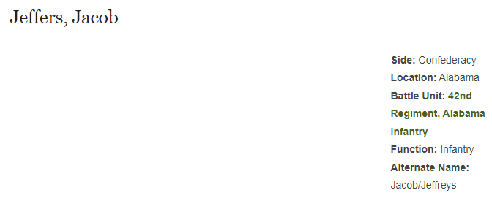

There is also another entry for “Jacob Jeffreys” as that is mentioned as an alternate name above:

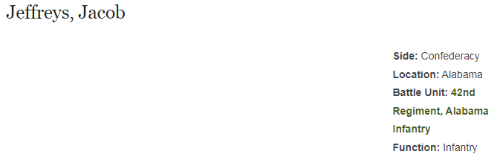

There are entries for a “Thomas Jeffreys” also:

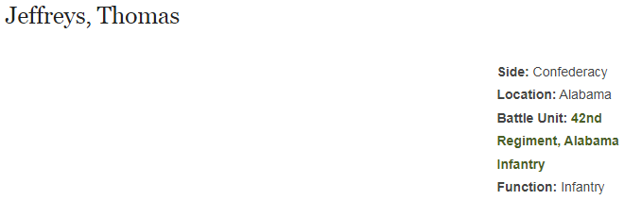

and

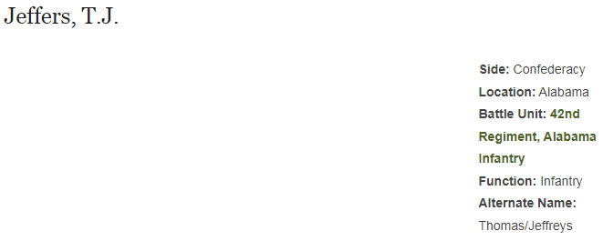

John Note: I think this should be Thomas Issac (see FindaGrave). Thomas was also in Company K of the 42 Regiment of the Alabama Infantry, Confederate side.

1870 US Federal Census, enumerated June 30, 1870 in the Western District of Marion County, AL, USA (nearest Post Office Pikeville)  In 1870, Jacob Jeffreys (34) and Caroline Askew (30) are living near Pikeville, AL. Jacob was a farmer, with a real estate worth of $100 and a personal estate worth $100. Jacob and Caroline were both born in AL and both are marked as unable to read or write.  Others living with Jacob and Caroline are:  - Rilda (Marilda), daughter, (5), born in AL  - Jane, daughter, (4), born in AL  - Sarah Escue (Askew), mother-in-law, (70), born in SC, marked as cannot read or write. Sarah is marked as owning $100 of real estate. | 208
1880 US Federal Census, enumerated June 26, 1880 in Township 11, Range 14 in Marion County, AL, USA  In 1880, Jacob (47) and Martha Caroline Askew (40) are living in Marion County, AL. Jacob was farming and Martha keeping house. Jacob was born in AL, but his parents were born in NC. Martha was born in GA, her father in TN, and her mother in SC.  Others living with Jacob and Martha were:  - Marilda, daughter (15), born in AL, assisting her mother  - James R., son (14), born in AL, working as farm laborer  - Samantha Jane, daughter (10), born in AL, assisting her mother  - Sarah E., daughter (5), born in AL  - Frederic Jackson, friend (23), farm laborer for part of the crop | 209
1890 US Federal Census  Most of the census' population schedules were badly damaged by a fire in the Commerce Department Building in January 1921. For more information about the fire, the National Archives published an article, "First in the Path of the Firemen: The Fate of the 1890 Population Census," in its Spring 1996 Prologue.  The extant schedules are numbered and noted following rolls 1-3 below.  Roll 1  Perry County, Alabama (Perryville Beat No.11 and Severe Beat No. 8) [fragments 1-455].  Roll 2  District of Columbia. Q, 13th, 14th, R, Q, Corcoran, 15th, S, R, and Riggs Streets, Johnson Avenue, and S Street [fragments 456-781].  Roll 3  Muscogee County (Columbus), Georgia; McDonough County (Mound Twp.), Illinois; Wright County (Rockford), Minnesota; Hudson County (Jersey City), New Jersey; Westchester County, (Eastchester); and Suffolk County (Brookhaven Twp.), New York; Gaston County (South Point Twp. and River Bend Twp.) and Cleveland County (Twp. No. 2), North Carolina; Hamilton County (Cincinnati) and Clinton County (Wayne Twp.), Ohio; Union County (Jefferson Twp.), South Dakota; Ellis County (J.P. No. 6, Mountain Peak, and Ovilla Precinct), Hood County (Precinct No. 5), Rusk County (No. 6 and J.P. No. 7), Trinity County (Trinity Town and Precinct No. 2) and Kaufman County (Kaufman) [fragments 782-1,233], Texas. | U. S. Census Information
In the 1890s, Jacob filed several applications for a pension due to his service in the Civil War.
1900 US Federal Census, enumerated June 7, 1900 in Precinct Two Ryes, Marion County AL, USA  In June 1900, we find the Jeffreys family living in Marion County, AL. Jacob (Jack in the Census) is 67 years old and is listed as born in July 1832. Martha Caroline Askew is 61 years old and is listed as born in May 1839. They have been married for 35 years, placing their marriage in 1865. Jacob was born in AL, his father in TN, and his mother in VA. Martha was born in AL, her father in AL and her mother in GA.  Martha and Jacob have had 4 children and all are still alive in 1900. Jacob can read, write, and speak English. Martha can read and speak English but not write. Jacob is a farmer.  The only child still living with them is Sarah E., who was born in July 1875 in AL, making her 24, almost 25 at the time of the Census. Sarah lists her father as born in AL, and her mother as born in AL. Originally, her mother was listed as born in GA, but there is a strikeout through GA and AL is written in above “Georgia”. Sarah can read, write and speak English. Sarah works as a laborer on the farm. | 418
Both Jacob and Martha died in 1902.

