FT-027

FT-030 |  |  |  |  | FT-XXX
John Read Long |  | Sara Miles |  |  | Father’s Name |  | Mother’s Name
1754 | 1819 | 1756 | 1819 |  | Birth Year | Death Year | Birth Year | Death Year

Reuben Long, Sr. |  |  | Susanna Mitchell
Born | 1794 | Married: | Born | 1796
Where |  |  | Where
Died | 1832 | Where: | Died
Where |  |  | Where
Buried |  | Source: | Buried
Source

Children:
Name | Born | Where | Source | Died | Where | Buried | Source

Other Marrriages:
Sources
Husband – Other wife
When
Where
Other Children
Comments

Sources
Wife – Other husband
When
Where
Other Children
Comments

FT-027

Story:
Activity | Sources
Pictures (people, gravestones, houses, etc.)
Marriage Certificates
Land Deeds
Slave Schedule Information
War Service Records
Social Security Applications
Newspaper Articles
Where lived?
1800 US Federal Census for John Read Long – Sara Miles family

In 1800, assistant marshals recorded the name of the county, parish, township, town, or city in which each family resided. Each family was listed by the name of the head of the household, and was asked the following questions:
- The number of free White males and females aged, respectively:
  - under 10 years of age
  - of 10 years but under 16 years
  - of 16 years but under 26 years
  - of 26 years but under 45 years
  - 45 years and upward
- Number of all other free persons
- Number of slaves

1800 US Federal Census for Susanna Mitchell family

In 1800, assistant marshals recorded the name of the county, parish, township, town, or city in which each family resided. Each family was listed by the name of the head of the household, and was asked the following questions:
- The number of free White males and females aged, respectively:
  - under 10 years of age
  - of 10 years but under 16 years
  - of 16 years but under 26 years
  - of 26 years but under 45 years
  - 45 years and upward
- Number of all other free persons
- Number of slaves

1810 US Federal Census, enumerated for Abbeville, Abbeville District, South Carolina, USA  The John Read Long – Sara Miles family was living in Abbeville, SC at the time of the 1810 Federal Census. The household consisted of:  - 1 White female under 10 years old  - 1 White male and 1 White female from 16 to 25 years old  - 1 White male and 1 White female 45 years or older.  - 8 slaves  Reuben would have been about 16 at this time, so that fits. John Read Long would have been about 56, so that fits. Sara would have been about 54 so that fits. | 297
1810 US Federal Census for Susanna Mitchell

In 1810, the slate of questions asked by assistant U.S. marshals was identical to the 1800 census. This census recorded the name of the county, parish, township, town, or city in which each family resided. Each family was listed by the name of the head of household and asked the following questions:
- Number of free White males and females aged, respectively:
  - under 10 years of age
  - of 10 years but under 16 years
  - of 16 years but under 26 years
  - of 26 years but under 45 years
  - 45 years and upward
- Number of all other free persons
- Number of slaves
First Economic Inquiries
In addition to population inquiries, the 1810 census was the first to collect data about the nation's manufactures. A May 1, 1810, act directed that, "it shall be the duty of the several marshals, secretaries, and their assistants aforesaid, to take, under the direction of the Secretary of the Treasury, and according to such instructions as he shall give, an account of the several manufacturing establishments and manufactures within their several districts, territories, and divisions." The act did not outline specific questions or prescribe a schedule, leaving those matters to the Secretary of the Treasury’s discretion.
To facilitate data collection, the Treasury Department divided manufactured products into 25 broad categories, encompassing more than 220 kinds of goods. As the U.S. marshals and their assistants conducted the decennial census, they also visited the manufacturing establishments in their assigned areas to obtain economic data. These data generally consisted of the quantity and value of products manufactured.
In March 1812, Congress authorized $2,000 for the Treasury Department to prepare a statistical report on the kind, quantity, and value of goods manufactured and the number of manufacturing establishments in each state, territory, district, and county. The May 1813 report noted that the economic data were of poor quality because of serious undercounting and omissions during the enumeration.

1820 US Federal Census, enumerated for the Abbeville District, Abbeville, South Carolina  The Reuben Long family is listed as  - 1 White female under 10 years old  - 1 White male 10 to 16 years old  - 1 White female 10 to 16 years old  - 1 White male 26 to 45 years old  - 2 female Slaves under 14 years old  - 1 female Slave 14 to 26 years old  No one was involved in agriculture, commerce or manufacturing.  I am not sure this is the Reuben Long, Sr. – Susanna Mitchell family I am searching for as they should have only married in 1819. There shouldn’t be all of these children. | 294
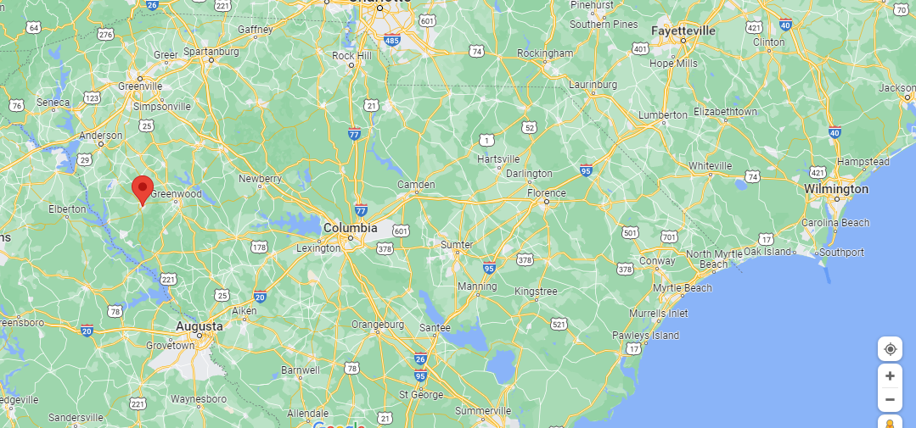 | Abbeville, South Carolina, US
1830 US Federal Census, enumerated for Greene County, AL USA, but no date listed.  The Reuben Long family is listed as:  - 1 White male under 5 years old  - 1 White male 5 to 9 years old  - 1 White male 30 to 39 years old  - 2 White females under 5 years old  - 1 White female 5 to 9 years old  - 1 White female 20 to 29 years old  - 1 Slave Male, under 10 years old  - 1 Slave Male, 10 to 23 years old  - 2 Slaves, Female, under 10 years old  - 1 Slave, Female, 10 to 23 years old  Reuben Long, Sr. is estimated to have been born in about 1794, so he would have been 36 in 1830. That fits the data in this Census. Susanna Mitchell is estimated to have been born in 1796, so she would have been 34 in 1830. This does not fit the data in this Census. Matilda was 3 years old at the time of the Census, so it does fit for her. It may be that this is not the correct Census document that I have stored in my Ancestry.com account for this family.  The data in the 1830 Census (Source 292) does match that in the 1820 Census (Source 294) for the oldest white male and female. | 292 (Page 1), 293 (Page 2)
1840 US Federal Census for Susanna Mitchell

Each head of family was asked:
- The number of free White males and females, respectively:
  - under 5 years
  - 5 to 10 years
  - 10 to 15 years
  - 15 to 20 years
  - 20 to 30 years
  - 30 to 40 years
  - 40 to 50 years
  - 50 to 60 years
  - 60 to 70 years
  - 70 to 80 years
  - 80 to 90 years
  - 90 to 100 years
  - 100 years and upward
- The number of slaves and free colored persons of each sex, respectively:
  - under 10 years
  - 10 to 24 years
  - 24 to 36 years
  - 36 to 55 years
  - 55 to 100 years
  - 100 years and upward
- The number of persons in each family employed in mining; agriculture; commerce; manufacture and trade; navigation of the ocean; navigation of canals, lakes and rivers; and learned professional engineers.
- Name and age of pensioners for Revolutionary or military service.
- The number of White persons who were deaf and dumb:
  - under 14 years
  - 14 and under 25 years
  - 25 years and upward
- The number of White persons who were were blind.
- The number of White persons who were insane and idiots (at public and private charge).
- The number of Colored persons who were deaf, dumb and blind.
- The number of Colored persons who were insane and idiots (at public and private charge).
- Number of colleges or universities, primary schools, and grammar schools.
  - Number of students or scholars associated with each institution.
  - Number of scholars at public charge.
- Number of White persons age 20 years and older who could not read and write.

1850 US Federal Census for Susanna Mitchell

The 1850 census saw a dramatic shift in the way information about residents was collected. For the first time, free persons were listed individually instead of by family. There were two questionnaires: one for free inhabitants and one for slaves.

Schedule No. 1 - Free Inhabitants
Listed by column number, enumerators recorded the following information:
- Number of dwelling house (in order visited)
- Number of family (in order visited)
- Name
- Age
- Sex
- Color
This column was to be left blank if a person was White, marked "B" if a person was Black, and marked "M" if a person was Mulatto.
- Profession, occupation, or trade of each person over 15 years of age
- Value of real estate owned by person
- Place of Birth
If a person was born in the United States, the enumerator was to enter the state they were born in. If the person was born outside of the United States, the enumerator was to enter their native country.
- Was the person married within the last year?
- Was the person at school within the last year?
- If this person was over 20 years of age, could they not read and write?
- Is the person "deaf, dumb, blind, insane, idiotic, pauper, or convict?"

Schedule No. 2 - Slave Inhabitants
Slaves were listed by owner, not individually. Listed by column number, enumerators recorded the following information:
- Name of owner
- Number of slave
Each owner's slave was only assigned a number, not a name. Numbering restarted with each new owner
- Age
- Sex
- Color
This column was to be marked with a "B" if the slave was Black and an "M" if they were Mulatto.
- Listed in the same row as the owner, the number of uncaught escaped slaves in the past year
- Listed in the same row as the owner, the number of slaves freed from bondage in the past year
- Is the slave "deaf and dumb, blind, insane, or idiotic?"

Age | Gender | Color | Other | Age | Gender | Color | Other

1860 US Federal Census for Susanna Mitchell

- Number of dwelling home in order of visitation by the enumerator
- Number of family in order of visitation by the enumerator
- Name
- Age
- Sex
- Color
Enumerators could mark "W" for Whites, "B" for Blacks, or "M" for Mulattos.
- Profession, Occupation, or Trade of each person, male and female, over 15 years of age
- Value of person's real estate
- Value of person's personal estate
- Place of birth
Enumerator could list the state, territory, or country of the person's birth
- Was the person was married within the last year?
- Did the person attend school within the last year?
- If the person was over 20 years of age, could he not read or write?
- Was the person deaf and dumb, blind, idiotic, pauper, or convict?
1860 Slave Schedule

Age | Gender | Color | Other | Age | Gender | Color | Other

