FT-030

FT-XXX |  |  |  |  | FT-XXX
John Long |  | Barbara Ann Read |  |  | Father’s Name |  | Mother’s Name
1724 | 1768 | 1738 | 1771 |  | Birth Year | Death Year | Birth Year | Death Year

John Read Long |  |  | Sara Miles
Born | 23-Jul-1754 | Married: | Born
Where | Leonardtown, St. Marys, Maryland USA |  | Where
Died | 15-Mar-1819 | Where: | Died
Where | Abbeville, South Carolina, USA |  | Where
Buried | ? | Source: | Buried
Source |  |  | Source

Children:
Name | Born | Where | Source | Died | Where | Buried | Source
Nancy | 1775 |  | Geni.com | 1857 |  |  | Geni.com
Mary Elizabeth | 1776 | Culpepper County, VA, USA | Geni.com | 1826 | Abbeville, SC, USA |  | Geni.com
Nicholas | 1785 |  | Geni.com |  |  |  | Geni.com
Elsie (aka Alcey, Alice) | 1787 |  | Geni.com |  |  |  | Geni.com
Lucy | 1789 |  | Geni.com |  |  |  | Geni.com
Reuben Porter, Sr. | 1794 | Abbeville, SC, USA | Geni.com |  |  |  | Geni.com
Harrison L. | 18-Jun-1812 | Anderson County, SC USA | Geni.com | 16-May-1890 | Anderson, GA, USA |  | Geni.com

Other Marrriages:
Sources
Husband – Other wife
When
Where
Other Children
Comments

Sources
Wife – Other husband
When
Where
Other Children
Comments

FT-027

Story:
Activity | Sources
Pictures (people, gravestones, houses, etc.)
Marriage Certificates
Land Deeds
Slave Schedule Information
War Service Records
Social Security Applications
Newspaper Articles
Where lived?
1790 US Federal Census, enumerated for Pendleton, South Carolina, USA  The John Read Long family was living in Pendleton, South Carolina for the first Federal Census of the United States. The family consisted of:  - 1 White males under 16 years  - 3 White males of 16 years and upward  - 6 White females  - 3 slaves  How does this match what we know so far? In 1790, John Read should have been 36, but I don’t know any other males (so far) that would have been 16 or older. Nicholas would have been 5, so that could be the other male under 16 years old. For the White females, there would be Nancy, Mary Elizabeth, Elsie, Lucy, and Sara plus one other unknown female. So we are missing one female and 2 males 16 or older. | 298
1800 US Federal Census, enumerated for Abbeville, South Carolina, USA  The John Read Long family had moved to Abbeville, South Carolina by 1800. At the time of the census, the family consisted of:  - 1 White female under 10 years of age  - 3 White males 10 years but under 16 years  - 1 White male 16 years but under 26 years  - 1 White female of 26 years but under 45 years  - 1 White male 45 years and upward  - 9 slaves | 299
1810 US Federal Census, enumerated for Abbeville, Abbeville District, South Carolina, USA  The John Read Long – Sara Miles family was living in Abbeville, SC at the time of the 1810 Federal Census. The household consisted of:  - 1 White female under 10 years old  - 1 White male and 1 White female from 16 to 25 years old  - 1 White male and 1 White female 45 years or older.  - 8 slaves  Reuben would have been about 16 at this time, so that fits. John Read Long would have been about 56, so that fits. Sara would have been about 54 so that fits. | 297
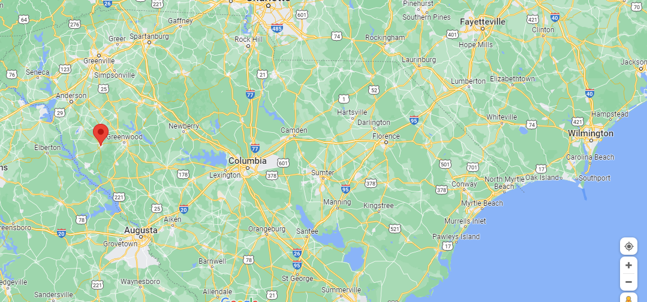 | Abbeville, South Carolina, US
John Read and Sara both died in 1819, John before Sara. His will reads:  “Last Will & Testament, John R. Long, Dec’d. South Carolina, Abbeville District  In the name of God Amen. I, John Read Long of the State and District of [unclear] said being of sound and disposing mind and memory but weak of body and calling to mind the uncertainty of life and the certainty of death and being desirous to dispose of all my Estate as it hath pleased God to bless me with do make and ordain this my last will and testament in manner and form following.  [Item] 1. I recommend my soul to God who give it in the hope of a blessed resurrection on the last day and my body to the earth to be buried in a Christian-like manner.  Item 2. And as touching my worldly goods, my will is that first of all my just debts shall be paid out of my Estate.  Item 3. I lend unto my beloved wife Sally during her natural life all that [tract?] of land whereon I now live also four Negroes viz. Peter, Nan, and Billy and [Syley?] , and also as much of my stock of horses, cattle, & hogs and sheep as she make think sufficient for use, and all my household furniture and kitchen furniture; and also as much of the present crop and stocks of provisions as she shall think sufficient for her support until she can raise a crop to support on.  Item 4. My will is that after the death of my wife Sally Long, the above name property shall be disposed of as is hereafter directed for the distribution of the other part of my estate.  Item 5. And whereas in time past I have given to my son Harrison Long five hundred dollars in cash which sum is to be counted in his portion of my Estate.  Item 6. And as I have given to my daughter Elizabeth Shirley a Negro boy named Nelson which with his services I calculate at the sum of twelve hundred dollars which sum is to be counted in as so much of her portion of my Estate rec’d by her.  Item 7. And whereas I gave to my daughter Lucy Swanzy dec’d one Negro boy named Hatter which with his services I value at twelve hundred dollars which sum is to be counted in as so much received by her of my Estate.  Item 8. My will is to dispose of the following Negroes in manner and form following that is [Tovery?] Long I value at nine hundred, [Armstead?] at nine hundred dollars, [Isaac] at nine hundred dollars, and Tom at eight hundred dollars which said Negroes shall be drawn for by Nancy Greenlee, Harrison Long, Reuben Long, Nicholas Long, and Alsey Sample and for each of them to be answerable of the value of the Negroes they shall draw [unclear] to the value I have fixed on said negroes as so much of their portion of my Estate received by them. And that one of my five last mentioned children who fails to draw one of the aforesaid four Negroes shall have in place thereof two Negroes viz. [Neice?] which I value at six hundred dollars and [Annica?] at four hundred dollars making one thousand dollars which sum shall be counted in as so much of my Estate received by whichever may get said last mentioned Negroes.  Item 9. My will is that the balance of my Estate which is not otherwise disposed shall be sold on a credit of twelve months and the money divided amongst my six children viz. Nancy Greenlee, Betsy Shirley, Harrison Long, Reuben Long, Nicholas Long, Alsey Sample, and the children of my daughter Lucy Swanzy dec’d. shall have the portion of my Estate that their mother would have had when made equal to the rest of my children after counting the sum of twelve hundred dollars rec’d. by their Mother so as to make all my children equal beginning with the one having the least portion and making them equal with the Others. The said children of Lucy Swanzy dec’d. to have one share among them to be equally divided between themselves.  Item 10. It is my will that if any of my children shall die without issue that their portion of my Estate shall return to my Estate and be equally divided as is directed for the other part of my Estate. [Unclear] also that if any of my children should die and leave child or children that they should have the part or portion of their father or mother.  Item 11. And lastly I do [make?] and appoint my beloved wife Sara Long Executrix and my son Reuben Long and Joel Lipscomb Esq. Executors to this my last will and testament, declaring this to be my last will and testament revoking all other previous to this date, in witness whereof I have hereunto set my hand and affixed my seal this twelfth day of January one thousand eight hundred and nineteen.  John Read Long  Signed, sealed, delivered in provenance of Alex R. Sample, John Pulliam, [Matthew?] Young  The foregoing will proven by the oath of Alex Sample March 15th 1819 before Moses Taggart [unclear] | 300, 300a

