FT-032

FT-XXX |  |  |  |  | FT-XXX
Ephraim Lewis |  | Margaret Elizabeth Walters |  |  | Father’s Name |  | Mother’s Name
1760 | 1818 | 1750 | 1820 |  | Birth Year | Death Year | Birth Year | Death Year

John Boley Lewis, Sr. |  |  | Lucinda Bush
Born | 1798 | Married: | Born | 1808
Where |  |  | Where | South Carolina, USA
Died | 1850 | Where: | Died | 1862
Where |  |  | Where | Marion County, AL USA
Buried |  | Source: | Buried | Unknown
Source |  |  | Source | Lucinda’s FindaGrave site says she was born in North Carolina, but the 1850 Census says SC.

Children:
Name | Born | Where | Source | Died | Where | Buried | Source
Isaiah |  |  | FT-023 |  |  |  | FT-023
Peter | ~1826 | South Carolina | 314 | April 15, 1863 | Corinth, Alcorn County, MS | Unknown | FindaGrave
Shadrack L. | ~1828 | South Carolina | 314 | 1862 | Unknown | Old Aberdeen Cemetery, Aberdeen, Monroe County, MS | FindaGrave
Margaret Rachel Lucinda | January 22, 1830 | Spartanburg County, SC | FindaGrave, Not mentioned in 1850 Census as she was already married | October 10, 1900 | Marion County, AL | Cooper Cemetery, Marion County, AL | FindaGrave
John Boley, Jr. | May 17, 1831 | Hackleburg, Marion County, TN  (JLS Note: I don’t know of a Hackleburg, TN, but there is a Marion County, TN). | 314,  FindaGrave | April 18, 1909 | Hackleburg, Marion County, AL | Carter Cemetery, Marion County, AL | FindaGrave
George | ~1835 | Alabama | 314
Ephraim | ~1837 | Alabama | 314 | Unknown | Unknown | Whittle Cemetery, Marion County, AL | FindaGrave
William Wiley | ~1841 | Alabama | 314 | January 19, 1909 | Arkansas | Bethel Methodist Church Cemetery, Jacksonville, Pulaski County, AR | FindaGrave
Mary | ~1839 | Alabama | 314
Thomas | ~1843 | Alabama | 314
Benjamin C. | ~1846 | Alabama | 314

Other Marrriages:
Sources
Husband – Other wife
When
Where
Other Children
Comments

Sources
Wife – Other husband
When
Where
Other Children
Comments

FT-032

Story:
Activity | Sources
Pictures (people, gravestones, houses, etc.)
Marriage Certificates
Land Deeds
Slave Schedule Information
War Service Records
Social Security Applications
Newspaper Articles
Where lived?
1800 US Federal Census
In 1800, assistant marshals recorded the name of the county, parish, township, town, or city in which each family resided. Each family was listed by the name of the head of the household, and was asked the following questions:
- The number of free White males and females aged, respectively:
  - under 10 years of age
  - of 10 years but under 16 years
  - of 16 years but under 26 years
  - of 26 years but under 45 years
  - 45 years and upward
- Number of all other free persons
- Number of slaves

1810 US Federal Census
In 1810, the slate of questions asked by assistant U.S. marshals was identical to the 1800 census. This census recorded the name of the county, parish, township, town, or city in which each family resided. Each family was listed by the name of the head of household and asked the following questions:
- Number of free White males and females aged, respectively:
  - under 10 years of age
  - of 10 years but under 16 years
  - of 16 years but under 26 years
  - of 26 years but under 45 years
  - 45 years and upward
- Number of all other free persons
- Number of slaves
First Economic Inquiries
In addition to population inquiries, the 1810 census was the first to collect data about the nation's manufactures. A May 1, 1810, act directed that, "it shall be the duty of the several marshals, secretaries, and their assistants aforesaid, to take, under the direction of the Secretary of the Treasury, and according to such instructions as he shall give, an account of the several manufacturing establishments and manufactures within their several districts, territories, and divisions." The act did not outline specific questions or prescribe a schedule, leaving those matters to the Secretary of the Treasury’s discretion.
To facilitate data collection, the Treasury Department divided manufactured products into 25 broad categories, encompassing more than 220 kinds of goods. As the U.S. marshals and their assistants conducted the decennial census, they also visited the manufacturing establishments in their assigned areas to obtain economic data. These data generally consisted of the quantity and value of products manufactured.
In March 1812, Congress authorized $2,000 for the Treasury Department to prepare a statistical report on the kind, quantity, and value of goods manufactured and the number of manufacturing establishments in each state, territory, district, and county. The May 1813 report noted that the economic data were of poor quality because of serious undercounting and omissions during the enumeration.

1820 US Federal Census
The 1820 census built on the questions asked in 1810. The age questions were the same, except for the addition of a 16 - 18 years category for males.
- The number of free White males and females aged, respectively:
  - under 10 years of age
  - of 10 years but under 16 years
  - of 16 years but under 18 years (for males)
  - of 16 years but under 26 years (for males)
  - of 16 years but under 26 years (for females)
  - of 26 years but under 45 years
  - 45 years and upward
- The number of male and female slaves aged, respectively:
  - under 14 years of age
  - of 14 years but under 26 years
  - of 26 years but under 45 years
  - 45 years and upwards
- The number of free colored males and females aged, respectively:
  - under 14 years of age
  - of 14 years but under 26 years
  - of 26 years but under 45 years
  - 45 years and upwards
- Number of foreigners not naturalized
- Number of persons (including slaves) engaged in agriculture, commerce, and manufactures

1830 US Federal Census, Bibb County, Alabama  In 1830, the John Boley Lewis, Sr. household consisted of:  - 2 males and 1 female under 5 years (Peter, Shadrack, and Margaret Rachel Lucinda)  - 1 male 5 to 10 years (Isaiah)  - 1 female 10 to 15 years (unknown, maybe a sister?)  - 1 female 20 to 30 years (Lucinda Bush)  - 1 male 30 to 40 years (John Boley Lewis, Sr.)  - 1 female 60 to 70 years (unknown, maybe Lucinda’s mother?)  - 1 male 70 to 80 years (unknown, maybe Lucinda’s father as John’s died in 1818?)  So a few unknowns, but it makes sense that this is John Boley Lewis’s family. | 320
1840 US Federal Census, enumerated in Socopatoy, Coosa County AL  In 1840, the John Boley Lewis household consisted of:  - 2 males and 1 female under 5 years (George, Ephraim, and Mary)  - 1 male 5 to 10 years (John Boley, Jr.)  - 2 males and 1 female 10 to 15 years (Peter, Shadrack, and Margaret Rachel Lucinda)  - 1 male 15 to 20 years (Isaiah Lewis)  - 1 female 30 to 40 years (Lucinda Bush)  - 1 male 40 to 50 years (John Boley Lewis, Sr.)  - 1 female 80 to 90 years (possibly Lucinda Bush’s mother, as John’s mother died in 1820)  So this Census matches all of the data that I have at this time. So we can say that in 1840, the John Boley Lewis, Sr. family was living in Socopatoy, AL! Socopatoy is now a ghost town and was chronicled here. It has a cemetery containing many pioneer families, but there are no Lewis’s listed in the Socopatoy Cemetery in FindaGrave. | 317
1850 US Federal Census, enumerated on November 28, 1850 in District 14, Marion County, Alabama, USA  In 1850, the John Boley Lewis, Sr. family was living in Marion County, Alabama. The family consisted of:  - John B. Lewis, male, 52 years old, Farmer, born in South Carolina, $40 worth of real estate  - Lucy Lewis (wife), female, 42 years old, born in South Carolina, cannot read or write  - Isaiah Lewis, male, 26 years old, Farmer, born in South Carolina  - Peter Lewis, male, 24 years old, Farmer, born in South Carolina  - Shadrack Lewis, male, 22 years old, Farmer, born in South Carolina  - John Lewis, male, 18 years old, Farmer, born in Tennessee  - George Lewis, male, 15 years old, Farmer, born in Alabama  - Ephraim Lewis, male, 13 years old, born in Alabama  - William W. Lewis, male, 9 years old, born in Alabama  - Mary Lewis, female, 11 years old, born in Alabama  - Thomas Lewis, male, 7 years old, born in Alabama  - Benjamin C. Lewis, male, 4 years old, born in Alabama | 314
1860 US Federal Census
- Number of dwelling home in order of visitation by the enumerator
- Number of family in order of visitation by the enumerator
- Name
- Age
- Sex
- Color
Enumerators could mark "W" for Whites, "B" for Blacks, or "M" for Mulattos.
- Profession, Occupation, or Trade of each person, male and female, over 15 years of age
- Value of person's real estate
- Value of person's personal estate
- Place of birth
Enumerator could list the state, territory, or country of the person's birth
- Was the person was married within the last year?
- Did the person attend school within the last year?
- If the person was over 20 years of age, could he not read or write?
- Was the person deaf and dumb, blind, idiotic, pauper, or convict?
1860 Slave Schedule

Age | Gender | Color | Other | Age | Gender | Color | Other

Information Regarding Peter Lewis from his FindaGrave Memorial:  ~~~~~~~~~~~~~~~~~~~~~~~~~~~~~  1st Married Caroline Hall ca. 1852 (JLS Note: Caroline died in 1853 - FindaGrave  Child: Amanda Caroline Lewis Boyett b.1853-1921  This child was raised by her Grandparents Josiah and Elizabeth Brown Hall  ~~~~~~~~~~~~~~~~~~~~~~~~~~~~~  2nd Married Sarah M. Bromley 9/10/1862  Child: Mary Ann Lewis Davis b. 1863  This wife and child went to Hardin County, Tennessee during the War and never returned to Marion County, AL  ~~~~~~~~~~~~~~~~~~~~~~~~~~~~~  Peter Lewis enlisted in the Union Army on 3/1-1863 at Glendale, Mississippi for a period of 1 year. He joined Company D 1st Alabama Cavalry. He died in the Post Hospital in Corinth, Alcorn County, Mississippi of Continued Fever.  ~~~~~~~~~~~~~~~~~~~~~~~~~~~~~  NOTE SOURCE: The Heritage of Marion County, Alabama; article PETER LEWIS pg.346 by: Joyce Riggan 2000  this information added by Joyce Rye Kasbery  ~~~~~~~~~~~~~~~~~~~~~~~~~~~~~  Burial place of Peter Lewis is unknown, although war record  states he died in Corinth, Mississippi. when I went to the  Nation Cemetery in Corinth to search for Peter, they had no  record of his burial. I gave them a copy for his war record to add to their files. added by NativePride.  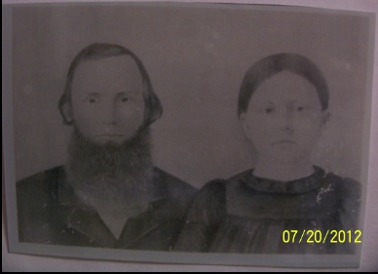  In this photo, I do not know if the wife is Caroline Hall or Sarah Bromley. | FindaGrave
Information about Shadrack Lewis from FindaGrave:  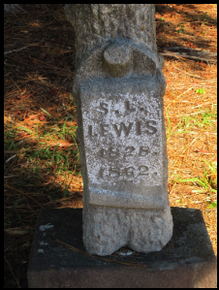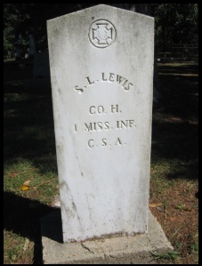  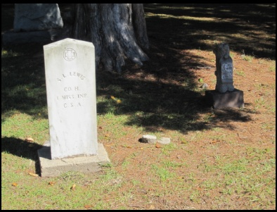 | FindaGrave
Information Regarding Margaret Rachel Lucinda Lewis:  Parents: John Boley & Lucinda "Lucy" Bush Lewis  ~~~~~~~~~~~~~~~~~~~~~~~~~~~~~~~~~  1st Husband: Johnson 'Jonce' Harris  Children:  Eli Pinkney Harris 8/11/1849-6/12/1918  Patience Harris Brooks  ~~~~~~~~~~~~~~~~~~~~~~~~~~~~~~~~~  2nd Husband: Jesse Huffman  Children:  James Washington Blanch Huffman  Mary L.J. Huffman Hamilton  Laura Frances Huffman Gilmer 1861-1936  John L. Huffman 1864-1927  Margaret A. Huffman Brown  Rachel Mulvenia Huffman Humphries 1869-  Lula Belle Huffman Rye  ~~~~~~~~~~~~~~~~~~~~~~~~~~~~~~~~~  NOTE SOURCE: The Heritage of Marion County, Alabama; article Jesse and Racheal Lewis Huffman; page 304-305 by: Joyce Riggan 2000.  ~~~~~~~~~~~~~~~~~~~~~~~~~~~~~~~~~ | FindaGrave
Information regarding John Boley Lewis, Jr. from FindaGrave  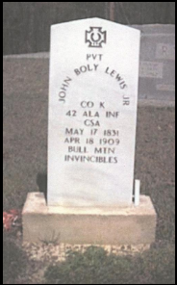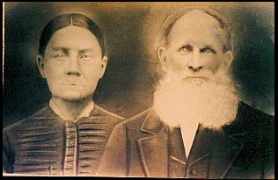  The photo is of John Boley Lewis, Jr. and his wife Mary Jane Hutcheson. | FindaGrave
Information regarding William Wiley Lewis from FindaGrave:  “William Wiley Lewis stated in pension records on Dec. 21, 1905 that he was born in Coosa Co. Ala. This information was told him by his older brother who was at that time now deceased. Family record of his birth was destroyed during the War of the Rebellion.  William W. Lewis married Sarah Margaret "Sally" Hutchins on Dec. 28, 1865 in Monroe County, Miss. William's brother John Boley Lewis, Jr., also married Mary Jane Hutchins in Monroe County. Probably Sisters. [John Sharp Note: note that Mary Jane’s name in the row above is spelled “Hutcheson”, not “Hutchins”. So I am not sure if this is true.]  William enlisted in Co. M, 1st Alabama Cavalry, USA on March 10, 1863. He was mustred out on Oct. 20, 1865 in Huntsville, Ala. His war records states that he was 5 ft. and 10 in. tall with a fair complection with brown hair and blue eyes.  While in service at Camp Davis, Miss., William was injured when his horse fell on him breaking his right arm below the elbow and his collar bone. This also caused injury to his right hip and right breast. His horse reared up and fell back on him. When this happened, he was trying to keep the horse in its proper place in line. William was carried to the regiment surgeon and then transferred to the hospital in Memphis, Tenn. for 2 months. After this he rejoined his unit doing light work until his discharge.  William and family moved several times after the war before settling in Arkansas. William and Sally were the parents of nine childrem - Lucinda (b. 2-20-1867); Wiley (B. 1-6-1869); Charley (b 3-15-1870); Isaac (B 2-26-1872); J. H. (b. 1876); Mary Etta (b.1877); Ann ( b. 4-22-1880); Walter Lee (b. 7-25-1882); Bell (b. 2-19-1890).  All is either from the pension records, Census records, Monroe County, Ms. marriage records or Family Knowledge. Added by Joyce Riggan (Lewis Decendant)”  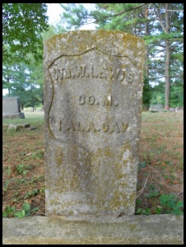 | FindaGrave

