FT-051

FT-052 |  |  |  |  | FT-063
Aaron Harlan, Sr. |  | Sarah Hollingsworth |  |  | Samuel Stuart* |  | Jane Dickey*
1724 | 1798 | 1722 | Death Year |  | 1714* | 1824* | 1735* | 1810*
* All Parental data from FindaGrave and other Ancestry.com members’ family trees
Aaron Harlan III |  |  | Elizabeth Stuart
Born | 1752 | Married: | Born | October 22, 1755 ³
Where | Chester County, PA USA ¹ | 1771 ² | Where | Chatham County, North Carolina, USA⁵
Died | August 6, 1806 ¹ | Where: | Died | September 21, 1835⁵
Where | Laurens County, South Carolina, USA ⁴ |  | Where | Perry County, Alabama, USA⁵
Buried | Harlan Cemetery, Union County, South Carolina, USA⁴ | Source: | Buried | Unknown, but probably somewhere in Perry County, AL, USA
Sources | 1. 484, p. 68.  4. FindaGrave | 2. 484, p. 68. | Sources | 3. 484, p. 68.  5. FindaGrave

Children:
Name | Born | Where | Source | Died | Where | Buried | Source
Samuel | 19 Apr 1772 | Chatham County, NC USA | 484, p. 68 | 18 Apr 1858 | Fayette County, IN USA | Village Creek Cemetery, Connersville, Fayette County, IN, USA | 484, p. 68  FindaGrave
Sarah | 13 Oct 1775 | Chatham County, NC USA | 484, p. 69  FT-049 | October 13, 1775 | Perry County, AL USA | Ocmulgee Baptist Church Cemetery, Perry County, AL USA | 484, p. 69  FT-049
George | 07 Jan 1778 | Chatham County, NC USA | 484, p. 69 | 1815 | Union County, IN USA | Unknown | 484, p. 69  FindaGrave
Joshua | 12 Feb 1781 | Chatham County, NC USA | 484, p. 69 | 26 Mar 1826 | Union County, IN USA | Unknown | 484, p. 69  FindaGrave
Jane | 20 Feb 1783 | Chatham County, NC USA | 484, p. 69 | 15 May 1870 | Lawrence County, AL USA | Milam Campground Cemetery or Heflin Cemetery, Moulton, Lawrence County, AL USA | 484, p. 69  FindaGrave
James | 21 Feb 1786 | Laurens County, SC USA | 484, p. 69 | 11 Feb 1865 | Tallapoosa County, AL USA | Old Providence Baptist Church Cemetery, Tallapoosa County, AL USA | 484, p. 69  FindaGrave
Mary | 05 Apr 1788 | Laurens County, SC USA | 484, p. 69 | 25 May 1824 | Anderson County, SC USA | First Baptist Church Cemetery, Anderson County, SC USA | 484, p. 69  FindaGrave
Aaron | 10 Jun 1792 | Laurens County, SC USA | 484, p. 69 | 27 Jun 1853 | Parke County, IN USA | Seybold Cemetery, Greene Township, Parke County, IN USA | 484, p. 69  FindaGrave
Joseph | 18 Feb 1796 | Laurens County, SC USA | 484, p. 69 | 27 Jul 1844 | Robertson County, TX USA | Providence Cemetery, Robertson County, TX USA | 484, p. 69  FindaGrave
Isaiah | 04 May 1798 | Laurens County, SC USA | 484, p. 69 | 29 Jan 1846 | Montgomery County, TX USA | Willis Cemetery, Willis, Montgomery County, TX USA | 484, p. 69  FindaGrave
Rebecca | 03 Aug 1801 | Laurens County, SC USA | 484, p. 69  FindaGrave | 1821 | Laurens County, SC USA | Harlan Cemetery, Union County, IN USA | 484, p. 69  FindaGrave

Other Marrriages:
Sources
Husband – Other wife
When
Where
Other Children
Comments

Sources
Wife – Other husband
When
Where
Other Children
Comments

FT-051

Story:
Activity | Sources
Pictures (people, gravestones, houses, etc.)
Marriage Certificates
Land Deeds
Slave Schedule Information
War Service Records
Social Security Applications
Newspaper Articles
Where lived?
1790 US Federal Census, Laurens, South Carolina, USA  In 1790, we find an Aaron Harlan family that consists of:  - 3 White males under 16 years (James, Joshua, and George)  - 2 White males of 16 years and upward (Samuel and Aaron)  - 5 White females (Mary, Jane, Sarah, Elizabeth, and Unknown)  - 1 slave | 576
1800 US Federal Census, Laurens District, South Carolina, USA  In 1800, in Laurens District, SC, we find an Aaron Harlan family that consists of:  - The number of free White males and females aged, respectively:  - 3 males under 10 years of age (Isaiah, Joseph, and Aaron)  - 1 male and 1 female of 10 years but under 16 years (James and Mary)  - 1 male and 1 female of 16 years but under 26 years (Jane and either Joshua or George. It was probably Joshua as he didn’t marry until about 1804. George married about 1800. See Source 489, page 228).  - 1 female of 26 years but under 45 years (Elizabeth)  - 1 male 45 years and upward (Aaron)  - 1 Slave (I think the name of this slave was | 575
Will of Aaron Harlan III  Aaron Harlan died on August 6, 1806. His will states:  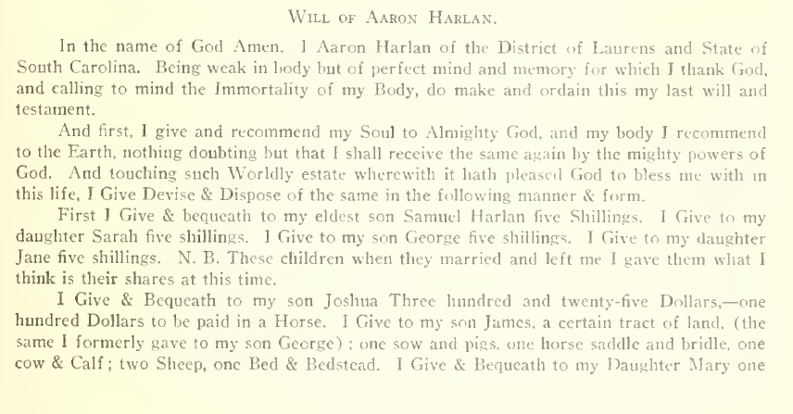  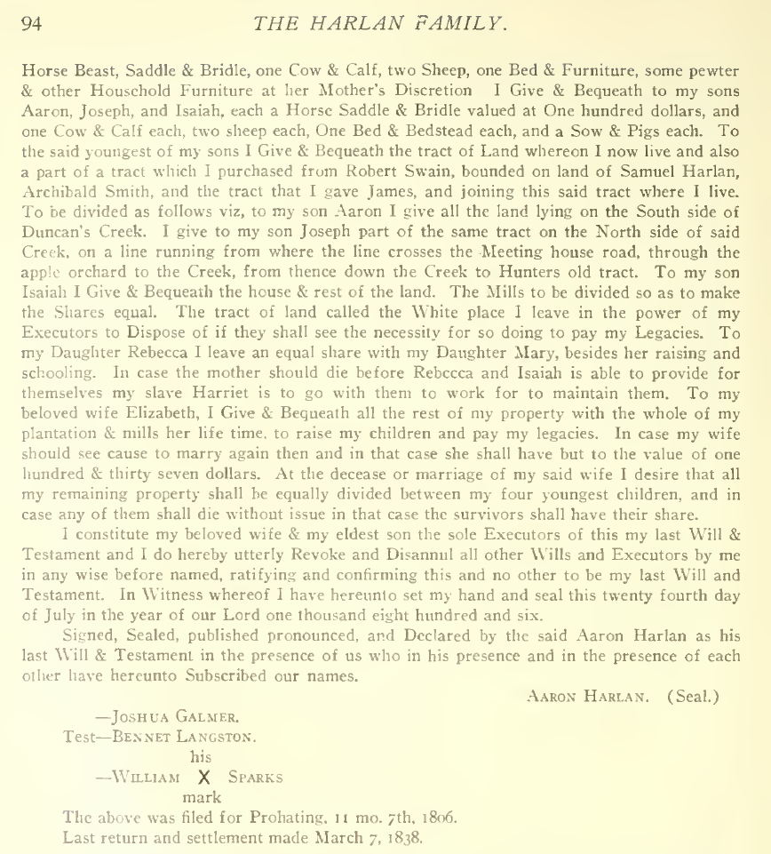  Transcribed version of Aaron Harlan III’s will from https://freepages.rootsweb.com/~holdridge/genealogy/will/harlanaaron1806.html  South Carolina  Laurens District}  In the name of God Amen. I Aaron Harlan of the District of Laurens and the State of South Carolina. Being weak in body but perfect mind and memory for which I thank God, and calling to mind the Immortality of my Body, do make and ordain this my last will and testament.  And first, I give and recommend my Soul to Almighty God, and my body I recommend to the Earth, nothing doubting but that I shall receive the same again by the mighty powers of God. And touching such Worldly estate wherewith it hath pleased God to bless me with in this life, I Give Devise & Dispose of the same in the following manner and form.  First I Give & bequeath to my eldest son Samuel Harlan five Shillings. I Give to my daughter Sara five shillings. I Give to my son George five shillings. I Give to my daughter Jane five shillings. N.B. These children when they married and left me I gave them what I think is their shares at this time.  I Give & Bequeath to my son Joshua Three hundred and twenty-five Dollars,- -one hundred Dollars to be paid in a Horse. I Give to my son James, a certain tract of land, (the same I formally gave to my son George); one sow and pigs, one horse saddle and bridle, one cow & Calf; two Sheep, one Bed & Bedstead. I Give & Bequeath to my Daughter Mary one Horse Beast, Saddle & Bridle, one Cow & Calf, two Sheep, one Bed & Furniture, some pewter &other Household Furniture at her Mother's discretion. I Give & Bequeath to my sons Aaron, Joseph, and Isiah, each a Horse Saddle & Bridle valued at One hundred dollars, and one Cow & Calf each, two sheep each, One Bed & Bedstead each, and a Sow & Pigs each. To the said youngest of my sons I Give and Bequeath the tract of Land whereon I now live and also a part of a tract which I purchased from Robert Swain, bounded on land of Samuel Harlan, Archibald Smith, and the tract that I gave James, and joining this said tract where I live. To be divided as follows viz, to my son Aaron I give all the land lying on the South side of Duncans Creek. I give to my son Joseph part of the same tract on the North side of said Creek, on a line running from where the line crosses the Meeting house road, through the apple orchard to the Creek, from thence down the Creek to Hunters old tract. To my son Isaiah I Give & Bequeath the house & rest of the land. The Mills to be divided so as to make the Shares equal. The tract of land called the White place I leave in the power of my Executors to Dispose of if they shall see the necessity for so doing to pay my Legacies. To my Daughter Rebecca I leave an equal share with my Daughter Mary, besides her raising and schooling. In case the mother should die before Rebecca and Isaiah is able to provide for themselves my slave Harriet is to go with them to work for to maintain them. To my beloved wife Elizabeth, I Give & Bequeath all the rest of my property with the whole of my plantation & mills her life time, to raise my children and pay my legacies. In case my wife should see cause to marry again then and in that case she shall have but to the value of one hundred & thirty seven dollars. At the decease or marriage of my said wife I desire that all my remaining property shall be equally be divided between my four youngest children, and in case any of them shall die without issue in that case the survivors shall have their share.  I constitute my beloved wife & my eldest son the sole Executors of this my last Will & Testament and I do hereby utterly Revoke and Disannul all other Wills and Executors by me in any wise before named, ratifying and confirming this and no other to be my last Will and Testament. In Witness whereof I have hereunto set my hand and seal this twenty fourth day of July in the year of our Lord one thousand eight hundred and six.  Signed, Sealed, published pronounced, and Declared by the said Aaron Harlan as his last Will & Testament in the presence of us who in his presence and the presence of each other have hereunto Subscribed our names.  Aaron Harlan (Seal)  Joshua Galmer  Bennet Langston  William Sparks  The above was filed for Probate November 7th, 1806  Last return and settlement made March 7, 1838 | 489 (pages 93-94)
Family of Aaron Harlan III  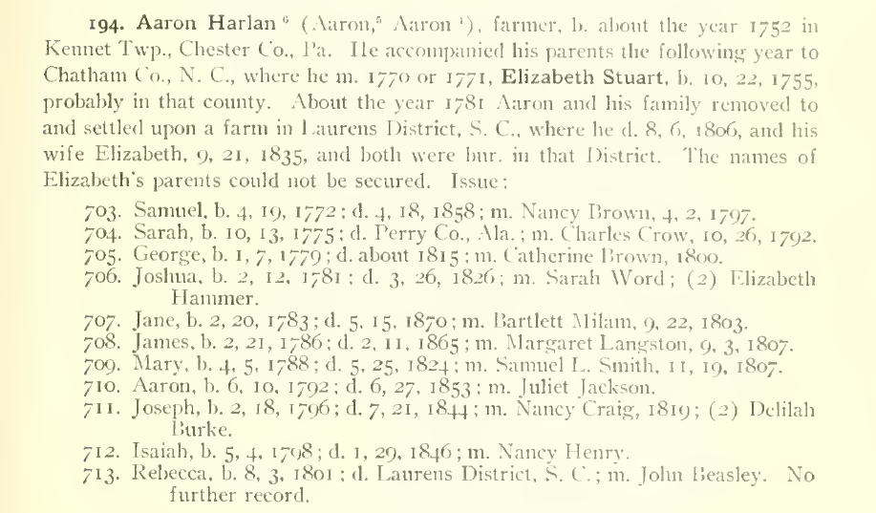 | 489 (page 93)
Family of Aaron Harlan III  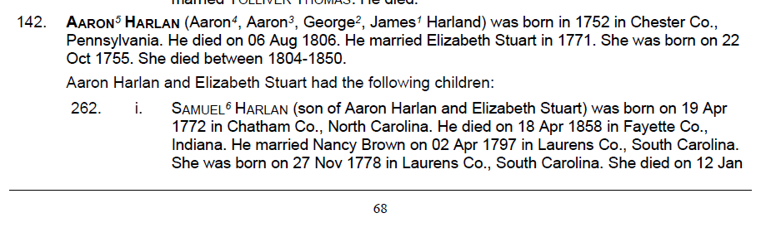  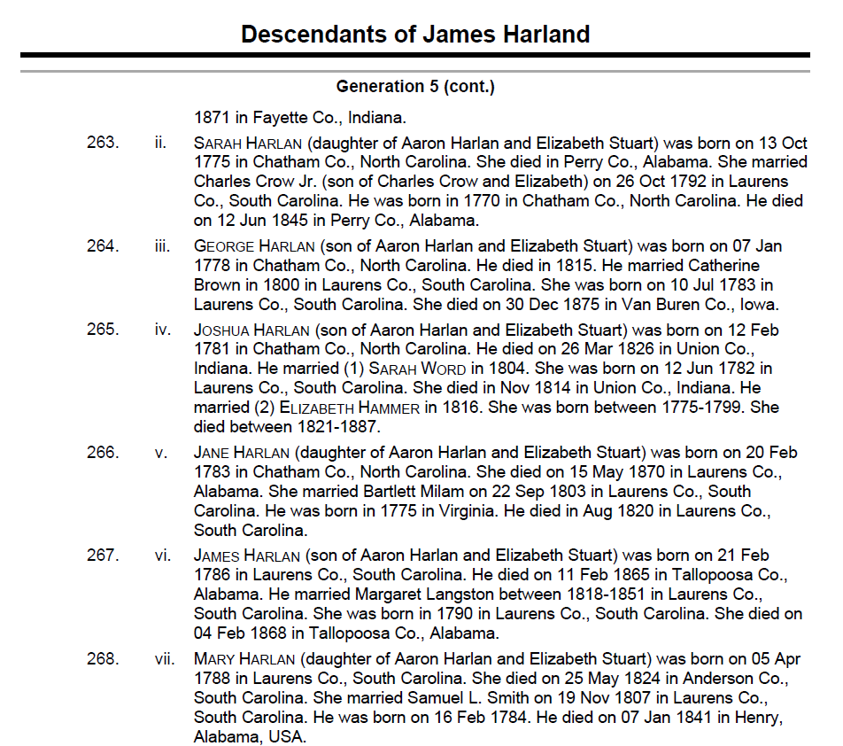  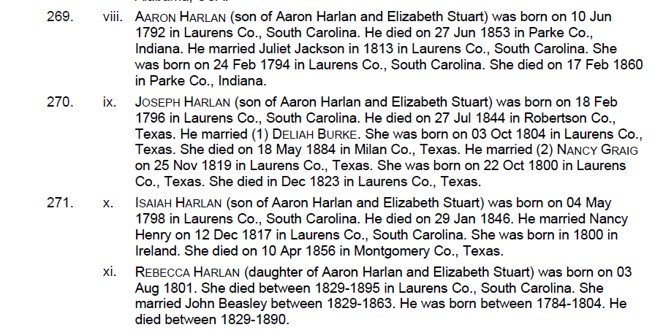 | 484 (pages 68 – 69)
Elizabeth Stuart Harlan died apparently in 1835. She was living with one of her children, according to her FindaGrave site. However, as she wouldn’t be the Head of the Household, her name would not be listed on any Census documents, so I cannot find where she went.
Joseph Harlan, son of Aaron and Elizabeth – From FindaGrave  A marker reads: "Joseph Harlan. Patriot, Volunteer Texas Ranger, Stockman, Planter, Justice of the Peace. Born February 18, 1796, Laurens District, South Carolina. Died July 21, 1844, Robertson County, Texas. Joseph Harlan, at an early age, enlisted in the War of 1812 at Charleston, South Carolina. Joseph married Nancy Craig in November 1819 and had two children. Following Nancy's death, Joseph married Delilah Burke in June 1825 and had seven children. Joseph came to Texas in 1836 and served in the War for Texas Independence under General Sam Houston at San Jacinto. In July 1836, he returned for his family in South Carolina. He arrived back in Old Wheelock, Robertson County, Texas on February 14, 1837. In November of the same year, he settled near this cemetery site on the northern edge of a headright grant from the Republic of Texas. Two sons, William Craig Harlan and Joseph Harlan Jr., are also buried here in marked graves. The fourth grave is unknown." Erected 1980 by the Defenders of the Republic of Texas.  __________________  HARLAN, JOSEPH SR., 2.18.1796 - 7.21.1844, b Laurens Co., SC, s Aaron & Elizabeth Stuart Harlan, w1 Nancy Craig, m 11.15.1819 Laurens Co., SC, c1 William Craig (1822 - 1843), Jane Elizabeth (Mrs. Logan Almoren) Stroud[1] (1823 - 2.1.1905, m 5.19.1842, b Old Springfield Cemetery, Limestone County), w2 Delilah Burke, m 6.1825, Laurens Co., SC, c2 Martha (1827 - 1842), Eliphalet (1829 - 1906), Alpheus (1830 - 1909), Isaiah (1831 - 1864), Mary (1833 - 1850), Sarah (1835 - 1852), Joseph Jr. (1838 - 1844). Some Harlan family information was obtained at www.familysearch.com. | FindaGrave
Isaiah Harlan, son of Aaron and Elizabeth – From FindaGrave  A bio of Dr. Harlan:  Dr. Isaiah Harlan (#712 in Alpheus Harlan’s History and Genealogy of the Harlan Family) was a doctor, planter and stockman. He was born on May 4, 1798, in Laurens District, S.C., a seventh generation descendent of Captain William Harland. He was only nine years old when his father, Aaron Harlan (#194), died.  Isaiah was quite young when he graduated as a medical doctor. He was a fine scholar (called brilliant) and excelled in the sciences and languages, including Latin, Greek and Hebrew. He continued his medical practice throughout his life, eventually also owning up to ten thousand acres of land in two counties in Texas and being a planter and a stockman.  He still lived in South Carolina when he married Nancy Henry (1800 -1852) on December 12, 1817. She was born upon a sailing vessel on the Atlantic Ocean, en route to America from Ireland.  In 1819, Isaiah, Nancy, and their first-born child, Martha (#2395), left South Carolina and moved to Indiana, where several of Isaiah’s older brothers had previously settled. They lived in Fayette County, Ind., with his oldest brother, Samuel Harlan (#703) until the birth of their second child (Mary #2396, listed in the 1820 Federal Census in Fayette County, Ind.). Isaiah then moved his family to settle about nine miles from Rockville, Ind., on Little Raccoon Creek in Parke County, Ind., where the family lived until 1834.  On August 24, 1829, his family was visited by a cousin, Reason R. Harlan (#229), who described Isaiah Harlan as a well-looking man, who then had seven children.  At some point, Isaiah had evidently set his eyes on the area then known as Tejas, for in 1825 he wrote a letter to Stephen F. Austin (founding father of Anglo-Texas) and requested information about obtaining a land grant there. Things did not work out immediately, and it was not until the fall of 1834 that the family arrived in the State of Coahuila, Mexico (which included Texas), as family immigrants in Sterling Clack Robertson’s Colony. Robertson was a noted land impresario in the Anglo settlement of the Republic of Texas.  Isaiah received a grant for a league of land (4,428 acres) in Sarahville de Viesca—then Robertson Colony Headquarters (site of present-day Falls County). The land granted to Isaiah was located in what became (in 1837) Robertson County, Republic of Texas, and in what (in 1850) became Falls County, Texas (the eastern section on which Blue Ridge community is located).  Texas Archive records reveal that Dr. Isaiah Harlan served under Captain N. Doyle as a Volunteer Ranger from March 8, 1839, to June 10, 1839, as did his brother Joseph Harlan (#711) and Joseph’s eldest son, William Craig Harlan (#2386). He was elected to the State Legislature of Texas, but declined to serve, not having a taste for public life.  Isaiah Harlan died January 29, 1847 (not 1846 as printed in the 1914 Harlan genealogy). He passed in his own home in Montgomery County, Texas, (present day Willis, Texas) and was buried in a mausoleum on his own property in what was then called Harlan Burying Ground (now Willis, Texas, Cemetery).  Isaiah’s wife, Nancy, passed on April 10, 1852 (not 1856 as printed in the 1914 Harlan genealogy). She is buried in the mausoleum beside her husband. She was the daughter of Matthew and Elizabeth Jean (Hunter) Henry, natives of Ireland who settled in Laurens District, S.C., in 1800.  Isaiah and Nancy were the parents of twelve children, but only six survived to marry and have families of their own. These six are:  #2395 Martha b. 12-8-1818; d. 3-8-1887 #2396 Mary b. 1-22-1820; d. 5-3-1902 #2399 Silas b. 9-11-1825; d. 10-4-1888 #2400 Jonathan b. 10-21-1828; d. 3-23-1891#2404 Charles b. 6-2-1833; d. 6-22-1869 #2405 George b. 2-2-1835; d.12-30-1919  The corrections contained in this history of Dr. Isaiah Harlan and Mrs. Nancy (Henry) Harlan have all been verified in the Archives of Texas, the Robertson Colony Papers and the Estate Records of Montgomery County, Texas.  The above information has been extracted from History and Genealogy of the Harlan Family by Alpheus H. Harlan (1914) and An Updated Genealogy: The Descendants of Aaron (#194) and Elizabeth (Stuart) Harlan by Joydelle Garrett Wolfram, compiler (1990). Note: All numbers are those found in the 1914  Contributor: Philip Patterson (49988161) | FindaGrave

