FT-052

FT-053 |  |  |  |  | FT-054
Aaron Harlan |  | Sarah Heald |  |  | Valentine Hollingsworth |  | Elizabeth Heald
1685 | 1732 | 1692 | 1747 |  | Birth Year | Death Year | Birth Year | Death Year

Aaron Harlan, Sr. |  |  | Sarah Hollingsworth
Born | 1724 | Married: | Born | 1726
Where | Kennett Square, Chester County, Pennsylvania, USA | March 1746 | Where | Kennett Square, Chester County, Pennsylvania, USA
Died | 1798 | Where: | Died | 1776
Where | Union County, South Carolina, USA | Old Swedes Church, Wilmington, New Castle Co., Delaware | Where | Union County, South Carolina, USA
Buried | Harlan Cemetery, Union County, South Carolina, USA | Source: | Buried | Harlan Cemetery, Union County, South Carolina, USA
Sources | FindaGrave | FindaGrave |  | FindaGrave

Children:
Name | Born | Where | Source | Died | Where | Buried | Source
George | Unknown (maybe 1756 but probably 1746 or 1747) | Chatham County, North Carolina, USA | FindaGrave | 1813 | Union County, South Carolina, USA | Harlan Cemetery, Union County, South Carolina, USA | FindaGrave
Mary | 1748 | Pennsylvania, USA | FindaGrave | 2 Sep 1831 | Monroe County, Kentucky, USA | Old Mulkey Church Cemetery,  Tompkinsville, Monroe County, Kentucky, USA | FindaGrave
Elizabeth | 1750 | Union, Union County, South Carolina, USA | FindaGrave | 1767 | Union, Union County, South Carolina, USA | Harlan Cemetery, Union County, South Carolina, USA | FindaGrave
Aaron, Jr. | 1752 | Chester County, Pennsylvania, USA | FindaGrave  FT-051 | 6 Aug 1806 | Laurens, Laurens County, South Carolina, USA | Harlan Cemetery, Union County, South Carolina, USA | FindaGrave  FT-051
Samuel | 1754 | Chatham County, North Carolina, USA | FindaGrave | 1 Nov 1831 | North Carolina, USA | Fairforest Baptist Church, Cemetery  Union, Union County, South Carolina, USA | FindaGrave
James | 8 Jun 1765 | North Carolina, USA | FindaGrave | 5 Sep 1842 | Darke County, Ohio, USA | Bethel Cemetery,  Fountain City, Wayne County, Indiana, USA | FindaGrave
Valentine, Sr. | 16 Oct 1766 | Chatham County, North Carolina, USA | FindaGrave | 16 Nov 1852 | Whitfield County, Georgia, USA | Dunagan Cemetery,  Rocky Face, Whitfield County, Georgia, USA | FindaGrave
Jacob | 1768 | Chatham County, North Carolina, USA | FindaGrave | 1798 | Union County, South Carolina, USA | Harlan Cemetery, Union County, South Carolina, USA | FindaGrave

Other Marrriages: None

FT-052

Story:
Activity | Sources
From FindaGrave:  Married Sarah Hollingsworth in Old Swedes Church, Wilmington, New Castle Co., Delaware in March 1746. Aaron eventually became a farmer, in South Carolina where he and his wife had 10 children. They were Quakers by birthright.  Aaron Harlan is a proven ancestor for the National Society of Daughters of the American Revolution, A050661.  Gravesite Details  Despite ongoing efforts to locate the Harlan Cemetery, thus far we have been unsuccessful. Heavy logging in the 19th century may have obliterated the site. | FindaGrave
Location of Aaron Harlan’s Land in South Carolina:

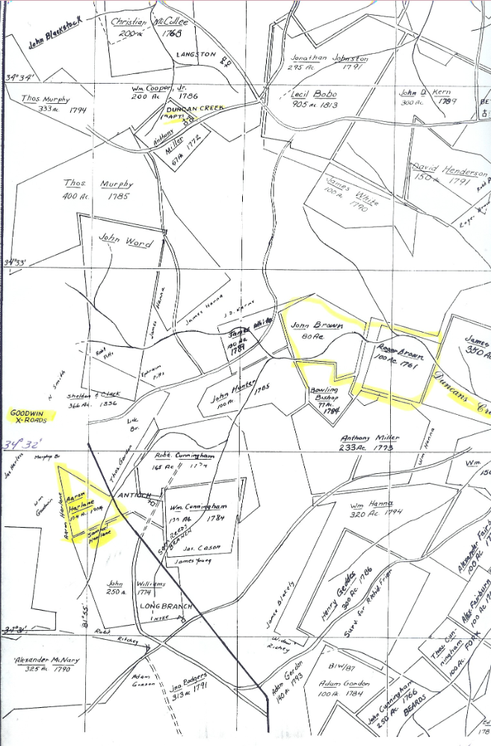

DAR Ancestor:  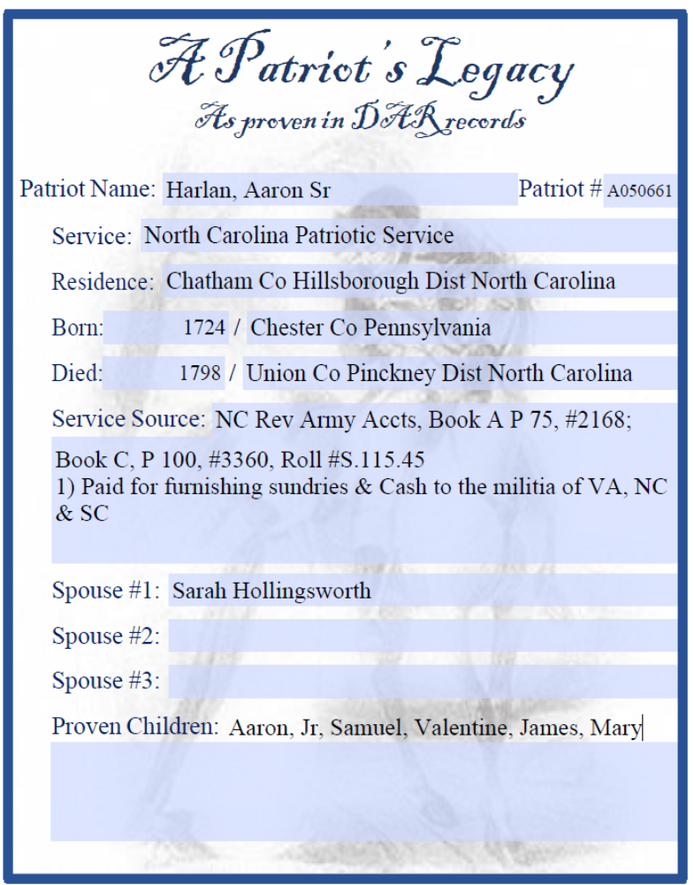 | 574
1790 US Federal Census
In 1790, assistant marshals listed the name of each head of household, and asked the following questions:
- The number of free White males aged:
  - under 16 years
  - of 16 years and upward
- Number of free White females
- Number of other free persons
- Number of slaves

1800 US Federal Census
In 1800, assistant marshals recorded the name of the county, parish, township, town, or city in which each family resided. Each family was listed by the name of the head of the household, and was asked the following questions:
- The number of free White males and females aged, respectively:
  - under 10 years of age
  - of 10 years but under 16 years
  - of 16 years but under 26 years
  - of 26 years but under 45 years
  - 45 years and upward
- Number of all other free persons
- Number of slaves

