FT-053

FT-055 |  |  |  |  | FT-056
George Harlan |  | Elizabeth Duck |  |  | Samuel Heald |  | Mary Bancroft
1650 | 1714 | 1660 | Death Year |  | 1668 | 1736 | 1673 | Aft. 1736

Aaron Harlan |  |  | Sarah Heald
Born | December 24, 1685* | Married: | Born | July 19, 1692†
Where | Parish of Donnahlong, County Down, Province of Ulster, Ireland | 1713 | Where | Mobberly, Cheshire, England
Died | November 1732 | Where: | Died | February 1747 ††
Where | Chester County, PA USA | Newark Meeting, New Castle County, Delaware | Where | Kennett Square, Chester County, PA USA
Buried | Old Kennett Friends Cemetery, Kennett Square, Chester County, PA USA | Source:  489 (p. 16) | Buried | Old Kennett Friends Cemetery, Kennett Square, Chester County, PA USA (Sarah’s grave is unmarked)
Source | FindaGrave, 489 (p. 16) |  |  | FindaGrave, 489 (p. 16)
* This is the date given in the FindaGrave site. However, Source 489, page 16 says “b. 10, 24, 1685.” This is due to the Quaker Calendar, in which we need to add 2 to the number of the month given in Quaker records.
† This is the date given in the FindaGrave site. However, Source 489, page 16 says “b. 5, 19, 1692.” This is due to the Quaker Calendar, in which we need to add 2 to the number of the month given in Quaker records.
†† This is the date given in the FindaGrave site. However, Source 489, page 16 says “d. 12 Mo., 1747/8.” This is due to the Quaker Calendar, in which we need to add 2 to the number of the month given in Quaker records.
Children:
Name | Born | Where | Source | Died | Where | Buried | Source
Charity | 1714 |  | 489, p. 16 |  |  |  | 489, p. 16
George | 1715 |  | 489, p. 16 | 1749 |  |  | 489, p. 16
Mary | 1718 |  | 489, p. 16 |  |  |  | 489, p. 16
Elizabeth | 1720 |  | 489, p. 16 |  | Union District, South Carolina |  | 489, p. 16
Samuel | 1722 |  | 489, p. 16 |  |  |  | 489, p. 16
Aaron | 1724 |  | 489, p. 16 | 1798 |  |  | 489, p. 16
Jacob | 1726 |  | 489, p. 16 | young |  |  | 489, p. 16

Other Marrriages: None

FT-053

Story:
Activity | Sources
Birth  8. Aaron Harlan⁴ (George³, James ²), Yeoman, Friend, b. 10, 24, 1685, in the Parish of Donnahlong, County Down, and Province of Ulster, Ireland.  Sarah Heald (a Friend), b. 5, 19, 1692, in Mobberly, Cheshire, Old England, | Source 489, p. 16.  Direct quotes are italicized.
Coming to America  He was but two years of age when his parents reached the shores of the New World, and  settled in the wilderness of the Colony of William Penn.  Samuel [Heald] and Mary [Bancroft Heald] came to America in 1703  So Aaron’s family came to Pennsylvania in 1687 and Sarah’s family in 1703. | Source 489, p. 16.  Direct quotes are italicized.
Marriage  Aaron and Sarah married by the ceremony of Friends at Newark Meeting, New Castle County, Delaware in 1713. | Source 489, p. 16.  Direct quotes are italicized.
Children  - Charity, b. 1714; d. ; m. Joseph Hackney, 1731 ; (2) Francis Baldwin, 1746.  - George, b. 1716 ; d. 1749 ; m. Elizabeth Hope, 3, 27, 1736.  - Mary, b. 1718 ; d. ; m. Owen Evans, 1734.  - Elizabeth, b. 1720; d. Union District, South Carolina; m. Valentine Hollingsworth, 1743.  - Samuel, b. 1722; d. ; m. Elizabeth Hollingsworth, 1745.  - Aaron, b. 1724 ; d. 1798; m. Sarah Hollingsworth, 3 Mo., 1746.  - Jacob, b. 1726 ; d. young ; bur. at Kennet. | Source 489, p. 16.  Direct quotes are italicized.
Life in America

Aaron Harlan Will  In Aaron Harlan’s will (see all of the Sources listed to the right), Aaron leaves one-third of the value of his entire estate to his wife (not mentioned by name). His sons must have been less than 21 years old, as his will keeps mentioning “when they come of age”. He leaves:  - George – his [Aaron’s] current dwelling place on the Brandywine River, about 300 acres and a clock  - Samuel l – another plantation of about 230 acres  - Aaron – another plantation in Kennett, PA  - Jacob – a portion of the value of his estate equal to that of George, Samuell, and Aaron, to be paid by them when he comes of age [which means they may have to sell some land to make this payment to Jacob]  - Charity - one grey filly  - Mary – 20 pounds  - Elizabeth – 20 pounds  Aaron appoints his wife and Samuell Hollingsworth as his executors. Samuell Pyle and Joshua Harlan are designated as trustees. George Hollingsworth and Dinah Heald are witnesses to the will. | 495a, 495b  496a, 496b, 496c  497a, 497b  498a, 498b
Sarah Heald Harlan Will (excerpts)  Name: Sarah Harlan  Description: Decedent  Residence: Kennett  Date: 5 Feb 1747  Prove Date: 3 Mar 1747  Book/Page: B:247  Remarks: Sarah Harlan of Kennett. February 5, 1747/8. March 3, 1747/8. B. 247.  To my 3 sons, viz George, Samuel and Aaron 5 shillings each. To my 3 daughters, viz Charity Baldwin, Mary Evans and Elizabeth Hollingsworth £20 each. To cousin Martha Way £4 when 18. Remainder to grandchildren. Executrix: daughter Mary Evans. Witnesses: John Clark, Francis Clark. | This story was originally added in Ancestry.com by knorth710 on 6/9/2018.
Death & Burial  Aaron and Sarah were buried at the Friends’ Burying Grounds at “Old” Kennett Meeting House  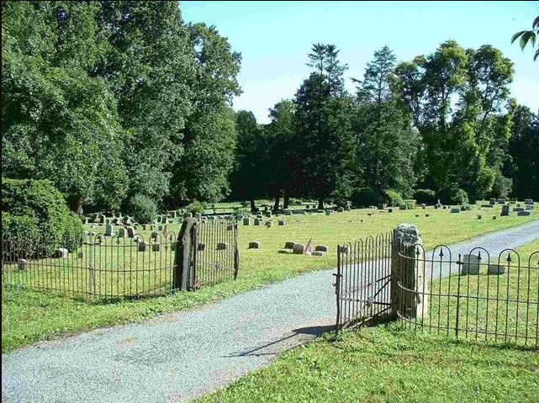 | Source 489, p. 16.  Direct quotes are italicized.  also  FindaGrave – Aaron  FindaGrave - Sarah
From Sarah’s FindaGrave webpage:  Sarah married Aaron Harlan, son of George Harlan and Elizabeth Duck on Nov. 1713 in Newark Meeting, New Castle, Delaware. Sarah and Aaron had the following children. Charity Harlan (Baldwin), born 1714, died 1764. George Harlan born 1716 in Kenneth Twp. Chester Co.,Pa. Mary Harlan (Evans) born Feb. 26, 1717 and died 1795. Elizabeth Harlan (Hollingsworth), born 1720 and died in Union District. S.C. Elizabeth married Valentine Hollingsworth Jr. son of Valentine Hollingworth and Elizabeth Heald, about 1743. Samuel Harlan was born 1722. Samuel married Elizabeth Hollingsworth, daughter of Valentine Hollingsworth and Elizabeth Heald, about 1745. Elizabeth was born about 1720 in Kenneth twp. Chester Co. Pa.  Aaron Harlan was born about 1724 and died 1798. Jacob Harlan was born 1726.  Bio by: LaVerne Dixon Beam | FindaGrave - Sarah

