FT-055

FT-057 |  |  |  |  | FT-058
James Harlan |  | Mother’s Name |  |  | Ezekiel Duck |  | Hannah Hoope
1625 | Death Year | Birth Year | Death Year |  | Birth Year | Death Year | Birth Year | Death Year

George Harlan |  |  | Elizabeth Duck
Born | March 11, 1650* | Married: | Born | May 5, 1660
Where | Durham County, England | 9 Mo. 17 D, 1678 | Where | Ireland
Died | July 5, 1714 | Where: | Died | November 12, 1712
Where | Chester County, PA, USA | Lurgan, Northern Ireland | Where | Chester County, PA, USA
Buried | Center Monthly Meeting Cemetery, Centerville, New Castle County, Delaware, USA | Source:  489, 490, 492 | Buried | Center Monthly Meeting Cemetery, Centerville, New Castle County, Delaware, USA
Source | FindaGrave |  | Source | FindaGrave
* This is the date given in the FindaGrave site. However, Source 489, page 2 says “ye 11th Day of First Month 1650.” In the Quaker Calendar, March was the first month of the year.
Children:
Name | Born | Where | Source | Died | Where | Buried | Source
Ezekiel | Mon. 6, Day 16, Year 1679 | Ireland | 489, page 2 | Mon. 4, Day 15, Year 1731 |  |  | 489, page 2
Hannah | Mon. 2, Day 4, Year 1681 | Ireland | 489, page 2 | Unknown |  |  | 489, page 2
Moses | Mon. 12, Day 20, Year 1683 | Ireland | 489, page 2 | 1747 |  |  | 489, page 2
Aaron | Mon. 10, Day 24, Year 1685 | Ireland | 489, page 2 | Mon. 9, Year 1732 |  |  | 489, page 2
Rebecca | Mon. 8, Day 17, Year 1688 | Ireland | 489, page 2 | Mon. 8, Day 17, Year 1775 |  |  | 489, page 2
Deborah | Mon. 8, Day 28, Year 1690 | Ireland | 489, page 2 | Unknown |  |  | 489, page 2
James | Mon. 8, Day 19, Year 1692 | Ireland | 489, page 2 | Unknown |  |  | 489, page 2
Elizabeth | Mon. 8, Day 9, Year 1694 | Ireland | 489, page 2 | Unknown |  |  | 489, page 2
Joshua | Mon. 11, Day 15, Year 1696 | Ireland | 489, page 2 | Mon. 5, Year 1744 |  |  | 489, page 2

Other Marrriages:
Sources
Husband – Other wife
When
Where
Other Children
Comments

Sources
Wife – Other husband
When
Where
Other Children
Comments

FT-055

Story:
Activity | Sources
Birth  3. George Harlan³ (James², William¹, Yeoman, "Ye sone of James Harland of Monkwearmouth, was Baptised at the Monastery of Monkwearmouth in Oald England, ye 11th Day of First Month 1650." He was b."Nigh Durham in Bishoprick, England," and remained there until he reached manhood, when, in company with his brother and others, he crossed into Ireland and located in the County of Down.  * Monkwearmouth Monastery was founded by Benedict Biscop in the year .A,. D. 672. It is situated in a town of the same name in the east division of Chester, County Durham, and one-half mile north of Sunderland. It receives its name from its location near the mouth of the river Wear. Burned and plundered time and ac;ain, only the tower and some detached parts of the church remain of the once celebrated monastery. In 1790 the parish registers, with the exception of some of the late records, were destroyed by fire, and it is very probable that information of untold value to us perished in the flames.  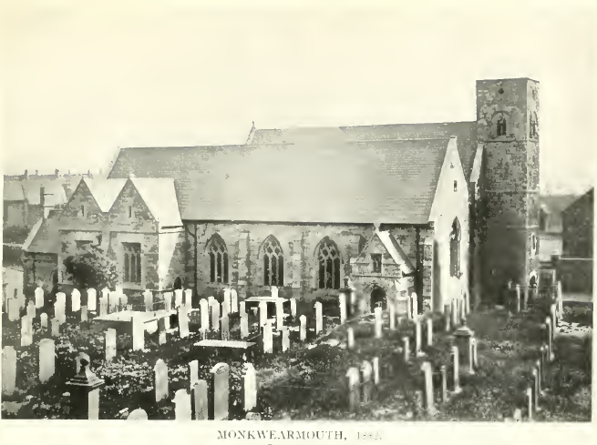  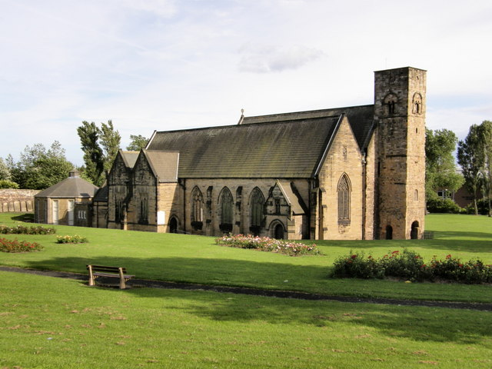  Location of monastery near current Jarrow, England.  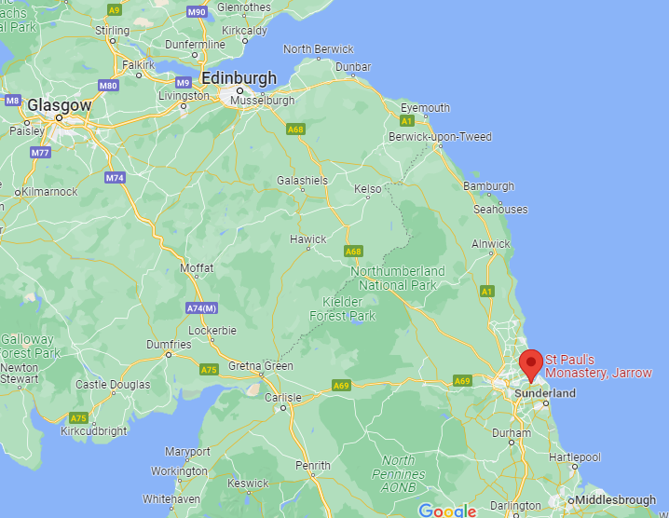 | 489, page 2  All items italicized are direct quotes from Source 489  Photo from Source 489, page 3. Photo taken some time in the 1880s.  More modern image from Wikipedia. A history of this monastery can also be found here.
Travel from England to Ireland  He [George Harlan] was b."Nigh Durham in Bishoprick, England," and remained there until he reached manhood, when, in company with his brother and others, he crossed into Ireland and located in the County of Down.  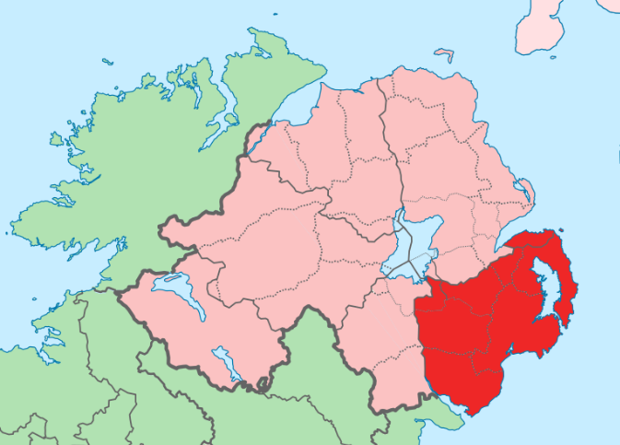 | 489, page 2  All items italicized are direct quotes from Source 489  Wikipedia map showing County Down in today’s Northern Ireland.
Marriage  While residing there [County of Down, Ireland] he m. by ceremony of Friends, 9, 17, 1678, Elizabeth Duck.  † George Harland, of Parish of Donahlong, Co. Down, Ireland, and Elizabeth Duck, of Lurgan, Parish of Shankill, Co. Armagh, were married "at the house of Marke Wright in  ye Parish of Shankill," 9 Mo. 17, 1678.  Signers to the certificate :  Henry Hollingsworth Wm Porter George Harland  John Calvert Timothy Kirk Elizabeth Harland  Roger Kirk Alphonsus Kirk  Deborah Kirk  Elinor Hoope  Robert Hoope  Thomas Harland  † Marriage Book of Lurgan Mo. Mtg., p. 91.  We find the names of George Harland, Alphonsus Kirk, etc., among the signers to Thomas Harland's first marriage certificate, but it seems that this brother did not venture to cast his lot in the new world. So far as we can learn he remained in Ireland; we find his descendants, some fifty years later, crossing into Pennsylvania, and settling in Chester County.  Google map below showing approximate location of Shankill Parish, where George and Elizabeth were married. I have no idea where “Marke Wright’s” house was in 1678! So we know that George and his brother moved to Ireland before this marriage in 1678.  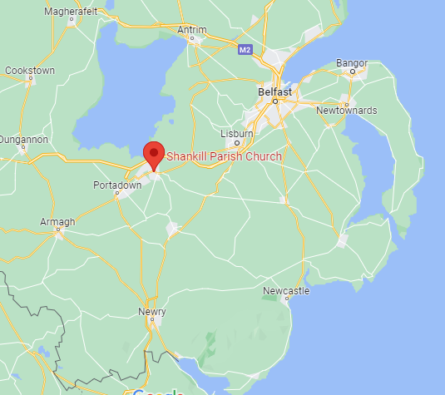 | 489, page 2  All items italicized are direct quotes from Source 489
From the Harlan Record, concerning where George Harlan lived:  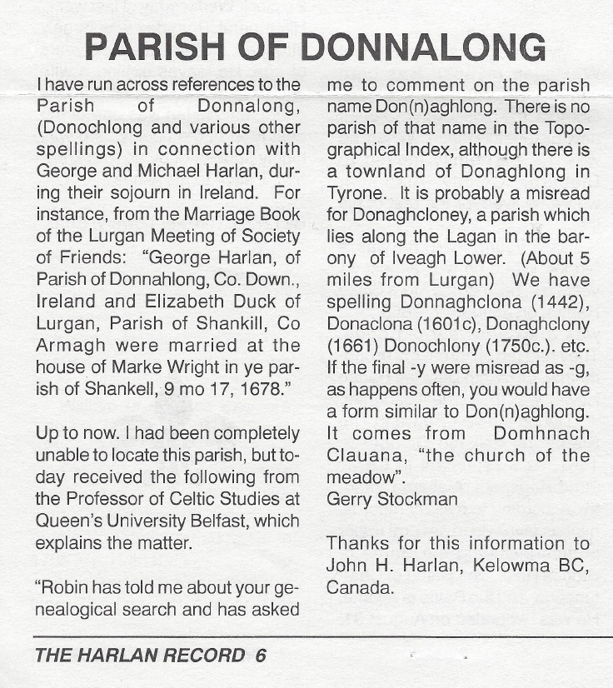 | 586, page 6
From the Harlan Record:  Copy of George & Elizabeth’s Marriage Certificate Received  Through the efforts of William Marion Harlan (Columbia, Missouri) and Arthur Chapman (Northern Ireland), a copy of the marriage certificate of George Harland and Elizabeth Duck made its way to mid-America.  Spelled out is the date of ‘the twenty seventh day of the ninth month of 1678’, contrary to the date of 9, 17, 1678 found in Alpheus Harlan’s book of Harlans. To obtain this copy, it was necessary to obtain written permission from the local Society of Friends. Then someone had to pick up the copy in person from the Public Record Office with permission in hand, which Mr. Chapman of Portadown, N.I., consented to do. Those who went on the Ireland leg of the 1994 Harlan Family tour will remember that Mr. Chapman was among those who greeted the group at the Friends Meeting House in Lurgan.  Thanks, Marion, for obtaining this very interesting document.To see a copy of the hard-to-read document and a "translation", which contains the names of 28 witnesses, visit the Harlan Web site and go to the link entitled ‘Historical Harlan Documents‘. | 592
The Harlans and the Quakers  The Society of Friends  George and Michael Harlan were members of the Society of Friends, or Quakers, and since this particular Christian sect has special significance in the story of the Harlan Family, we will consider it in some detail. The movement was founded by George Fox (1624-91), and at the time of its inception, it was just one among many dissenting sects of the day, like the Diggers, Seekers, Ranters, Muggletonians, etc., all of which are today just footnotes in the history of religion. Although it never numbered a huge number of adherents, Quakerism influenced society and events in 17th and 18th centuries in Britain and in the early history of the American colonies, far out of proportion to the size of the denomination. A period of very active proselytizing followed the movement's foundation in 1647, with preachers spreading the word in England and Ireland, and traveling to Germany, the Netherlands and the American Colonies. William Edmundson convened the very first Quaker meeting in Ireland in Lurgan in 1655. He was known as "The Great Hammer of Ireland," a remarkably muscular nickname for a peace-loving Quaker, but one which reflected his temperament and military background. Edmundson had served in the Cromwellian army, and went on to achieve fame in Ireland and beyond, as a preacher in his own right, and had much to do with the establishment of Quakerism in North Carolina. It is reasonable to ascribe, at least in part, the Harlans' specific choice of the Lurgan area as the place to settle, to their awareness of a significant Quaker presence there.  Later on the Quaker movement, in a manner of speaking, turned in upon itself, losing its missionary zeal, ceasing to seek converts, and developing a tendency to exclusivity together with an obsession with internal discipline. In America, a series of disastrous schisms split the movement, and congregations dwindled as members drifted away to other denominations, or in the worst case were "cast out" or "disowned" when they disagreed with the elders …. often over relatively trivial matters. Things were quite different in Quakerism's early days, with the first wave of converts like the Harlan brothers being much more outward looking, and engaging in enthusiastic proselytizing. Paradoxically, this period of exponential growth was also the era in which the Friends were obliged to endure the most vicious persecution. In England, Quakers were the target of a series of oppressive legislative measures passed between 1662 and 1665, including the Quaker Act, the Five-Mile Act, the Test Act, and the Conventicle Acts, and it is said that more than 300 Friends died in jail, and 200 were transported as slaves to the West Indies. It was not until 1689 that these oppressive laws were repealed with the passage of the Toleration Act, but in the meantime many Quakers had been severely mistreated. Nor was persecution limited to England. In America, the Puritan authorities of Massachusetts found their beliefs and practices were particularly objectionable, and in 1659 they went so far as to hang four Quakers on Boston Common.  Principle is one thing, and money is another, and from the authorities point of view, failure of the Quakers to pay tithes was the last straw. "Tithes", nominally a tenth of income, can be thought of as a church tax, and were the main source of income for the Established Church. As non-Anglicans, Quakers regarded tithing as a rank injustice, and by refusing to pay up, laid themselves open to prosecution. Because of inertia, folk tend to resign themselves to this sort of injustice, but when pushed beyond a certain point, like the Israelites departing the land of Egypt, they decide to vote with their feet. Those offenders lucky enough to escape jail had crops or property forcibly seized in lieu of payment, and opposition to tithing was undoubtedly explains why many early Quakers pulled up stakes and headed for greener pastures. This process sometimes involved a series of such removes, and the Brothers' peregrinations fit this pattern. As it happens in their case, we can back this up with a contemporary news item:  "In 1680, George Harland, of County Down had taken from him in Tithe, by Daniel MacConnell, twelve stooks and a half of oats, three stooks and a half of barley, and five loads of hay, all worth ten shillings and ten pence"{17}. [John Note: Source 489, page 2, original citation in Wm. Stockdale's "A Great Cry of Oppression."]  Quakers believed in plain speech and plain dress; titles were not used nor hats doffed as a token of respect; they addressed each other as "thee" and "thou" instead of "you"; and the Quaker gray of their clothing, unadorned by lapels or fancy buttons, together with the flat hat, made the Quaker recognizable from afar. Denied careers in the military, academic or professional world, they gravitated into business and manufacturing, where because of abstemious life style, willingness to work long hours, refusal to haggle, and punctiliousness about keeping their word and meeting their obligations, many achieved considerable financial success. | Harlan Family Website, George and Michael Harlan: The Irish Interlude. Again, direct quotes are italicized.
Children and Travel to America  George Harlan brought his family to America in 1687, and the nine years intervening were without doubt spent in the above-named parish and county [County of Down, Ireland], and there, too, in all probability, his first four children were born. George and Elizabeth were the parents of nine children :  5. Ezekiel, b. 6, 16, 1679 ; d. 4, 15, 1731 ; m. Mary Bezer and Ruth Buffington.  6. Hannah, b. 2, 4, 1681 ; d. ; m. Samuel Hollingsworth.  7. Moses, b. 12, 20. 1683 ; d. 1747 ; m. Margaret Ray.  8. Aaron, b. 10, 24, 1685 ; d. 9 Mo. 1732 ; m. Sarah Heald.  9. Rebecca, b. 8, 17, 1688 ; d. 8, 17, 1775 ; m. William Webb.  10. Deborah, b. 8, 28, 1690; d. ; m. Joshua Calvert.  11. James, b. 8, 19, 1692; d. ; m. Elizabeth .  12. Elizabeth, b. 8, 9, 1694; d. ; m. Joseph Robinson.  13. Joshua, b. II, 15, 1696; d. 5 Mo. 1744; m. Mary Heald.  * After coming to America George and Michael Harland dropped the final "d" and the name is almost universally spelled Harlan.  In the early months of the year 1687, in company with his wife and four children, and his brother Michael, then unmarried, he took ship at Belfast for America. They had bought lands before coming * which were within that part of the Province of Pennsylvania now embraced in the County of New Castle. Ascending the river Delaware they landed at the town of New Castle (now in Delaware State), and settled near the present town of Centreville. Here the elder brother remained for some years, and about 1698/99, having purchased higher up the Brandywine Creek, he moved his family and settled in what is now † Pennsbury Township, Chester County, Pennsylvania.  * From the old warrants granted "within the County of New Castle, on Delaware," we learn that "George Harland" and "James & Thomas Harlin" purchased lands there in the summer of 1686. and that "James Harland" did likewise in January of 1701.  † It was then in Kennett, but later the township was subdivided. | 489, page 2  All items italicized are direct quotes from Source 489  489, page 3  All items italicized are direct quotes from Source 489
Why Move to America?  There is a really fascinating story on the Harlan Family website that discusses the various moves the Harlans made as they journeyed from England to Ireland and then onto America. Essentially, they were probably looking at the world in the late 1600s and saw great discoveries happening in the New World, while they sat in a little backcountry area of England. At the same time, England was having lots of trouble with their conquest of Scotland and some English troublemakers and decided it might be a good idea to ship them over to Ireland to England’s new colony of Ulster (the old name for Northern Ireland). That way, they got rid of troublemakers, and planted a bunch of Protestants in an area where they could serve as a guard against the Catholic Irish.  Of significance to Harlan Family history, is an area in northeast Armagh, near the modern town of Lurgan. … This area was settled largely with English, as distinct from Scottish, planters, and remarkably to this day, dialectologists can detect traces of this difference in background in the speech of folk of this particular area. Surviving records indicate that tenants on the Brownlow estate included Peter Harland, townland of Ballyblagh in 1635, and John Harland, townland of Liscorran in 1659 [These townlands are now totally overbuilt and incorporated in the town of Lurgan.] Peter is listed on a Muster Roll as "pikeman," and this together with the early dates suggest that he was not a Quaker, at least not then. It would seem they survived the events of 1641 described below, and if, as seems probable from the family name, they were related to the Brothers, their prior presence in the area is another reason why the later arrivals chose to settle near Lurgan.  …  In America, the story of the Friends is inextricably bound with the foundation of Pennsylvania and the career of Sir William Penn, the Younger. His father Admiral Sir William Penn (1621-1670) was a professional naval officer, who not only contrived to survive the political pitfalls which beset his Navy colleagues during the Commonwealth period, but became involved with the Restoration of 1660, and the return of Charles II to the throne of England. While superintending the family estates in Ireland, his son William Penn (1644-1718) became a Quaker. He proselytized actively there, and it is not inconceivable that the Harlans would have heard him preach in Lurgan.  Admiral Penn had loaned 12,000 pounds to King Charles at a juncture when the latter was in financial straits, and in 1681 to settle this obligation, Penn's son persuaded the King to grant him a tract of land west of the Delaware River, 40,000 square-miles in extent, roughly speaking, modern Pennsylvania and Delaware. The grant abutted lands granted to the Duke of York (now New York and New Jersey), and those granted to Lord Baltimore (now Maryland).  Penn's plan was to found a colony based on Quaker principles, a "Holy Experiment" as he called it, and starting in 1681 broadsheets promoting the venture were distributed widely at Quaker meetings in Ireland, prompting a trickle of pioneers set off to the New World. A.C. Myers {18}, suggests that in the next few years there was considerable interaction between the Colony and Ireland, people going back and forth, and letters from the pioneers, describing their life in America, being passed from hand to hand at the Quaker Meetings. Thus the members of the Lurgan Meeting all knew of the Colony, and it is not difficult to see how George and Michael Harlan became persuaded that their future lay across the ocean. Some Irish Quakers went out to the Colony as indentured servants, but the Brothers had enough money to purchase land before they left Ireland. As relatively early arrivals, they settled in the eastern part of the territory, near where New Castle, Delaware, now stands, ultimately purchasing land on Brandywine Creek. Quaker dominance in the affairs of Pennsylvania was to continue until the latter half of the 18th Century, when during the Indian Wars and the subsequent War of Independence, their unwillingness to bear arms brought them into conflict with the spirit of the times. As a footnote, James Logan (1674-1751), a giant figure in the history of Pennsylvania Quakerism, was born and brought up in Lurgan, and would have been 13 years of age at the time when the Brothers sailed for America. Logan looked back with little pleasure to his days in Lurgan, but we can be sure he, both in Ireland and America, would have known the Brothers. | Harlan Family Website, George and Michael Harlan: The Irish Interlude. Again, direct quotes are italicized.
George Harlan and Quakerism  No certificate of the membership of George Harland with Friends is upon record, but his marriage certificate shows us that at that time he was a member, and as early as "Tenth Month" (December), of 1687, he was placed upon committees of responsibility in Friends' Affairs in his new neighborhood. At the time of his residence in Ireland, William Penn was urging Friends of England to become settlers upon his lands, cautioning them, however, against "leaving their own country out of idle curiosity or of a rambling disposition." But names signed above we find later in the new world, and, as we have seen, George was buried upon "Alphonsus Kirk's land." So they were not without friends when they made their  settlement near the Delaware. | 489, page 3  All items italicized are direct quotes from Source 489
While Living in Pennsylvania  While living in Kennet † Township (now Pennsbury), George Harlan had for neighbors a settlement of Indians who lived in the "Great Bend" of the Brandywine. After they had gone he obtained, in 1701, a warrant for 200 acres of land in the bend, which was granted to him "  in regard for the great trouble and charge he had borne in fencing and maintaining the same for said Indians while living thereon."  We find his name among the signers of the return for a road laid out in the winter of 1704-5. This road ran "from the fork of the Brandywine, in Alice Vestal's land" to a white oak" standing by y^{e} road from George Harlands to Neman's Creek Mill."  † The spelling of the name will be found to vary in this volume. It is generally spelled with two "t's," but the original spelling on the old court records was with one "t." and it is spelled in England in the same wa,. both on early and modern maps.—Futhey and Cope's History of Chester County, Pennsylvania.  George Harlan first belonged to Newark Meeting, but after his removal up the Brandywine and westward, he was too remote from this meeting for punctual attendance, especially in the winter, and at a request of himself and others, a meeting "beyond Brandywine" was established. From the Monthly Meeting records of Center Meeting, as the meeting was called, we read: "This meeting appoints George Harlan, Thomas Hollingsworth, Alphonsus Kirk, & Samuel Groves, to take y^{e} oversight of y^{e} building of y^{e} Centre Meeting House requesting y^{m} with all convenient speed to let out y^{e} work to some workmen in order y^{t} it may more speedly done & return an acctt to y^{e} next meeting how they proceed." The deed for the land had been conveyed by Alphonsus Kirk, while yet a member of Newark, to John Craig, Samuel Groves and John Richardson. The consideration was £2, 5s.  George Harlan soon became one of the foremost citizens of the colony. He had been one of the provincial governors of the "three lower counties," now the state of Delaware, in 1695, and was a member of the Colonial Assembly in 1712. His colleagues in the latter were Caleb Pusey, David Lloyd, William Davis, John Baker, Nathaniel Newlin, Nicholas Fairlamb, John Wood, Isaac Taylor and John Maris.  Upon the first day of March, 1713. he deeded 203 acres to his son-in-law, William Webb, for a consideration of 30 pounds. On the ninth day of the same month, "in consideration of the Natural Affection & fatherly love which he hath" and also "for divers other good causes and valuable considerations," he deeded 200 acres each to his sons James and Joshua.  George Harlan died in "Fifth Month" (July), 1714. The date of the death of his wife is unknown, but in his will he requests that he be buried beside his" deare wife in the new burying grounds. | 489, page 4  All items italicized are direct quotes from Source 489  489, page 5  All items italicized are direct quotes from Source 489
Will  Will of George Harlan  I George Harlan of Brandywine Creek and in the Township of Kennet and County of Chester in the province of Pennsylvania Yeoman. Being weak at this time in body but of sound and disposing mind and memory & calling to mind the certainty of Death & the uncertainty of the time thereof doe make & ordain this my last will & Testament in manner & form following. That is to say, ffirst I yield up my soul into the hands of almighty God as unto a ffaithful Creator hoping through the merrits sufferings Resurrection & mediation of my blessed Savior Jesus Christ to find mercy & forgivness with compleat salvation & my body to be buried by my deare wife in the new burying place on Alphonsus Kirks land at the discretion of my Executors hereinafter named. Also my will is that all my Just debts & funeral Expenses be fully paid & discharged. Also I Give unto my son Aaron my Clock & my Great Brass Kettle. Also I Give unto my Brother Michael Harlan the young Susquhanna Mare. Also I Give unto my servant woman named Mary Mathews at the expiration of her time one cow & calf & one young mare not less than three yeares old. And lastly I make nominate & appoint my sons Ezekiel & Aaron Harlan Executors of this my Last Will & Testament & also appoint my brother Michael Harlan aforementioned & my son Samuel Hollingsworth Trustees & assistants to my Executors aforementioned in the performance & Accomplishment of this my Last will & Testament. Also my will is that after my debts Legacies Bequests & expenses aforesaid are fully payed & satisfied that what shall then remain of my moveable & personal Estate if any so there be then it shall be equally divided between all my children Sons & Daughters share & share alike. In witness thereof I have to this my said will set my hand & seal this one & twentieth Day of the Second month called Aprill in the year of our Lord one thousand seven hundred and fourteen.*  George Harrlan (Seal)  Sealed signed & published & declared by Testator George Harlan to be his last will & Testament in the presence of us who have subscribed our names as Witnesses hereunto in his presence.  Daniel McFakson.  Nathan Maddock.  Thomas Pierson.  An Inventory of the Goods, Chattles Rights & Credits which were of George Harlan late of Kennet in the County of Chester valued & appraised by us whose names are hereunder written the Twentyeth Day of October in the yeare of our Lord one thousand seven hundred  & ffourteen.  £-s-p  Imprimis. Wearing apparall 5—00—00  Imp. 1 Bed l Bolster & 2 pillows & pillow cases 5—00—00  Imp. 2 p[air] of sheets 18—00  Imp. 1 Rug & 1 Blanket 1—10—00  Imp. 1 Bedsted 18—00  Imp. 1 Table 10—00  Imp. 1 Couch 06—00  Imp. 22 Y[ards] of Bagging 2—00—00  Imp. 1 old warming pan fire shovel & 2 p[air] tongues & toster 18—00  Imp. 2 chests 09—00  Imp. 6 p[ieces] of old puter weighing 12 [lbs] @ 18p per pound 18—00  Imp. 2 p[ieces] more weighing 31 [lbs] 05—00  Imp. 1 Brass skillitt 03—00  Imp. 1 fying pann 03—00  Imp. 3 floats & 3 pales & i churn & i wooden bottel 11—00  Imp. 1 Gunn 1—00—00  Imp. 2 cows 1 black & 1 Red 5—00—00  Imp. 1 stone horse 9—01—00  Imp. 1 Darke brown meare called Midge & this yeares horse colt 9—01—00  Imp. 1 Black Ridgelin 3—00—00  Imp. 1 Darke brown meare with bay yearling 6—00—00  Imp. 1 cross cut saw & 1 hand saw & 1 frame saw 12—00  Imp. 3 augurs 02—00  Imp. 7 planes 13—00  Imp. 1 screw tarkel 13—00  Imp. 5 wimbels bitts & 1 gimblet 02—00  Imp. 12 Chezsells & gouges 06—00  Imp. 2 axes 04—00  Imp. 2 p[air] [unknown] 01—00  Imp. 1 stock nife & hammer 04—00  Imp. Some old iron 04—00  Imp. 1 spade & 1 scithe 08—00  Imp. 2 p[ieces] of chane one whereof is at Mosess 03—00  * Proven 8 Mo. 2, 1714.—Ed.  £-s-p  Imp. 1 grindstone 08—00  Imp. 1 brode ax more 05—00  Imp. 1 old bed tick & i bolster 12—00  Imp. 1 Bond from J[ohn] Battin & Sam[uel] Heald 46—00—00  Imp. 1 Bond from Aaron Harlan [his son Aaron—Ed.] 100—00—00  Imp. 1 Book Dept 5—00—00  Imp. 1 Book Dept 25—00—00  Imp. one Book Dept more 19—07—00  Imp. one Book Dept more 2—10—00  Imp. one bay meare a[bout] 15 y[ears] old in the woods 1—10—00  Imp. one bay horse & 1 Bay meare & 1 sorrel colt 11—12—00  Imp. one brown Bay horse colt A[bout] 1 y[ear] old 1—10—00  Imp. 14 y[ards] of Blanketting 1—06—00  Imp. 18 p[ounds] of old iron 09—00  Imp. one Gray meare & colt 4—10—00  Sum Totall £276—02—00  Imp. There is the sum of Fifty Pounds Sterling Due from Nathan Matlack To be paid Ten Pounds p[er] yeare for five yeares  William Brinton.  Joseph T.aylor.  Item. The Ex[tra] Charges themselves with above Goods and Chattles hereafter mentoned  To wheat in the Barn appraised at 17—10—00  one yearling Brown horse colt 4—00—00  one Gray meare two yeares old 4—00—00  one brown bay horse 4—00—00  Sum Total of all Sums £355—12—00  George Harlan's estate "paid Isaac Taylor for Physic as y, his receipt Dated y [this]25: 1 mo: 1715, £8, 13s. | 489, page 6-7.  Entire will is almost verbatim from Source 489
Death  He [George Harlan] d. in "Fifth Month " (July), 1714, and was buried beside his "deare wife in the new burying grounds on Alphonsus Kirk's land," which was afterwards, and is yet. Center Meeting Burying Grounds. | 489, page 2  All items italicized are direct quotes from Source 489

