FT-061

FT-XXX |  |  |  |  | FT-XXX
Henry Hollingsworth |  | Catherine ? |  |  | Thomas Calvert |  | Jane Glassond
Birth Year | Death Year | Birth Year | Death Year |  | 1617 | Death Year | Birth Year | Death Year

Valentine Hollingsworth |  |  | Ann Calvert
Born | 6 Mo. (August), 1632 | Married: | Born | November 2, 1650
Where | Bellenickcrannel*, Parish of Segoe*, County Armagh*, Northern Ireland | April 12, 1672 | Where
Died | 1711 | Where: | Died | October 17, 1697
Where | Newark, New Castle County, Delaware | The house of Marke Wright, Shankell Parish, Lurgan, County Armagh | Where | Newark, New Castle County, Delaware
Buried | Newark Union Cemetery, Wilmington, New Castle County, Delaware | Source: | Buried | Newark Union Cemetery, Wilmington, New Castle County, Delaware
Source | FindaGrave | Lurgan Meeting Minutes | Source | FindaGrave
* There are various spellings of these places in different documents. I see “Belleniskcrannel” vs. “Bellenickcrannel”, “Legoe” vs. “Segoe” (“Segoe” is correct, as “Legoe” is a misinterpretation), and “Ardmagh” vs. “Armagh” (“Armagh” is correct).
Children:
Name | Born | Where | Source | Died | Where | Buried | Source
Samuel | March 27, 1673 | Bellenickcrannel, Parish of Segoe, County Armagh, Northern Ireland | 499d  FindaGrave | September 1748 | Birmingham, Chester County, PA, USA | Old Kennett Friends Cemetery, Kennett Square, Chester County, PA, USA | FindaGrave
Enoch (1) | August 7, 1675 | Bellenickcrannel, Parish of Segoe, County Armagh, Northern Ireland | 499d  FindaGrave | October 24, 1687 | New Castle County, DE, USA | Newark Union Cemetery, Wilmington, New Castle County, DE, USA | FindaGrave
Valentine | November 12, 1677 | Bellenickcrannel, Parish of Segoe, County Armagh, Northern Ireland | 499d  FT-054  FindaGrave | March 25, 1757 | Kennett Square, Chester County, PA, USA | Old Kennett Friends Cemetery, Kennett Square, Chester County, PA, USA | FindaGrave
Ann | December 28, 1680 | Bellenickcrannel, Parish of Segoe, County Armagh, Northern Ireland | 499e  Rootsweb | October 26, 1712 | Salem County, NJ, USA |  | Rootsweb
John | April 19, 1684 | New Castle County, Delaware, USA | 499e  FindaGrave | April 22, 1722 | Chester County, PA, USA | Old Welsh Tract Baptist Church Cemetery, Newark, New Castle County, DE, USA | FindaGrave
Joseph | May 10, 1686 | New Castle County, Delaware, USA | 499e
Enoch (2) | 1688 | Shellpot Creek, New Castle County, DE USA | 499e  FindaGrave  Rootsweb | September 26, 1690 | Shellpot Creek, New Castle County, DE USA | Newark Union Cemetery, Wilmington, New Castle County, DE, USA | FindaGrave  Rootsweb

Other Marrriages:
 |  | Sources
Husband – Other wife | Ann Ree* (b. 1628, d. Feb. 1, 1671) | 499b
When | Married April 7, 1655 | 499b
Where | Tanderagee, County Armagh, Northern Ireland | 499b
Other Children | - Mary, b. 25th January, 1656 at Belleniskcrannel, Northern Ireland. m. (firstly) Thomas CONOWAY, who d. 17th July, 1689; m. (secondly) Randal MALIN, in 1693.  - Henry, b. September 7, 1687 at Belleniskcrannel, Parish of Legoe, County Armagh, Northern Ireland; d. 1721 at Elkton, Cecil County, Maryland  - Thomas, b. March 1661  - Catharine, b. May 1663; d. June 29, 1746 | 499c
Comments | *Ann Ree was also spelled Ann Wraye at times.

FT-061

Story:
Activity | Sources
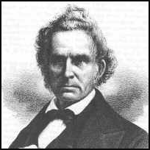 | Photo of Valentine Hollingsworth from FindaGrave
Northern Ireland Locations

The map below shows today’s Northern Ireland. This is just to give an idea of where County Down and County Armagh are.

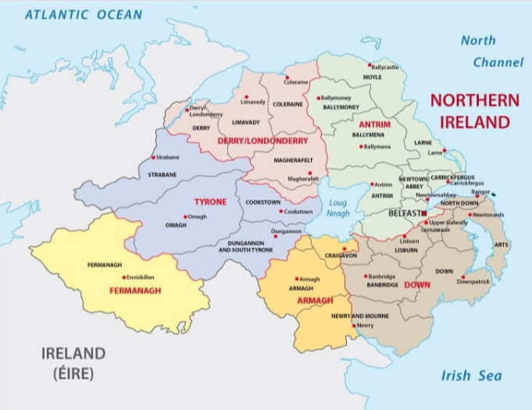

The map below shows some of the locations within County Armagh that are discussed in this document. You can see Lurgan in the upper right, the city of Armagh in the lower left, and Tandragee (where Valentine’s first wife Ann Rea was born) in the lower center.

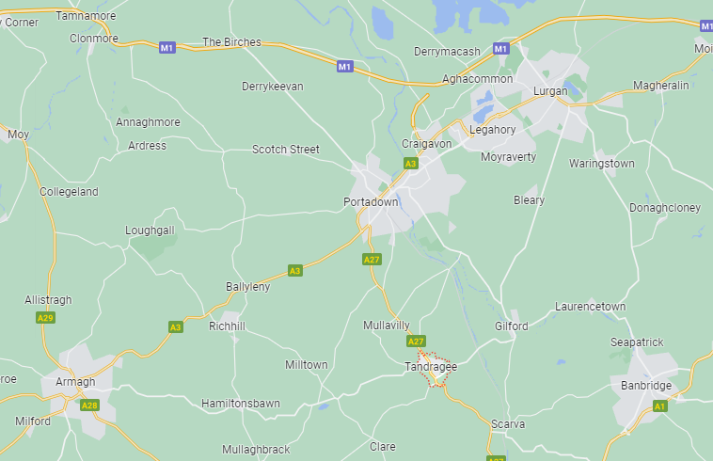

Crest (although I don’t think it’s for Valentine’s family)  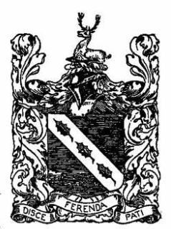 | From: Colonial Families of the USA, 1607-1775, Volume VII, Hollingsworth Family, starting on page 291 in Ancestry.com Card Catalog
Interesting Link on Hollingsworth Hall, ancient home of the Hollingsworth Family

https://www.hollingsworthassociates.com/Hollingsworth_Hall.htm

Background on Hollingsworths  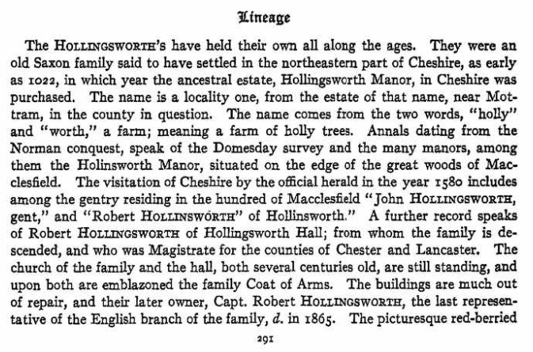  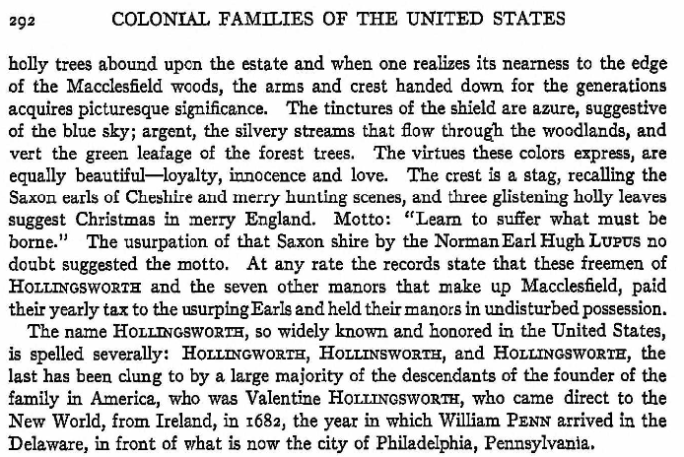 | From: Colonial Families of the USA, 1607-1775, Volume VII, Hollingsworth Family, starting on page 291 to the top of page 295 in Ancestry.com Card Catalog. These 5 pages are also saved as Sources 499a through 499e.
Note on the above information from Colonial Families of the USA, 1607-1775, Volume VII, Hollingsworth Family  This information is from “The Hollingsworth Register”, Vol. I, No. 2, July 1965. Harry Hollingsworth, C. G. was the editor of this newsletter from 1965 to 1992. This document can be accessed at: https://hollingsworthregister.files.wordpress.com/2015/11/hr-002-1-2-1965-jul1.pdf. All 112 issues of “The Hollingsworth Register” can be accessed at: https://hollingsworthregister.com/. John Sharp  “But, before we close this section of our series, let us set forth some very much needed corrections to what are felt to be “gross errors” of some decades duration. We beg the pardon of those who would like to claim a descent or relationship to the so-called “great” families of Europe and England. But a clearcut report of facts is always the better way to begin any search into the cloudy past.”  … (continued on page 86)  “Another error, or series of errors, was committed in the book “Descendants of Valentine Hollingsworth, Sr.,” by Joseph Adger Stewart (1925 – J. P. Morton & Co., Louisville, Kentucky, U.S.A.) Let us briefly correct them. We hope not to make more errors in the process!”  “Firstly, Mr. Stewart opens his narration on an un-numbered page, with the words “The Hollingsworths have held their own all along the ages…” There follows a long paragraph full of errors. Then on page 1 and 2 the actual genealogical facts about Valentine begin. There are not so many errors here, except the misinterpretation of the “Old Style” dates used in Quaker records. But the fact that must be brought out here, is that, the first two pages of text, and then pages 1 & 2, seem not to be the writing of Mr. Stewart! At least, they are in no way original to his 1925 book, and they do not appear in the 1884 pamphlet upon which nearly all of the rest of the book is based. Those four pages were printed, almost word for word, in “Colonial Families of the U.S.A., “ Volume 7, edited by MacKenzie, and copyrighted 1920 – five years before Stewart’s book! The glaring mistake is realized when one reads the words on page 1 “He (Valentine) was the son of Henry Hollingsworth of Belliniskcrannell, Parish of Legoe, …” The correct spelling is, of course, “Segoe,”, not “Legoe.” This SAME TYPOGRAPHICAL ERROR is in the MacKenzie Volume 7, pp. 291-300. (This vol. was edited by Nelson Osgood Rhoades, successor to MacKenzie, who died before its production.) The apparent writer of the article was Joseph Edwin Hollingsworth, 328 North MacNeill St., Memphis, Tennessee, for his name is given as the article begins.”  “Other errors follow and precede this minor one. Mention is made of “Hollingsworth Hall,” in Mottram. This is incorrect. The name of the Hall, now in ruins since 1944, was “HOLLINGWORTH HALL.” The letter “s” never was used by the old family who once lived in it. Mention is made of a roll for Mottram Parish, c1580, wherein “Robert Hollingsworth” and “John Hollingsworth” are mentioned. (The MacKenzie work used the used the spelling “Hollinsworth.”) The editor has not seen the original rolls, but “History of East Cheshire,” 1886, by J. P. Earwaker (2 vols) makes quotations to the effect that their name was “HOLLINGWORTH”. See also pp. 47, 48 of April’s Register, for the predominant spelling used by Cheshire families. Mr. Earwaker tells us of two pedigreed families, and the Harleian Mss. prove him correct. Both spelt their surname “Hollingworth,” originally “de Hollynworthe.” He also, however, makes mention of “yeoman” families nearer Manchester, of the name. These bore no official arms and had no pedigree registered. The American clans may have sprung from one of these.”  … (continued on page 87)  “A final error perpetuated in the Stewart and MacKenzie works is as follows: “The late owner (of the hall), Captain Robert Hollingsworth, the last representative of the English branch of the family, died in 1865.” Mr. J. P. Earwaker, in his very authoritative work above cited, clarifies this error. He shows us that “Hollingworth Hall” was sold by the Hollingworth family to another owner. From this owner (not the Hollingworths), the place was purchased, early in the 19th Century, by a person named “Captain de Hollyngeworthe,” who claimed to be a blood descendant of the original family. His name doesn’t appear upon the pedigrees! (Note the curious “ancient” spelling of his name!) Of even more surprising note, is the fact that this Captain de Hollyngeworthe planned to do some rather extensive and expensive architectural work on the Hall, which he apparently never had enough sterling to accomplish. But he did publish a painting of his hall in a book called “Twycross East Cheshire Mansions,” which depicted the structure as he would have like it to appear, not as it was. You can imagine your editor’s chagrin, when reading this news, after having believed so implicitly in what was in the Stewart book! So, beware! If you catch your editor in a mistake, call his attention to it, but document your correction.” | 501, starting on page 85
Marriage to Ann Calvert  Source: https://cephasfisher.net/LurganMinutes.htm It looks like someone has transcribed this information from microfilm at Public Records Office of Northern Ireland (PRONI). I cannot vouch for the correctness of the transcription, but based on the names of the witnesses, this looks legit. John Sharp  1672 Lurgan Marriage Book, 12th of fourth month 1672.  This is to certify the truth to all people that Valentine Hollenworth in y^{e} psh of Sego in y^{e} county of Armagh, and Anne Calvert of the same psh having intentions of marriage according to the ordinances of God, and God’s joining, Did lay it before men’s meeting before them their marriage being propounded, then y^{e} meeting desired them to wait some time, wch they did, so the meeting making inquiry between the time whether y^{e} man be free from all other women, and the woman free from all other men, and so the second time they comeing before the mens meeting, all things being clear, so they being left to their freedome. A meeting of the people of god being appointed and assembled together at the house of Marke Wright, in the psh of Shankell the twelfth day of the fourth month in y^{e} yeare 1672 whene they tooke one another in marriage in the presence of god and of his people according to y^{e} law of god, we are witnesses of the same whose names are hereunto subscribed ye day and yeare aforesaid. Val: Holengworth, Anne Holengworth.  Ffrancis Robson William Williams Jo’ Calvert Chris Hillery  Hugh Stamper George Hodgshon Jam. Harison Dorothy Hillery  Roger Webb Will pearson Nic’ Harison Elis’ Gaus  Robert Hoope Mark Wright John Wright Alice Williams  Michael Staise Tmo’ kirk James Bradshaw An. Bradshaw  Tho. Wederall Rob Chambers Tho. Calvert deborn Kirk  Will Dixon Antho. Dixon Fergus Softly Alice Wright  Dinc Kirke Mary Walker | From a transcription of the Lurgan Meeting Minutes
Valentine Hollingsworth’s Family  This information is from “The Hollingsworth Register”, Vol. I, No. 1, April 1965. Harry Hollingsworth, C. G. was the editor of this newsletter from 1965 to 1992. This document can be accessed at: https://hollingsworthregister.files.wordpress.com/2015/11/hr0011-11965apr.pdf . All 112 issues of “The Hollingsworth Register” can be accessed at: https://hollingsworthregister.com/.  Please keep in mind that what you see below is my transcription of a transcription [Henry Hollingsworth, in The Hollingsworth Register] of a transcription [Mr. John V. Hollingsworth’s account] of a transcription [by a clerk] of the Lurgan Quaker Meeting Minutes. From what I have seen of some Quaker Meeting Minutes from this time period, they are almost indecipherable, with large sections blotted out, missing, and other sections extremely hard to read.  As a further note, I have attempted to use the exact spellings shown in “The Hollingsworth Register” article, so some words may look weird, but are understandable. Also, my comments on the information below are highlighted in bold red font.  We begin! From “The Hollingsworth Register”, cited above, the 12th page of the document, numbered page 8 of the document:  “As an appendix to Mr. John V. Hollingsworth’s excellent account, and we believe, with his approval, we are reproducing here a copy of one of the pages of Lurgan Quaker Meeting, Co. Armagh, Ireland, Book of births & deaths, which is the clerk’s account of the family record of Valentine Hollingsworth, Sr.”  Page 203 [John Note: I don’t know if this page number refers to Mr. John V. Hollingsworth’s account, or is the page number in the Lurgan Quaker Meeting book for County Armagh].  Vallantine Hollingsworth son of Henry Hollingsworth of Bellenickcrannell, in the parish of Sego and County of Ardmagh and of Katherine his wife, was born at Bellenickcrannell, aforesaid, about the sixth month of the yeare 1632, and upon the seaventh day of the fowerth month – Anno Domini, 1665, he tooke to wife Ann the daughter of Nicolas Ree of Tanragee [John Note: spelled today Tandragee] in the County of Ardmagh aforesd. and of Ann his wife who was born in Tanragee aforesaid about the yeare 1628, and had by her children borne as followeth. - - - -  Mary Hollingsworth first daughter of Vallantine Hollingsworth and of Ann his wife was born at Bellenickcrannell in the parish of Sego and County of Ardmagh, the five and twentyeth Day of y^{e} first month Anno Domini, 1656 - - - -  Henry Hollingsworth first son of Vallantine Hollingsworth and of Ann his wife was born at Bellenickcrannell, aforesaid y^{e} seaventh day of y^{e} 2/mth 1658 - - - -  Thomas Hollingsworth second son of Vallantine Hollingsworth and of Ann his wife was born at Bellenickcrannell, aforesaid the beginning of the third month Anno Domini, 1661 - - - -  Katheran Hollingsworth second daughter of Vallantine Hollingsworth and of Ann his wife was born at Bellenickcrannell, aforesaid in the fifth month, Anno Domini, 1663 - - - - (All of the above written in one hand)  And it came to pass that on the first Day of the second month Anno Domini, 1671, the aforesaid Ann (wife to y^{e} said Vallantine Hollingsworth) Died, and upon the twelueth day of the fouerth month, Anno Domi. 1672, he againe tooke to wife Ann the Daughter of Thomas Calluart of Dromgorr in the parish of Sego and County of Ardmagh aforesd. and of Jane his wife) Who was borne in Killwarling [John Note: spelled today Kilwarlin] in y^{e} County of Down, about y^{e} ninth month Anno Domi. 1650 and had by her children borne as followeth - - - - - -  Samuell Hollingsworth first sonn of Vallantine Hollingsworth and of Ann his wife was born at Bellenickcrannell, aforesd. , the twenty seauenth Day of the first month Anno Domi. 1673 - - - -  Enoch Hollingsworth second son of Vallantine Hollingsworth and of Ann his wife was born at Bellenickcrannell, aforesd. the seauenth Day of the sixth month Anno Domi. 1675 - - - -  Vallantine Hollingsworth third son of Vallantine Hollingsworth and of Ann his wife was born at Bellenickcrannel, aforesaid the twelueth day of the eleauenth month Anno Domi. 1677 - - - - (above in one hand apparently at a single sitting, by same clerk, but at a later time than the section closing with “fifth month, Anno Domini, 1663,” - - - )  Ann Hollingsworth first Daughter of Vallantine Hollingsworth and of Ann his wife was born at Bellenickcrannel, aforesd. y^{e} twentyeight Day of y^{e} tenth month, Anno Domi. 1680. - - - -  (This final entry appears possibly to have been written by a different clerk, although many similarities appear in the entries. This accounts for the eight children born in Ireland, four to the first, and four to the second wife. In America, yet three more children were born to Ann (Calvert) Hollingsworth by Vallentine Hollingsworth, her husband. These were named John, Joseph, and Enoch (2), who was born after the death of the first Enoch, above.)” | 500
Ann Calvert Lineage  This information is from “The Hollingsworth Register”, Vol. I, No. 1, April 1965. Harry Hollingsworth, C. G. was the editor of this newsletter from 1965 to 1992. This document can be accessed at: https://hollingsworthregister.files.wordpress.com/2015/11/hr0011-11965apr.pdf . All 112 issues of “The Hollingsworth Register” can be accessed at: https://hollingsworthregister.com/.  Please keep in mind that what you see below is my transcription of a transcription [Henry Hollingsworth, in The Hollingsworth Register] of a transcription [Mr. John V. Hollingsworth’s account] of a transcription [by a clerk] of the Lurgan Quaker Meeting Minutes. From what I have seen of some Quaker Meeting Minutes from this time period, they are almost indecipherable, with large sections blotted out, missing, and other sections extremely hard to read.  As a further note, I have attempted to use the exact spellings shown in “The Hollingsworth Register” article, so some words may look weird, but are understandable. Also, my comments on the information below are highlighted in bold red font [although I don’t think I made any comments in this article].  Starting on the 13th page of the document, numbered as page 9 of the document:  “John V. Hollingsworth, Chadds Ford, Pennsylvania, has been interested in Quaker research for a number of years. He also maintains that faith in his own life, perpetuating the belief of the founder of his line. Consequently, he has become familiar with the Quaker Meeting records. Your editor received a letter of recent date, from Mr. Hollingsworth, in which, we think, hitherto unexploited information has been brought to light. In a discussion about the Quaker records, he relates that, on page 200, of the same record book, the following appears: (We quote only in brief.)  Thomas Calvert, son of John Calvert, of Moresome, neere Gisbrough, in Yorkshire, in England, and of Gwale his wife, was borne at Lygakowy (now Lurgan) in the County of Ardmagh, in Ireland, in the year 1617, and about the 11th of y^{e} 2nd month, 1647 he took to wife Jane, daughter of Hugh Glassond and of Margaret his wife of Stranmillis (now Belfast) in the County of Antrim, and had by her children borne as followeth, - - - -  Ann Calvert first daughter of Thomas Calvert and Jane his wife was borne in Killwarlin (now Hillsborough) in the County of Down about the ninth month, Anno Domini, 1650 - - - -  Four children are noted, Ann being second. Hillsborough is a town a few miles east of Lurgan, over the line in County Down. This Calvert family came first into Lurgan, and then moved to what is now Hillsborough, and then back to Lurgan. But the invaluable information is in their original English Parish Home. We know that all descendants of Vallentine Hollingsworth will be pleased to take the ancestry back farther, even if it is on the “distaff” side!  “Moresome” neer Gisbrough is correctly called “Great Moresome,” now often written “Great Moorsholm.” It lies within the Parish of Skelton-in-Cleveland, and is a township thereof, being six miles east by south, of the town of Guisborough, in North Riding of the County of York, England. (See: Samuel Lewis: Topographical Dictionary of England.)  From an examination of the records of Yorkshire Parish Register Society, there is little doubt that the Calverts did indeed , originate in Moorsholm. Volume XIX, p. 28, of “Wills in the York Registry Office,” covering years from the 1400’s until the late 1600’s, shows:  “CALVERDE, Thomas, Morsom, Psh. of Skelton. Will July 1, 1572 19-370  “CALVERD, John, Morsom, Par. Skelton. Will Oct. 10, 1562 17-427  “CALVART, Thomas, Great Morsom, (bur. Skelton) Will July 12, 1598 27-524  “CALVART, Robert, Skelton Will, Dec. 16, 1597 27-450  “CALVART, John, Gisburn, Cleveland Adm. Sept. 30, 1613 - - - -  “CALVERDE, Thomas, Westbye Hall, Parish of Gisburn Adm. Sept. 15, 1553 - - - -  “CALVARDE, Robert, Morsom Adm. Mar. 5, 1574 - - - -  “CALVARD, Elizabeth. Adm. May 6, 1584 - - - -  As far as we know, anyone may apply to the York Registry Office, York, England, and obtain photocopies. The numbers given to the right of the dates in the wills above, refer to Volume, and page of original registry. No doubt one or more of the above persons are directly in the ancestry of Ann Calvert Hollingsworth. Good luck to you, trying to read 16th century English!  NOTE: The name of the townland where Valentine Hollingsworth resided is correctly spelt BallyMacRandall, but formerly (in his days) “BallemcCrannell.” It is difficult to decipher in old writing. Thomas Calvert (Calluart) resided in a nearby townland now and then called “Drumgor,” called here “Dromgorr.” ” | 500
Quaker Life in Lurgan, Northern Ireland  The Hollingsworth family was deeply involved in the Quaker community in Lurgan, Northern Ireland. Here are some of the weddings that were witnessed, as listed in Source 500. I do not know if these dates were corrected for the Quaker Calendar:  Date Details  May 9, 1673 Robert Chambers and Jain Wright, signed by Valentine. The Wright family were probably the most important in Lurgan Meeting. Many of the meetings were held in the house of Jain’s father, Mark Wright.  April 10, 1674 William Matthews and Margery Harding, Wit. Valentine Hollingworth.  January 12, 1675 James Greer and Eleanor Rea, wit. Ann Hollingsworth and Mary Rea. Mary Rea was the sister of Valentine’s first wife, Ann Rea. Ann Calvert was the 2nd wife of Valentine (who did not sign). This shows a friendship between the two families.  July 5, 1676 Hinion [Minion?] Simpson & Margaret Noble, wit. Valentine Hollingsworth.  March 7, 1676 William Crooke and Mable Mason, wit. Ann and Valentine Hollingsworth.  March 17, 1676 Timothy Kirke and Katherine Robinson, wit. Ann and Valentine Hollingsworth. (NOTE: This family later migrated to Delaware and became members of Newark Monthly Meeting).  January 29, 1676 John Robson and Sarah Atkinson. Sarah was a sister to Henry Hollingsworth’s wife. Later, a fuller account will be given of Henry, oldest son of Valentine.  September 17, 1678 George Harland and Elizabeth Duck, wit. Henry Hollingsworth. This couple came to America at the same time with Valentine. George’s brother Michael Harland also came with Valentine. The Hollingsworth and Harlands intermarried many times.  April 28, 1682 Thomas Conaway and Mary Hollingsworth, wit. Ann, Katherine, Valentine, Henry, and Thomas Hollingsworth, also Elizabeth and Margaret Calvert. This was a family affair. Ann, the mother; Katherine, the sister; Valentine, the father; Henry and Thomas, brothers to the bride. There is an interesting historical story in the minutes of the Newark Meeting that will be told later.  May 19, 1682 John Fawsett and Judith Thwayts, wit. Valentine, Henry, and Ann Hollingsworth. This later marriage happened about the time that Valentine and his family, except Henry, sailed for Penna.  The Quakers were very oppressed in England and its colonies (see the MS Word document “FB Posts - Quakers in US History and in our Family.docx” that I created for a Facebook post). While their religion was suppressed, they were still expected to tithe to the Church of England to support it. These tithes were taken forcibly from the Quakers. William Stockdale, a Scottish Quaker who migrated to Ireland documented the suffering of the Irish Quakers in his book “A Great Cry of Oppression” (a very rare book!):  Year Details  1672 County Ardmagh. Valentine Hollingsworth had taken from him for tithe, by Edmund O’Maghan, for the use of the foresaid, twenty-six stooks of Wheat, three car-loads of Hey, twenty-six stooks of Oats, and twenty-six stooks of Barley, all worth two pounds, eighteen shillings  1673 Valentine Hollingsworth had taken from him for tithe by Edmund Maghan and Thomas Proctor, Corn and Hey worth two pounds. (Here, I insert another entry that does not apply to Valentine, but it does show more of the suffering the Quakers had to bear for their convictions.) Francis Hobson had taken from him for tithe, by the said persons, twenty-six stooks of Wheat, fifteen stooks of Barley, and thirteen stooks of Oats, all worth four pounds. (And if this was not enough – The writer’s per.) Being also sued in the Bishop’s Court at Ardmagh for two pounds tithe of [Milches?] by the aforesaid George Walker, and by a warrant from two Justices of the Peace, upon a definitive sentence was taken by David Mulligan, Constable, the second day of the sixth month, and committed the Gaol of Ardmagh, and was Prisoner two years and four months and about the thirtieth of the tenth month, 1675, died in said Gaol.  1674 Valentine Hollingsworth had taken from him for tithe for the use of the said Thomas Smith, seven loads of Hey, eleven stooks of Wheat, nine stooks of Oats, eleven stooks and a half of Barley, all worth three pounds, four shillings.  1675 Valentine Hollingsworth had taken from him for tithe, by the said Daniel, for the said Thomas Smith, twenty stooks of Wheat and Maslin [John Note: a mix of different grains], twenty-two stooks of Oats, eight stooks and a half of Barley, and seven car-loads of Hey, all worth 4 pounds, fourteen shillings.  1676 Valentine Hollingsworth had taken from him for tithe, by the said Cantelan, thirty-seven stooks of Wheat and Rye, forty stooks of Oats, eighteen stooks of Barley, and nine loads of Hey, all worth two pounds, five shillings, eight pence. (Valentine Hollingsworth had nothing taken in 1677 or 1678, although the list of those who had property taken was much larger than in previous years.)  1679 Valentine Hollingsworth of the said Parish (Segoe) had taken from him for tithe, by William Gibson, five stooks of Barley, three stooks of Oats, and three loads of Hey, all worth six shillings, ten pence.  1680 Valentine Hollingsworth had taken from him for tithe, by Rory O’ [damell?] and Arer O’Nell, for the use of the said Thomas Smith, thirty-three stooks of Wheat and Rye, fourteen stooks of Barley, thirty-three stooks of Oats, and some Hey, all worth two pounds, seven shillings, sixpence.  1681 Valentine Hollingsworth had taken from him for tithe, by Ever O’Nell [John Note: possibly the same as “Arer O’Nell” from the entry immediately above?] and Rory O’damell, for the said use, ten loads of Hey, thirty stooks of hard corn, twenty stooks of Oats, and twelve stooks of Barley, and by the said Ever and others, Apples worth one shilling, and by Elizabeth Pow, seven stooks and a half of Barley, one stook and a half of Oats, and two car-loads of Hey, all worth four pounds, five shillings.  “Valentine now had enough. If a woman could start and sieze his goods, what would happen next year? Anyway William Penn had been in his area and had promised religious freedom to him and his in Pennsylvania. So on the 25th day of the 5th month, 1682, Valentine Hollingsworth asked Lurgan Monthly Meeting, Ireland, for a certificate of removal for himself and also for y^{e} rest y^{t} go with him. He probably sailed within a month. His son, Samuel Hollingsworth, in making a deposition before the Mayor of Philadelphia, said: “they came into Pennsylvania in the latter part of 1682, and were at Chester, Pennsylvania, the day that William Penn arrived.” From this it appears that Valentine and all his family except Henry, probably arrived a month before the arrival of Penn.” | 500, page 10  There is also a good website on Quakers in Lurgan here.
Travel to America  According to Source 655 (p120), it is likely that Valentine Hollingsworth, Sr. and his family landed in New Castle on the Delaware River around December 10, 1682, having sailed on the ship Antelope from Belfast, Ireland. Although there is no direct evidence that this is the date Valentine Sr. (and Valentine Jr.) arrived, the circumstantial evidence is quite strong. | 655
Settling in America  “Valentine HOLLINGSWORTH was a Quaker and belonged to the Society of Friends; this in a way explains his departure for the New World when in 1682, Valentine HOLLINGSWORTH and his family, accompanied by his son-in-law, Thomas CONNAWAY, and by John MUSGRAVE an indented servant, sailed from Belfast, for the Delaware River, arriving a few months after William PENN’S arrival in the good ship Welcome. He settled on a large plantation of nearly a thousand acres on Shelpot Creek in Brandywine Hundred, New Castle County, Delaware, about five miles northeast of the present city of Wilmington, and not far from the Fort Christina, or Christiana of the Swedes. That Valentine HOLLINGSWORTH was a man of extraordinary ability and influence is demonstrated from the fact that almost immediately after his arrival in the New World, he was called upon to hold office and participate in public affairs. He was a Member of the First Assembly of the Province of Pennsylvania, shortly after William PENN’S advent, that of 1682-1683; also of the Grand Inquest empaneled 25th October 1683, to consider the famous case of Charles PICKERING** and others charged with counterfeiting. He served in several subsequent sessions of the Assembly, those of 1687, 1688, 1689, 1695, and 1700, from New Castle County, and was a Justice of the Peace from the same County. He was also a Signer of PENN’S Great Charter and a Member of the Pro-Provincial Council. He d. circa 1711; his wife Ann, d. 17th August 1697; both were buried in the old burial ground at Newark, Delaware, which he had presented to the Friends in 1687.  ** From http://numismatics.org/digitallibrary/ark:/53695/nnan49620  The initial record of counterfeiting in Pennsylvania is found in the Minutes of the Provincial Council for a session held in Philadelphia on the 8 mo. 24, 1683. Governor William Penn informed the board that it was convenient a warrant should be sent to arrest some persons on suspicion of passing bad money. Thereupon one Robert Fenton (or Felton), a servant, was brought in, sworn, and questioned. His answers were to the effect that he had received twenty-four pounds of "bard" silver from a certain Charles Pickering to coin for him. He also made the "seales" (dies), and Pickering and Samuel Buckley helped him to coin the bits. He was vague about the amount of copper alloy which was added to the silver, but stated that the silver brought him had already been alloyed and also admitted that Pickering and Buckley sometimes put in more copper than he knew of.  On the warrant, which was promptly issued, Pickering and Buckley were brought before the council, whereupon the governor taxed them with their abuse to the government in coining "Spanish Bitts and Boston money." They then readily confessed that they had put off new bits but claimed that all their money was as good silver as any Spanish coin. They also denied having had any hand in the coining, and Pickering declared that he had heard one John Rush swear that he spent half his time in making bits.  At this the governor turned his attention to Buckley, who made a ready confession that he had taken part in melting money, adding copper alloy, and striking bits, all done together with Pickering's servant, Robert Fenton. He also admitted that he had passed some of the bits.  John Rush, whose name had been mentioned by Pickering, was next summoned and examined, but he denied everything that had been affirmed by Pickering. Then Buckley and a certain Thomas Philips provided security in the amount of five hundred pounds that Buckley would appear before the council when required and would not leave town without permission. Pickering and Richard Wall furnished bail in the same amount and under the same terms for Pickering. The sheriff was ordered to take Fenton into custody, and the same afternoon a warrant was issued to summon a grand and petit jury for the trial of Pickering and Buckley.  The next day an indictment was ordered drawn up against these two men, and John Symcock, a member of the council, was sent to the Provincial Assembly to request that a certain Griffith Jones be permitted to come before the board to be examined on business of moment. Next, as complaint was made to the council about "New Bitts and New England Shillings," it was decided that a proclamation should be issued forthwith to cry them down.  When Griffith Jones arrived, he stated under oath that Pickering sent him eight pounds in "New Bitts" to pay New England men, who, however, refused to accept the coin; at that he went to Mary Bartholomew, who changed forty shillings for him upon his promise to take them back again.  The following day the Grand Jury found the bill against Charles Pickering "as being a Heynous and Grievous Crime." Pickering pleaded not guilty, whereupon Attorney General John White produced as witnesses Jones and Mary Bartholomew, who told the story related previously by Jones, while one Caleb Pusey also swore that Pickering paid him fifteen pounds in new bits, which were then produced in court. The foreman of the jury asked Pickering from whom he obtained the money which he had paid to several people, but the prisoner sought to avoid answering, replying that he would change the money that any person received of him and that no man should lose anything by him. The jury then retired and soon brought in a verdict of guilty as charged.  Buckley and Fenton were indicted and pleaded guilty, both confessing that together with Pickering they had made the money. Fenton added that he had made the dies for Pickering, having worked a week or more on them and having finished one pair before he absented himself, while the other set was completed afterwards. Both Buckley and Fenton declared that their mint was not located in the Province of Pennsylvania.  The governor now sentenced Charles Pickering for the high misdemeanor of which he had been found guilty: he was to make full satisfaction to every person who within a month should bring in "any of this false, Base and Counterfeit Coyne, (wch will by tomorrow by Proclamation be called in,) according to their respective proportions, and that the money brought in, shall be melted into gross" before being returned to him; in addition Pickering was to pay a fine of forty pounds towards building a courthouse in Philadelphia and to find security for his good behavior.  Buckley was considered by the court to have been "more Engenious" than Pickering and was therefore fined only ten pounds to be used for a public courthouse and was required to provide satisfactory security for his "good abearance." Fenton, because he had frankly confessed and was a servant, was only sentenced to sit in the stocks for one hour the next morning.  The day after sentence had been pronounced a proclamation was issued to put down the coins counterfeited by Pickering and to announce that he was to make satisfaction to all persons wronged by him.  Some months later the sheriff brought before the council the grievance of the people concerning the new bits put out by Pickering. When Pickering was asked about the matter he replied that he would give money and plate to satisfy those who had complained. Thereupon the council ordered the sheriff to go to Pickering and receive the same amount of good money as he, the sheriff, had received bad money from the people. Then he was to pay out the good coin to the people who had surrendered to him the false bits.  It is recorded that Pickering's privileges of a freeman were restored in 1685 and that in 1690 he was elected to the Assembly. In his will, by which he left a fairly large estate and which was filed in 1749, he gave his trade as that of goldsmith. | 499b, 499c
From: https://homepages.rootsweb.com/~jayken/hollingsworth/othrline/1_val.htm

1. VALENTINE¹ HOLLINGSWORTH, SR (HENRY^{A}, ROBERT^{B}) was born Aug-15-1632
in Belleniskcrannel, Armagh Co., Ireland, and died Oct-13-1710 in
New Work Mm, New Castle Co., Delaware.
He married (1) ANN REE Jun-07-1655 in Lurgan, Armagh, Ireland,
daughter of NICHOLAS REE and ANN REE. She was born 1628 in Tandgree,
Kilmore, Ireland, and died Apr-01-1671.
He married (2) ANN CALVERT Jun-12-1672 in Lurgan,Armagh Co. Ireland
(Drumgor), daughter of THOMAS CALVERT and JANE GLASFORD. She was
born Nov-1650 in Kilwarling, Down, Ireland, and died Oct-17-1697 in
Shellpot Creek, New Castle, De.

Children of VALENTINE HOLLINGSWORTH and ANN REE are:
2. i. MARY² HOLLINGSWORTH, b. Mar-25-1656, Ballymaccrannel,
Seagull, Armagh, Ireland; d. 1746, Newcastle, Co, Delware.
3. ii. HENRY HOLLINGSWORTH, b. Nov-07-1658, Belleniskcramel,
Sego,Armagh,Ireland; d. Mar-1719/20, Elkton, Cecil Co.,
Maryland.
4. iii. THOMAS HOLLINGSWORTH, b. May-01-1661, Belleniskcrannel,
Armagh Co., Ireland; d. Feb-02-1726/27, Winchester,
Virginia.
iv. KATHERAN HOLLINGSWORTH, b. May-1663, Belleniskcramel,
Sego, Armagh, Ireland; d. Jun-29-1746, Newark, Delaware;
m. GEORGE ROBINSON, Nov-02-1688; b. Abt. 1666, Northern
Ireland; d. Sep-08-1738, New Castle Co., Pa..

Children of VALENTINE HOLLINGSWORTH and ANN CALVERT are:
5. v. SAMUEL² HOLLINGSWORTH, b. Mar-27-1673, Donnahlong, Down
Co., Ireland; d. Oct-1748, Birmingham Township, Chester
Co., Maryland.
vi. ENOCH HOLLINGSWORTH I, b. Aug-07-1675, Ballyvickcrannell,
Armagh; d. Oct-24-1687, Newcastle Co., Delaware.
6. vii. VALENTINE HOLLINGSWORTH, JR, b. Nov-12-1677, County
Armagh, Ireland; d. Mar-1757, Kennett Township, Chester
Co, Pa..
viii. ANN HOLLINGSWORTH, b. Dec-28-1680, Ballymaccrannel,
Seagull, Armagh, Ireland; d. Oct-26-1712, Salem Co., New
Jersy; m. JAMES THOMPSON, Sep-30-1700, Newark MM;
b. Oct-1668, Donard Co. Wicklow, Ireland; d. Apr-01-1712.
ix. JOHN HOLLINGSWORTH, b. Apr-19-1684, Shellpot Creek, New
Castle, De; d. Aug-1722, Chester Pa. or Cecil Co. Md;
m. KATHRINE TYLER, Mar-25-1706, Newark Meeting;
b. Aug-12-1690, Salem NJ; d. Abt. 1755, Northwest Branch
Cape Fear River Bladen Co. NC.
x. JOSEPH HOLLINGSWORTH, b. Jul-10-1686, Shell Pot Creek,
Newcastle Co., Delaware; d. Abt. 1732, Opeckan, Orange
Co. Va.; m. ELIZABETH, Bet. 1708 - 1710; b. Abt. 1690;
d. Aft. 1733, Ope..
xi. ENOCH HOLLINGSWORTH II, b. Abt. 1688, Shellpot Creek,
New Castle, De; d. Sep-26-1690, Shellpot Creek, New
Castle, De.

From https://homepages.rootsweb.com/~jayken/hollingsworth/othrline/6_val.htm#6

6. VALENTINE² HOLLINGSWORTH, JR (VALENTINE¹, HENRY^{A}, ROBERT^{B}) was
born Nov-12-1677 in County Armagh, Ireland, and died Mar-1757 in
Kennett Township,Chester Co, Pa.. He married ELIZABETH HEALD
May-02-1713, daughter of JOHN HEALD and MARTHA HEALD. She was
born 1680, and died Unknown.

Children of VALENTINE HOLLINGSWORTH and ELIZABETH HEALD are:
i. JAMES³ HOLLINGSWORTH, b. 1714; d. 1763; m. MARY HARVEY,
Unknown; b. Unknown; d. Unknown.
ii. RACHEL HOLLINGSWORTH, b. 1716; d. Unknown; m. ELIJA
BARNES, Unknown; b. Unknown; d. Unknown.
iii. VALENTINE HOLLINGSWORTH, b. 1718; d. 1766; m. ELIZABETH
HARLAN, Unknown; b. 1720; d. 1768.
iv. ELIZABETH HOLLINGSWORTH, b. 1720, Chester Co. PA;
d. 1745; m. SAMUEL HARLAN, Unknown; b. 1722, Chester Co.
PA; d. 1754.
v. SARAH HOLLINGSWORTH, b. 1722; d. 1746; m. AARON HARLAN,
Unknown; b. 1724; d. 1798. [John Note: I am not sure Sarah died in 1746. I have information that says her son Aaron Harlan, Jr. was born in 1752. Maybe Aaron Sr. had a second wife?]

Burial

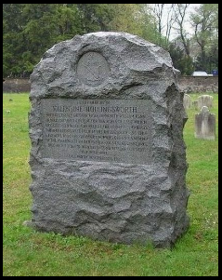

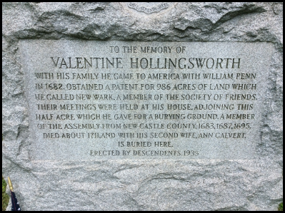

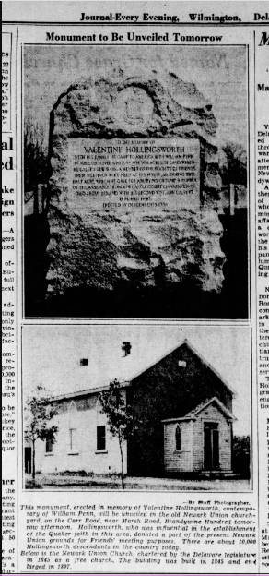

The Hollingsworth Register Articles

- No. 3, pp 97-100. Arrival in America, Valentine’s children, Henry’s marriage
- No. 3, p 120. The Good Ship “Antelope”
- No. 3, pp 140-142. Old English Hollingsworths
- No. 3, pp 143-144. Henry Hollingsworth in Northern Ireland
- No. 4, pp 154-157. More Old English Hollingsworths
- No. 4, pp 181-182. Hollingsworth births listed in Newark Monthly Meeting books.
- No. 4, p. 183. Subsidy rolls listing Harlans, Calverts, in Shankill Parish
- No. 4, pp 184-186. Information on Catherine Tyler’s family. Catherine was the wife of John Hollingsworth, son of Valentine H. and Ann Calvert, born in Newcastle, DE.
- No. 4, pp 193-195. Information on life of Valentine Hollingsworth Sr. in Newcastle, DE Quaker life, and Pennsylvania Assembly.
- No. 5, pp 1-3. More on Valentine Hollingsworth’s service in Assemblies in Pennsylvania.
- No. 5, pp 4-6. More on the Tylers. Catherine Tyler was the wife of John Hollingsworth, son of Valentine H. and Ann Calvert, born in Newcastle, DE.
- No. 10, pp 61-64. More on Samuel Hollingsworth, son of John Hollingsworth (son of Valentine, Sr.).
- No. 10, pp 65-67. List of Hollingsworth probate documents from Union District, South Carolina up to about 1875 from Salt Lake Genealogical Library.
- No. 10, pp 67-69. First Hollingsworth in Mississippi – Jacob Hollingsworth.
- No. 10, pp 84-85. Good section on Mottram, debunking the myth that the Hollingsworth manor in Cheshire went back to the Norman conquest.
- Start on No. 12 next time.

