Change History
Version | Date | Changes
FT-065.01 | 06-Jul-2024 | Original Document
FT-065.02 | 24-Jul-2024 | - Added FT-066 for Patience’s parents (Reuben Benthall and Sarah Wade)  - Added information on William living in Carteret County, NC after the Revolutionary War and buying goods at the Estate Sale of Reuben Benthall
Notes: The newest version is in blue font, and the changes made to the document are also denoted in blue font in the document below.
Parents of this Family
FT-XXX |  |  |  |  | FT-066
Philip Sanders |  | Sophia Austin |  |  | Reuben Benthall |  | Sarah Wade
1730 | 1779 | 1740 | 1782 |  | 1737 | 1782 | 1745 | 1784

This Family
William Sanders |  |  | Patience Benthall
Born | June 13, 1760^{1,2} | Married: | Born | 1765¹
Where | Carteret County, NC, USA^{1,2} | February 18, 1782 | Where | Carteret County, NC, USA¹
Died | March 13, 1851^{1,2} | Where: | Died | 1831¹
Where | Jefferson County, AL USA^{1,2} | Carteret County, NC USA | Where | Jefferson County, AL USA¹
Buried | Rock Creek Baptist Church Cemetery, Alliance, Jefferson County, Alabama, USA¹ | Source: | Buried | Unknown, probably Rock Creek Baptist Church (same as Wiliam Sanders), but no known grave.
Sources | - FindaGrave  - 707 | Geneanet | Sources | - 452b

Children:
Name | Born | Where | Source | Died | Where | Buried | Source
David |  |  | FT-035-01 |  |  |  | FT-035-01
Nancy | 1784 |  | Geneanet
Philip | 1786 |  | Geneanet
Francis | 1788 |  | Geneanet
Tamar | 1793 |  | Geneanet
Thomas | 1794 |  | Geneanet
Elijah Jones | 1795 |  | Geneanet
John W. | 1798  1803³³³ |  | Geneanet
Emily | 1798 |  | Geneanet
Ezekial | 1800 |  | Geneanet
William L. | 1801  1790³³³ |  | Geneanet
Sophia Burton | 1805  1806³³³ |  | Geneanet
Absalom | 1809  1808³³³ |  | Geneanet

Other Marriages: None

Story:
Activity | Sources
 | 729a
Revolutionary War Service  William Sanders is a DAR-recognized Revolutionary War Soldier (Ancestor # A099800). His DAR Record is:  SANDERS, WILLIAM  Ancestor #: A099800  Notice: PROBLEMS HAVE BEEN DISCOVERED WITH AT LEAST ONE  PREVIOUSLY VERIFIED PAPER - SEE ANCESTOR’S FULL RECORD  Service: NORTH CAROLINA Rank: SERGEANT  Birth: 13 Jun 1760 CARTERET CO NORTH CAROLINA  Death: 13 Mar 1851 JEFFERSON CO ALABAMA  Service Source: R9183V  Service  Description:  1) ALSO PVT, CAPT LANIER, COL JOHNSON, NC TROOPS  The note in bold red font has to do with a person who was seeking authentication of their relationship to William Sanders having an error in their genealogy. They had said that William’s son (also William) was married to an “Amma Cromby”, which is wrong. William married a “Rebecca Beauchamp”. However, this does not affect our family’s genealogical links to William Sanders or his Revolutionary War record.  William was denied a pension for his Revolutionary War service, as he could not prove at least six months of service.  Source 333 also has some other information on William’s service:  William Sanders, Lieutenant and Captain, 4th North Carolina Regiment. His name appears on a record of the proceedings of a board of officers of the North Carolina [line?] dated Feb. 6, 1782, which shows Commissioned Captains Feb. 8th, 1779.  He was in the Battle of Briar Creek, GA, Savannah River, served under Gen. Lincoln (See Records).  From American History Channel:  The Battle of Briar Creek, Georgia — A Crushing Loss for American Forces in the South  March 3, 1779  The Battle of Briar Creek (1779) was a key battle in the Southern Campaign. British forces defeated Americans in Eastern Georgia, securing British control of the area.  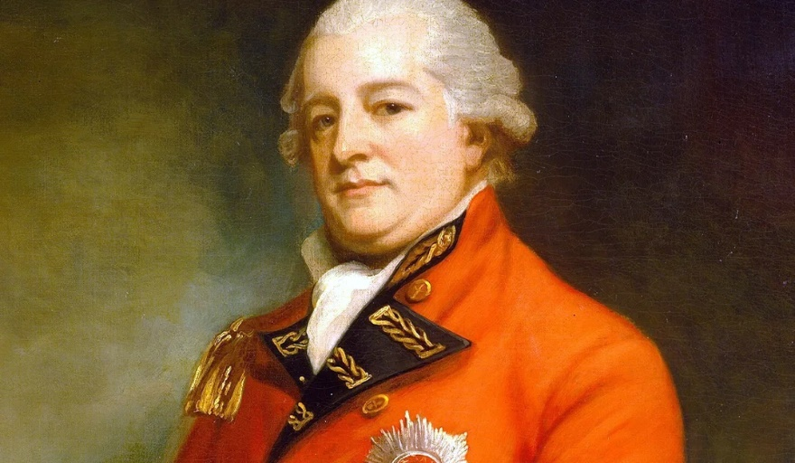  Archibald Campbell. Image Source: Wikipedia.  Battle of Briar Creek Summary  The Battle of Briar Creek — also spelled as Brier Creek — was fought between the United States of America and Great Britain on March 3, 1779, near Sylvania in eastern Georgia, around the confluence of Briar Creek and the Savannah River, during the American Revolutionary War. British forces executed a surprise attack on American forces under the command of General John Ashe after Ashe positioned his troops near Briar Creek. The British took advantage of a gap in the American line and rushed in with fixed bayonets, causing the American militia to flee. The British easily routed the Americans and captured men and supplies. With the victory, the British retained their hold on Georgia.  Battle of Briar Creek Quick Facts  - Date Started: The Battle of Briar Creek started on March 3, 1779.  - Date Ended: The battle ended on March 3, 1779.  - Location: The Battle of Briar Creek was fought in eastern Georgia, around the confluence of Brier Creek and the Savannah River.  - Theater: The battle took place in the Southern Theater of the Revolutionary War.  - Campaign: The Battle of Briar Creek was part of the Southern Campaign.  - Who Won: Great Britain won the Battle of Briar Creek.  What led to the Battle of Briar Creek?  After the British surrendered at Saratoga, the British were forced to reassess their military strategy in America. Although the British had control of New York City and Philadelphia, the war was not going well in the North or in the Middle Colonies. Further, France declared war on Britain and pledged military and financial support to the United States.  Believing there was strong Loyalist support in the South, General Henry Clinton, Commander-in-Chief of British forces in North America, devised a plan that relied on the idea that Loyalists would turn out and fight with the British. The goal was to capture the Southern Colonies, control the South, and force the rest of the American Colonies into submission.  As part of the strategy, he evacuated Philadelphia and sent troops to capture Savannah, Georgia. On June 18, 1778, the British occupation of Philadelphia ended as Clinton and around 15,000 men left the city and sailed to New York.  The British Open the Southern Campaign  Clinton sent Lieutenant Colonel Archibald Campbell and 3,100 men from New York to Savannah, for the purpose of capturing the city. A second British force, led by General Augustine Provost, marched out of St. Augustine, in the British Colony of East Florida, toward Savannah.  British Forces Capture of Savannah at the First Battle of Savannah  On December 23, Campbell landed downriver from Savannah. The city was defended by a small force of 650 to 900 men, under the command of General Robert Howe. The Americans took defensive positions just south of Savannah, where they were surrounded by swamps, which Howe hoped would slow the British advance. The British found a path through the swamps on the right flank of the American line and attacked. The Americans were overwhelmed and quickly retreated. Within an hour, the British were in control of Savannah.  British Forces Capture Augusta  After the battle, Augustine Prevost arrived and reinforced Campbell. As Campbell’s superior, Prevost assumed command of the garrison at Savannah. A month later, Campbell marched toward Augusta, expecting to be joined by Loyalists and Native American Indians who were allied with the British. The response was nothing near what Campbel expected. During the march, he was harassed by American forces, under the command of General Andrew Williamson. However, Williamson was not able to stop Campbell and the British captured Augusta on January 29, 1779.  American Victory at Kettle Creek  Soon after the British captured Augusta, Colonel John Boyd, a Loyalist, worked his way through the backcountry of North Carolina and South Carolina, gathering Loyalists who were willing to fight for the British. As he marched to Augusta, he was harassed by Patriot forces. When General Benjamin Lincoln deployed American forces around Augusta, Campbell decided to abandon the city and return to Savannah on February 13. Boyd was unaware and continued his march, crossing into Georgia. Boyd was also unaware that South Carolina forces led by Colonel Andrew Pickens were closing in to engage him. On the morning of February 14, Boyd and his men were on the march when they stopped near Kettle Creek in Wilkes County, Georgia, just long enough for Pickens to launch his attack. After intense fighting carried on for roughly an hour and a half, Boyd was shot and fell, mortally wounded. Seeing him fall, his men scattered and moved south. The Loyalists suffered heavy casualties and the Patriots captured around 75 men. Although the Battle of Kettle Creek was a small victory, it came less than two weeks after the American victory at the Battle of Beaufort and helped boost American morale in Georgia.  What happened at the Battle of Briar Creek?  While Pickens moved to attack Boyd, General Benjamin Lincoln made preparations to attack British forces and drive them out of Georgia. He targeted Augusta, and from his camp at Purrysburg, he deployed:  - General Andrew Williamson and 1,000 men to the east side of the Savannah River, directly across from Augusta.  - General Griffith Rutherford and 800 men went to the Black Swamp.  - General John Ashe and Colonel Samuel Elbert marched to reinforce Williamson. Ashe had 1,400 North Carolina Militia under his command and Elbert had 100 Georgia Continentals. Ashe led the reinforcements and they arrived at Williamson’s position on February 13.  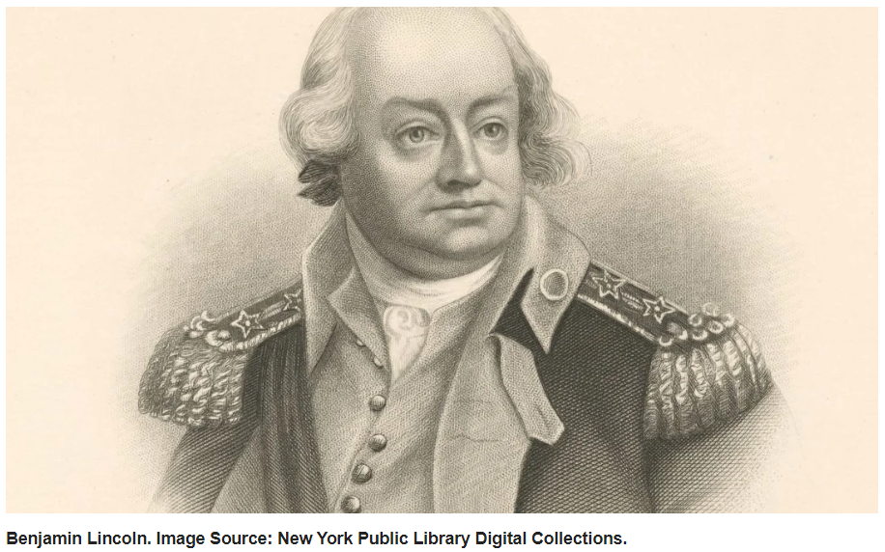  As American forces converged near Augusta on the 13th, Campbell, and the British left and marched to Savannah.  Although most of his men were inexperienced militia, Ashe pursued Campbell and crossed into Georgia on February 25. Two days later, he found the Freeman-Miller Bridge over Briar Creek had been burned by the British. The bridge was necessary to cross the creek, which was close to the Savannah River and surrounded by a deep swamp.  Ashe ordered his men to start rebuilding the bridge and waited for reinforcements from Lincoln and Rutherford. Once they joined together, they planned to resume the pursuit of Campbell.  Campbell was near Hudson’s Ferry, a fortified British outpost 15 miles south of Briar Creek when he received orders from General Prevost to engage Ashe and his men. Prevost also sent reinforcements. Campbell and the officers devised a plan that included:  - A diversion — Major William Macpherson and his First Battalion of the Seventy-first Regiment, along with a Loyalist Militia, would occupy the south bank of Briar Creek and fire on the Americans with two cannons.  - An attack on the American rear — Lieutenant Mark Prevost, The general’s younger brother, would attack the rear of the American forces with the Second Battalion of the Seventy-first, Captain Sir James Baird’s light infantry, three companies from the Sixtieth Regiment, a troop of mounted Loyalists, and 150 militia infantry.  The rear of the American force included General David Bryant’s brigade, Lieutenant William Lytle’s light infantry, Elbert’s Georgia Continentals, three small cannons, and two hundred mounted Georgia militia under the command of Colonel Leonard Marbury. On March 1, some of Marbury’s men had spotted the British but the messenger they sent to warn Ashe’s camp was intercepted.  On March 3, Campbell’s men moved into position and attacked. They were within 150 yards when Elbert’s Continentals moved out and fired on them. During the fight, a gap appeared in the American line. The British took advantage and rushed into the gap with their bayonets fixed. The militia forces on the line panicked and fled. Elbert and the Continental Regulars held their ground but they were surrounded, forced to surrender, and captured.  Ashe tried to rally his men, but too many of the militia headed for the swamps and the Savannah River. Although many of them were able to escape by crossing the river on rafts or by swimming, some of them also drowned.  Significance of the Battle of Briar Creek  The Battle of Briar Creek is important to United States history because it was a significant victory for the British, allowing them to maintain control of Georgia. From there, they planned to move north and capture the rest of the Southern Colonies.  William Moultrie’s Account of the Battle of Brier Creek  The different divisions of our army formed several camps, one at Purrysburg, commanded by Maj. Gen. Lincoln, of between 3 and 4,000 men: one at Briar Creek, on the west side of the river commanded by Maj. Gen. Ashe, of about 2,300 men; and one at Williamson’s house, on Black Swamp, under Gen. Rutherford, of 7 or 800 men; besides Gen. Williamson’s division at Augusta of about 1200 men all these together made a pretty strong army, and we began to prepare to cross the river, and give the enemy battle; and Gen. Lincoln sent a messenger to Gen. Ashe, to meet him and myself at Gen. Rutherford’s camp, to hold a council of war; upon a plan of operations, and of crossing the river, and attacking the enemy: accordingly, about the first of March, Gens. Lincoln, Ashe, Rutherford, and myself, had a meeting, and we agreed to march the army from Purrysburg (first leaving a strong guard there, to watch the enemy’s motion) to Gen. Rutherford’s camp, and cross the river, to join Gen. Ashe; this being settled, Gen. Lincoln and myself returned to Purrysburg. At the council of war, in conversation with Gen. Ashe, he assured us that he thought himself perfectly safe where he was; that he had taken a good position on Briar Creek, that his camp was very secure; and that the enemy seemed to be afraid of him, believing his numbers to be much greater than they were; he only asked for a detachment of artillery, with a field-piece or two, which Gen. Lincoln immediately ordered, under the command of Major Grimkie. On the 3d of March, in the evening, to our great surprise and astonishment, Col. Eaton having swam the river with his horse, came full gallop into our camp, and told us that Gen. Ashe and his whole army were cut off: this to be sure occasioned grave faces in camp: presently after this, Gen. Lincoln received the following letter from Gen. Ash.  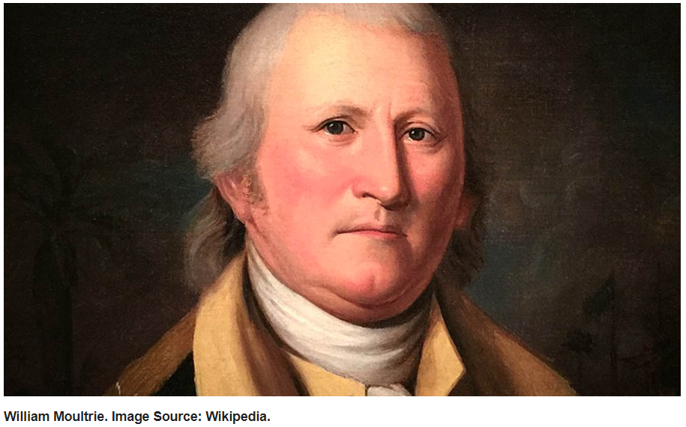  Ashe’s Letter to Benjamin Lincoln  I am sorry to inform you that at 3 o’clock, p.m. the enemy came down upon us in force what number I know not: the troops in my division did not stand fire for five minutes; many fled without discharging their pieces. I went with the fugitives half a mile and finding it impossible to rally the troops, I made my escape into the river swamp, and made up in the evening to this place; 2 officers and 2 soldiers came off with me; the rest of the troops, I am afraid, have fallen into the enemy’s hands, as they had but little further where they could fly to: luckily Major Grimkie had not got the artillery out of the boat so that I shall keep them here with Gen. Rutherford’s brigade to defend this pass until I receive further orders from you. This instant Gen. Bryant and Col. Perkins arrived.  Since writing the above, a number of officers and soldiers have arrived: we have taken a man, who says he was taken by them, and would not take their oath, and was formerly under Lee to the Northward. He informed there were 1,700 redcoats, in the action, also a number of new levies from New York, Georgia militia, and Florida scouts: that 1,500 men had marched up to Augusta, to fortify that place; that they are fortifying Hudson’s very strongly: that the day before they marched off, 7,000 men had arrived from New York. Gen. Bryant and Rutherford are of opinion that it is better to retreat to your quarters; therefore I am inclined to march tonight when we get all our fugitives over. [John Note: End of Citation]  Other articles about this battle can be found at:  - The Battle of Briar Creek  - American Revolutionary War  [John Notes about William’s Revolutionary War Service]  Looking at William Sanders’ DAR record, it says he was a Seargent, but also a Private, serving under Captain Lanier, who served under Colonel Johnson in North Carolina. If I go to Carolina.com, I can find lists of NC people who served in the Revolutionary War by rank. So if I look under Privates, who served under a Captain Lanier, we find:  Name Unit Year Enlisted Year Discharged Service Description Battles  Sanders, William 2nd NC Regiment 1777 1780 2/1/1777, a Private under Capt. Benjamin Williams for 3 years. Discharged on 2/1/1780.  Sanders, William DQMG 1780 1781 1780, a Private under Col. Nicholas Long (DQMG). Lived in Franklin County. 1781, a Private under Capt. William Christmas (Warren County Regiment) and Col. Pinketham Eaton (a Continental Major acting as a Militia Colonel). Guilford Court House.  Ok, so no luck on finding a link between a William Sanders as a Private and a Captain Lanier. Ok, now look under Captains for a Captain Lanier, we find:  Name Unit Year Enlisted Year Discharged Service Description Battles  Lanier, James Pitt County Regiment 1778 1779 1778-1779, a Captain under Col. John Simpson. 1779, attached to Col. Jonas Johnston (Edgecombe County Regiment) at the battle of Stono Ferry, SC. Stono Ferry (SC).  There is another Captain Lanier, but he is not associated with a Colonel Johnson (or Johnston, in this case – maybe a mis-spelling). So that is promising, but we need to find a link between Captain Lanier and a William Sanders. If I look for a William Sanders as a Lieutenant (which is what Source 333 says), we find:  Name Unit Year Enlisted Year Discharged Service Description Battles  Saunders, William 1st NC Regiment 1779 1783 Was an Ensign. 2/8/1779, a Lieutenant. Then a Captain. Resigned on 1/1/1783. Aka William Sanders. R20211.  I am not sure if this is our William Sanders, as this one enlisted in 1779 and left service in 1783, and our William Sanders couldn’t prove 6 months of service in order to get a pension.  So difficult to make the data I find match with the data from the DAR, but I think I will stop worrying about it. | 333  American History Channel
William Sanders in Carteret County, NC pre-Revolutionary War  In my research on Reuben Benthall, I ran across William Sanders living next to Reuben in Carteret County, NC after Reuben died in approximately 1782. In this document, we can see that William Sanders was living next door to Reuben Benthall when Reuben died. Also William spent quite a bit of money buying some of Reuben’s belongings at the first Estate Sale of Reuben’s goods on October 23, 1784. Willam bought £123, 10 pence of stuff, which equates to about $28,000 in today’s money!  Not all of Reuben’s goods sold on October 23, 1784. There was a second auction sale on September 8, 1786. At this sale, William bought a bible belonging to Reuben’s family and a ram for 14 shillings and 6 pence.  William lived next door to Reuben Benthall at this time (again, see 729a). So it makes sense that he would know and marry Patience Benthall. | 729a
1790 US Federal Census, unknown enumeration date, Carteret County, North Carolina, USA  In 1790, a William Sanders was living in Carteret County, North Carolina. The household consisted of:  - 2 males under 16 years  - 1 male 16 and over  - 4 females  Again, according to Geneanet, these would be:  - 2 males under 16 years (David and Philip)  - 1 male 16 and over (William)  - 4 females (Nancy, Francis, ?, and Patience)  This fits reasonably well with our other sources of information, except for the extra female. That person could be a mother-in-law, a sister, or a daughter who died after the census was taken and that we do not know anything about. | 714
1800 US Federal Census, unknown enumeration date, Wilmington, Onslow County, North Carolina, USA  In 1800, there is a William Sanders in Wilmington, North Carolina. It consists of 10 people:  - 4 males and 1 female under 10 years of age  - 1 male and 1 female of 10 years but under 16 years  - 1 male of 16 years but under 26 years  - 1 male and 1 female of 26 years but under 45 years  If we compare this information to that from Geneanet, does it match? In 1800, according to this Geneanet site, the following children of William and Sanders would be alive:  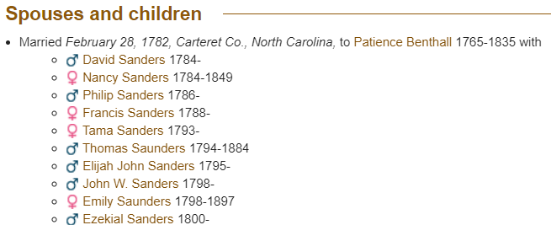  So the 4 males under 10 years old would be: Ezekial, John W. Elijah John, and Thomas. The 1 female would be either Emily or Tama (so not a great fit, but maybe Tama died before 1800?). The male 10 to 16 would be Philip and the female 10 to 16 would be Francis. The male 16 to 26 would be David. The older male would be William, who would be 40 years old in 1800. The older female would be Patience, who should be 35 years old. So everything fits except for the extra female under 10 years old. So not a bad fit. It’s also in the right place. | 713
1810 US Federal Census, enumerated August 6, 1810, in Hopkinsville, Christian County, Kentucky, USA  In 1810, we find the William Sanders – Patience Benthall family living in Hopkinsville, Christian County, Kentucky. This one was a little tricky, as there are two William Sanders on the same page of the Census document, and it took me some time to figure out how to get “my” William Sanders to show up in my list of saved documents. But eventually I did. William’s household consists of  - 3 white males and 1 white female under 10 years of age  - 2 white males of 10 years but under 16 years  - 4 white females of 16 years but under 26 years  - 1 white male and 1 white female 45 years and upward (William and Patience)  - No other free persons  - No slaves  I don’t know who all of the children are. Geneanet lists the following children:  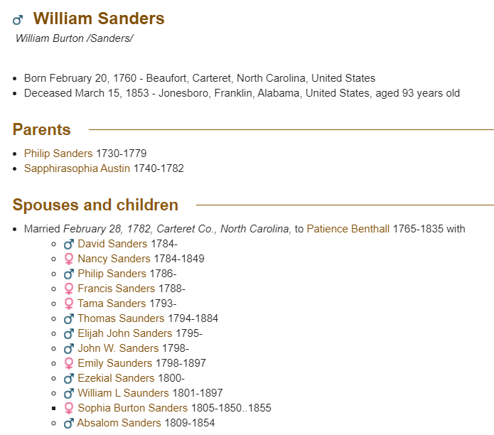  So in 1810, the 3 boys under 10 years old could be Absalom (b. 1809), William L. (b. 1801) and Ezekial (b. 1800). The 1 girl could be Sophia Burton (b. 1805). The 2 boys 10 to 15 could be John W. (b. 1798), Elijah John(b. 1795). The 4 girls 16 to 25 years old could be Nancy (b. 1784), Francis (b. 1788), Tama (b. 1793), and maybe Emily (b. 1798). Emily would have only been 12 to 13, but maybe someone made a mistake here. It is most likely that Philip (b. 1786) and David (b. 1784) were off and on their own. In fact, on the same page of the Census document in Source 711, there is a David Sanders and a Philip Sanders. I will have to look at them to see if the ages are right.  David Sanders in Source 711 Household:  - 2 males under 10 years old (Owen and Ammon)  - 1 male 26 to 44 years old (David)  - 1 female 16 to 25 years old (Unknown, but maybe David’s sister Nancy?)  - 1 female 26 to 44 years old (Margaret)  So this is potentially the correct David. It also helps that David served in the War of 1812 in a company known as the “Kentucky Rifles”, so he should have been in Kentucky during this period.  Philip Sanders in Source 711 Household:  - 1 male under 10 years old  - 1 male 26 to 44 years old (Philip should be 24 to 25 years old)  - 2 females under 10 years old  - 1 female 26 to 44 years old  So not a great fit for Philip, but then again, I don’t know much about Philip.  But I think we have found the right William and the right David Sanders now. | 711
1820 US Federal Census  In 1820, William Sanders and Patience Benthall should have been living in Jefferson County, AL. The Rock Creek Baptist Church in Jefferson County was organized on May 25th, 1820 and William and Patience were founding members. However, I cannot find any record of a William Sanders in Alabama in 1820.  The 1820 census built on the questions asked in 1810. The age questions were the same, except for the addition of a 16 - 18 years category for males.  - The number of free White males and females aged, respectively:  - under 10 years of age  - of 10 years but under 16 years  - of 16 years but under 18 years (for males)  - of 16 years but under 26 years (for males)  - of 16 years but under 26 years (for females)  - of 26 years but under 45 years  - 45 years and upward  - The number of male and female slaves aged, respectively:  - under 14 years of age  - of 14 years but under 26 years  - of 26 years but under 45 years  - 45 years and upwards  - The number of free colored males and females aged, respectively:  - under 14 years of age  - of 14 years but under 26 years  - of 26 years but under 45 years  - 45 years and upwards  - Number of foreigners not naturalized  - Number of persons (including slaves) engaged in agriculture, commerce, and manufactures | 147, 311 (same document)
1830 US Federal Census, unknown enumeration date, from Jefferson County, AL USA  In 1830, we find William Sanders still in Jefferson County, AL. He is between 70 and 80 years old (he should be about 70 at this time) and is living with two women. One is between 70 and 80 years old (Patience?) and one between 15 and 19 years old (not necessarily Sophia, who should be about 25 years old at this time). William’s family owns no slaves. | 710
1840 US Federal Census, unknown enumeration date, Jefferson County, AL USA  In 1840, I think we have found William Sanders in Jefferson County, AL. It’s hard to tell, as the copy of the census is so bad that it’s difficult to be sure. William is classified as between 70 and 80, which is about right for our William as he should be about 80 at this time. He is living with a woman who is between 20 and 30 years old. William and Patience had a daughter – Sophia – who was born around 1805 (before Absalom), so she would be about 35 years old and unless the census taker put the mark in the wrong column, it is not Sophia that William is living with. We will have to see if other daughters that are younger than Sophia show up in earlier census documents.  As Patience (if she were still alive and living with William) would be about 75 years old, she must have died (or left) before 1840. | 709
1850 US Federal Census, enumerated December 7, 1850, in Jefferson County, AL USA  In 1850, we find William Sanders – 90 years old – living in the household of his son, Absalom (40) and his wife Ann (35). Absalom is a farmer, and owns $500 of real estate. Absalom and Ann’s children were:  - William, son, 11 years old, born in AL  - John W., son, 9 years old, born in AL  - Robert B., son, 6 years old, born in AL  - Margaret, daughter, 3 years old, born in AL  - Absalom W., son, 11 months old, born in AL  So we know Patience must have died prior to 1850.  William was born in NC, Absalom in KY, and Ann in GA.  I searched the 1850 Slave Schedules and didn’t see any record of an Absalom Sanders owning slaves in the schedule.  What this also tells us is that we should look for William Sanders in the 1810 Census in Kentucky. | 708
William Sanders Death  William Sanders died in Jefferson County, AL on March 13, 1851. Source 707 is a copy of William Sanders’ obituary from July 12, 1851 in the “Tennessee Baptist” newspaper in Nashville, TN. There’s a typo in the article in the first paragraph which says that the year he died was 1852, but it was 1851. | FindaGrave  707

