|  |  |
| --- | --- |
| **RD-010** | Solomon Smith’s (1785 – 1861) Parents |

In my system, an “RD-###” document is a “Research Document” that is used before I transfer information to an “FT-###” document, which is a “Family Tree” document. The Family Tree documents are more statements of the various facts of that particular family, while the Research documents are more investigative, intuitive, and sometimes just plain guessing. If you see something named “Source ###”, that is my numbering system for the various sources that back up the conclusions in the FT and RD documents. Sources, FT documents, and RD documents are all numbered sequentially as I create them.

So I have been having trouble identifying Solomon Smith’s parents. Smith is such a common name that it is presenting great difficulties in identifying particular Solomon Smiths. I think I have traced Solomon Smith solidly back to 1810 in Laurens County, SC. But going back further requires a bit of research. So let’s get started.

|  |  |  |  |
| --- | --- | --- | --- |
| **Item #1** | **Census** | **Ancestry.com** | **1800 US Federal Census, unknown enumeration date, Spartanburg, SC USA (Source 473)** |

In 1800, my Solomon Smith was only about 15 years old and was probably living with his parents. I have seen some information suggesting his father’s name was also Solomon (or Soloman). There are 3 Solomons (or Solomans) living in SC at this time – one in the Pendleton District (which was abolished in 1826). The Pendleton District was out in western SC. A second Solomon Smith was in Lancaster District. I think my Solomon Smith is from the Spartanburg District, as that is where my Solomon Smith was born. So that’s the census document represented by Source 473. In that Census document, the family consists of:

* 2 males under 10 years of age
* 1 male and 1 female of 16 years but under 26 years

Not quite a good match. Assuming that the older male and female are the parents, there is no male child approximately 15 years old. So it is probable that this is not my family. Maybe my Solomon’s father is not named Solomon after all. We will continue looking.

|  |  |  |  |
| --- | --- | --- | --- |
| **Item #2** | **Lineage** | **Google Search on “Solomon Smith” AND “South Carolina” AND 1785.** | **https://www.smithsworldwide.org/tng/getperson.php?personID=I101006&tree=tree1** |

This webpage lists Solomon Smith and his wife Elizabeth Crow, but doesn’t have any information on Solomon’s parents.

|  |  |  |  |
| --- | --- | --- | --- |
| **Item #3** | **Lineage** | **Google Search on “Solomon Smith” AND “South Carolina” AND 1785.** | **https://www.geni.com/people/Soloman-Smith/6000000003506713397** |

This Geni.com webpage says Solomon’s parents were Nathan Smith and Mary “Polly” Langston. The problem with this is that the website also says that Nathan died in 1770 and Solomon was born in 1785. So that’s a problem! I don’t think I can trust this page either.

|  |  |  |  |
| --- | --- | --- | --- |
| **Item #4** | **Lineage** | **Google Search on “Solomon Smith” AND “South Carolina” AND 1785.** | **https://ancestors.familysearch.org/en/KJ4N-5VT/sarah-helen-smith-1816-1874** |

FamilySearch.org is the Mormon genealogical website, and is a “one world” tree. So anyone can make changes to the “one tree” for all the world. There is a lot of bad work on this website. So it’s difficult to trust it. In our case, it doesn’t matter, since FamilySearch.org doesn’t have any information on Solomon’s parents!

|  |  |  |  |
| --- | --- | --- | --- |
| **Item #5** | **Lineage** | **Google Search on “Solomon Smith” AND “South Carolina” AND 1785.** | **https://gw.geneanet.org/tdowling?lang=en&pz=timothy+michael&nz=dowling&p=solomon&n=smith&oc=4** |

This is Tim Dowling’s Geneanet.com webpage, and I am totally untrusting of Tim’s work, as he says he has over a half million people in his family tree. So probably very little verification work is being done here. It doesn’t matter to us, as he doesn’t list any parents for Solomon.

|  |  |  |  |
| --- | --- | --- | --- |
| **Item #5** | **Lineage** | **Google Search on “Solomon Smith” AND “South Carolina” AND 1785.** | **https://www.anamericanfamilyhistory.com/TennesseeFamilies&Places/Smith%20Family/Smith%20Zebulon%201758.html** |

This looks like someone’s personal webpage for Smith Family history, and they list a Solomon Smith as someone who hired a “Zebulon Smith” as his substitute for the Revolutionary War in 1780. Our Solomon Smith was born in 1785, so it’s not him. If our Solomon’s father was also Solomon, then that’s a possibility.

This page does say that Zebulon had a child named Solomon who was born in 1787, so that’s pretty close to our Solomon’s birth year of 1785. Let’s leave this as a possibility.

|  |  |  |  |
| --- | --- | --- | --- |
| **Item #6** | **Lineage** | **Google Search on “Solomon Smith” AND “South Carolina” AND 1785.** | **http://genealogytrails.com/scar/spartanburg/land_records3.htm** |

This is a page talking about land records for the Couch family. It lists some land that was bordered by land owned by a Solomon Smith, but no lineage information.

|  |  |  |  |
| --- | --- | --- | --- |
| **Item #7** | **Lineage** | **Google Search on “Solomon Smith” AND “South Carolina” AND 1785.** | **http://files.usgwarchives.net/al/perry/cemeteries/ocmulgee.txt** |

This is a list of burials in Ocmulgee Church Cemetery in Perry County, AL, USA. Of interest to us are:

Smith, Elizabeth (Mrs.) Dec 15, 1797 Nov 19, 1889 Consort of Solomon Smith and oldest child of Rev. Charles Crow

Smith Solomon Oct 22, 1785 May 6, 1861 Born in Spartanburg, SC

Crow, Rev. Charles [1770] Jun 12, 1845 Age 75 Late pastor of Ocmulgee Ch. Ordained Aug 30, 1807

But no lineage information for Solomon Smith. Let’s keep looking.

|  |  |  |  |
| --- | --- | --- | --- |
| **Item #8** | **Lineage** | **Google Search on “Solomon Smith” AND “South Carolina” AND 1785.** | **http://www.blankensteingenealogy.net/smith.htm** |

This webpage also appears to be a family’s genealogy webpage. There are no sources listed for the information in this page. What is does have is:

**Dianne's Mother's Line**

**Descendants of William Smith**

**Generation No. 1**

[WILLIAM1 SMITH](http://www.blankensteingenealogy.net/william_smith_&_anne.htm)died Bef. 1796 in Union, South Carolina. He married ANNE. Children of WILLIAM SMITH and ANNE are:

1. CATHERINE2 SMITH, d. November 20, 1839.
2. POLLY SMITH, m. BENNETT LANGSTON.
3. MILLY SMITH, m. WILLIAM EDWARDS.
4. MARTHA SMITH, m. STEPHEN LAYTON, JR..
5. JOHN SMITH, m. NANCY.
6. WILLIAM SMITH, m. NANCY.
7. ELIZABETH SMITH, m. WILLIAM PARKER.
8. SOLOMON SMITH, m. PATSY.
9. FRANCIS SMITH, m. SALLY.
10. NATHAN SMITH.

This shows that a Solomon Smith married a “Patsy”. Our Solomon Smith married Elizabeth Crow, so I don’t think this is our Solomon Smith.

If you click on the link above for “William Smith1”, you get to a page that shows a quit claim for William Smith’s wife Anne. Again, I am not sure if this is my Smith family since the wife of this Solomon doesn’t seem to be correct.

|  |  |  |  |
| --- | --- | --- | --- |
| **Item #9** | **Lineage** | **Google Search on “Solomon Smith” AND “South Carolina” AND 1785.** | **https://www.werelate.org/wiki/Person:Zebulon_Smith_%282%29** |

This is another page that refers to Zebulon Smith, but seems to be better documented. This lists one of his children as a Solomon Smith, but states that this Solomon Smith was born about 1781 in Sullivan County, TN. So this is probably not our Solomon Smith, and therefore Zebulon Smith is not our Solomon’s father.

|  |  |  |  |
| --- | --- | --- | --- |
| **Item #10** | **Lineage** | **Google Search on “Solomon Smith” AND “South Carolina” AND 1785.** | **https://www.genealogy.com/forum/users/834175795/** |

This webpage shows some forum threads on various families, some of which are related to me. The particular threads that I am interested in are:

<https://www.genealogy.com/forum/users/834175795/pg-2/> - these are posts by Mary Carol Sheets. She and I must definitely be related as she is researching many of my ancestors. The issue is that most of her posts were in the year 2000 or thereabouts. She may not be doing this any longer, so we will have to see how her work went 23 years ago!

|  |  |  |  |
| --- | --- | --- | --- |
| **Item #11** | **Lineage** | **Google Search on “Solomon Smith” AND “South Carolina” AND 1785.** | **http://woodswell.com/family/genealogy/p85.htm** |

This is an interesting page. It seems well documented. It states that Solomon’s father was William Smith (same as an earlier webpage) and his mother was Anne Langston. Their information is:

## William Smith

M, d. 1796

|  |  |  |
| --- | --- | --- |
| Census* | 1779 | William **Smith** appeared on the census of 1779 at Ninety-Six, South Carolina; Name:      William Smith State:      SC County:      Ninety-Sixth District Township:      No Township Listed Year:      1779 Database:      SC Early Census Index.1 |
| Census | 1790 | He appeared on the census of 1790 at Page No. 6, Spartanburg, South Carolina; Name:      Wm Smith County:      Spartanburg State:      South Carolina Number of Free White Males Under 16:      4 Number of Free White Males 16 and Over:      2 Number of Free White Females:      2 Number of Slaves :      13 Number of Household Members:      21.2 |
| Religion* | between 1794 and 1804 | He was In membership books: Caleb Smith, Dicy Smith, James Smith, John Smith, Jr., Polly Smith, William Smith.3 |
| Will* | circa 1796 | He left a will circa 1796 at Union, South Carolina; p. 385 William Smith, of Union District, died about 1796 leaving widow, Anne, and children: John, Patsy, Solomon, Catherine (wife of Nathan Langston), Polly (wife of Bennett Langston), Milly (wife of William Edwards), Elizabeth (wife of William Parker), Nancy (wife of John Smith), Nancy Ann (wife of William Smith), Martha (wife of Stephen Layton).4 |
| Death* | 1796 | He died in 1796 at Union, South Carolina.4 |

|  |  |  |
| --- | --- | --- |
| Family |  | |
| Children |  | * [Catherine **Smith**](http://woodswell.com/family/genealogy/p183.htm#i11437)**+**4 b. 6 Jan 1764, d. 20 Nov 1839 * [Mary Polly **Smith**](http://woodswell.com/family/genealogy/p183.htm#i11438)4 b. bt 1771 - 1780, d. 22 Jul 1819 * [Solomon **Smith**](http://woodswell.com/family/genealogy/p85.htm#i4766)**+**4 b. 22 Oct 1785, d. 6 Jan 1861 * [(?) **Smith**](http://woodswell.com/family/genealogy/p183.htm#i11428)5 b. c 1786 |

### Citations

1. [[S498](http://woodswell.com/family/genealogy/s4.htm#s498)] *South Carolina Census, 1790-1890.*
2. [[S709](http://woodswell.com/family/genealogy/s11.htm#s709)] 1790 US Census, Provo, Utah, Utah, Page: 24; Image: 34.
3. [[S525](http://woodswell.com/family/genealogy/s4.htm#s525)] Leah, Ph.D. Townsend, *South Carolina Baptists 1670-1805.*
4. [[S523](http://woodswell.com/family/genealogy/s4.htm#s523)] George Leland, SR., A.B., A.M. Summer, *Newberry County, South Carolina Annals.*
5. [[S489](http://woodswell.com/family/genealogy/s11.htm#s489)] Unknown record type, unknown repository address.

## Ann Langston

F, b. circa 1765

|  |  |
| --- | --- |
| Father* | [Solomon **Langston** Senior](http://woodswell.com/family/genealogy/p184.htm#i11453) b. 1732, d. 1825 |
|  |  |

|  |  |  |
| --- | --- | --- |
| Birth* | circa 1765 | Ann **Langston** was born circa 1765 at South Carolina.1 |
|  |  | She was the daughter of [Solomon **Langston** Senior](http://woodswell.com/family/genealogy/p184.htm#i11453). |
| Census* | 1800 | Ann Langston appeared on the census of 1800 at Spatanburg, South Carolina; Name:      Ann Smith County:      Spartanburg District State:      South Carolina Free White Males 10 to 15:      1 Free White Females 10 to 15 :      1 Free White Females 26 to 44 :      1 Number of Household Members Under 16 :      2 Number of Household Members Over 25 :      1 Number of Household Members:      3.2 |
| Census | 1810 | She appeared on the census of 1810 at Spartanburg, South Carolina; Name:      Ann Smith County:      Spartanburg State:      South Carolina Free White Males Under 10:      2 Free White Females 16 to 25:      1 Free White Females 26 to 44:      1 Free White Females 45 and Over:      1 Number of Household Members Under 16:      2 Number of Household Members Over 25:      2 Number of Household Members:      5.1 |

### Citations

1. [[S708](http://woodswell.com/family/genealogy/s11.htm#s708)] 1810 unknown record type, Provo, Utah, Utah, Roll 61; Page: 427.
2. [[S489](http://woodswell.com/family/genealogy/s11.htm#s489)] Unknown record type, unknown repository address.

|  |  |  |  |
| --- | --- | --- | --- |
| **Item #12** | **Lineage** | **Citation #4 from Item #11** | **Results (see below)** |

As I said above, Item #11 looks very interesting. I decided to investigate some more. The 4th footnote for William Smith above is cited to refer to William’s children: Catherine, Mary Polly, Solomon, and an unknown 4th child. The citation is:

[[S523](http://woodswell.com/family/genealogy/s4.htm#s523)] George Leland, SR., A.B., A.M. Summer, *Newberry County, South Carolina Annals.*

I clicked on the [S523] link, and got an expanded citation of:

[S523] George Leland, SR., A.B., A.M. Summer, *Newberry County, South Carolina: Historical & Genealogical Annals* (Baltimore, MD: Glearfield Company, Genealogical Publishing Company, 1950, reprinted 1980, 1992, 1995, 2002). Hereinafter cited as *Newberry County, South Carolina Annals.*

I did a Google search on “Newberry County, South Carolina: Historical & Genealogical Annals” and found a place that I could purchase a pdf of this book (Source 474). After paging through this document, on page 384 I found the citation that I was seeking:

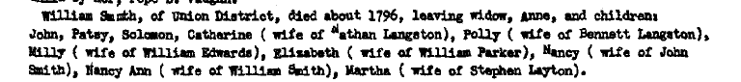

So this is the source of the statement that Solomon Smith’s father is William Smith. It is also encouraging that several Langstons are mentioned. The Langstons and Smiths lived near each other when they both attended Upper Duncan Creek Church in the 1820s and 1830s. I guess the next questions are:

* How close are the Union District and Spartanburg, where Solomon was born.
* Can I find William’s family in the 1790 Federal Census, with a male child of Solomon’s approximate age?
* Is there any research among Solomon’s siblings and their spouses that will point out that this is the right family?

|  |  |  |  |
| --- | --- | --- | --- |
| **Item #13** | **Locations** | **How close are the Union District and Spartanburg?** | **Results** |

In the map posted below, you can see that Union County (outlined) is VERY near Spartanburg and also Laurens. These are all of the places that are associated with my Smith family in South Carolina. So this supports the theory that the William Smith who died in Union County may be the father of my Solomon Smith.

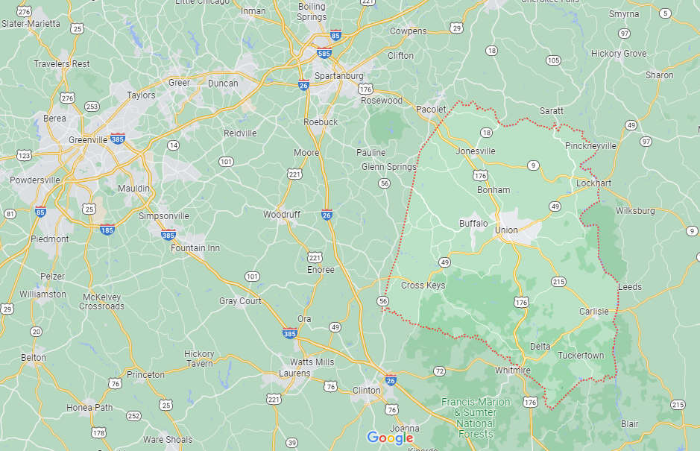

|  |  |  |  |
| --- | --- | --- | --- |
| **Item #14** | **1790 US Federal Census** | **Can I find William’s family in the 1790 Federal Census, with a male child of Solomon’s approximate age?** | **Results (See below and Item #11)** |

Here is a map showing how the Districts of South Carolina were divided up into counties.

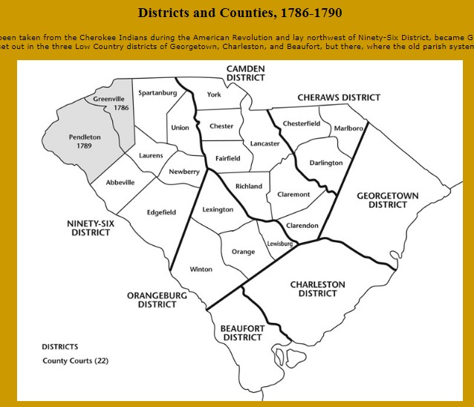

After digging through the 1790 Federal Census for the Ninety-Six District of South Carolina (Union, Laurens, Spartanburgh, and Newberry Counties) (Sources 478x, 480x, 482x, 483x), here are the options I have come up with:

| **County** | **Head of Household** | **White males =>16 years** | **White males < 16 years** | **White females** | **All Other Free People** | **Slaves** |
| --- | --- | --- | --- | --- | --- | --- |
| Laurens | John Smith | 1 | 1 | 1 | 0 | 5 |
| Laurens | James Smith | 1 | 1 | 2 | 0 | 0 |
| Laurens | Peter Smith | 1 | 1 | 2 | 0 | 0 |
| Laurens | John Smith | 1 | 1 | 1 | 0 | 0 |
| Laurens | William Smith | 1 | 2 | 3 | 0 | 0 |
| Laurens | William Smith | 1 | 3 | 2 | 0 | 0 |
| Laurens | Charles Smith | 1 | 2 | 2 | 0 | 5 |
| Newberry | William Smith | 1 | 2 | 3 | 0 | 0 |
| Newberry | Thomas Smith | 2 | 2 | 4 | 0 | 0 |
| Newberry | Daniel Smith | 2 | 1 | 2 | 0 | 0 |
| Newberry | James Smith | 1 | 3 | 5 | 0 | 0 |
| Spartanburgh | William Smith **1** | 1 | 3 | 3 | 0 | 0 |
| Spartanburgh | Charles Smith **2** | 4 | 4 | 7 | 0 | 0 |
| Spartanburgh | John Smith | 2 | 2 | 6 | 0 | 0 |
| Spartanburgh | Peter Smith | 2 | 3 | 2 | 0 | 0 |
| Spartanburgh | James Smith, Jr. | 1 | 0 | 2 | 0 | 0 |
| Spartanburgh | James Smith, (Sr.?) | 2 | 2 | 6 | 0 | 8 |
| Spartanburgh | William Smith | 1 | 3 | 5 | 0 | 0 |
| Spartanburgh | John Smith | 1 | 0 | 1 | 0 | 0 |
| Spartanburgh | Joel Smith | 1 | 1 | 3 | 0 | 0 |
| Spartanburgh | Joshua Smith | 1 | 2 | 4 | 0 | 0 |
| Spartanburgh | James Smith, (Sr.?) | 1 | 0 | 2 | 0 | 0 |
| Spartanburgh | Thomas Smith | 1 | 0 | 1 | 0 | 0 |
| Spartanburgh | Flemmon Smith | 2 | 2 | 5 | 0 | 0 |
| Spartanburgh | Samuel Smith | 1 | 1 | 3 | 0 | 0 |
| Spartanburgh | Zepho Smith | 1 | 0 | 1 | 0 | 0 |
| Spartanburgh | Bucknier Smith | 2 | 2 | 5 | 0 | 1 |
| Spartanburgh | William Smith | 2 | 4 | 2 | 0 | 13 |
| Spartanburgh | Elish Smith | 1 | 3 | 3 | 0 | 1 |
| Spartanburgh | William Smith | 2 | 5 | 2 | 0 | 0 |
| Union | James Smith | 1 | 1 | 2 | 0 | 0 |
| Union | Joseph Smith | 1 | 1 | 2 | 0 | 0 |
| Union | Leonard Smith | 2 | 5 | 3 | 0 | 0 |
| Union | Robert Smith | 1 | 3 | 1 | 0 | 0 |
| Union | Samuel Smith | 1 | 2 | 4 | 0 | 0 |
| Union | Rebeckah Smith | 0 | 2 | 1 | 0 | 0 |
| Union | Caleb Smith | 1 | 2 | 4 | 2 | 0 |
| Union | Robert Smith | 1 | 1 | 3 | 0 | 0 |
| Union | Caleb Smith | 1 | 3 | 4 | 0 | 0 |

Footnotes:

1. Lots of “Crows” around this Smith family! Looks promising. (Source 482a)
2. Near William Smith and many Crows, but large family that I cannot account for.

Here are some thoughts about this (long) list.

* No Solomon Smiths. Seeing as my Solomon Smith would have been about 5 years old in 1790, I think that eliminates the thought that his father was also a Solomon Smith.
* If Solomon’s father was William Smith, as discussed in Item # 12, the options from these 4 counties are:

| **County** | **Head of Household** | **White males =>16 years** | **White males < 16 years** | **White females** | **All Other Free People** | **Slaves** |
| --- | --- | --- | --- | --- | --- | --- |
| Laurens | William Smith | 1 | 2 | 3 | 0 | 0 |
| Laurens | William Smith | 1 | 3 | 2 | 0 | 0 |
| Newberry | William Smith | 1 | 2 | 3 | 0 | 0 |
| Spartanburgh | William Smith | 1 | 3 | 3 | 0 | 0 |
| Spartanburgh | William Smith | 1 | 3 | 5 | 0 | 0 |
| Spartanburgh | William Smith | 2 | 4 | 2 | 0 | 13 |
| Spartanburgh | William Smith | 2 | 5 | 2 | 0 | 0 |

There is no William Smith listed as living in Union County in 1790 (where William Smith died in 1796 or so). In his will in Item #12, in 1796, William has the following family:

* Wife Anne
* Son John
* Daughter Patsy
* Son Solomon
* Daughter Catherine (married Nathan Langston)
* Daughter Polly (married Bennett Langston)
* Daughter Milly (married William Edwards)
* Daughter Elizabeth (married William Parker)
* Daughter Nancy (married John Smith)
* Daughter Nancy Ann (married William Smith)
* Daughter Martha (married Stephen Layton)

2 sons and 8 daughters! If there are only 2 sons, and our Solomon was born in 1785 (therefore 5 years old in 1790), then at maximum there would be 2 sons under 16 years old for the 1790 Census, which brings us down to:

| **County** | **Head of Household** | **White males =>16 years** | **White males < 16 years** | **White females** | **All Other Free People** | **Slaves** |
| --- | --- | --- | --- | --- | --- | --- |
| Laurens | William Smith | 1 | 2 | 3 | 0 | 0 |
| Newberry | William Smith | 1 | 2 | 3 | 0 | 0 |

For both of these, there is only one white male 16 years old or older, which would be William. Both have 3 white females – Wife Ann and 2 daughters. We will have to do more work to see who the daughters may have been. Or if we find more daughters in 1790 than listed here, we know we are off track here.

|  |  |  |  |
| --- | --- | --- | --- |
| **Item #15** | **William Smith’s & Ann Langston’s Children** | **Catherine Smith and Nathan Langston** | **Results (See below)** |

<https://www.familysearch.org/ark:/61903/3:1:3Q9M-CSKJ-QVNX?i=27&cat=340217>

|  |  |  |  |
| --- | --- | --- | --- |
| **Item #15** | **William Smith’s & Ann Langston’s Children** | **Polly Smith and Bennett Langston** | **Results (See below)** |

|  |  |  |  |
| --- | --- | --- | --- |
| **Item #15** | **William Smith’s & Ann Langston’s Children** | **Milly Smith and William Edwards** | **Results (See below)** |

|  |  |  |  |
| --- | --- | --- | --- |
| **Item #15** | **William Smith’s & Ann Langston’s Children** | **Elizabeth Smith and William Parker** | **Results (See below)** |

|  |  |  |  |
| --- | --- | --- | --- |
| **Item #15** | **William Smith’s & Ann Langston’s Children** | **Nancy Smith and John Smith** | **Results (See below)** |

|  |  |  |  |
| --- | --- | --- | --- |
| **Item #15** | **William Smith’s & Ann Langston’s Children** | **Nancy Ann Smith and William Smith** | **Results (See below)** |

|  |  |  |  |
| --- | --- | --- | --- |
| **Item #15** | **William Smith’s & Ann Langston’s Children** | **Martha Smith and Stephen Layton** | **Results (See below)** |

|  |
| --- |
| **Summary of Information researched** |

[John Note: This is the area where I summarize what I am learning as I go in this Research Document. I imagine this document will change as I find new information.]