RD-013 | Who were Mary Ann Kynerd’s Parents and Siblings?

In my system, an “RD-###” document is a “Research Document” that is used before I transfer information to an “FT-###” document, which is a “Family Tree” document. The Family Tree documents are more statements of the various facts of that particular family, while the Research documents are more investigative, intuitive, and sometimes just plain guessing. If you see something named “Source ###”, that is my numbering system for the various sources that back up the conclusions in the FT and RD documents. Sources, FT documents, and RD documents are all numbered sequentially as I create them.

Item # 1 | Mary Ann Kynerd’s Parents | Geneanet Webpage on Mary Ann Kynerd | Tim Dowling’s Geneanet Webpage on Mary Ann Kynerd

This is Tim Dowling’s Geneanet webpage, so I have to take it with a large grain of salt! Maybe a whole tub of salt!
At any rate, Time says that Mary’s parents were Jacob Kynerd (1796 – 1873) and Rosanna Taylor (1798 – 1872). This agrees with the information I got from my Source 459 (see Item #2 below) where Jacob Smith (Mary Ann Kynerd’s and George Rayford Smith’s son) that Jacob Kinard married Rosanna Taylor about 1780 (this doesn’t match well with their birth years in Tim Dowling’s data).

Item # 2 | Mary Ann Kynerd’s Parents | Neshoba Democrat newspaper, December 13, 1935 (Source 459) | Article on Jacob Smith (Mary Ann Kynerd’s and George Rayford Smith’s son)

From this issue of the Neshoba Democrat:
“I was born in Perry Co., Ala. In 1847. My father, George R. Smith, was born in Abbeville, S. C., in 1822, and came to Perry Co., Ala., about 1825. In 1842 father married Mary Ann Kinard. My great-grandfather, Solomon Smith, was born in Abbeville, S. C., and came to Ala about 1805. My maternal grandfather, Jacob Kinard and wife were born in S. C. The father of Grandfather Kinard was in the Revolutionary War and died during the time of it. Grandmother [John Sharp note: he must mean “Great” Grandmother here] Kinard also died during that war, and grandfather Kinard was raised an orphan by a man by the name of Taylor. Jacob Kinard married Rosanna Taylor about 1780 and were parents of 11 children, 7 of whom lived to be grown.
“My grandmother Taylor must have come from the old country. I have heard another say that she had heard her read from her old Dutch Bible many times. My grandfather, Solomon Smith, I have been told was a red-headed Irishman. He likely came from the old country, too. Both grandfather Kinard and grandfather Smith were good providers. They owned a large bunch of negroes at the end of the Civil War.
Item # 3 | Mary Ann Kynerd’s Parents | FindaGrave webpage for Jacob Kynerd | https://www.findagrave.com/memorial/89524547/jacob-kynerd

On this FindaGrave webpage, we find Jacob Kynerd’s memorial for his grave in the Jacob Kynerd Cemetery in Perry County, AL. He and Rosanna are both buried here. We see two sons listed – Salathiel W. Kinerd and Andrew Jackson Kynerd (looks like people can’t decide how to spell their last name. The picture of the gate to the cemetery clearly shows it is “Kynerd”.) No mention of Mary Ann Kynerd.
There is a page from a document on this FindaGrave webpage with information on Jacob and Rosannah. Here is a copy of it:
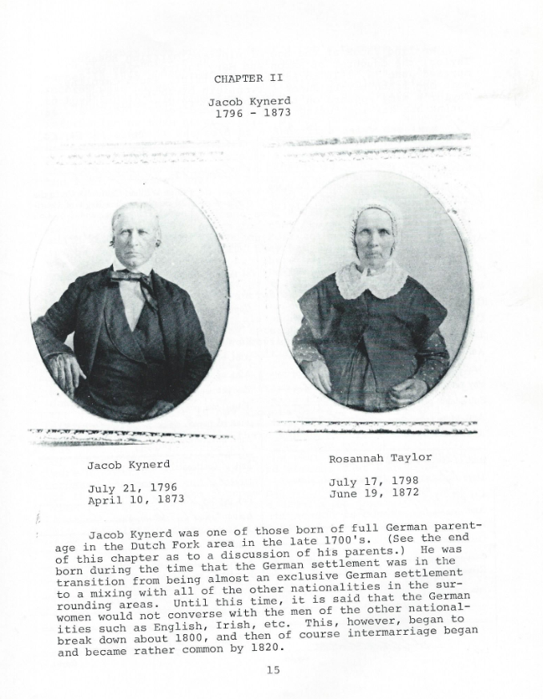

My assumption is that this may be a page from the book “Footprints of Jacob Kynerd, Kinard, Kynard, Kinerd, and His Descendants” by Dan P. Kinard. I am probably wrong about that, but that’s my first assumption. A short statement is given on this page (leading to a copy of the book) to the effect that “Jacob Kynerd (1796-1873) was born in the Dutch Fork area of South Carolina. He married Rosannah Taylor in 1816. In 1818 they settled in Perry County, Alabama. Descendants (spelling the surname Kynerd, Kinerd, and chiefly Kinard) and relatives lived in Alabama, Georgia, Mississippi, Tennessee, Florida and elsewhere.” Since that statement seems to match well the statement on the page from the FindaGrave webpage, it seems that these may be from the same document. I can’t find a copy of this this book yet.
August 14, 2023 update: I finally obtained a copy of this book. And I can verify that the page above is from “Footprints of Jacob Kynerd, Kinard, Kynard, Kinerd, and His Descendants” by Dan P. Kinard.
Item # 4 | Mary Ann Kynerd’s Parents | Wright Tucker Family Genealogy  (Source 556) | http://woodswell.com/family/genealogy/p84.htm#i4729

I have seen this webpage a few times as I search for my ancestors. In this section, it shows some of the Kynerds in my family.
In this document, it shows Mary Ann Kynerd’s parents as Jacob Kynerd and Rosannah Taylor. So it seems that this is true. Several documents have now stated this, so the preponderance of weight is supporting this conclusion. None of the documents are “definitive”, but this is becoming the overall conclusion.
From this document, the family is:
Jacob Kynerd (b. 21-Jul-1796 in South Carolina – d. 10-Apr-1783 in Perry County, AL) & Rosannah Taylor (b. 17-Jun-1798 – d. 19-Jun-1872). Jacob is listed as having served during the War of 1812, in Juhan’s Battalion from South Carolina. Rosannah’s father is listed as Aaron Taylor. According to this document, their children are:
- David C. Kynerd (b. 29-Oct-1816 – d. 26-Apr-1893).
- Mary Ann Kynerd (b. 13-May 1819 – d. 13-Sep-1911).
- Salathiel Kynerd (b. 15-Jan-1821 – d. 1-Dec-1912).
- Tillitha Kynerd (b. 12-Mar-1823 – d. 3-Dec-1852).
- Michael Kynerd (b. 17-Nov-1824 – d. 29-May-1837).
- Jesse B. Kynerd (b. 25-Oct-1826 – d. 15-Jul-1873).
- Daniel P. Kynerd (b. 6-Jan-1829 – d. 19-Oct-1861).
- Jacob Hilliard Kynerd (b. 25-Sep-1830 – d. 28-Sep-1872).
- Permelia Ann Kynerd (b. 13-Nov-1832 in Perry County, AL – d. 20-Jun-1908 in Perry County, AL). Permelia married George William Hopper on 14-Feb-1856.
- Andrew Jackson Kynerd (b. 13-Dec-1834 in Perry County, AL – d. 23-Jan-1885 in Perry County, AL). Andrew married Elizabeth J. Fike (daughter of German (aka Jerman) Fike and Catherine Smith on 13 December 1855 in Perry County, AL. This is another cross-over in Lewis Sharp’s family, as Catherine is the daughter of Solomon Smith and Elizabeth Crow. Andrew served in the Confederate Army during the Civil War, in the AL 28th Infantry. He was captured sometime after early 1864, and held by Union forces until the end of the War in May 1865. Apparently he was a physician in Uniontown, Perry County, AL.
- William Kynerd (b. 18-Apr-1837 – d. 16-Jun-1837).
- George Washington Kynerd (b. 25-Apr-1838 – d. 9-Oct-1863).
- Emanuel Kynerd (b . 28-Apr-1840 – d. 7-May-1840).
- Betsy Caroline Kynerd (b. 6-May-1841 – d. 29-Oct-1841).

Item # 5 | Mary Ann Kynerd’s Parents | Lineage | Footprints of Jacob Kynerd, Kinard, Kynard, Kinerd and His Descendants

Ok, I finally got a copy of this book! It cost me $65 on eBay, but I now have it. I am not sure of how authoritative this book is, as there are very few sources listed. However, the author has many of the sources that I do. He also traces the Kynerds down to even my parents and everything matches what I have verified. Another issue with the book is that it seems he did all of this research over two and a half years. However, he was retired and being of the old school, he probably didn’t have any work he had to do around the house (pity his wife!), so if he worked on this everyday, he could probably do most of the work. He also had access to family members who already had a great deal of the work done. So it’s possible.
At any rate, the book lists Jacob Kynerd and Rosannah Taylor as Mary Ann Kynerd’s parents. It doesn’t list who are Jacob’s parents. The author (Dan P. Kinard) thinks it is John and Mary Kynerd, but he didn’t have any data in 1986 (pre-internet) to confirm this. His suspicions are that John Kynerd (actual original German name was Keynat (or Keynot, which was changed to Kynerd over the years) came from the Palatinate region of Germany. Dan does say that he knows the following about Jacob’s parents:
- His father died when he was a young person.
- His mother could only speak German and lived in the “Dutch Fork” area of South Carolina, and was still living around 1851.
- Andrew Jackson Kynerd was a cousin of John M. Kinard, a banker in Newberry.
- When Jacob was born, only John Kynerd’s people spelled the name the way Jacob spelled it.
- He was kin to George W. Kynerd. (He came to Perry County about the same time as Jacob or shortly thereafter.
- His father or grandfather fought in the Revolutionary War.
I am not sure how he knows all of this, but Dan says he does.
Rosannah’s parents are Aaron Taylor and Mary Taylor of the Lexington District, South Carolina. Aaron is listed in the 1800 and 1810 Federal Censuses, however Aaron is not listed in the 1820 Federal Census. He may have died between 1810 and 1820.

Summary of Information researched

So it seems that Jacob Kynerd and Rosannah Taylor are Mary Ann Kynerd’s parents. I don’t have any definitive document that states this, but it seems that this is the case.

