RD-014 | Who were Jacob Kynerd’s Parents and Ancestors?

In my system, an “RD-###” document is a “Research Document” that is used before I transfer information to an “FT-###” document, which is a “Family Tree” document. The Family Tree documents are more statements of the various facts of that particular family, while the Research documents are more investigative, intuitive, and sometimes just plain guessing. If you see something named “Source ###”, that is my numbering system for the various sources that back up the conclusions in the FT and RD documents. Sources, FT documents, and RD documents are all numbered sequentially as I create them.

Item # 1 | Mary Ann Kynerd’s Parents | Lineage | Footprints of Jacob Kynerd, Kinard, Kynard, Kinerd and His Descendants by Dan P. Kinard

Ok, I finally got a copy of this book! It cost me $65 on eBay, but I now have it. I am not sure of how authoritative this book is, as there are very few sources listed. However, the author has many of the sources that I do. He also traces the Kynerds down to even my parents and everything matches what I have verified. Another issue with the book is that it seems he did all this research over two and a half years. However, he was retired and being of the old school, he probably didn’t have any work he had to do around the house (pity his wife!), so if he worked on this every day, he could probably do most of the work. He also had access to family members who already had a great deal of the work done. So it’s possible.
At any rate, the book lists Jacob Kynerd and Rosannah Taylor as Mary Ann Kynerd’s parents. It doesn’t list who are Jacob’s parents. The author (Dan P. Kinard) thinks it is John and Mary Kynerd, but he didn’t have any data in 1986 (pre-internet) to confirm this. His suspicions are that John Kynerd (actual original German name was Keynat (or Keynot, which was changed to Kynerd over the years) came from the Palatinate region of Germany. Dan does say that he knows the following about Jacob’s parents:
- His father died when he was a young person.
- His mother could only speak German and lived in the “Dutch Fork” area of South Carolina, and was still living around 1851.
- Andrew Jackson Kynerd was a cousin of John M. Kinard, a banker in Newberry.
- When Jacob was born, only John Kynerd’s people spelled the name the way Jacob spelled it.
- He was kin to George W. Kynerd. (He came to Perry County about the same time as Jacob or shortly thereafter.
- His father or grandfather fought in the Revolutionary War.
I am not sure how he knows all of this, but Dan says he does.
Rosannah’s parents are Aaron Taylor and Mary Taylor of the Lexington District, South Carolina. Aaron is listed in the 1800 and 1810 Federal Censuses, however Aaron is not listed in the 1820 Federal Census. He may have died between 1810 and 1820.
Item # 2 | Jacob Kynerd | Lineage | http://www.dutchforkchapter.org/index.html

There is a group called the “Dutch Fork Chapter” of the South Carolina Genealogical Society. This group has done considerable research on early German immigrants into the Dutch Fork area of South Carolina. They have a page on Early German Settlers in South Carolina, and another page on German Settlers in the Dutch Fork area.
From the Early German Settlers in South Carolina page:
INTRODUCTION
Between the years 1730 and 1766 the Colonial government of South Carolina actively encouraged immigration of foreign Protestants to the Province. Appreciable numbers of immigrants from Germany began to arrive in the 1740s. The year 1752 represented the peak of the migration with about 1800 German settlers who arrived on several ships in the fall of that year. Saxe-Gotha, Amelia, Salkehatchie, and the fork of the Broad and Saluda (Dutch Fork) became predominantly German settlements. The Dutch Fork was the most densely settled, becoming home to 483 settler families by 1760, almost all of whom were of German origin (E. B. Hallman, “Early Settlers in the Carolina Dutch Fork 1744-1760”, Master’s Thesis, Wofford College). It has been estimated that by the year 1765 there were 7500-8000 Germans and German-Swiss who had come to the province of South Carolina (R. L. Meriwether, “Expansion of South Carolina, 1730-1765”).
The church records of German towns and villages are the main source of emigration information. These records are available to the public on microfilm. Hannelore Enderle is a native of the Reutlingen area of the German state of Baden-Württemberg, identified most of the entries in this list using the resources of the Hauptstaatsarchiv in Stuttgart and the Generallandesarchiv in Karlsruhe. Many of the emigrants in the following list have not been identified in previous publications. Printed publications that have been helpful in compiling this list are cited at the end of this publication.
From the German Settlers in the Dutch Fork page:
INTRODUCTION
This collection of German emigrants (auswanderer) represents an attempt to bring together information on the origins of the first inhabitants of the Carolina cnbsp; The great majority of the original settlers of the Dutch Fork were German Protestants. According to E. B. Hallman’s list of Dutch Fork settlers there were 483 families who obtained land grants before 1760. These families represented about 1400 people. Some of these people moved away, some families died out, and some original family names were lost when their daughters married sons of other settlers.
The Adolf Gerber list of Württemberg emigrants, originally published in Germany during the 1920s, has been found to contain only eight German immigrant families who either settled in the Dutch Fork or their children resided there. In recent years several publications have greatly expanding our knowledge of the origins of the first families of the Carolina Dutch Fork.
Many of the German immigrant settlers in the Dutch Fork came in 1752 on one of several ships. Several earlier immigrant families had arrived in 1749 on the Griffin, coincident with the time that some German families moved into the Dutch Fork, having lived before in Pennsylvania and Maryland. As the list of emigrants has grown it has become increasingly clear that the first ships in 1752 (the Upton and Cunliffe) contained mostly emigrants from Baden and, to a lesser extent, from the Palatinate. The Caledonia and Elizabeth which arrived at Charleston shortly thereafter have so far been found to contain only settlers from Württemberg. The passengers of the Rowand also appear to have been made up mostly of people from Württemberg. Württembergers also arrived in 1754 on the Priscilla, some of whom settled in the Dutch Fork. These insights may be of help when considering likely places to search German Church records.
The page on Early German Settlers in South Carolina:
Keinat, Michael (1744). Undingen, 72820 Sonnenbühl, Landkreis Reutlingen, Baden-Württemberg
Carpenter. Born 31 October 1697, son of Johannes Keinat (Carpenter) and Lucia Koch of Winterlingen. Married 15 February 1724 in Undingen, Anna Maria Letsche, born 9 June 1694, daughter of Johann Jacob Letsche and Anna Gugel of Undingen. Children: (1) Johann Friderich, born 6 November 1724; (2) Johannes, born 9 July 1726; (3) Matthäus, born 7 March 1728; (4) and Johann Martin Keinat, born 11 December 1736. The bounty petition in January 1750 of Johannes Keinat says the parents were indented to Henry Middleton and had died in his service. The name in SC is Kinard. The present day name in Germany is Keinath.
On St. Andrew. Johannes and Johann Martin Keinat had 50A bounty grants on Crims Cr. 50A bounty grant of Matthäus Keinat on Cannons Cr.
The page on the Dutch Fork German Settlers mentions the following potential “Kynerd” ancestors:
KEINAT, MICHAEL (1744). Undingen
Carpenter. Born 31 October 1697, son of Johannes Keinat (Carpenter) and Lucia Koch of Winterlingen. He married on 15 February 1724 in Undingen, Anna Maria Letsche, born 9 June 1694, daughter of Johann Jacob Letsche and Anna Gugel of Undingen. The bounty petition of the son, Johannes Keinat, in January 1750 says the parents were indented to Henry Middleton and had died in his service. The petitions of Johannes and Matthäus Keinat both indicate that they came to S.C. in 1744 on Capt. Brown’s ship, the St. Andrew. Johannes and Johann Martin Keinat had 50 acre bounty grants on Crims Cr. A 50 acre bounty grant to Matthäus Keinat was on Cannons Cr. The present day name in Germany is Keinath.
Children:
- Johann Friderich Keinat, born 6 November 1724 and 2. Johannes Keinat, born 9 July 1726.
Both of these men were known only as John Kinard, Sr., in the Colonial records of S.C. One of these men lived from an early date in the area of Bethlehem Lutheran Church, Pomaria, and died before 1786. Many of his descendants were members of Ruffs Meeting House and later Bethlehem Lutheran Church which came into existence in 1817. The other of these two men lived in Pennsylvania for awhile and did not petition for land in S.C. until 1772. His family lived in the area of Prosperity, S.C., and his descendants left Newberry Co. area at an early date.
- Matthäus Keinat, born 7 March 1728, died before 1790. His family lived in the area of Bachman Chapel Lutheran Church, Prosperity. Some of his family moved to Perry and Greene (later Hale) Counties, AL, and to Winston Co., MISS.
- Johann Martin Keinat, born/died 23 April 1730.
- Johann Martin Keinat, born 3 April 1731, died the following day.
- Hans Jacob Keinat, born 20 March 1732, died 14 February 1733.
- Clara Keinat, born 7 July 1734, died 1 October 1735.
- Johann Martin Keinat, born 11 December 1736, died about 1805, wife named Mary, said to have been Mary Witt. Lived on Crims Cr. and, after his death, the homeplace was sold in 1805 with deed naming the children, including names of the daughter’s spouses (Newberry Deeds L-183).
I will use a PowerPoint graph to show this lineage information.
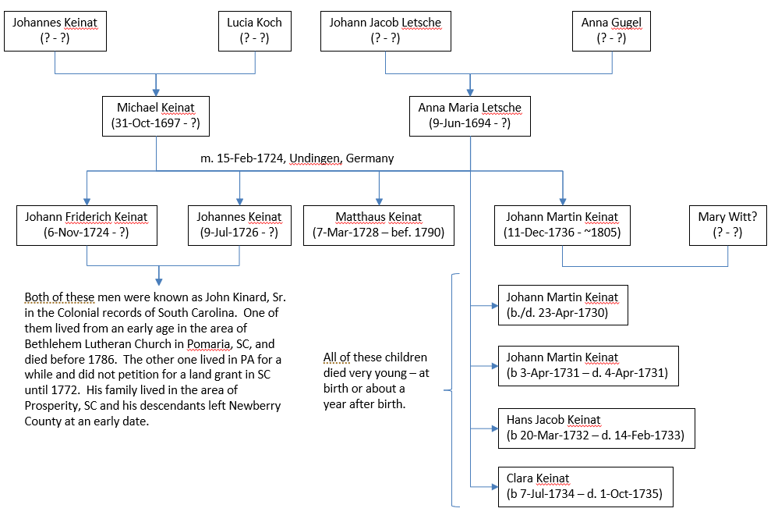

Item # 3 | Jacob Kynerd’s Lineage | Lineage | FindaGrave Pages for Keinats

I started this section in one way, then decided it would work better in more of a visual format like family trees. So I went to PowerPoint and created the following slides. I lose the bio information from FindaGrave, but I think the PowerPoint slides are easier to follow. However, because these are just images, the URLs don’t work. So you will need to go to Source 563 for the working URLs.
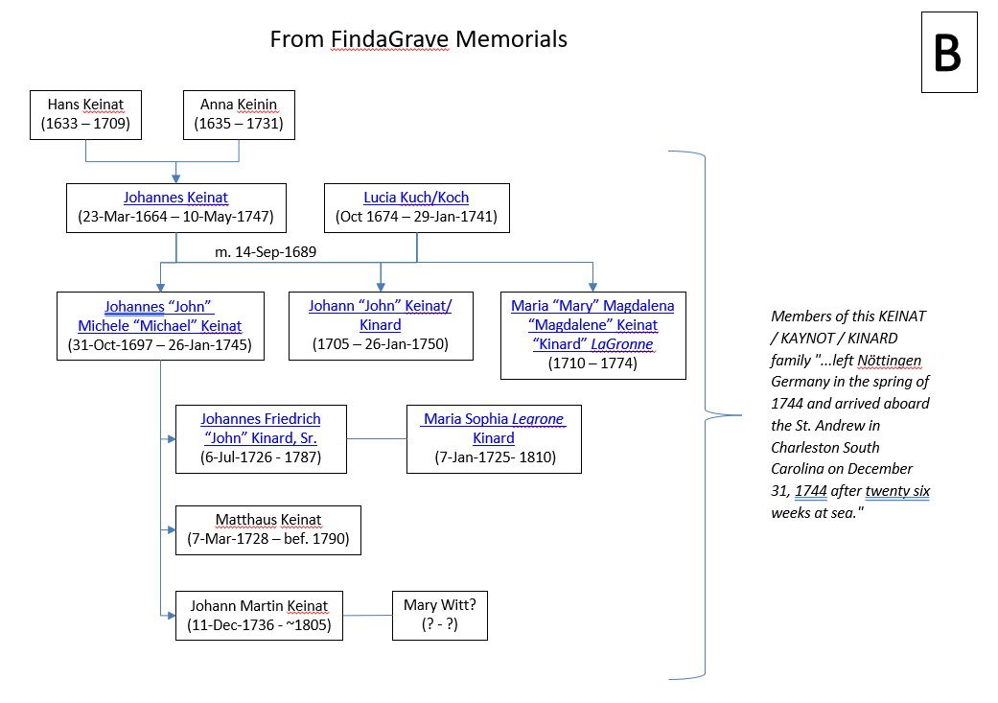
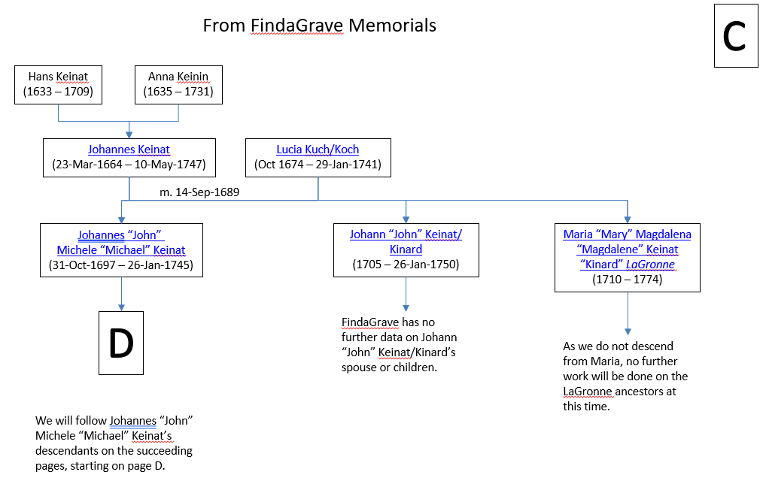
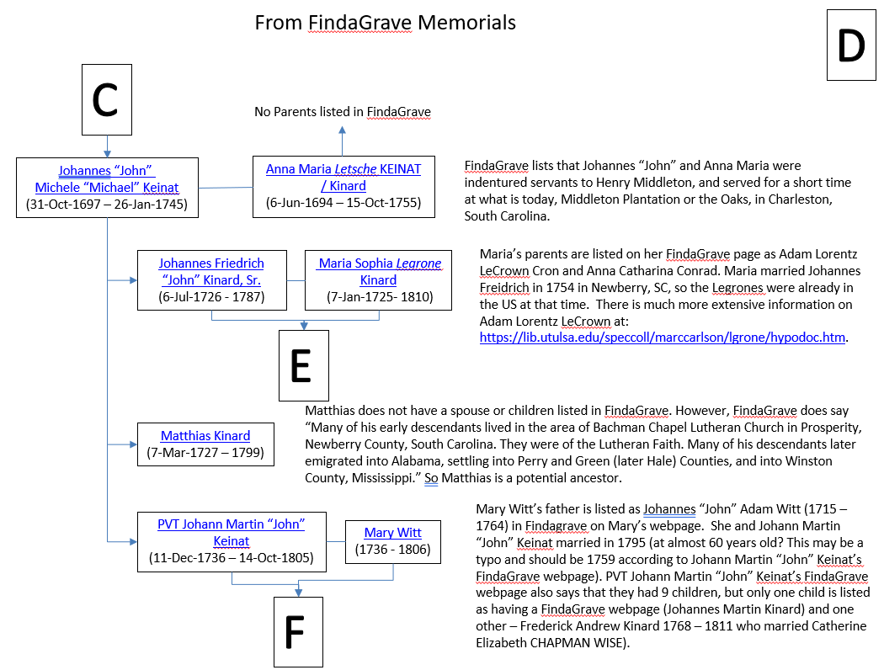
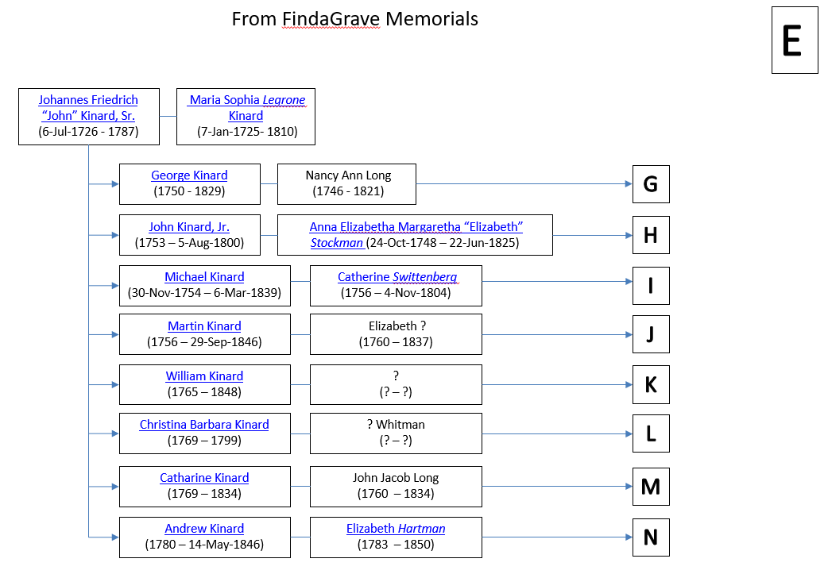

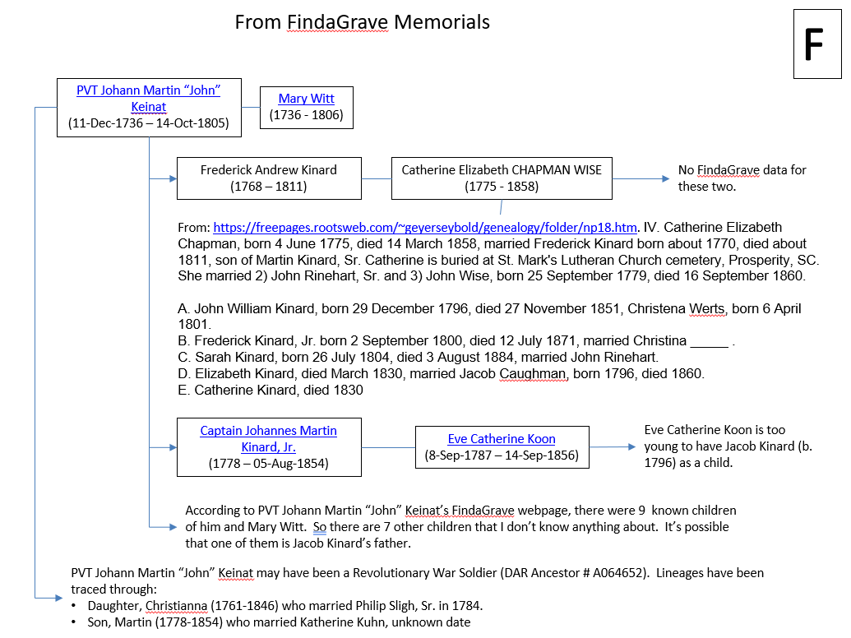
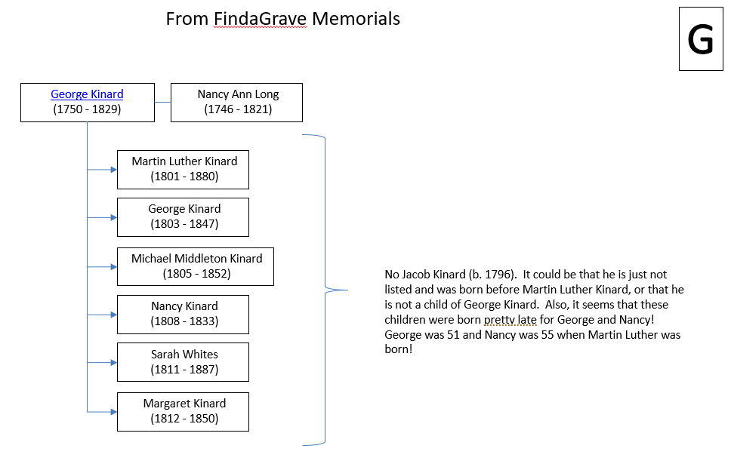
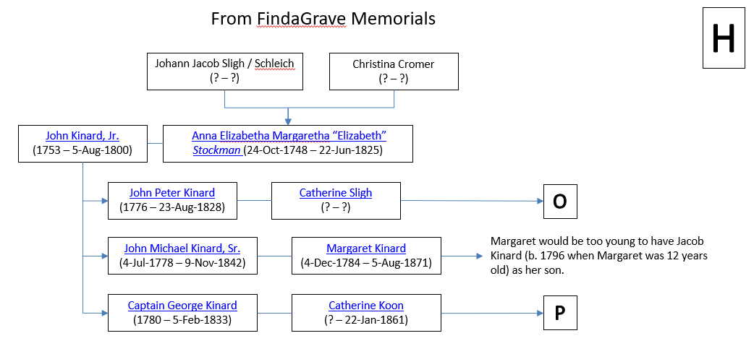
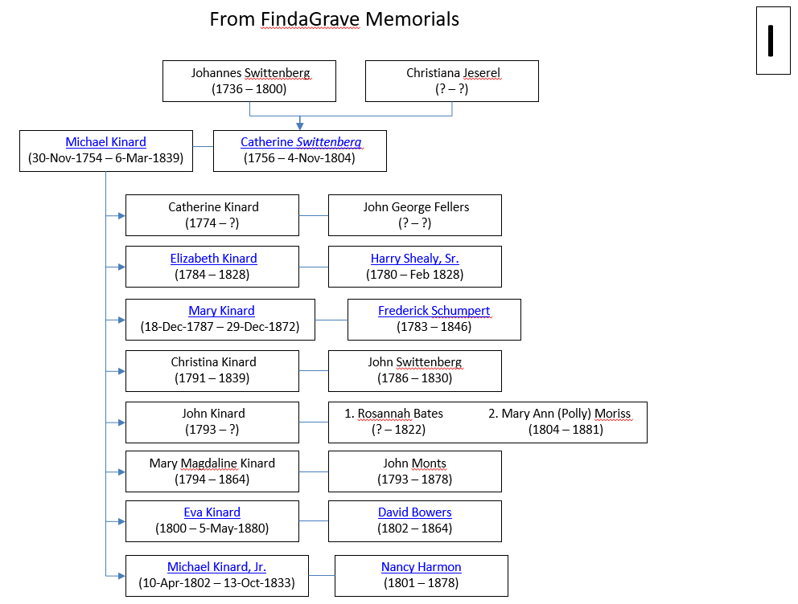
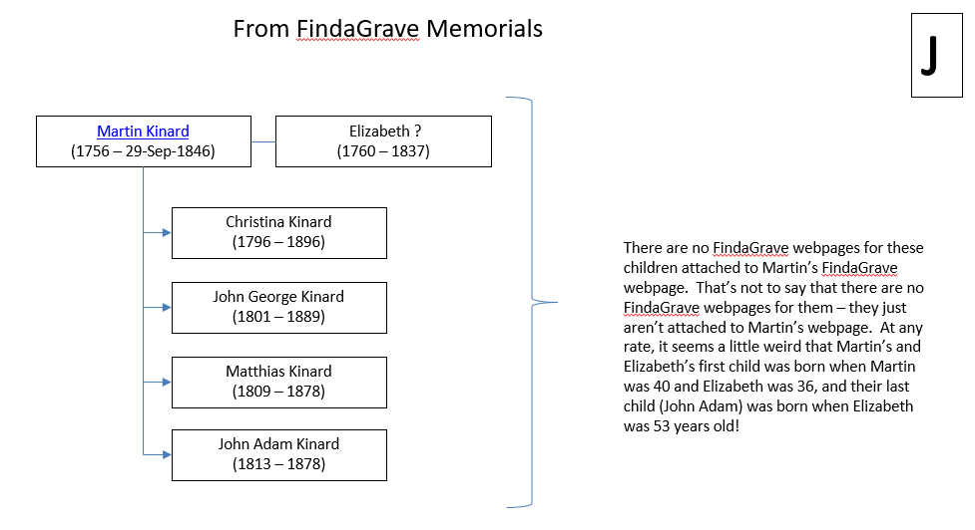
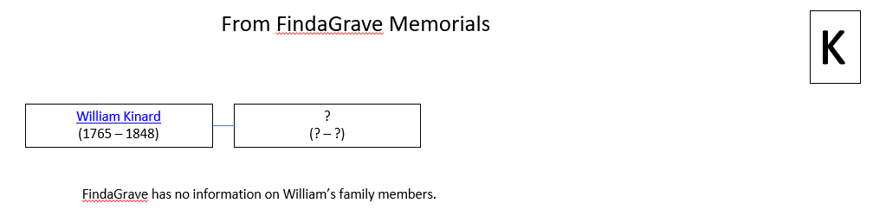
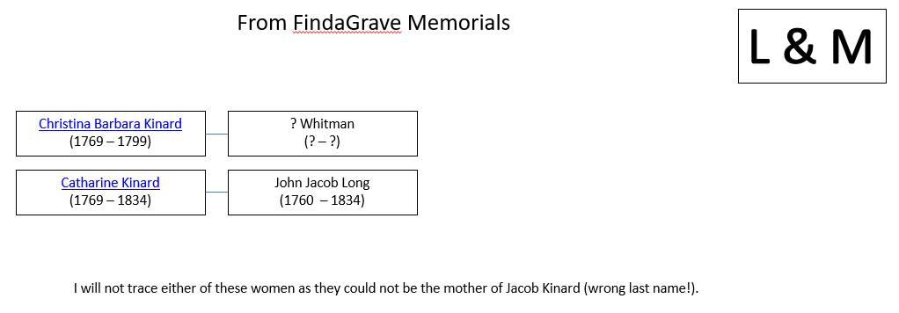
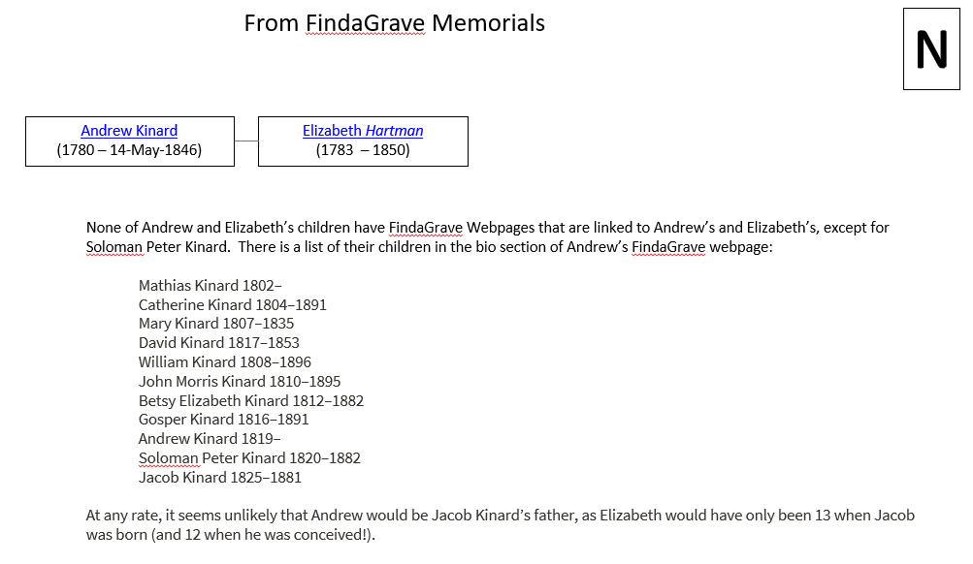
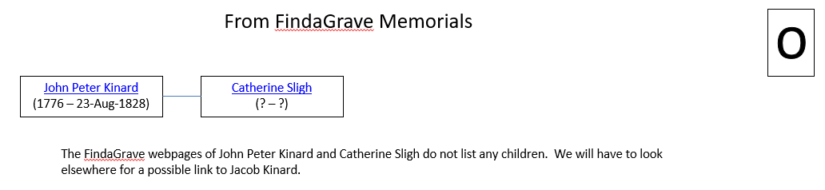
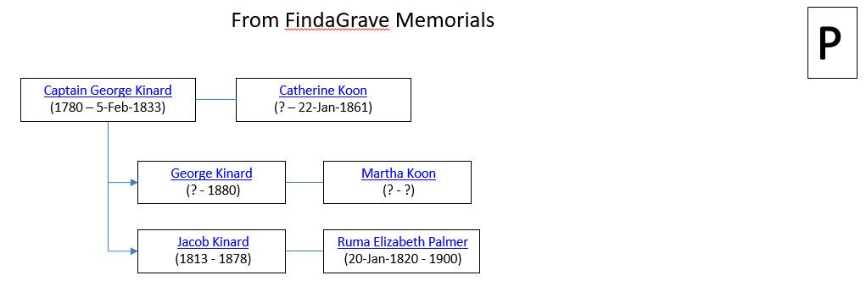
Ok, here is what we know from all of this effort! Not much! The problem is that we don’t know how complete or correct the information is on FindaGrave. Normally, there is no information or sources included with an attribution of a parent, spouse, or child. Anyone can state anything on FindaGrave. So nothing we have found is definitive.
However, we should be able to use FindaGrave as “supporting information” to other more definitive data we find. If we look strictly at the data on Slides 3 through 15, and we make some assumptions like:
- Jacob’s father and mother should be less than 50 years old and at least 15 years old at his birth in 1796. So his mother and father should be born sometime between 1746 and 1781.
- Of course Jacob’s father should be a Kinard (or Kynard, or Kynerd, or Kinerd, or Keinat, etc.)
Our options on these pages now become:
- Captain George Kinard and Catherine Koon on Slide P. This is highly unlikely as the ages barely meet our requirements for Captain George Kinard and may not meet them for Catherine Koon (we don’t know her birth year). The other weakness in this option is that these two named another son Jacob Kinard, who was born in 1813. Our Jacob Kinard was still alive that time, so it’s unlikely they would have named a second son (1813 Jacob) the same name as the 17 year old 1796 Jacob.
- John Peter Kinard and Catherine Sligh on Slide O. I don’t know anything about their children, but they are definitely an option at this time.
- William Kinard on Slide K. FindaGrave doesn’t have any information on him, but he is a potential father.
- Martin Kinard and Elizabeth on Slide J. I don’t know if this list of children is complete. However a potential weakness is that another child was already born in 1796. I have found that normally there was a 1 to 2 year gap between children in olden days, so this is a weaker candidate for Jacob’s father.
- Michael Kinard and Catherine Swittenberg on Slide I. It’s possible that an unnamed son (our Jacob) could have been born between Mary Magdalene (b. 1794) and Eva (b. 1800).
- John Kinard, Jr. and Anna Elizabetha Margaretha “Elizabeth” Stockman on Slide H. This seems unlikely, as Jacob would have been born 16 years after Captain George Kinard (our first option above). Also John Kinard, Jr. and Anna were getting a little old at this point.
- George Kinard and Nancy Ann Long on Slide G. George and Nancy were pretty old (51 and 55, respectively) for their first child listed as born in 1801 in FindaGrave. So there is room for Jacob Kinard (b. 1796) to be their child.
- The last option I see is Frederick Andrew Kinard (1768 – 1811) and Catherine Elizabeth CHAPMAN WISE (1775 - 1858) on Slide F. The weakness in this option is that this couple is already listed as having a child born in 1796 - John William Kinard, born 29 December 1796. So it’s unlikely that these are Jacob Kinard’s parents.
So my strongest options are: 2. John Peter Kinard and Catherine Sligh , 3. William Kinard, and 5. Michael Kinard and Catherine Swittenberg, possibly George Kinard and Nancy Ann Long. These are the ones we will tackle first.
Item # 4 | Jacob Kynerd’s Lineage | John Peter Kinard and Catherine Sligh

I see lots of hints in my Ancestry.com information saying that Jacob Kynerd’s parents were likely John Kinard, Jr. (1753 – 1800) and Anna Elizabetha Margaretha Stockman (1748 – 1825). However, I am not convinced of this. It’s possible, though. John Jr. would have been 43 and Elizabeth 48 in 1796. A little old, but not out of the question. We do know that John Peter Kinard (1776 – 1828) was a child of John Jr. and Elizabeth. From http://dutchforkchapter.org/auswanderer_settlers.html, we see:
John Uriah Wicker, died August 1808, married Catherine Sligh, daughter of John Jacob Sligh, Sr. and wife, Christina. After his death she remarried John Peter Kinard, son of John Kinard, Jr. and wife, Elizabeth.
I guess a problem with John Peter Kinard and Catherine Sligh being the parents of Jacob Kynerd, is that Dan Kinard (in “Footsteps of Jacob Kinard?) says that Jacob’s father died when he was young, but his mother was still living in the Dutch Fork, SC area in 1851.
So maybe this is a better way to search – look for a couple where the father died soon after 1796, but the mother lived on until at least 1851.
Option  # above | Couple | Died before Jacob was 10-ish?
2 | John Peter Kinard (1776-1828) and Catherine Sligh (?-?) | No
6 | John Kinard, Jr. (1753 – 1800) and Anna Elizabetha Margaretha Stockman (1748 – 1825) | Yes for Father, No for mother
3 | William Kinard (1765 – 1848) | No
5 | Michael Kinard (1754 – 1839) and Catherine Swittenberg (1756 – 1804) | No for father, yes for mother
7 | George Kinard (1750 – 1829) and Nancy Ann Long (1746 – 1821) | No
Not listed above | Pvt John Martin Kennard (1736 – 1800) and Mary Witt (1736 – 1806) | Yes

From this table, I can see why Ancestry.com keeps suggesting that John Kinard, Jr. (1753-1800) and Anna Elizabetha Margaretha Stockman (1748-1825) might be the parents of Jacob Kinard – assuming the story about Jacob’s father dying soon after his birth, but his mother living on for a while. However, Anna Elizabetha Margaretha Stockman’s FindaGrave webpage doesn’t list Jacob Kinard as a son. BUT, there is a gap in the list of Anna’s children between Samuel Kinard (b. 1786) and Elizabeth Kinard (b. 1797). Anna was having children every 1 to 2 years from 1776 to 1786, so it may be that some of the children died after Samuel, but I am not sure why Jacob wouldn’t be listed if he was born in 1796.
There aren’t any other Kinards listed in FindaGrave that show a Jacob Kinard (b. 1796) as a child. So we have reached a brick wall on this one unless I travel to South Carolina and find some old paperwork that Sherman didn’t burn on his March to the Sea.

Item # 5 | Jacob Kynerd’s Lineage

Another thought is to look at Jacob’s and Rosannah’s children’s names. My thought is that if I find that their children’s names were listed in the parental options above, that might lend strength to any arguments about Jacob’s parents.
So let’s list their children and the children of various parental options.
Jacob & Rosannah’s Children | Is this name used by the following Parental Options?
 | John Peter Kinard & Catherine Sligh | John Kinard Jr & Anna Stockman | Michael Kinard and Catherine Swittenberg | George Kinard & Nancy Ann Long | John Martin Kennard & Mary Witt
Mary Ann | According to WikiTree, there were no children from this marriage. | No | Yes | No | No
Salathiel W. |  | No | No | No | No
Telitha |  | No | No | No | No
Daniel P. |  | No | No | No | No
Jacob H. |  | No | No | No | No
Permelia |  | No | No | No | No
Andrew J. |  | No | No | No | No
George W. |  | Yes (George) | No | Yes (George) | No

Ok, not a lot of good news here. I wonder if there are other Kinards that I didn’t look at above in FindaGrave that lists children? No luck there in South Carolina, Georgia, or Alabama for potential families. Looks like this was a bum idea.
Item # 6 | Jacob Kynerd’s Lineage |  | The Kinards of Ninety-Six, South Carolina, ed. By Joe Dew Kinard (Source 566)

I ran across this book cited as a source in WikiTree. In the book, on page 26 of the document (page 21 of the book), we can find the family of George Kinard and Nancy Ann Long (mentioned above in Section 3 on Slide G). This book has more children listed than I was able to find on FindaGrave. From this book you can see:
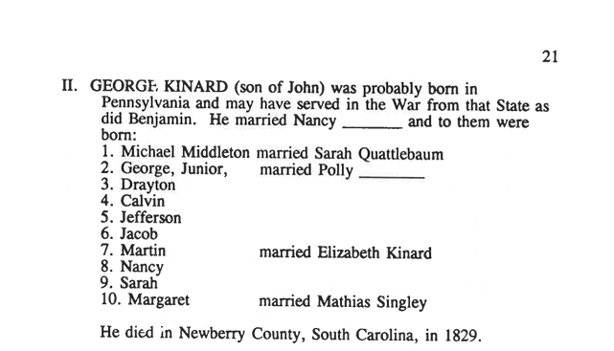
Here we can see some of the children listed in Slide G, but some additional children as well including a Jacob!
The issue with this Source is that I only have the first 28 pages of the book, and I don’t know much about how well the author sourced his work. The work builds on the work of an earlier amateur genealogist – Henry Hubert Kinard. Unfortunately, I do not have the part of this book where H. H. Kinard’s sources were included. The book is originally 73+ pages long, but as I said before, I only have the first 28 pages. The family information for George Kinard shown above is from H. H. Kinard’s work. I have learned that this book was unpublished. There are some copies out there, one in possession of Lee and Karen Breasbois, The Kinard House, 227 West Main Street, Ninety Six, S.C., at least back in 2008. At that time, Lee and Karen were about 76 and 77 years old, so they may not be alive any longer here in 2023.
This book mentions an article in “The State” from March 10, 1929, a newspaper from Columbia, South Carolina. The article was written by G. L. Summer and is titled “The Kinards”. I got a copy of it (Source 567), and while interesting, it doesn’t shed any new light on Jacob Kinard’s parents.
If the information in the book is correct, AND the Jacob Kinard listed above is our Jacob, that would put his ancestors as:
- Jacob Kinard, whose parents were:
- George Kinard and Nancy Ann Long. George’s parents were:
- Johannes Friedrick “John” Kinard, Sr. and Maria Sophia LeGrone. Johannes’ parents were:
- Johannes “John” Michele “Michael” Keinat and Anna Maria Letsche. Johannes’ parents were:
- Johannes Keinat and Lucia Kuch/Koch. Johannes’ parents were:
- Hans Keinat and Anna Keinin.
The trouble with this genealogy is that the link between #1 and #2 above is totally speculative, and #3 through #6 is based completely on FindaGrave information with no sources cited.

Item # 7 | Jacob Kynerd’s Lineage |  | Ancestry.com investigations of Kinards and Taylors in Lexington County, SC in 1790, 1800, and 1810

There are stories that I run across that say that Jacob Kinard’s parents died soon after his birth. Jacob was then raised by the family of Aaron Taylor, and ended up marrying Aaron’s daughter, Rosannah. Both of these families seemed to be in Lexington District (now County), SC. So if I go and search on Ancestry for these two families for the Census years of 1790, 1800, and 1810. What I am looking for is a young Kinard family who may be present in 1790, maybe 1800 (with a sone about 4 years old), but not present at all in 1810. Then I want to match this up with Aaron Taylor not having a 4 year old boy in 1800, but with a 14 year old boy in 1810). So let’s see what we can find.
Kinards in 1790 in Lexington County, SC
Name |  | Present in 1800? | Present in 1810?
Matt Kennard
John Kinner
Martin Kinner
John Renard
William Rener
Philip Kener

Kinards in 1800 in Lexington County, SC
Name | Family Members | Male under 10?
William Kinard | 3 males <10  1 male 26-44  3 females <10  1 female 26-44  1 female 45 + | Yes
George Kinard | 1 male 26-44  1 female 26-44 | No
Matthew Kinard | 1 female 45 +  2 males 16-25 | No
Martin Kenard, Jr. | 1 male < 10  1 male 22-44  1 female < 10  1 female 26-44 | Yes
Michel Kinard, Sr. | 1 male < 10  1 male 45 +  3 females < 10  1 female 10-15 | Yes
Elizabeth Kinard | 1 male < 10  3 males 10 – 15  1 male 16 – 25  1 female < 10  1 female 45 + | Yes
George Kinard | 1 male < 10  1 male 16 – 25  1 female 16 – 25 | Yes
Percy Kinard | 1 male 16 – 25  1 female 16 – 25 | No
Martin Kinard | 1 male 10 – 15  1 male 16 – 25  1 male 45 +  1 female 10 – 15  1 female 45 + | No
Michael Kinard | 1 male < 10  1 male 26 – 44  1 female < 10  1 female 26 - 44 | Yes
John Kenmore (Kinard) | 3 males < 10  1 male 26 – 44  1 female < 10  1 female 26 - 44 | Yes
Fredric Kinard | 1 male < 10  1 male 26 – 44  1 female < 10  1 female 26 - 44 | Yes
Andrew Kinard | 1 male 16 – 25  1 male 26 – 44  1 female 45 + | No

OK, let’s delete those without males under 10 years old and see who is present in the 1810 Federal Census:
Name | Family Members in 1800 | Male under 10? | Present in 1810 Federal Census? | Family Members in 1810
William Kinard | 3 males <10  1 male 26-44  3 females <10  1 female 26-44  1 female 45 + | Yes | No | NA
Martin Kenard, Jr. | 1 male < 10  1 male 22-44  1 female < 10  1 female 26-44 | Yes | There are 2 Martin Kinards | (1) with 7 slaves  2 males < 10  1 male 26 – 44  1 female < 10  1 female 26 – 44  (2) with No slaves  3 males < 10  1 male 26 – 44  1 female 10 – 15  1 female 16 - 25
Michel Kinard, Sr. | 1 male < 10  1 male 45 +  3 females < 10  1 female 10-15 | Yes | Yes  (as Michl Kinard – the one with 1 slave) | 1 male < 10  1 male 26 – 44  3 females 10 – 15  1 female 45 +
Michael Kinard | 1 male < 10  1 male 26 – 44  1 female < 10  1 female 26 - 44 | Yes | Yes  (as Michl Kinard – the one with 10 slaves) | 1 male < 10  1 male 16 – 25  1 male 45 +  2 females 10 -15
Elizabeth Kinard | 1 male < 10  3 males 10 – 15  1 male 16 – 25  1 female < 10  1 female 45 + | Yes | Yes | 1 male 10 – 15  1 female 10 – 15  1 female 26 – 44  *Not sure about the older female’s age! Maybe the 1800 Census was wrong on her age!
George Kinard | 1 male < 10  1 male 16 – 25  1 female 16 – 25 | Yes | Yes | 3 males < 10  1 male 16 – 25  2 females < 10  1 female 26 - 44
John Kenmore  (Kinard) | 3 males < 10  1 male 26 – 44  1 female < 10  1 female 26 - 44 | Yes | Yes  (as John P. Kinard) | 1 male 26 – 44  1 female 26 – 44  *Probably not the same John Kinard.
Fredric Kinard | 1 male < 10  1 male 26 – 44  1 female < 10  1 female 26 - 44 | Yes | Yes | 1 male < 10  1 male 10 – 15  1 male 26 – 44  3 females < 10  1 female 16 - 15

So William Kinard seems to be the only Kinard present in 1800, but not in 1810, who had a < 10 year old son in 1800. Now let’s see if an extra 10 – 15 year old son showed up in Aaron Taylor’s household in 1810.
For the Aaron Taylor Household, we can see that in 1800, the family consists of:
- 1 male < 10
- 1 male 26 – 44
- 2 females < 10
- 1 female 26 – 44
In 1810, the family consisted of:
- 3 males < 10
- 1 male 10 – 15
- 1 male 26 – 44
- 1 female < 10
- 2 females 10 – 15
- 1 female 26 – 44
So the 1800 male < 10 years old is probably the 1810 male 10 to 15 years old. Jacob Kinard would be 14 years old in 1810. So there doesn’t seem to be an extra 14 year old boy in the Aaron Taylor household in 1810, unless the boy < 10 years old in 1800 died before the 1810 Federal Census.

Item # 8 | Jacob Kynerd’s Lineage |  | Source 555 from Lauderdale County, Mississippi Archives “Kynerd – Kynard Family”

From: http://www.lauderdalecountymsarchives.org/uploads/2/6/2/1/2621480/keynerd_-_kinard_family.pdf
This document gives lots of (undocumented) information on the Kynerd/Kinard family. However, it is not factual in several instances. It states that Aaron Taylor (Rosannah’s father) was a Revolutionary War soldier and there is no evidence of that in the DAR Genealogical Records. There was an Aaron Taylor in the Revolutionary War, but he was from Massachusetts, not South Carolina.
So I don’t think there is anything in this document I can trust unless I verify each individual fact.
Summary of Information researched

Well, I guess I am officially at a brick wall, and can’t identify Jacob Kinard’s parents. And that’s that.

