Author | John Sharp, jhnshrp@gmail.com

Change History
Version | Date | Changes
FT-007.00 | 19-Sep-2022 | - Original document (not the original document, but I am going to call it that)
FT-007.01 | 29-Feb-2024 | - Added Change History table  - Added titles “Parent of this Family” and “This Family” to this page.  - Added a Header to all pages.  - Deleted “FT-000” box on second page of the document, as it keeps moving around and is superfluous anyway with a Header.  - Researched 1950 US Federal Census data for Mary Rebecca Brown Lewis. James Houston Lewis died in 1941, but I cannot find where Mary lived in 1950. This is a brick wall for the time being.
FT-007.02 | 26-Sep-2024 | - Added Author Table to top of document.  - Updated the Table of Children so that the header row shows up when the table breaks across a page.  - Added page number at bottom of each page.  - Added gravestone picture and directions to the gravestone in the cemetery.
Notes: The newest version is in blue font, and the changes made to the document are also denoted in blue font in the document below.
Parents of this Family
FT-014 |  |  |  |  | FT-018
William Jeptha Lewis |  | Marilda Caroline Jeffreys |  |  | John Moses Brown |  | Sarah J. Wooton
1854 | 1916 | 1864 | 1942 |  | 1862 | 1915 | 1855 | 1921

This Family
James Houston Lewis |  |  | Mary Rebecca Brown
Born | April 22, 1886 | Married: | Born | January 1894 (Source 019, 1900 US Federal Census)  February 7, 1893 (gravestone – probably not correct)
Where | Hamilton, Marion, Alabama, USA | December 24, 1908 | Where | Alabama, USA
Died | April 28, 1941 | Where: | Died | March 28, 1959
Where | Tyronza, Cross, Arkansas, United States | Marion County, AL USA | Where | Tyronza, Cross, Arkansas, USA (assumed)
Buried | Tyronza Cemetery, Tyronza, Cross, Arkansas, USA | Source: | Buried | Tyronza Cemetery, Tyronza, Cross, Arkansas, USA
Sources | FindaGrave | 014, 014a | Sources | FindaGrave

Children:
Name | Born | Where | Source | Died | Where | Buried | Source
Catherine Lee Alma |  |  | FT-004 |  |  |  | FT-004
Albert | October 13, 1909 | Alabama | U.S., Social Security Death Index, 1935-2014 | May 1985 | Tucson, Pima County, Arizona, USA (assumed) | East Lawn Palms Cemetery and Mortuary  Tucson, Pima County, Arizona, USA | FindaGrave
Lula Belle | November 9, 1913 | Hamilton, Marion County, AL, USA | Findagrave | December 15, 1981 | Corinth, Alcorn County, MS, USA | Henry Cemetery, Corinth, Alcorn County, MS, USA | Findagrave
Nettie J. | August 28, 1917 | Hamilton, Marion County, AL, USA | U.S., Social Security Applications and Claims Index, 1936-2007 | January 23, 1996 | Michie, McNary County, TN, USA (assumed) | Lebanon Cemetery, Michie, McNary County, Tennessee, USA | FindaGrave
Opal Inez | November 11, 1922 | Hamilton, Marion County, AL, USA | U.S., Social Security Death Index, 1935-2014 | May 15, 2009 | Jonesboro, Craighead County, Arkansas, USA | Jonesboro Memorial Park Cemetery, Jonesboro, Craighead County, Arkansas, USA | U.S., Social Security Death Index, 1935-2014,  FindaGrave

Other Marrriages:
Husband – Other wife |  | Sources
When
Where
Other Children
Comments

Wife – Other Husband |  | Sources
When
Where
Other Children
Comments

Story:
Activity | Sources
Current Status:  - Need 1950 US Federal Census Data for Mary Rebecca Brown Lewis | Searched again Sep 26, 2024.
1890 US Federal Census – The vast majority of the 1890 census was lost in a fire | U. S. Census Information
1900 US Federal Census, enumerated June 9, 1900 – Millville, Lamar County, AL  J. Moses Brown is the head of the house. He was born in January 1862, is 38 years old, and has been married to Sallie Brown for 18 years. He was born in Alabama, but both his parents were born in Georgia. Sallie was born in May 1860, and is 40 years old. She was born in Alabama, and both of her parents were born in Georgia also. Moses and Sally have had 8 children, but only 6 are still alive. Moses is a farmer, cannot read or write, while Sallie can read and write. They are renting the farm on which they live.  The children living with Moses and Sallie are:  - Ella Lee (daughter), born March 1882 (18 years old), born in Alabama. Ella can read and write, but hasn’t attended school in the past year  - William (son), born in October 1884 (15 years old), born in Alabama. William is working as a farm laborer, but hasn’t been employed for a month. He cannot read or write and hasn’t attended school in the past year  - Luther B (son), born August 1888 (11 years old), born in Alabama. Luther is also working as a farm laborer, but hasn’t worked in 2 months. He cannot read or write.  - Fry G (son), born October 1892 (7 years old), born in Alabama.  - Mary (daughter), born January 1894 (6 years old), born in Alabama. This birth date differs from what is on her gravestone (February 7, 1893), unless these are two different Mary Browns with a father named Mose (or Moses) Brown in Lamar County, Alabama.  - Minnie L (daughter), born December 1894 (5 years old), born in Alabama.  The birth dates for Mary and Minnie are possibly correct, as it doesn’t make sense that Fry was born in October 1892 and Mary was born in February 1893 (4 months later). But Mary’s tombstone does say her birth date was February 7, 1893. | 019, FindaGrave (For Mary Rebecca Brown Lewis)
1900 US Federal Census, enumerated June 7, 1900 – Rye, Marion County, AL  William J. Lewis is head of the house. He was born in April 1864, is 46 years old, and has been married to Marilda for 18 years. He was born in Alabama, as were his parents. She was born in Alabama, as were her parents. William and Marilda have had 5 children and all are living at this time. William is a farmer, but hasn’t been employed for 3 months. William and Marilda can both read and write and they own their farm free of mortgage.  Others living in the house are:  - John R. (son), born in June 1882 (17 years old), born in Alabama. He is an employed farm laborer, and can read and write. He has not attended school in the past year.  - James H. (son), born in April 1886 (14 years old), born in Alabama. He is also an employed farm laborer, and can read and write. He has not attended school in the past year.  - Luller J. (daughter), born in January 1888 (12 years old), born in Alabama. She is also an employed farm laborer and can read and write. She has not attended school in the past year.  - William E. (son), born in August 1897 (2 years old), born in Alabama.  - Lizzie B. (daughter), born in January 1900 (4 months old), born in Alabama.  - Marthia J. (sister), born in February 1866) (34 years old), born in Alabama. The census also says her parents were both born in Alabama, so at least it matches Williams’s data! She is an employed farm laborer and can read and write. | 013
James Houston Lewis and Mary R. Brown were married on December 24, 1908 at J. M. Brown’s by John B. Lewis, MG (not sure if there is a relationship or not. John B. Lewis was a local minister in Marion County). James H Lewis and D. M. Ballard paid $200 for the marriage bond. I am not sure who D. M. Ballard is at this time. He appears to be some type of county auditor or manager and gave permission for multiple marriages in Marion County, AL. However, there is a note on the marriage license where a “Mose Brown” (See 014a) who says Mary is his girl. So it’s possible that Mose Brown was married to Sarah J. Brown.  At the time of the marriage, James H Lewis was 22 years old, 5’ 8”, 135 pounds and was a farmer. Mary was 15 years old, 5’, 120 pounds. Both were Freewill Baptists and lived in Detroit, AL. This was the first marriage for both of them. | 014, 014a
1910 US Federal Census  I cannot find a family consisting of James Houston Lewis and Mary Rebecca Brown Lewis in the 1910 US Federal Census. There is a possibility, so I will lay it out here.  In the Census for Rye, AL in 1910 (enumerated April 22, 1910) (Source 164), there is a Mary R. Lewis (17) who is married to Isach H. Lewis (24), with a son named John A. (5 months). All were born in AL. Isach owns his own farm, free of mortgage. Both Isach and Mary can read & write and have been married 1 year. The problems with this option are “Isach” instead of “James” and “John A.” for the child’s name instead of “Albert”. I don’t know if the child was “John Albert” or something else.  However, everything else matches. It’s the right town, Isach’s and Mary’s ages are right, the age of the son is about right, they have been married the right amount of time, the birth places of Isach, Mary, and their parents are in the right place. Rye only had 647 people in 1920 (see page 76, 10th page in Source 165) for population information. It seems very unlikely that there would be two couples in Rye that matched so closely.  For now, we will have to leave it at the assumption that for some reason, James use the name “Isach” at that time, and the child’s name was somehow altered later. | 164, 165
1920 US Federal Census, enumerated June 10 & 12, 1920 – Rye, Marion County, AL  James Houston Lewis (33) and Mary Brown (26) are living in their own home, mortgage-free. Both can read & write, and they and their parents were all born in Alabama. James is a farmer.  Their children are:  - Albert, son, (9), attending school  - Alma, daughter, (8 according to the Census, but should have been 9), attending school  - Lulu Bell, daughter (6), not in school yet  - Nettie J., daughter (2 years, 4 months), and  - Sarah J. Brown (Mary’s mother – widowed) (65). Sarah can read & write. It is interesting that the name is “Sarah” here, whereas the name “Sallie” was used in the 1900 US Federal Census (Source 019). However, “Sallie” is a nickname for “Sarah”, and it makes sense that Sarah’s parents would call her “Sallie” but she went back to “Sarah” once she grew up. Also, the age of 65 in the 1920 Census would imply that Sarah was born in 1855, whereas Sallie was born in 1860 in the 1900 US Federal Census (Source 019). Sarah’s parent’s are listed as being born in Alabama, whereas as Sallie’s were listed as being born in Georgia. So it seems very possible that Source 019 is for a different family, but I cannot find any other family that matches up in the 1900 Census.  Everybody in the family and their parents are listed as being born in Alabama. It’s possible that Sarah wasn’t around when the 1920 Census was filled out, and James H. just gave the best answers he knew. I think when I do the Census data on the J. Moses Brown – Sarah Brown family, I may learn more. | 004 - Federal Census_1920_James Houston Lewis-Mary R Brown Family.jpg
1930 US Federal Census, enumerated April 15, 1930 in Tyronza, Poinsett County, AR  The Lewises have now moved to Tyronza, AR, where they are renting a home. James is now 43 and Mary is 37. Both can still read & write. It looks like James is self-employed as a farmer.  Their children living with them are:  - Lula, daughter (16), attending school, can read & write  - Nettie, daughter (12), attending school, can read & write  - Opal, daughter (7), attending school, can’t read or write yet.  Alma has now moved out of the family home. She married Walter Burrow Godsey on August 19, 1928. They had a son (born in 1927), named Ulyes (I have seen this spelled many ways!). Walter died June 18, 1934 in Shelby, TN at 24 years old.  As Sarah Brown isn’t living with them any longer (according to the 1930 Census), she must have died since the 1920 Census. Source 018 is a picture of a gravestone that is of a Sarah Brown that was born February 18, 1855 and died on December 21, 1921. The grave is in Whitefield Cemetery, Ogemaw, Ouachita County, AR. It is a single gravestone, not a joint gravestone with her husband (who I have not yet identified). I don’t know if Sarah was buried in Arkansas. | 015, 018
1940 US Federal Census, enumerated May 15, 1940 in Tyronza, Poinsett County, AR  We find James (54) and Mary (47) still living in Tyronza, AR, working on their own farm. A new question in the Census is where did they live in 1935 (on a farm in Poinsett County, AR – probably where they are living in 1940). Another new question is the highest grade completed by each person. James and Mary both completed the 3rd grade.  The only other person living with them at this time is a grandson named Ulyless, who is probably the daughter Alma’s (my grandmother) son. Ulyless is 13 years old at this time, but is not attending school. Ulyless highest grade is listed as the 7th grade. | 163
James H Lewis died on April 28, 1941 and Mary died on March 28, 1959 (5 days after I - John Sharp - was born!). | 017  FindaGrave
I cannot find any 1950 US Federal Census for Mary Rebecca Brown Lewis. John Sharp 29-Feb-2024. Searched again on 26-Sep-2024 – no luck.
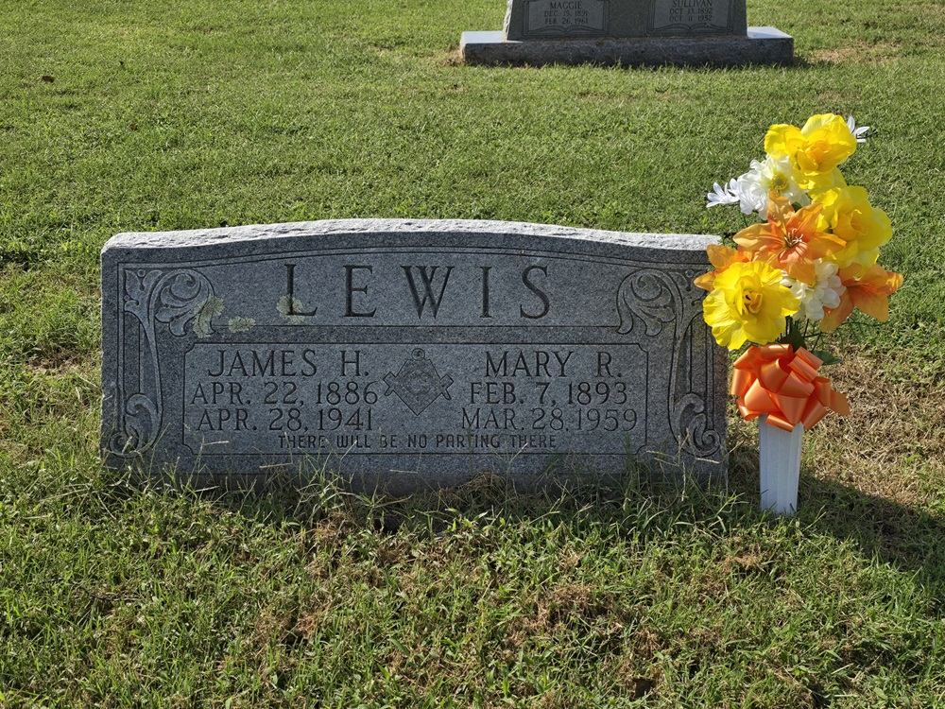 | Gravestone picture taken by John Sharp on 26-Sep-2024. John also added the flowers to the gravesite. The gravestone can be found by driving into the cemetery through the archway towards the gazebo. The gravestone is about a hundred feet before the gazebo on the left about 15 feet off the roadway.

