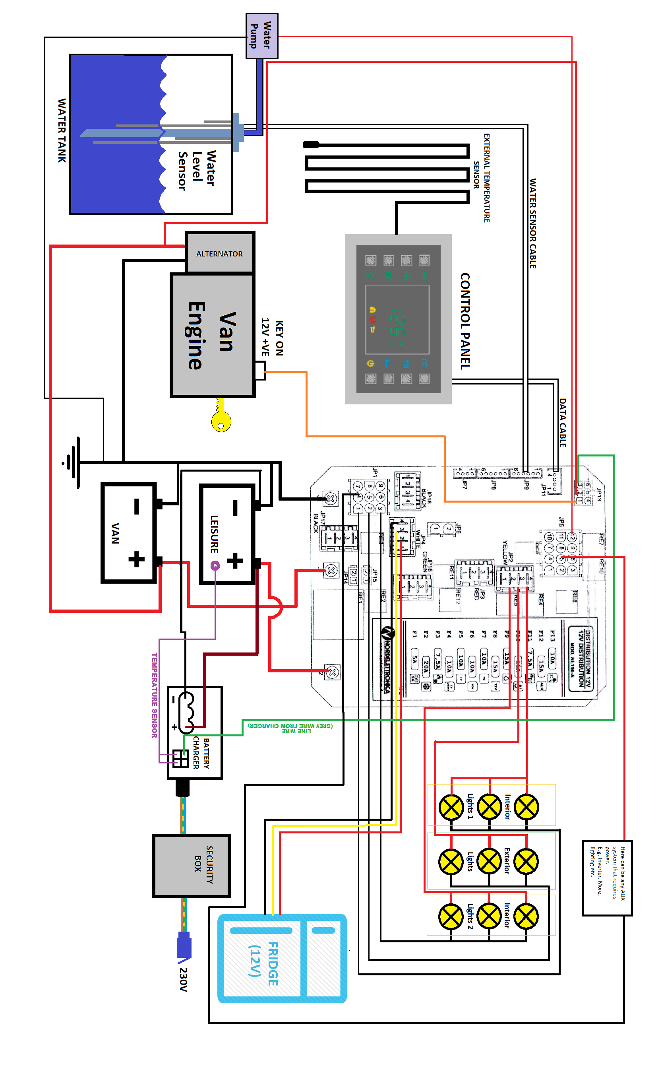
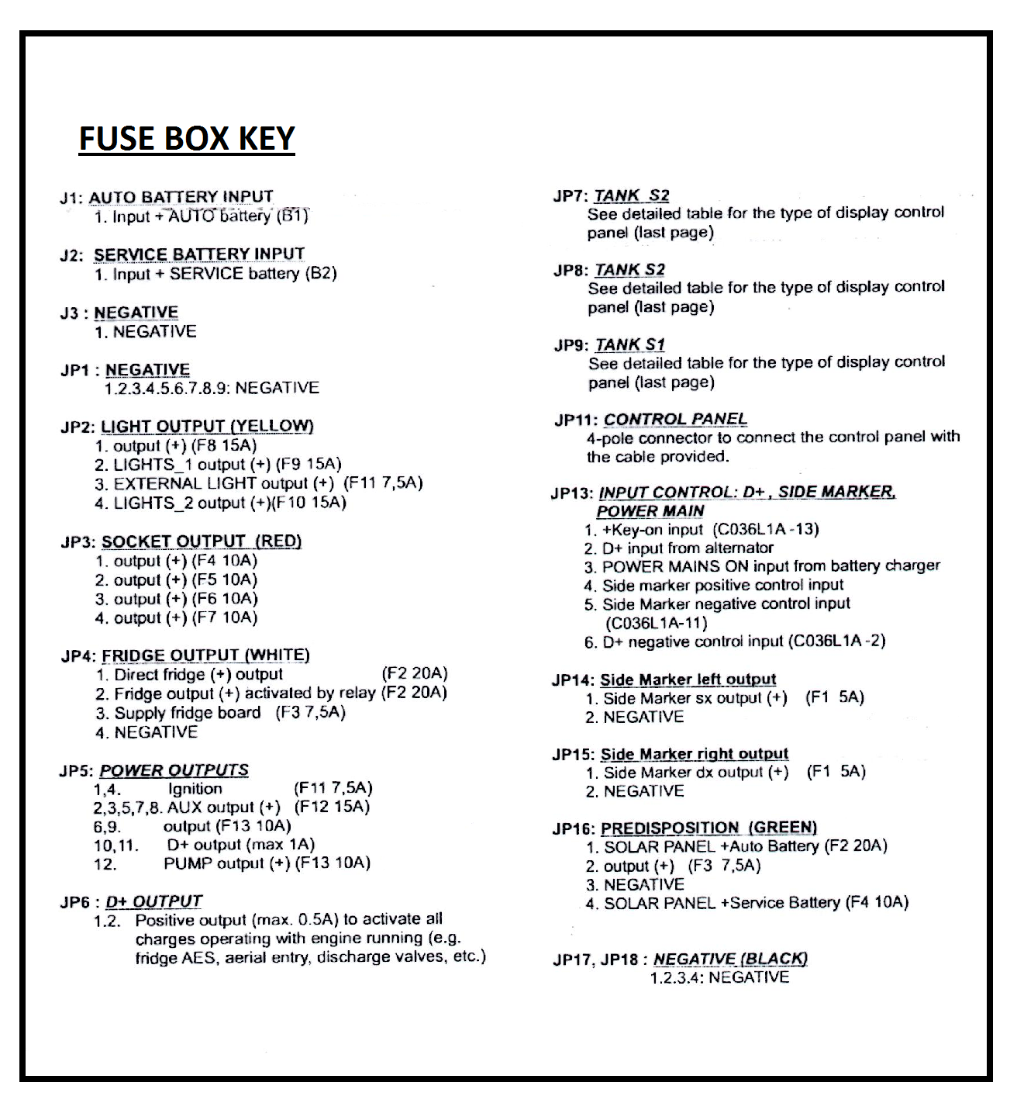
Basic Installation guide
Thank you for purchasing your Nordelettronica Van Power Conversion Kit.
NOTE: Delta Components, Delta Conversions and Nordelettronica recommend this kit be installed by an automotive electrician or equivalent professional. If attempted by other persons Delta Components, Delta Conversions and Nordelettronica accept no responsibility for any failures to the kit and/or other consequential occurances/damages/injury to any vehicle or persons during, prior or post installation of this kit.
Parts needed to install kit:
- Van conversion kit:
- Battery Charger (NE 287)
- Security Box (NE 198)
- 12V Fuse Box (NE 196)
- Control Panel (NE 274) and data cable
- External Temperature Sensor
- Water Temperature Sensor and data cable.

Additional Parts Required:
- 12V Leisure Battery
- 1 x male single phase plug
- 30cm length of electric cable
- Water tank, extraction pump and hosing
- Wires to attach the provided connectors to and to create wiring looms
Optional Extra components (to be chosen and supplied by purchaser of kit separately):
- 12V Fridge
- 12V to 230V power inverter
- Internal Lighting (inside van)
- External Lighting (outside van)
- Other 12V appliances e.g. Microwave

INSTRUCTIONS
Location of Security box, fuse box, leisure battery and battery charger + wiring battery charger to the security box
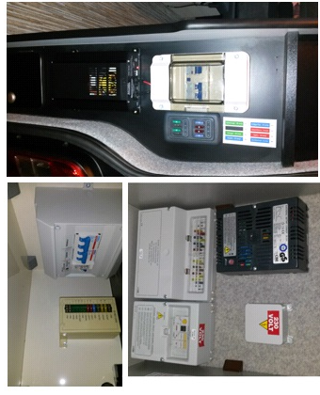
- Pick a suitable mounting point in the van that the 3 parts of the kit won’t get damaged but are accessible if necessary.
- Place and secure the leisure battery in a safe place where it can’t be damaged, knocked or have anything land on the terminals.
- Remove the covers from the Security box and Fuse Box.
- Once mounted remove the Household plug from the battery charger power cable, strip back the outer wire and strip the ends of each wire in the cable.
- Attach the three metal connectors that plug into the 3 pin male plug provided with the security box and push the connectors into the back of the plug.
NOTE; when pushing the metal connectors into the plug, make sure they correspond with the wiring colours for the female plug on the circuit board inside the security box.
- Plug the battery charger wire with the new connector on into one of the circuit board mounted outputs inside the security box shown below:
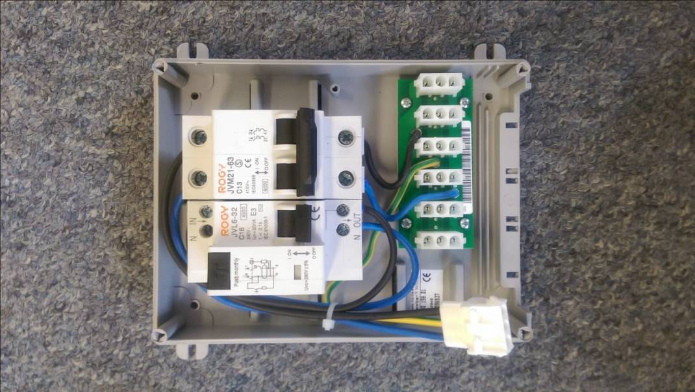

Making power connection lead and wiring leisure battery/ battery charger to 12v fuse box
NOTE: Please leave the terminals of the leisure battery disconnected until all aspects of the kit have been connected first and then the leisure battery can be connected up once your installation is complete
- Attach blue male single phase plug to the 30cm length of cable, and on the other end strip back the outer wire and strip the ends of each wire in the cable.
- Now attach the three metal connectors that plug into the 3 pin female plug provided with the security box and push the connectors into the back of the plug.
- Plug this end into the plug inside the security box that is on the end of the 3 wires feeding into the top of the circuit breakers shown below:
- Replace the Security Box cover and leave the cable with the single phase plug attached on the end that you have just connected hanging down out of the bottom of the box.
- Using small loom provided for output of the charger, cut 3 lengths of the wire (2 long enough and the same size wire to extend the red and black cables on the charger output loom so that they reach the terminals of the leisure battery, and the other wire the same gauge as the grey signal wire, long enough to extend the signal wire so it reaches the 12v fuse box).
- Extend the 3 wires on the output loom for the charger using the wires you have cut.

- Strip the other end of the 3 wires and on the 2 wires (black and red) connected to the Positive and Negative outputs of the charger, crimp a ring connector on each one so they can be attached to the terminals of the leisure battery.
- Attach the positive and negative charging wires to the leisure battery and the 3rd wire (grey wire) needs one small male pin connector that corresponds with the small 6 pin plug shown below the next point.
- The small 6 pin plug plugs into connection JP13 (see below and wiring diagram on page 1) located on the circuit board inside the 12v fuse box, push the pin connector into the pin 3 hole of the plug (again see below and wiring diagram) and leave the plug unplugged as more wires will need to be added to that plug later:
Pin 3 in Plug JP13
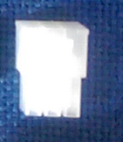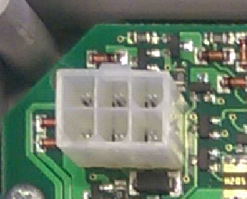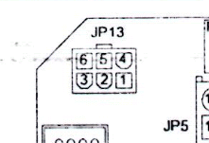
- Now using appropriate gauge wire, make up the power cables for your leisure battery and connect them to the fuse box:
- +ve wire to connection J2
- -ve wire to connection J3
- 2nd -ve cable to connect to an appropriate earthing point on the body of the van from the -ve terminal of the leisure battery
(see picture below and wiring diagram):
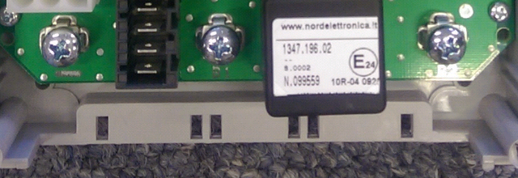
J3
J2

Mounting and Wiring Control Panel, External Temperature Sensor and Water Level Sensor
- Pick a suitable mounting point in the van for the Control panel so that it won’t get damaged but is accessible for use, perhaps in one of the ply lining panels in the back of the van, and make sure it has enough space behind it so that when the data cable is plugged in, it isn’t fouling on anything.
- Now the panel is mounted, plug the data cable and the external temperature sensor into the back of the control panel into the connectors shown below:
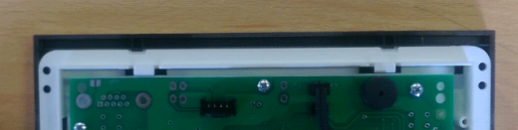
Plug for External Temperature Sensor
Plug for Data Cable
- Now attach the probe of the Temperature Sensor to the top of the Leisure Battery using some electrical insulating tape and plug the data cable into the JP11 plug inside the fuse box (see wiring diagram).
- Secure your water level sensor into your water tank and connect your water pump and hosing to it.
- Connect the water sensor cable to the water sensor and connect the other end to the JP9 plug inside the fuse box (see wiring diagram).
- The positive and negative connections for the water pump you have installed need to be wired up as follows:
- +ve wire needs to be connected to the 12th pin of the JP5 12 pin plug (shown below) using the appropriate metal connector that fits into the 12 pin plug, crimping it onto the wire and pushing it into the back of the plug.
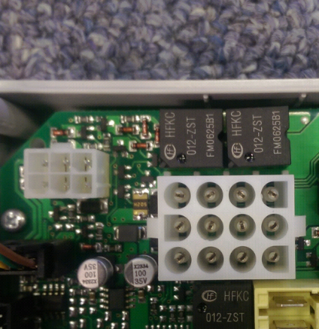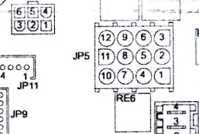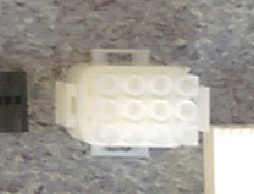
- -ve wire needs to be connected to an appropriate earthing point on the body of the van.
Additional wiring and additional Components
NOTE: Please disconnect the -ve termainal on the vans battery before you perform any wiring tasks on the van
- A new +ve cable has to be made to connect the +ve terminal of the van’s main battery to connection J1 in the fuse box (see wiring diagram)
- A wire connected to a 12v key on live feed (a feed that only has 12v travelling down it when the van’s ignition key is in the ON position) has to have the appropriate metal connector crimped on and pushed into the back of the 6 pin plug plugged into connection JP13 in the fuse box in the pin 1 hole (shown below):
- A wire connected to the main +ve connection of the vans alternator has to have the appropriate metal connector crimped on and pushed into the back of the 6 pin plug plugged into connection JP13 in the fuse box in the pin 2 hole (shown below):
- All other additional components (E.g. 12v fridge, 12V to 230V power inverter, Internal Lighting (inside van), External Lighting (outside van), 12v microwave) can be connected to the fuse box by following the wiring diagram and using the appropriate metal connectors and plastic plugs provided with this kit.
- You have now completed the basic installation of your power conversion kit.

