12v Power and Split Charging System for Van Conversions Not Equipped with Stop/Start Function
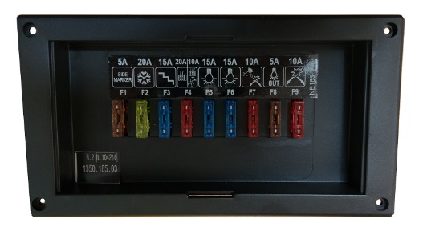
This Basic system from Nordelettronica includes a combination of either the NE185 or NE196 fuse board with either of the NE274 or NE293 Control panels.
Both Fuse boards have built in split charging relays (which can be used in vans without a stop/start ignition function.
The Control panels both have a feature for displaying both the leisure and vehicle battery voltages. The NE274 can also give you the percentage of charge in both batteries whilst with an external temperature sensor connected, give you ambient temperature both inside and outside the van.
This system is an islanded version of our full system which includes the 230v side for hooking up to a mains source; a mains powered battery charger that will charge both batteries in the system and also 230v mains circuit breaker box for protection against fluctuating incoming current from a generator for example.
NE185
- Flush mounted
- Clear Perspex cover
- Dims: 18cm (w) x 10cm (h) x 7cm (d)

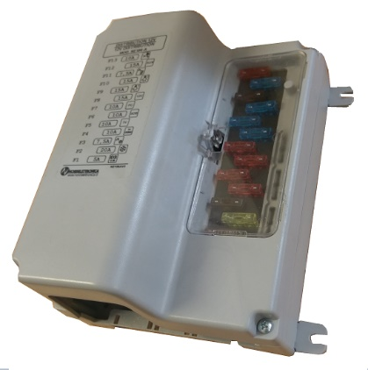
NE196
- Surface mounted
- Larger unit – more outputs
- Dims: 14cm (w) x 18cm (h) x 9cm (d) (excluding ‘c’ brackets)

NE274
- Flush mounted
- Voltage & charge % readout (both batteries)
- Extra functions inc. in/out temperature
- Dims: 18cm (w) x 10cm (h) x 7cm (d)
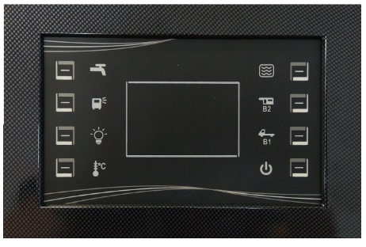

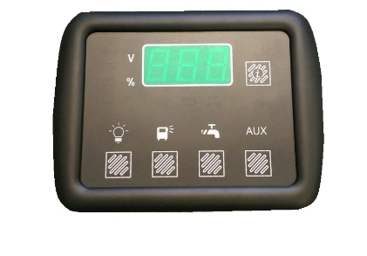
NE293
- Flush mounted
- Voltage readout (both batteries)
- Dims: 18cm (w) x 10cm (h) x 7cm (d)

On the following page is a basic wiring diagram for the system using the NE274 control panel and NE196 fuse box, then on the final page is a pricing break down of all in the afore mentioned parts for reference:

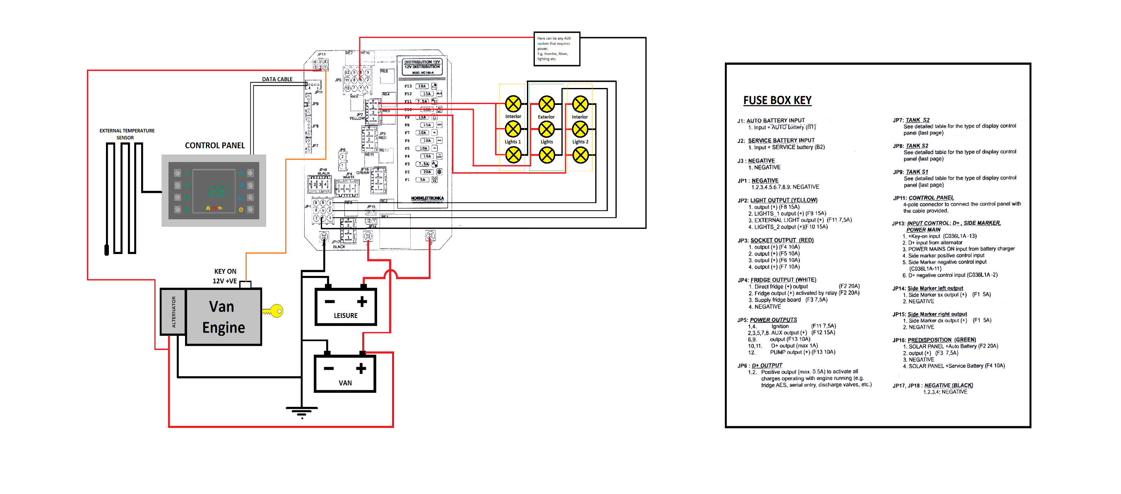

System Pricing:
Part | Description | Price (ex VAT)
NE185 | Smaller Fuse Board. | £77.00
NE196 | Larger Fuse Board. | £77.00
NE274 | Large Control Panel. | £40.00
NE293 | Small Control Panel. | £32.00
Data Cable | For connecting the control panel to the fuse board. | £9.00
Temp. Sensor | For use with NE274 (optional). | £5.00
Plugs & Connectors | Pack of all connections on fuse board (wire to be provided by customer) | £5.00
NE287 | Battery Charger (21amp, 300W) | £75.00
NE198 | Mains Fuse Box. | £38.00
Water Sensor | Customisable as per the depth of your tank inc. sensor cable. | £10.00
All prices are excluding VAT and delivery and are only relevant when buying a complete kit, individual part prices will differ from the above – check our online shop for details.

(Next day delivery cost from stock = £8.00)
For any more details please contact:

Sackville House
Old Crown Farm
Sackville Lane
Hartfield
East Sussex
TN7 4AW

Paul Bowers

Tel: 01732 865435
Mob: 07947 278899
Email: sales@deltaconversions.com

