WEDDING INFORMATION AND PACKAGES
LUCCOCK PARK
UNITED METHODIST CHURCH CAMP
888-223-8131 www.luccockpark.org www.luccockmanager@gmail.com
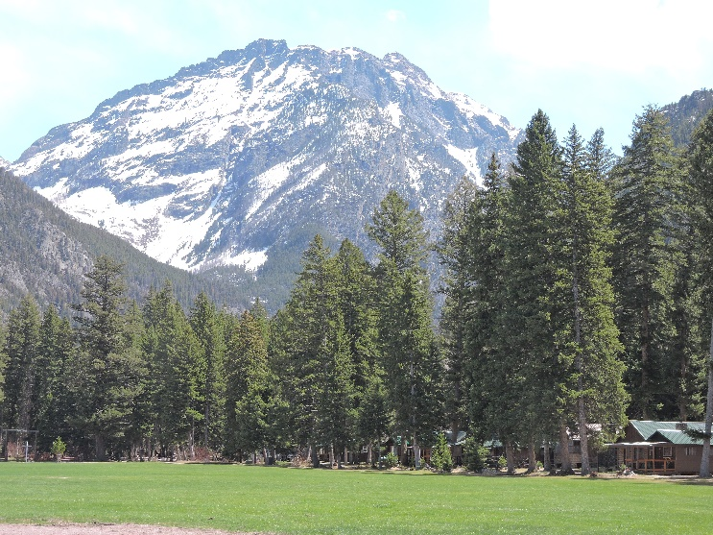
Luccock Park is situated in the heart of Paradise Valley with a seven-acre meadow, which is where our outside weddings take place. The meadow is surrounded by towering fir trees and watched over by three majestic mountains that we at Luccock have fondly named Faith, Hope and Charity. Guests enjoy views of mountains in one direction and with a 180-degree turn look across Paradise Valley. Pine Creek also runs cold and clear on our northern boundary and provides a unique setting for your wedding photos.
When brides step out of our quaint wedding chapel, they are stunning as they walk across the meadow towards towering Black Mountain (Hope). Guests stroll the grounds and enjoy peace and quiet while laughing with friends and family.
Weddings may choose to use our dining and meeting halls, an outdoor pavilion, and a small playground.
The following information is to assist you in determining costs and options for your wedding day. We also find that many wedding parties like to extend their stay here so guests can enjoy not just your special day, but a quiet vacation.
17 miles from Livingston, the road is paved right to our front gate, and the wind seldom blows in our little valley. Yellowstone National Park is only 45 miles south, Chico Hot Springs is 15 miles south and we are 5 miles above the Yellowstone River. Hiking and relaxing are also major attractions here at Luccock.
The Luccock Board of Directors and management are dedicated to making your wedding a special occasion.
The mission of the Luccock Park United Methodist Camp is to be a sanctuary of Christian hospitality, renewal, and learning within God’s natural world.

Our Wedding packages are flexible and include a wedding dinner of brisket or fried chicken, use of recreation areas, and one or more bathhouses and cabins. We do expect you to do set up and tear down of all seating and sweep the floors at the end of your event. Packages can be customized so your day will be exactly what you dreamed of celebrating your union.
Package 1 A Day to Remember- $2300
6 hours, no meal service or overnight stays, up to 100 guests, 2 cabins for the wedding party to dress
This simple mountain wedding is the perfect package for couples who want a carefree day with their friends and family. Smaller weddings will enjoy use of the chapel, and larger events will enjoy having space to spread out.

Package 2 Love is in the Air -$4250
24 hours, 3 meals, up to 50 overnight/ceremony guests with use of 5 cabins

This popular package gives couples the chance to fully enjoy a wedding at Luccock. You’ll enjoy watching the sunrise in the east and the moon settling in over the mountains in the west. Our goal is for you and your guests to be relaxed and comfortable while celebrating your special day.

Package 3 Moon Over The Mountains -$7500

48 hours, 6 meals, up to 50 overnight guests plus 50 additional ceremony guests, use of 5 cabins
Wedding parties that want to have the most possible time together choose this package. Your family and friends will settle into cabins for two nights of celebration and togetherness.

STAYING TOGETHER- Have your entire celebration at our facility and enjoy hours of fun and laughter with your friends and family. $55 per night, per additional guest, prearranged meal guests are welcome. An ADA cabin, with a shower is available for use by handicapped individuals. Groups of 60 or more enjoy exclusive use of the camp.
Note: Additional ceremony guests are $10 for all packages
All Fees are Subject to Change!

DEPOSITS AND FEES
Deposits of one-half total fees are required at the time of signing contract. Deposits are refundable if event is canceled up to 120 days prior after 119 days deposit is non-refundable. Balance is due two weeks prior to event, when the Go Form is submitted to the camp manager. Additional guests or services will be invoiced and paid for on the day of the event.
Damage Deposits – $500.00 due with the Go Form; deposit will be returned to payee no later than 7 days after event. If damage is incurred the deposit is forfeited by the payee and may be subject to further charges.
Miscellaneous – Any other fees incurred will be discussed and agreed upon by both Luccock Park and the event payee. Please designate one person to communicate and approve any additions or changes.

FAQ
May we bring our pets? Each event may have up to two pets in attendance. These pets may not be in the meadow, chapel, cabins, or dining hall. Pets must be leashed at all times, and may not harass the wildlife or humans. Your party will be accessed $100 for any feces clean-up (We did host a wedding that was preformed on horseback! So talk to us about special pet needs!)
Will we have exclusive use of Luccock? Events with greater than 60 guests can ask for exclusive use of Luccock. Because we are a seasonal camp, volunteers may be onsite working on various projects during your event but will not make noise during your ceremony.
May we decorate the dining hall? Yes! You may decorate as long as you remember to undecorate. We charge a minimum of $350 for any clean up our staff has to preform outside of the ordinary in the hall, cabins or bathhouses.
May our guests have liquor? NO. We do allow up to two beer or wine drinks per guests, but hard alcohol is prohibited at Luccock. If you will have over 50 guests we do require that you to have a TIPS certified and licensed caterer doing the serving.
Dances? You are welcome to have a dance with a live band or DJ. Outdoor music must end at 9:45 pm, and indoor music ends at 11 pm, in consideration of our neighbors and staff.
Reminder: There is no driving or parking on the meadow. Guests need to park at the east end of camp.
All Fees are Subject to Change!
Our goal is to provide a memorable event, in a beautiful and safe setting. Please let us know if you have additional needs or questions.

9/21

