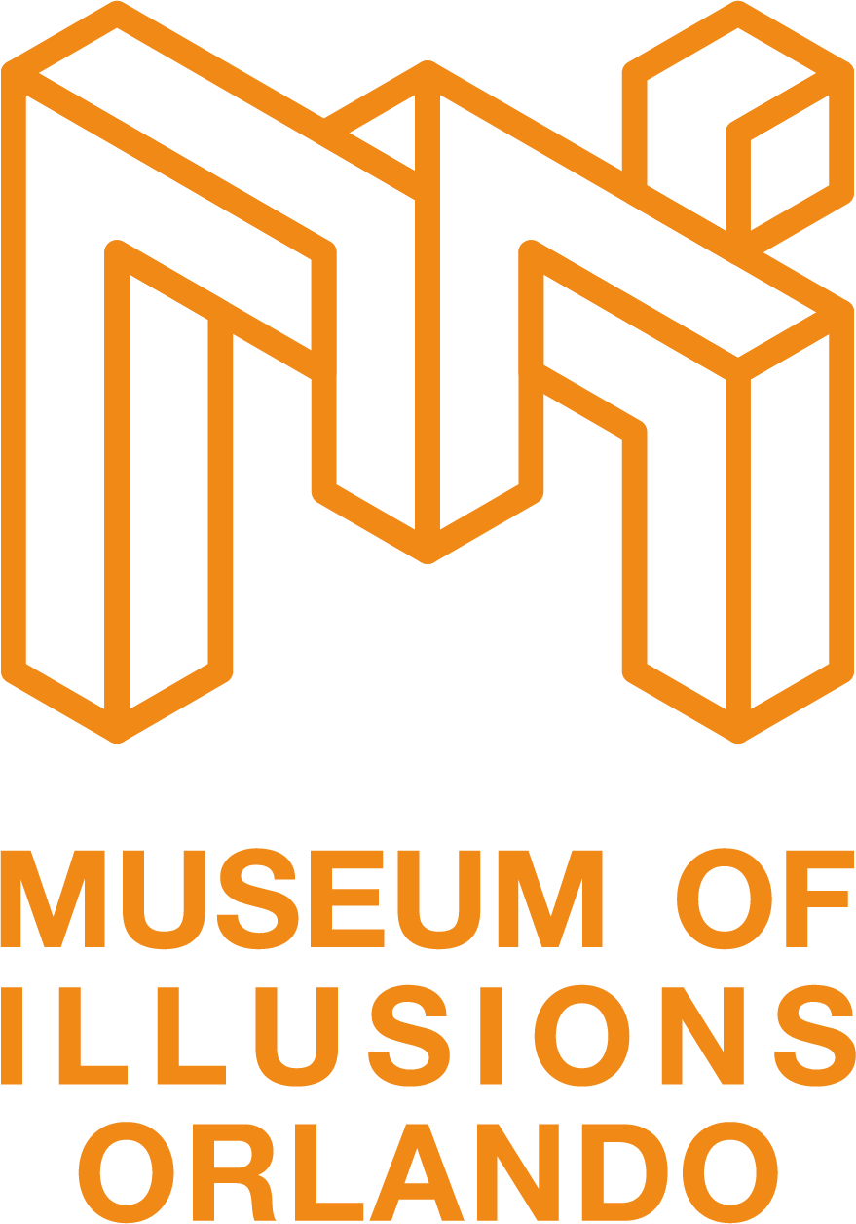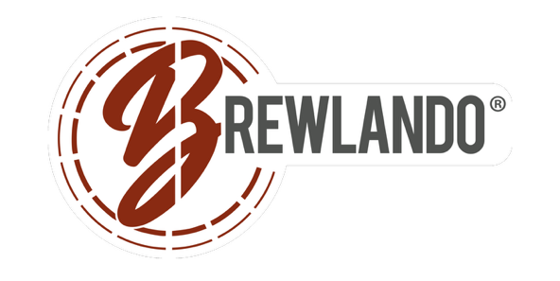

Museum of Illusions Orlando Launches Date Night Package with Brewlando®

The Winery and Tasting Room powered by Brewlando introduces a locally driven tasting experience for travelers

ORLANDO, Fla. (Jan. XX, 2026) — Museum of Illusions Orlando and Brewlando® are setting the stage for a memorable date night with a limited time Date Night Package available through February. Designed for couples looking to mix fun, flavor and photo worthy moments, the experience pairs interactive illusions with handcrafted drinks just steps away.
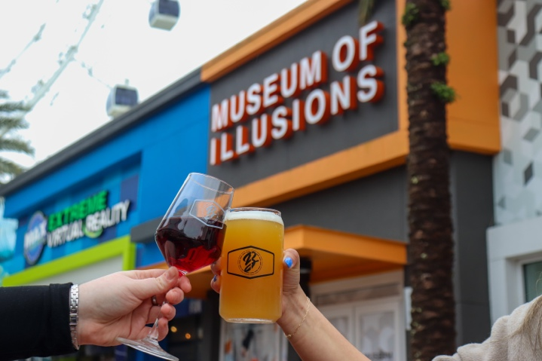
The Date Night Package includes two tickets to Museum of Illusions Orlando and two drinks at The Winery and Tasting Room by Brewlando for $59.99. Guests can explore mind bending exhibits, immersive rooms and playful photo opportunities before or after enjoying locally crafted wine, cider or beer at Brewlando’s tasting room.
Just in time for Valentine’s Day, the package also includes access to a special Valentine’s themed photo opportunity inside the museum. Guests can download and print their photos featuring a festive Valentine’s overlay, perfect for sharing or keeping as a keepsake.
The Date Night Package is now available for purchase through February and is ideal for couples, friends or anyone looking for a unique night out in Orlando.
For more information or to purchase tickets, visit www.moiorlando.com. For more information on Brewlando and its craft beer offerings, visit www.brewlando.com.

About Museum of Illusions Orlando
Grammable, likeable, shareable - Musuem of Illusions Orlando puts "edutainment" and interactive fun within reach. Whether guests are looking for indoor family fun, a new take on date night or a great time with friends — everyone will leave with unforgettable memories and one-of-a-kind photos with jaw-dropping illusions. With over 50 exhibits, Museum of Illusions Orlando, conveniently located in ICON Park, offers more eye-fooling fun under one roof than any other destination in Central Florida. Museum of Illusions is also available for group visits, field trips and venue rentals to bring your next outing or event come to life.

For operating hours and to purchase tickets online, visit https://moiorlando.com/. Museum of Illusions Orlando is located at ICON Park™, 8441 International Drive Suite #250 Orlando, Florida, 32819. Stay connected on Facebook and Instagram. @museumofillusions.orlando #museumofillusionsorlando

About Enthoosia Group
Founded in 2018, The vision of Enthoosia Group is to develop and operate companies that provide memorable and exciting educational experiences while constantly evolving its activities, creating new, innovative experiences. Learn more at www.enthoosia.com.

About Brewlando
Brewlando is Orlando’s premier craft beverage destination, renowned for its innovative approach to brewing and its commitment to quality, creativity, and community. With over 20 beers on tap, all crafted in-house, Brewlando offers an extensive selection that caters to a variety of tastes. The brewing process emphasizes quality ingredients and innovative techniques, allowing us to create both classic favorites and bold new flavors. Whether you’re a seasoned beer and cider enthusiast or new to the craft beverage scene, Brewlando provides an inviting atmosphere where you can explore and enjoy our diverse lineup.

Media Contact
Will Wellons
Wellons Communications
407-339-0879
will@wellonscommunications.com

