**Competitive Edge Partners named to list of**

**Top 100 Women-Led Businesses in Florida**

*Specialty contractor honored by The Commonwealth Institute Florida*

**ALTAMONTE SPRINGS, Fla. (June XX, 2022) —** Debbie Rodriguez, the owner and CEO of Competitive Edge Partners, has always been proud to be a woman leader in the male-dominated construction field. Now, Rodriguez and CEP have even more to be proud of.

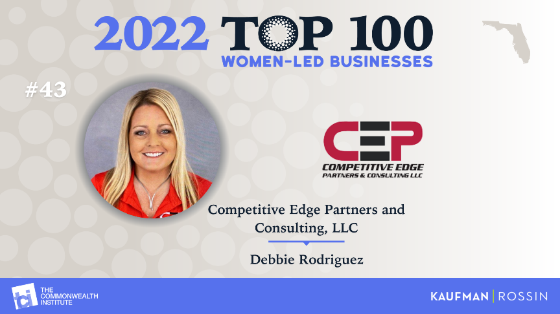CEP was recently honored among the Top 100 Women-Led Business in Florida. The list was compiled by The Commonwealth Institute-Florida (TCI-FL) and Kaufman Rossin. CEP came in at No. 43.

“As a woman in a male-dominated field, I know how hard it is to be a successful leader, and I’m incredibly honored to be in the company of these amazing woman-led businesses across the state,” Rodriguez said. “I couldn’t have done this without my team at CEP, who drive my decisions and dedication every day.”

CEP was formally honored among other businesses at the 17th annual TCI-FL luncheon in Miami on June 14. Though TCI-FL has hosted the event honoring women business leaders for many years, this is the first year the nonprofit compiled a list to represent women-owned businesses across all parts of Florida.

The list was ranked by factors such as innovation, customer service, revenue and employee programs.

CEP and Rodriguez have been honored for their leadership and success many times in the past. Rodriguez was named to the Orlando Business Journal’s 2021 list of Women Who Mean Business and was a past 40 Under 40 honoree. She has received recognition from trade organizations such as the Associated Builders and Contractors of Central Florida and community organizations such as the Hispanic Chamber of Commerce of Metro Orlando. CEP has been named to the OBJ’s list of top minority-owned businesses and top women-owned business multiple times.

To learn more about the event, click [here](https://commonwealthinstitute.org/2022/06/congratulations-to-the-2022-top-100-women-led-businesses-in-florida/).

For more information about Competitive Edge Partners, visit <https://compedgellc.com/>.

**About Competitive Edge Partners**

Competitive Edge Partners & Consulting is a Central Florida-based prime subcontractor. The company specializes in electrical, painting, prime services and safety. CEP consults with each client on every project, providing accuracy and compliance for each scope of work and going the extra mile to ensure success. CEP is dedicated to exceeding expectations and providing superior service through safety, accountability, commitment, integrity and passion. The company is minority and woman-led by CEO Debbie Rodriguez. For more information about CEP, visit [compedgellc.com](https://compedgellc.com/).

**MEDIA CONTACT:**

Will Wellons

Wellons Communications

(407) 339-0879

[will@wellonscommunications.com](mailto:will@wellonscommunications.com%0d)