UTV USE RULES

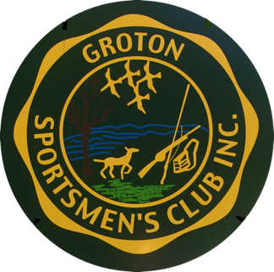

- The Groton Sportsmen’s Club SHWC UTV is a club asset to be used for day to day operations and club sponsored events.

- To use the UTV you must be vetted by the SHWC Chairman or his/her designee. The Chairman and his/her designees are listed in the SHWC book. The names of those vetted will be recorded in the SHWC book.

- Users must perform a Preventive Maintenance Checks and Services (PMCS). The PMCS is to be performed before, during and after use. It is to include but is not limited to fuel level (never below half full), oil level, tire pressure, lighting, damage, removal of any debris and to ensure it is clean.

- The UTV is not to be driven on public roads except for an emergency situation.

- The UTV shall only be used on approved property and trails on Groton Sportsmen’s Club Property. The trails must be wide enough that the full width of the UTV fits on the trail.

- Seat belts must be used while operating the UTV. The mesh door panels shall be utilized during operation.

- The UTV shall be transported in accordance with state law. The trailer shall be registered. The UTV shall be secured to the trailer with four points of contact. Ratchet straps are under the UTV seat. The UTV and trailer shall be free of dirt and debris that may fall off during transport.

- When not in use the UTV shall have the key secured and the UTV shall be locked in place.

- The UTV shall be driven with safety in mind at the minimum reasonable speed for trail capability, terrain and people density.

- The UTV rules are subject to change without notice. The most up to date copy will be kept in the SHWC book. The website will be updated as practicable.

UPDATED JULY 30, 2022
ED CULLEN
CHAIMAN

