**INTRODUCTION TO LONG RANGE AND PRECISION SHOOTING**

**INFO/FAQs**

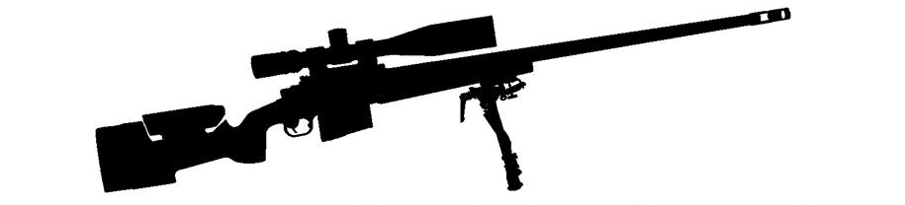**MIL/MOA conversion Formula:**

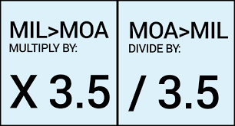

**Distance Calculation Formulas:**

**MIL/MOA size (in inches) 100-1000 yards:**

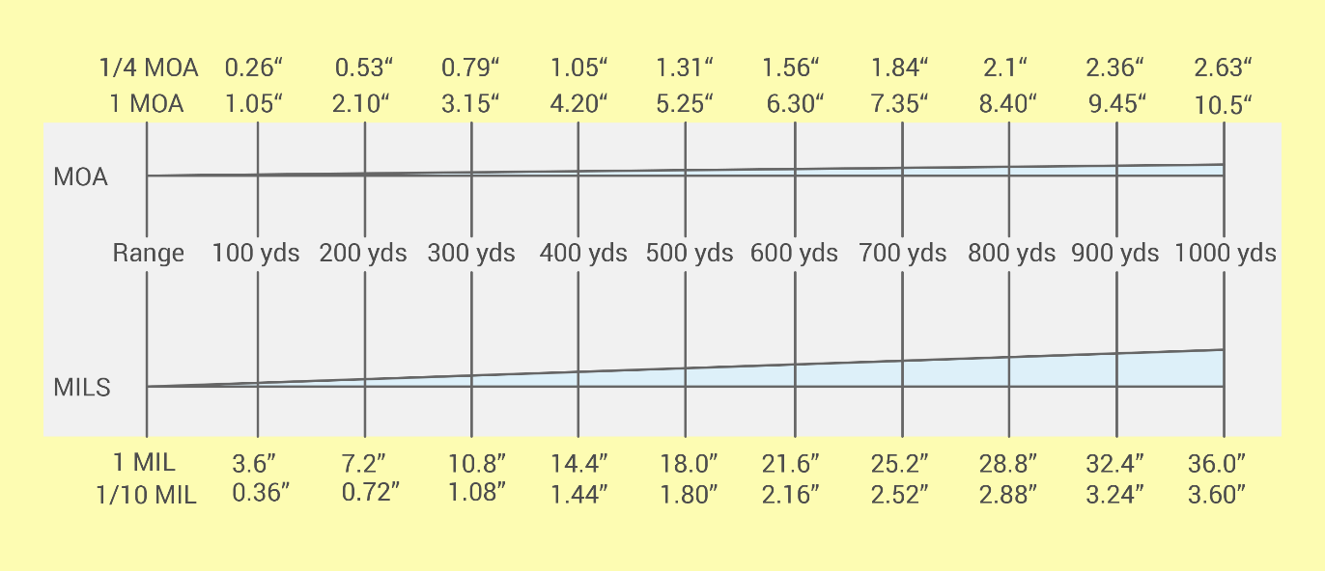

**Free Ballistic Calculators:**

<https://www.jbmballistics.com/ballistics/calculators/calculators.shtml>

<https://geoballistics.com/>

<https://www.hornady.com/team-hornady/ballistic-calculators/#!/>

**Where to Find Local Competitions:**

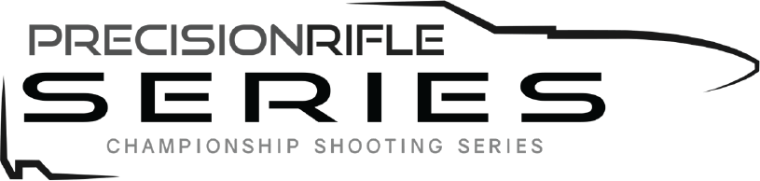 

<https://www.precisionrifleseries.com/> <https://nationalrifleleague.org/>

 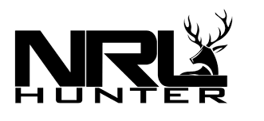

<https://nrl22.org/> <https://nrlhunter.org/>

**FORUMS:**

[**https://www.snipershide.com/precision-rifle/**](https://www.snipershide.com/precision-rifle/)

[**https://forum.accurateshooter.com/tags/long-range**](https://forum.accurateshooter.com/tags/long-range)

[**https://www.longrangehunting.com/**](https://www.longrangehunting.com/)

**PODCASTS:**

[**http://www.everydaysniper.com/**](http://www.everydaysniper.com/)

[**https://moderndaysniper.com/podcasts/**](https://moderndaysniper.com/podcasts/)

**New England Gun Clubs with Medium to long distance Ranges:**

Groton Sportsman’s club - Stonington, CT – (500 yds) <http://www.grotonsportsmen.com>

Ledyard Sportsman’s club - Ledyard, CT – (400 yds) <http://www.ledyardsportsmanclub.com/>

Granby Rod and Bow Club - Granby, Ma - (1000 yds) <https://www.granbybowandgun.club/>

Alderbrook Sportsmen’s Association - Littleton, NH – (1100 yds) <http://alderbrooksportsmensassoc.com/>

Sheepdog Warrior – Catskill, NY – (1000 yds) <https://sheepdogwarrior.com/>

**Find this FAQs sheet and additional class information:**

[**https://odintacticalsolutions.com/**](https://odintacticalsolutions.com/)