Academic Achievement 2019-2020
September 2019- September 2020 | 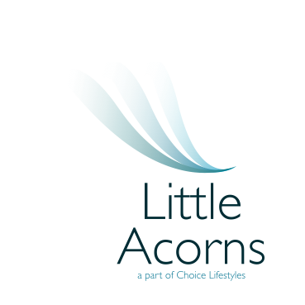

This cohort consisted of 6 pupils

% Achieving Expected Progress in Literacy | 100
% Achieving Expected Progress in Numeracy | 75
% Achieving progressing in Reading through Read, Write, Inc | 100
% Achieving Stage 5 or above in the Oxford Reading Tree | 75
% of emerging readers | 20

