Curriculum policy
Little Acorns School

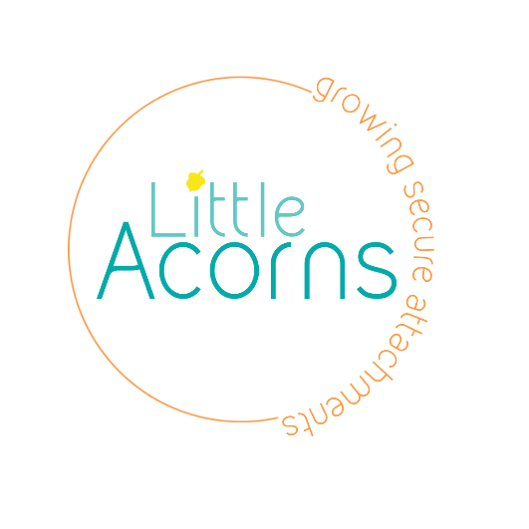

Completed by: | Alison Neal | Date: 09/08/21
Last reviewed on: | 09/08/21
Next review due by: | 09/08/23

Our aim is to create the opportunities for pupils to be successful and develop a positive self-image while fostering a life-long love of learning. Every pupil at Little Acorns is entitled to a rich and varied curriculum which is challenging and inspiring and which offers every individual the opportunity to fulfil their potential to the highest possible standard and from which they can achieve personal satisfaction and a sense of achievement.

Fundamentally, we understand that we are all individuals. Our approach is not a ‘one size fits all’ but instead offers a tailored, rich, and stimulating education experience for all our pupils, according to their needs. We recognise that many of our pupils encounter additional challenges in terms of their well-being, learning needs, early experiences of school and anxieties about being in school. Therefore, everything we do is crafted to deliver a bespoke education, carefully nurturing each pupil to ensure that positive outcomes are achieved – and their life chances are improved.

1. Curriculum aims
Our curriculum aim to:
- Provide a broad and balanced education for all pupils that’s coherently planned and sequenced towards cumulatively sufficient knowledge for skills and future learning and employment
- Enable pupils to develop knowledge, understand concepts and acquire skills, and be able to choose and apply these in relevant situations
- Support pupils’ spiritual, moral, social and cultural development
- Support pupils’ physical development and responsibility for their own health, and enable them to be active
- Promote a positive attitude towards learning
- Ensure equal access to learning for all pupils, with high expectations for every pupil and appropriate levels of challenge and support
- Have a high academic/vocational/technical ambition for all pupils
- To meet the outcomes of each child’s EHCP.
- Equip pupils with the knowledge and cultural capital they need to succeed in life

2. Legislation and guidance
This policy reflects the requirements for independent schools to provide a broad and balanced curriculum as per the Independent School Standards and the programmes of study we have chosen to follow.
It also reflects requirements for inclusion and equality as set out in the Special Educational Needs and Disability Code of Practice 2014 and Equality Act 2010.

3. Roles and responsibilities
3.1 The governing board
The governing board will monitor the effectiveness of this policy and hold the headteacher to account for its implementation.
The governing board will also ensure that:
- A robust framework is in place for setting curriculum priorities and aspirational targets
- Proper provision is made for pupils with different abilities and needs, including children with special educational needs (SEN)
- It participates actively in decision-making about the breadth and balance of the curriculum
3.2 Headteacher
The headteacher is responsible for ensuring that this policy is adhered to, and that:
- All required elements of the curriculum, and those subjects which the school chooses to offer, have aims and objectives which reflect the aims of the school and indicate how the needs of individual pupils will be met
- The amount of time provided for teaching the required elements of the curriculum is adequate and is reviewed by the governing board
- They manage requests to withdraw children from curriculum subjects, where appropriate
- The school’s procedures for assessment meet all legal requirements
- The governing board is fully involved in decision-making processes that relate to the breadth and balance of the curriculum
- The governing board is advised on whole-school targets in order to make informed decisions
- Proper provision is in place for pupils with different abilities and needs, including children with SEN

4. Organisation and planning

At Little Acorns School we strive to deliver a curriculum that is accessible to all our pupils. We aim to offer a balanced, interesting and relevant curriculum which is created around the individual learners. The curriculum is broken into 6 themes throughout the year- New Beginnings, Celebrations, Extreme Earth, Excellent Engineering, Nurturing Nature and Keep Calm and Carry on. Within these themes we also consider how to support the following areas: well-being, communication, contribution, exploration and belonging.

Reading is at the heart of the curriculum and is explicitly taught as a standalone session each day. We recognise that this is the core skill that will help in all areas of development and progress both inside and outside of education. Our intent is for all pupils to read at a near age-appropriate level as they can, through rigorous and sequential lessons and assessment. A Read, Write, Inc phonics screening is completed upon entry and the individuals reading plan put together as a result. All children have a 45-60 minute Read, Write, Inc session daily. As well as Read, Write, Inc interventions such as Language Through Colour and Language for Thinking are used to help develop both spoken and written English. This is linked to work with the Speech and Language Therapist where necessary.

As well as reading we give emphasis in our curriculum to the development of:
- Numeracy Skills with all children being introduced to Numicon: Breaking Barriers Scheme ( unless they are more able whereby the Hamilton Trust schemes of work are utilised.
- Social, Emotional and Mental Health, including SRE (see individual policy)
- Paws. B Mindfulness
- Physical Skills including PE, swimming, individual therapies, using the community and Life Skills. This also includes daily sensory circuits and activities.
- Outdoor Learning and connecting to the environment (Forest Schools and woodland bootcamps). Some children have the opportunity to attend a local Young Farmer group.
- SMSC- including the fundamental British Values. We use the resources provided by CEOP to support this learning.
- AQA Unit Awards
- Academic Progress (using the Hamilton Scheme of work for English, Maths and Science)
- Topic work is based on the likes/dislikes and interests of the children, whilst ensuring coverage of the National Curriculum where appropriate.
- Therapeutic Interventions such as Equine Therapy, Music Therapy, Play Therapy and Yoga/Meditation.
- Makaton is used with all the children and utilised where possible within the curriculum.

5. Inclusion
We adapt the Curriculum for individual learners according to their needs, whilst respecting the fact that all children have the right to a broad, balanced and relevant education which provides continuity and progression. We recognise children’s strengths’, needs and interests and build on these to promote achievement and success. We identify our children’s strengths through the Annual Review Process and plan and adapt the provision and learning opportunities to meet these needs. Each learner has an individualised Provision Map which is regularly updated to reflect the individual needs of the learner. Support staff, teaching staff, carers, social workers and parents (where suitable) are involved with and made aware of the outcomes on these plans.

Children who have suffered trauma, and have additional needs, have often had turbulence in their schooling before they arrive at Little Acorns. We seek to engage children so that a baseline can be sought, but sometimes this can be difficult. We believe that is important to understand each pupil in order that the curriculum is well matched, planned and sequenced so that they are able to engage in the lessons. We adapt the curriculum to meet the individual; we do not expect the individual to adapt.

Teachers set high expectations for all pupils. They will use appropriate assessment to set ambitious targets and plan challenging work for all groups, including:
- More able pupils
- Pupils with low prior attainment
- Pupils from disadvantaged backgrounds
- Pupils with SEN
- Pupils with English as an additional language (EAL)
Teachers will plan lessons so that pupils with SEN and/or disabilities can study every National Curriculum subject, wherever possible, and ensure that there are no barriers to every pupil achieving.
Teachers will also take account of the needs of pupils whose first language is not English. Lessons will be planned so that teaching opportunities help pupils to develop their English, and to support pupils to take part in all subjects.
Further information can be found in our statement of equality information and objectives, and in our SEN policy and information report.

6. Monitoring arrangements
Monitoring and Evaluation of the Curriculum is achieved by:

- Observation of lessons with a specific focus
- Staff Development meetings between all staff
- Use of pupil data: on Classroom Monitor
- Regular scrutiny of workbooks
- Termly or annual amendment of curriculum structure dependent on the individual needs of pupils
- Regular updates of the individual children’s Provision Map.

7. Links with other policies
This policy links to the following policies and procedures:
- Assessment policy
- SEN policy and information report
- Equality information and objectives
- RSE Policy

