Little Acorns School
Curriculum Policy
Updated: February 2020  To be reviewed: February 2022 | 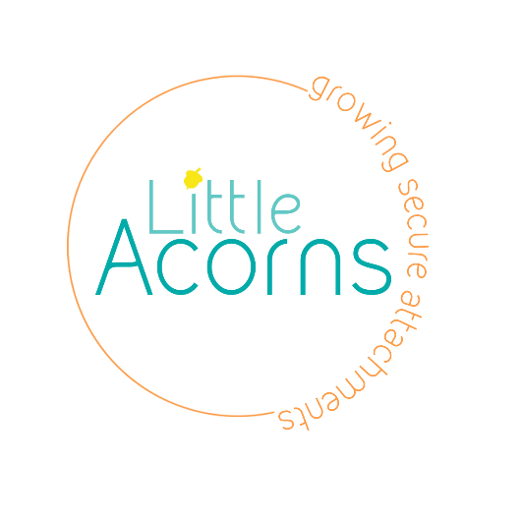
Our aim is to create the opportunities for pupils to be successful and develop a positive self-image while fostering a life-long love of learning. Every pupil at Little Acorns is entitled to a rich and varied curriculum which is challenging and inspiring and which offers every individual the opportunity to fulfil their potential to the highest possible standard and from which they can achieve personal satisfaction and a sense of achievement.

The Curriculum

At Little Acorns School we believe all children have the right to learn. We wish to help change the stigma attached at vulnerable children achieving poorly in school. As well as academic learning, here at Little Acorns we hope all children will acquire the skills and knowledge that they will need going into there teenage years and then adult life. We have high expectations for all our learners by offering a curriculum that;
- Is broad, balanced and relevant
- Guides all students towards achieving their full potential
- Is matched to individual students’ needs
- Has intrinsic value
- Builds on students’ existing knowledge, skills and understanding
- Equips them with the skills to enable lifelong learning
- Reflects the multicultural nature of society, also taking into account the spiritual, moral, social and cultural development of the children.
- Encourages confidence, high self-esteem, independence and mutual respect
- Develops a respect for the environment
- Prepares students for the opportunities, responsibilities and experiences of adult life and life away from Little Acorns Therapeutic Community.
- Supports physical development of the children and promotes a healthy lifestyle.

We are part of an increasingly complex and interdependent world. We therefore work towards continuing development of a curriculum that increases awareness of and sensitivity towards the society in which we live.

Each child has their own Individual Curriculum Plan each term which is linked to the outcomes of the children’s EHCP.

Legislation and Guidance

This policy reflects the requirements for independent schools to provide a broad and balanced curriculum as per the Independent School Standards and the programmes of study we have chosen to follow.
It also reflects requirements for inclusion and equality as set out in the Special Educational Needs and Disability Code of Practice 2014 and Equality Act 2010.
Roles and Responsibilities
The Governing Board:
- The advisory board of Little Acorns School will monitor the effectiveness of this policy and hold the head teacher to account for its implementation.
The governing board will ensure that:
- A robust framework is in place for setting curriculum priorities and aspirational targets.
- The school implements the relevant statutory assessment arrangements
- Proper provisions are in place for the different abilities and needs of the children with any level of SEN including ensuring provisions such as RWI, Equine Therapy and Numicon are in place.
The Headteacher
The Headteacher, Alison Neal, is responsible for ensuring that this policy is adhered to and that:
- All required elements of the curriculum, and those subjects the school chooses to offer, have aims and objectives which reflect the aims of the school and indicate how the individual needs of the children will be met. Children’s individual interests and current topics and themes must be taken into account.
- The amount of teaching time required for elements of the curriculum is adequate.
- The school’s procedures for assessment meet all legal requirements
- Proper provision is in place for pupils with different abilities and needs.
- Interventions such as Equine Therapy, Yoga and Meditation are planned and implemented taking into account the individual needs of the children.
Other Staff
Other staff will ensure that this policy is implemented in accordance with this policy.
- AN to oversee planning in Maple Class and to check planning in Oak Class.
- LSA’s to plan and implement interventions including Emotional Literacy and Read, Write, Inc.
- Staff with subject specialism teaching responsibilities plan and implement accordingly eg PE

4. Organisation and planning
At Little Acorns School we strive to deliver a curriculum that is accessible to all our pupils. We aim to offer a balanced, interesting and relevant curriculum which is created around the individual learners.

Reading is at the heart of the curriculum and is explicitly taught as a standalone session each day. We recognise that this is the core skill that will help in all areas of development and progress both inside and outside of education. Our intent is for all pupils to read at a near age-appropriate level as they can, through rigorous and sequential lessons and assessment. A Read, Write, Inc phonics screening is completed upon entry and the individuals reading plan put together as a result. All children have a 45-60 minute Read, Write, Inc session daily. As well as Read, Write, Inc interventions such as Language Through Colour and Language for Thinking are used to help develop both spoken and written English. This is linked to work with the Speech and Language Therapist where necessary.

As well as reading we give emphasis in our curriculum to the development of:
- Numeracy Skills with all children being introduced to Numicon: Breaking Barriers Scheme ( unless they are more able whereby the Hamilton Trust schemes of work are utilised.
- Social, Emotional and Mental Health, including SRE (see individual policy)
- Paws. B Mindfulness
- Physical Skills including PE, swimming, individual therapies, using the community and Life Skills. This also includes daily sensory circuits and activities.
- Outdoor Learning and connecting to the environment (Forest Schools and woodland bootcamps). Some children have the opportunity to attend a local Young Farmer group.
- SMSC- including the fundamental British Values. We use the resources provided by CEOP to support this learning.
- AQA Unit Awards
- Academic Progress (using the Hamilton Scheme of work for English, Maths and Science)
- Topic work is based on the likes/dislikes and interests of the children, whilst ensuring coverage of the National Curriculum where appropriate.
- Therapeutic Interventions such as Equine Therapy, Music Therapy, Play Therapy and Yoga/Meditation.
- Makaton is used with all the children and utilised where possible within the curriculum.

5. Inclusion
We adapt the Curriculum for individual learners according to their needs, whilst respecting the fact that all children have the right to a broad, balanced and relevant education which provides continuity and progression. We recognise children’s strengths’, needs and interests and build on these to promote achievement and success. We identify our children’s strengths through the Annual Review Process and plan and adapt the provision and learning opportunities to meet these needs. Each learner has an individualised Provision Map which is regularly updated to reflect the individual needs of the learner. Support staff, teaching staff, carers, social workers and parents (where suitable) are involved with and made aware of the outcomes on these plans.

Children who have suffered trauma, and have additional needs, have often had turbulence in their schooling before they arrive at Little Acorns. We seek to engage children so that a baseline can be sought, but sometimes this can be difficult. We believe that is important to understand each pupil in order that the curriculum is well matched, planned and sequenced so that they are able to engage in the lessons. We adapt the curriculum to meet the individual; we do not expect the individual to adapt.

Monitoring and Evaluation

Monitoring and Evaluation of the Curriculum is achieved by:

- Observation of lessons with a specific focus
- Staff Development meetings between all staff
- Use of pupil data: on Classroom Monitor
- Regular scrutiny of workbooks
- Termly or annual amendment of curriculum structure dependent on the individual needs of pupils
- Regular updates of the individual children’s Provision Map.

Links with Other Policies

This policy links to the following policies and procedures:
- Assessment policy
- SEND policy
- Equality information and objectives
- Sex Education Policy

